1. ER Diagram

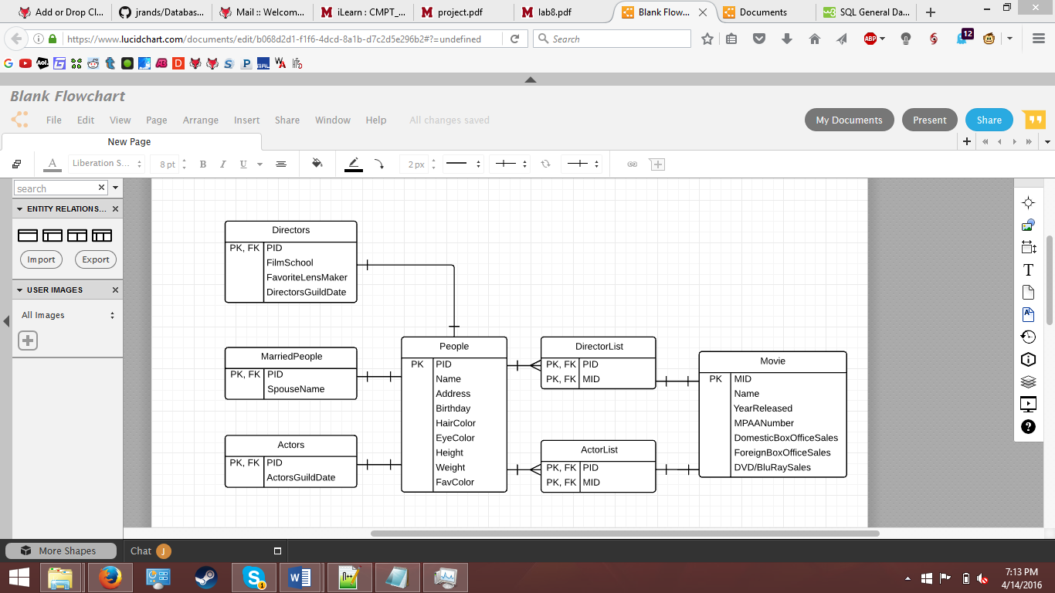

1. Create Statements:

CREATE TABLE People (

PID char(4) not null,

Name text,

Address text,

Birthday date,

HairColor text,

EyeColor text,

Height integer,

Weight integer,

FavColor text,

PRIMARY KEY (`PID`)

);

CREATE TABLE Directors (

PID char(4) not null references People(PID),

FilmSchool text

FavoriteLensMaker text,

DirectorsGuildDate date,

primary key (PID)

);

CREATE TABLE MarriedPeople (

PID char(4) not null references People(PID),

SpouseName text,

KEY PK, FK (PID)

);

CREATE TABLE Actors (

PID char(4) not null references People(PID),

ActorsGuildDate date,

KEY PK, FK (PID)

);

CREATE TABLE DirectorList (

PID char(4) not null references People(PID),

MID char(4) not null references Movie(MID),

primary key (PID, MID)

);

CREATE TABLE Movie (

MID char(4) not null,

Name text,

YearReleased char(4),

MPAANumber integer,

DomesticBoxOfficeSales numeric(12,2),

ForeignBoxOfficeSales numeric(12,2),

DVD/BluRaySales integer,

primary key(MID)

);

1. Functional Dependencies:

People Table:

PID -> Name, Address, Birthday, Hair Color, Eye Color, Height, Weight

Directors Table:

PID -> Film School, Favorite Lens Maker, Directors Guild Date

Actors Table:

PID -> Actors Guild Date

Married People Table:

PID -> Spouse Name

Movies Table:

MID -> Name, Year Released, MPAA Number, Domestic Box Office Sales, Foreign Box Office Sales, DVD/Blu Ray sales