1.

Team Table: (TeamName) → AgeGroup, HeadCoachID

Player Table: (PeopleID, TeamName) → AgeGroup

People Table: (PeopleID) → PeopleID, FirstName, LastName, Address, PhoneNumber

Coach Table: (PeopleID) → YearsCoaching

Coach List Table: (TeamName, HeadCoachID) → AssistantCoachID

2.

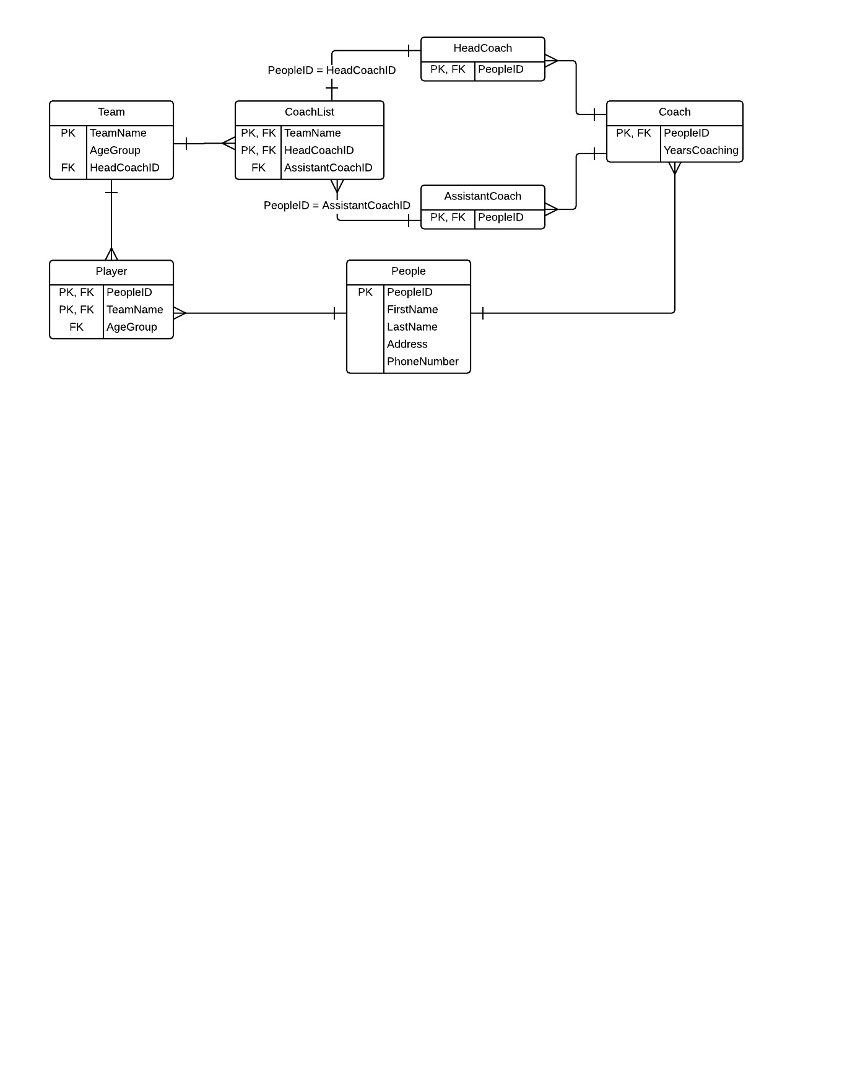

3. The database is in third normal form because the attributes in each of the tables depends on the key, the whole key, and nothing but the key.