# Library Management System in Java

Library Management System is a software application implemented in Java platform using MS Access database design. It is useful for libraries in any university, [college](https://www.codewithc.com/online-college-management-system-project-php/), or similar educational institution to manage and maintain data in database through computerized system. Using this system, users need not search the entire library to find a book; the list of books available is displayed by the application.

**Library Management System Project Abstract:**

LMS is a software application useful for librarians in any educational institution for management and handling of typical operations in the library. It manages data through computerized system in a database which eradicates the tediousness in searching a particular book in the entire library.

**Existing System:**

The existing [library management system](https://www.codewithc.com/mini-project-in-c-library-management-system/) is very traditional and manual. Most of the things such as record of students who’ve issued the book, no. of books in the library, fine of [students](https://www.codewithc.com/online-student-management-system-asp-net-project/), etc. are recorded using pen-paper system. This traditional system requires a lot of time and manpower for performing simple operations in the library.

The drawbacks of existing system are:

* Record keeping is paper-based.
* The system is not computerized.
* There’s high risk of data mis-management.
* Students face a lot of problem while searching a book.
* Chances of book theft from the library is high.
* A lot of paperwork and manpower is to be allocated for simple library management operations.
* The existing system is very inefficient and unreliable.

**Proposed System:**

The proposed library management software is developed after the analysis of issues, problems, and drawbacks of the existing system. Here, different modules have been assigned for managing and organizing different [tasks](https://www.codewithc.com/task-management-system-project-asp-net/) in a library. Using this software, librarian can store information of all the books, with author name, faculty, etc., available in the library. Only one person can handle the entire library.

The main feature of this system is that all the books available in the library can be displayed in a list so that students need not roam through the entire library to find a book. Additionally, the application effectively maintains the details of users/students to whom books have been issued; it also records the issued date and return date.

**Features:**

* Add, modify and delete book details into the database.
* Search feature for finding book availability in library [stock](https://www.codewithc.com/stock-management-system-project-java/).
* Add students records upon issue of a book.
* Record issue date, return date, and fine (penalty).
* Payment system/feature allows the librarian to calculate payment details and print bill.

**Technologies and Products Used:**

* NetBeans 5.0
* Tomcat 5.5 embedded in NetBeans
* Oracle10g Express Edition
* Jboss 4.0.3
* Java Server Pages (JSP)
* Java Beans
* Enterprise Java Beans

**Modules Overview:**

1. Insertion Module: With the help of this module, librarian can insert information and details of users along with book details and time and date of book issue.
2. Updating Module: This module allows modification to the existing records and details in the library management system database.
3. Report Generation Module: This module allows task such as printing payment details, stock details of books, etc.

**Screenshots:**

[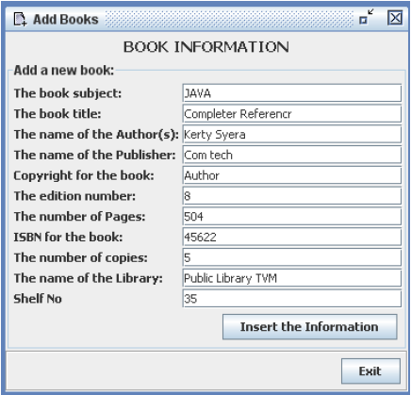](https://www.codewithc.com/wp-content/uploads/2015/05/LMS-add-new-books.png)Add New Books [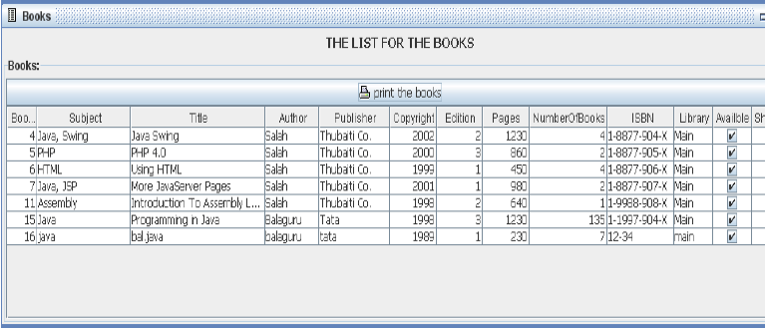](https://www.codewithc.com/wp-content/uploads/2015/05/LMS-list-of-all-books1.png)List of All Books [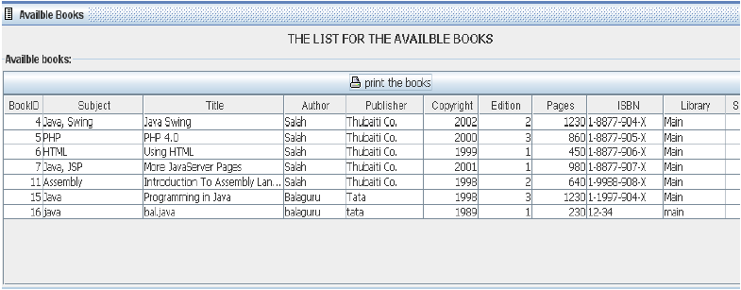](https://www.codewithc.com/wp-content/uploads/2015/05/LMS-available-books.png)Available Books

**System Configuration:**

**Hardware Configuration:**

* Processor: Pentium III 630MHz
* RAM: 128MB
* Hard Disk: 20GB
* Monitor: 15″ Color Monitor
* Keyboard: 122 keys

**Software Configuration:**

* Operating System: Windows NT/ Windows 98/ Windows XP
* Language: Java 2 Runtime Environment
* Database: MS Access

**Conclusion:**

The proposed library management system meets the current requirements of users of a typical library, but many new features and enhancements can be added into the system as per user requirements. Some of these include developing system using RFID, adding SMS module, sending SMS to check book availability, etc.