**Objectify Storage Evaluation with granular flexibility to Subjectify aspects relevant to your need?**

The co-existence of Hybrid Cloud is the way to go for consume virtual infrastructure where many people questioned this IT model 3-4 years back. The richness, robustness and ease of usage of Public Cloud will keep IT consumers to go for AWS, Azure, and GCP etc. At the same time, the need of security, cost, compliance and governance, latency etc will keep people hosting certain set of workloads in Private Cloud.

***Hybrid cloud is reality! Private cloud is going to be there!***

It is inefficient to design Private Cloud with Public Cloud mindset. It sounds contrasting? Yes, it is! We should not forget that Private Cloud is customer centric. It has to be designed to optimize hosting of customer centric applications unlike public cloud. It has to be designed keeping homogeneity of workloads hosted on-prem. The same is not true for public cloud. It is a humongous centralized computer with distributed computing engine across geographies (often termed as availability zone like AWS US EAST, AWS US WEST etc). It is assumed to have infinite resources which keeps getting added under the carpet as need arises for a specific service. An example might help here to convey the point. Let us take the following use cases:

1. A medical record archival company needs to storage tons of medical records with occasional access of data sets. Don’t they need infinitely horizontally scalable but low cost storage system?
2. A live streaming company needs ability to quickly stream content on demand. Don’t they need high performant and low latency storage system?

Will we choose same underlay infrastructure for both? No, not at all. But public cloud has to do so as they are not aware of their customers. But Private cloud is in most of cases. However one thing is very clear: the usability, billing and security model has to be same for both cloud. Both needs pay-as-you go model, ability to access like a service from anywhere. So, designing a private cloud should look for commonality in usage but not in selecting underlay infrastructure. In a nutshell, there is set of message!

***Every private cloud is different but user experience is same like public cloud.***

***Do not make a mistake in choosing same underlay infrastructure to create private cloud for all customers. Otherwise, we will be seeding conflict between business goals and architectural goals.***

Above context gives us to define the problem statement for the paper.

***How do we choose specific underlay infrastructure for Private cloud***

***without conflict architectural and business goal?***

There are 3 core components defining underlay infrastructure for private cloud: Compute, Storage and Networking. Compute is more or less get tied to sizing if clarity of scale is achieved. The networking puzzle is more tied to water flow rate (i.e. bits at per second) and remains more or less frozen once decided. Amidst of these, storage is naughty because of the following reason:

* Many vendors
* Many different architecture: traditional, converged, hyper converged, software defined etc
* Many protocols: FC, FCoE, iSCSI, NFS etc.
* Multiple hypervisor: ESXi, Hyper-V, KVM
* Endless list of feature set with each being relevant in specific use case. For e.g. de-duplication, thin provisioning, encryption, backup, clone, snapshot etc.
* Need of scalability, agility and robustness of cloud
* Many more

In this paper, we will device a model which is more of illustration how we can objectify selection of storage system amidst of above heterogeneity. Also, we will address how we can leeway some flexibility to fine tune some parameters to make the overall decision system more affective. The above brief discussion helps us to define the problem statement being addressed in this paper.

***How do we objectify selection of storage system amidst of heterogeneity?***

The mechanism used to objectify the evaluation is depicted below.

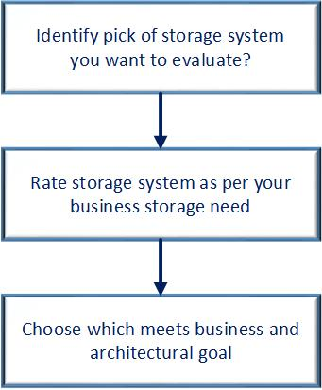

The below data apply same to determine the storage system for a cloud which needs storage and compute to grow in tandem – a typical private cloud data center. The following storage systems have been considered to keep discussion compact and illustrative:

1. HPE SimpliVity 380
2. VMware VSAN
3. Dell EMC Unity

As the considered storage system seems to resemble in features, there is need to drive a objective evaluation system to determine the perfect fit for private cloud of specific organization need. In this section, the methodology assigns a point in a scale of 1 (low) to 5 (high).

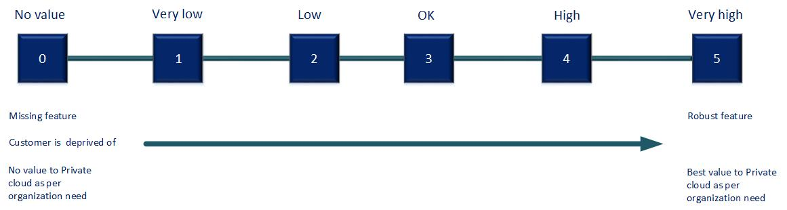

|  |  |  |  |  |
| --- | --- | --- | --- | --- |
| **Area** | **Criteria** | **vSAN** | **HPE SimpliVity** | **Dell EMC Unity** |
| Usability, manageability and operability | Leverage as hyper-converged solution | 5 | 5 | 0 |
| Easy to manage | 5 | 5 | 5 |
| Initial cost (low cost = higher points) | 5 | 5 | 3 |
| Incremental horizontal scaling cost | 5 | 5 | 2 |
| Maximum RAW capacity | 4 | 4 | 5 |
| **Sub-total** | **24** | **24** | **15** |
| Performance | IOPS | 3 | 5 | 4 |
| Ability to support differentiated storage based on feature sets (no usage of VVOL), leveraging data storage separation. | 5 | 5 | 3  (need to design datastore very thoughtfully leveraging storage policy concept of VMware) |
| Ability to support IOPS throttling as native support from data store (as much as I understand) | 5 | 5 | 0 |
| **Sub-total** | **13** | **15** | **7** |
| Enterprise feature | De-duplication | 4 | 5 | 4 |
| Compression | 4 | 5 | 4 |
| Thin provisioning | 5 | 5 | 5 |
| Encryption | 3 | 3 | 4 |
| Fault tolerance | 5 | 5 | 5 |
| Advanced VM based backup | 2 | 5 | 1 |
| Advanced VM based snapshot | 2 | 5 | 1 |
| Advanced VM based clone | 2 | 5 | 1 |
| Advanced VM based DR | 2 | 5 | 1 |
| Availability | 4 | 5 | 4 |
| Public cloud compatibility | 0 | 0 | 0 |
| **Sub-total** | **33** | **48** | **30** |
| Scalability | Easy to tweak compute to storage ratio horizontally (a very critical criteria in case of cloud) | 4 | 4 | 1 |
| Granular horizontal scalability of standalone storage system | 5 | 5 | 1 |
| Granular vertical scalability of standalone storage system | 1 | 1 | 5 |
| Granular segmented scalability of standalone storage system | 5 | 5 | 2 |
| **Sub-total** | **15** | **15** | **9** |
| Miscellaneous | Open source | 0 | 0 | 64 |
|  | **0** | **0** | **5** |
|  | **Total** | **85** | **102** | **77** |

Based on above evaluation parameters, we can rate storage system for our private cloud as depicted below.

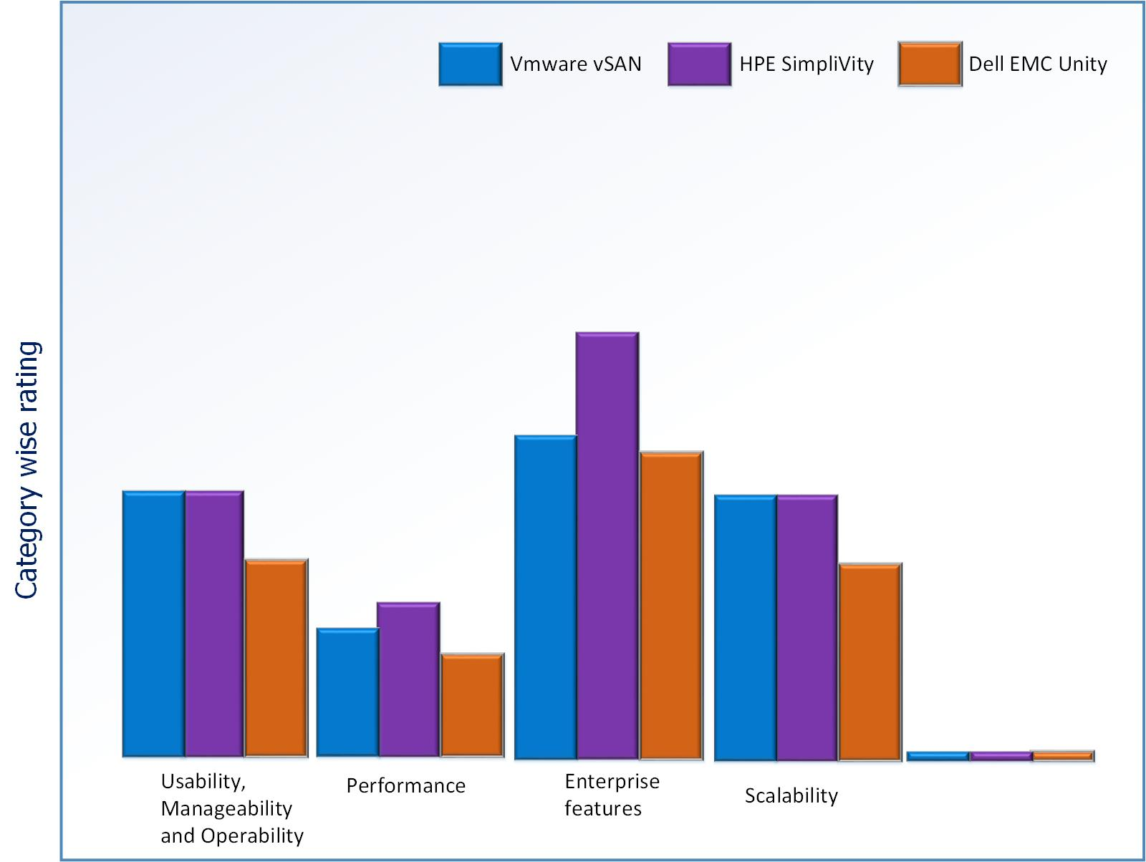

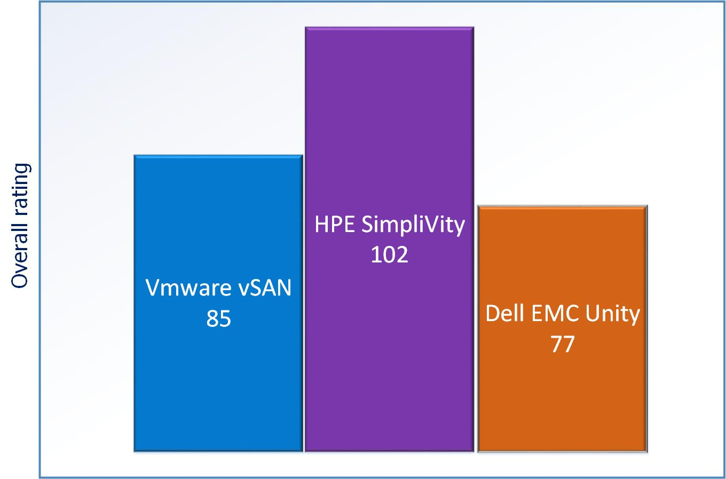

To summarize, every Private Cloud is different. You need more granular control and specialized underlay infrastructure to create cloud unlike public cloud. Leverage the awareness of application workload to extra maximum value add instead of focusing only on usage model i.e. XaaS model and leaving the infrastructure part unattended. This challenge is not because of lack of understanding but two different sets of world having different perspective.

***Are you ready for objective evaluation of CAPEX requirement of your Private Cloud to offer OPEX model like Public Cloud?***

***Declaration:***

***Author works for Hewlett Packard Enterprise at the time of drafting the proposal. The parameters and rating associated with that is of author’s understanding of storage system. The purpose is to illustrate the concept of evaluation model rather than promoting any storage system and hence does hold any official declaration.***