Molecular modeling of differential ERK1/2-ligand dynamic interactions and the development of ERK1/2 inhibitor resistance

The development of small molecule inhibitors for the ERK1 and ERK2 kinases is a highly active area of research, as these two isoforms are key drivers of cancer cell proliferation. However, drug resistance is the “Achilles heel” of kinase inhibitors. As members of signaling pathways that are critical to an array of cellular processes, kinase inhibition gives rise to strong selection pressure for drug resistance conferring mutations in patients. Because ERK1 and ERK2 are highly similar in both sequence and structure, it is unclear what selection pressure differences occur at the ERK1/2 binding site, and whether this contributes to drug resistance events in certain patients. In particular, there has not been a thorough exploration of how preferentially certain molecules can bind to ERK1 or ERK2, and whether there are key structural and/or dynamic differences in their binding modes. Recently, we conducted a study that encompassed (i) the structure-based docking of a series of inhibitors in the binding site of ERK2, (ii) the independent molecular dynamics (MD) simulations of each ERK2-inhibitor complex, and (iii) the computation of novel “MD descriptors” to characterize the dynamic non-covalent ERK2-inhibitor interactions. We discovered these MD descriptors could distinguish ERK2 binders from non-binders. In this project, we conduct this modeling workflow for a curated and refined set of small molecule inhibitors that have been tested against both ERK1 and ERK2 kinases. Our chemocentric analysis identifies significant differences between the dynamic intermolecular interactions of highly potent ERK2 inhibitors versus ERK1 inhibitors. This analysis deepens the understanding of why certain inhibitors interact differently with these two isoforms. We identify residues where the selection pressure driving drug resistance may be different, and inform chemists of strategies to design new ERK inhibitors with greater efficacy. At last, our analysis of ERK-ligand dynamic interactions that confer specificity to ERK1, ERK2, or both will aide in the development of new chemical probes capable of more selective inhibition

# Introduction

Kinase inhibitors are the next generation of cancer drugs. With tens of compounds already on the market and even more currently in clinical trials,1 the research community is on the path to developing a large collection of potent kinase-mediated drugs and chemical probes. However, there are two main limitations to the efficacy of kinase inhibitors: drug resistance acquired by patients and side effects due to lack of kinase selectivity. Usually, drug resistance is overcome by targeting multiple kinases2, either with inhibitors that bind multiple targets3 or cocktails of highly specific inhibitors4. Thus, understanding the polypharmacology of kinase inhibitors has become a critical task for the cancer research community2. However, the sheer number of kinases has made understanding the structure activity relationship (SAR) for every possible polypharmacological profile a daunting task. The kinases super family is the largest family of druggable genes that bind a common substrate (ATP), so kinase inhibitors have a high propensity for target promiscuity. To address the need for a better understanding of the polypharmacology of kinase inhibitors, vendors will now screen inhibitors against panels that cover over half of the kinome. Several large scale analyses of the distribution of bioactivities for many inhibitors by many kinases have been conducted5,6. One study of interest7 analyzed the polypharmacology profiles of 2106 inhibitors, 482 kinases and 661 patients. Traditional molecular descriptors along with protein descriptors were used to build proteochemometric (PCM) models that were highly predictive of affinity towards each kinase (externally validated R­2 of .74). These models may be used to provide reasonable predictions the pharmacology of any new kinase inhibitor.

In this study, we focus on ERK inhibitors, specifically their activity towards ERK1 and ERK2. ERK1 and ERK2 are members of the mitogen activated protein (MAP) kinase pathway (Ras/Raf/MEK/ERK), an evolutionarily conserved signaling cascade that is over-activated in about one third of human cancers, especially in melonomas.8,9 Recently, the development of selective BRAF or MEK inhibitors to target the MAP kinase pathway has shown remarkable clinical activity in numerous tumor types with one BRAF inhibitor being approved by the U.S. Food and Drug Administration for the treatment of metastatic melanoma.10 However, initial tumor shrinkage is often followed by resistance.8 Since resistance is often conferred by the reactivation of ERK1/2, there has been a resurgence in interest for the development of ERK inhibitors. Recent studies have shown that cancer cells that develop BRAF and MEK inhibitor resistance are still dependent on the MAP kinase pathway, and treatment with ERK inhibitors blocks their proliferation.8,9 However, a key mutation that confers ERK1/2 inhibitor resistance has been recently discovered.11

Importantly, ERK1 and ERK2 have 82% sequence similarity and substantial structural similarity.12 Many lines of evidence suggest the functional redundancy of ERK1 and ERK2, including a recent phylogenetic analysis showing that non-synonymous substitutions occurring after the duplication of the ERK1/2 ancestor are far from functional sites and likely neutral.12 However, there is also evidence for functional divergence, such as expression differences in ERK1 and ERK2 as well as a few key structural differences.12 Even in the context of strong similarities between ERK1 and ERK2 binding sites, mutations distant from a protein's binding site can still have allosteric effects that result in large changes in a binding pocket's conformational dynamics.13 For example, Jackson et al. have shown that an enzyme's binding pocket can have its conformation dynamics and catalytic efficiency affected by far removed mutations.14 This evidence along with the numerous sites available for selection pressure changes in kinases 15 suggests that the amino acid differences between ERK1 and ERK2 could create differences in the conformational dynamics of their binding pockets, which may affect the binding modes of their respective ligands.

In this study, we build upon our recent paper16 regarding ERK2 and a series of inhibitors modeled according to different levels of molecular representation. We demonstrate that differences between ERK1 and ERK2 binding pockets become apparent when simulating and exploring the conformational space of both kinases bound to small molecule inhibitors. By studying the dynamic non-covalent protein-ligand interactions between ERK1 and ERK2 and a set of known ERK1/2 inhibitors, we establish new relationships between those dynamic interactions and compounds potency and selectivity. Since the functional redundancy of ERK1 and ERK2 is an ongoing debate, a key outcome of this research is the identification of features of protein-ligand dynamics that confer specificity to ERK1 or ERK2, informing the design of chemical probes for selective inhibition of the isoforms, so that their functional divergence can be further explored.

# Preliminary Methods and Results

A focused library was constructed by mining the ChEMBL (<https://www.ebi.ac.uk/chembl/>) chemogenomics database for all ligands tested against ERK1 (CHEMBL3385) and ERK2 (CHEMBL4040). Our preliminary analysis retrieved 958 ligands with known activity towards ERK1 and 969 ligands with known activity towards ERK1. Knime17 was used to preprocess the ligands according to a curation protocol co-developed by the Fourches lab18,19. Briefly, all salts, inorganic, and compounds with structural errors were flagged and removed. All structural duplicates were also removed using ChemmineR20. If there were multiple IC50 values measures, the mean was computed and standard deviations above 1 were flagged (only a couple of these instances, should probably throw out this data). IC50 values were transformed to pIC50s with a negative log base 10 transform. After preprocessing, only 71 compounds had binding potencies (pIC50) available towards both ERK1 and ERK2. Figure 1 shows that most activities measured were highly similar and had correlation coefficient of .893. There were only 10 ligands with larger than 1 pIC50 difference (IC50 fold change of 10) between ERK1 and ERK2. Staurosporine was removed as it had multiple pIC50 values reported with a range larger than 1. Three other ligands were removed due to poor ADMET properties. Tannic Acid had too large of a molecular weight (1701.2 MW). Idoquinol is known to be poorly absorbed in the gastrointestinal tract, and Hexachlorophene is an organochlorine compound. The remaining six compounds belonged to an analog series reported by Awadallah et al21. The activities for all compounds in this analog series are reported in Table 1.

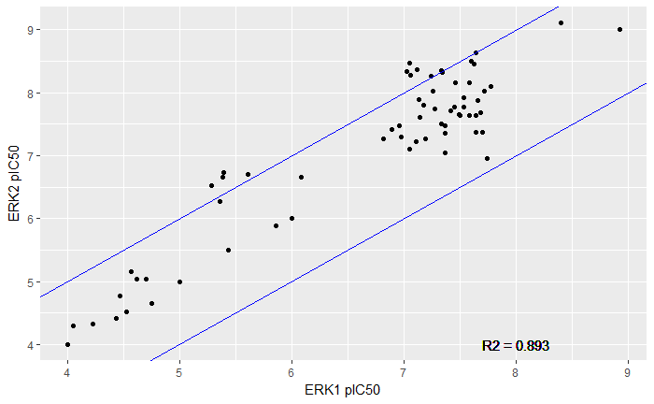

**Figure 1. Scatterplot of ERK1 pIC50 versus ERK2 pIC50.** Points outside of the blue band have a difference in pIC50 greater than 1. The activity values are highly correlated with an R­2 of 0.893.

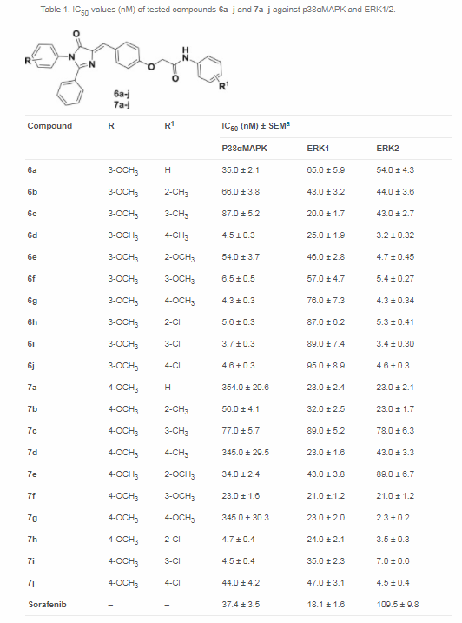

**Table 1.** **IC50 for all compounds in the analog series tested by Awadallah et al21 against ERK1 and ERK2.**

There were a number of other compounds that showed statistically significant differences when the experimental variability of the pIC50 measurements was considered. All of the compounds with a fold change in IC50 greater than 2 between ERK1/2 showed statistical significance. Therefore, these compounds were considered to have large changes in IC50. There were 11 of these compounds with higher affinity towards ERK2, and one compound with higher affinity towards ERK1.

Next, we docked each of the compounds in the analog series in both the ERK1 and ERK2 binding pockets. Compounds with large differences in activity toward ERK1/2, and those without large differences were docked to determine what differences in protein ligand interactions could attributed to differences in activity. We used the 4QTA and 4QTB PDB crystal structures and Schrodinger’s Glide software22. These crystal structures were selected because they were crystallized by the same lab with the same native ligand, SCH77298423. This ligand was also more structurally than the only other ligand cocrystallized with ERK1 in the pdb, 2ZOQ, and the majority of the cocrystallized ligands with ERK2. The induced fit protocol24 was used because the compounds in the analog series had large structural differences from the native ligands, resulting in a difference in induced fit.

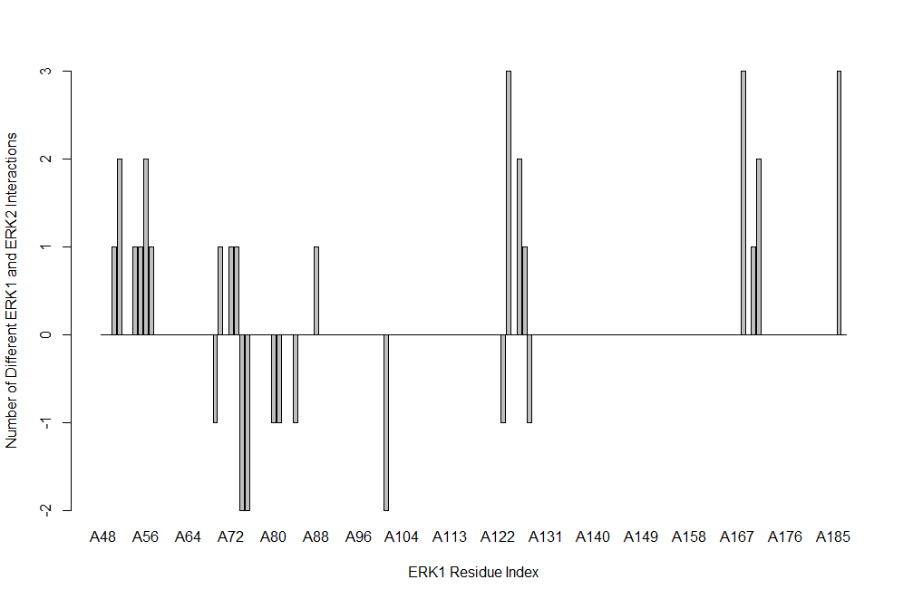

**Figure 2. Difference in the number of ligands with non-covalent interactions between ERK1 and ERK2 for each residue in the binding pocket.**

Figure 2 shows the number of ligands with different non-covalent interactions per residue in the ERK1/2 binding pocket. Three residues had the largest number of interaction differences -- three ligands forming interactions in ERK1 that were not present for ERK2. Figure 3 shows ligand interaction diagrams for a ligand with a difference in all three of these interactions in ERK1/2. The first residue was Leucine 124 (all amino acids numbered with respect to ERK1), which is in the critical hinge region of the ERK1/2. This is the region of ERK1/2 that all inhibitors target as the hinge regions binds ATP (ERK1/2 inhibitors are ATP competitors). The second residue was Lysine 168, which is interacting with the benzene, which also interacts with the P-Loop (amino acids 49 - 54). The third residue was Glycine 186, which is interacting with the terminal chlorobenzene in the induced hydrophobic pocket. In addition to these differences in interactions, there are also numerous differences in interaction in the P-Loop.

These differences in interactions are interesting because Ring et al have shown that there is a difference in conformational mobility of inactivated ERK1 and ERK2 in the hinge and P-loop regions25. They propose that when inactivated, as the ERK1/2 proteins are in the 4QTA/B crystal structures, ERK2 has a constraint that prevents the closure of its C-Terminal domain on a bound ligand, while this constraint is not present in ERK1. The difference in conformational mobility in these regions may explain the difference in affinity that these ligands have for these two targets. To further study this protein ligand interactions over the course of long run molecular dynamics will need to be studied.

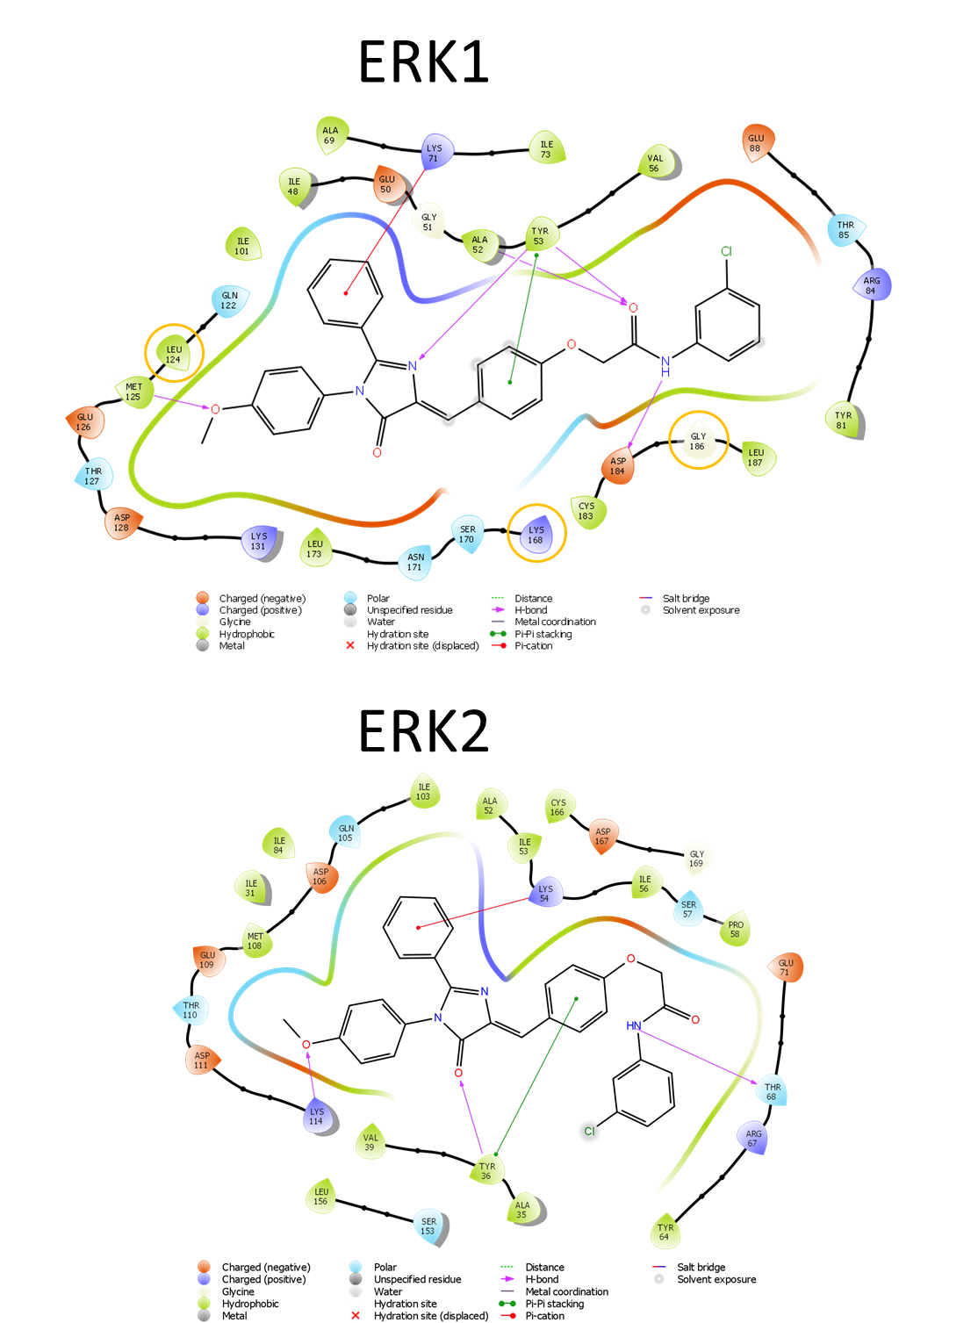

**Figure 3. Representative molecule with difference in most frequent protein ligand interactions.** Docked conformation of CHEMBL3577644 in both ERK1 and ERK2. Interactions of interest that are present in ERK1 but not ERK2 are circled in orange.

# References

(1) Wu, P.; Nielsen, T. E.; Clausen, M. H. Small-Molecule Kinase Inhibitors: An Analysis of FDA-Approved Drugs. *Drug Discov. Today* **2016**, *21* (1), 5–10.

(2) Knight, Z. A.; Lin, H.; Shokat, K. M. Targeting the Cancer Kinome through Polypharmacology. *Nat. Rev. Cancer* **2010**, *10* (2), 130–137.

(3) Apsel, B.; Blair, J. A.; Gonzalez, B.; Nazif, T. M.; Feldman, M. E.; Aizenstein, B.; Hoffman, R.; Williams, R. L.; Shokat, K. M.; Knight, Z. A. Targeted Polypharmacology: Discovery of Dual Inhibitors of Tyrosine and Phosphoinositide Kinases. *Nat. Chem. Biol.* **2008**, *4* (11), 691–699.

(4) Sawyers, C. L. Cancer: Mixing Cocktails. *Nature* **2007**, *449* (7165), 993–996.

(5) Bain, J.; Plater, L.; Elliott, M.; Shpiro, N.; Hastie, J.; Mclauchlan, H.; Klevernic, I.; Simon, J.; Arthur, C.; Alessi, D. R.; Cohen, P. The Selectivity of Protein Kinase Inhibitors: A Further Update. *Biochem. J* **2007**, *408*, 297–315.

(6) Bamborough, P.; Drewry, D.; Harper, G.; Smith, G. K.; Schneider, K. Assessment of Chemical Coverage of Kinome Space and Its Implications for Kinase Drug Discovery.

(7) Christmann-Franck, S.; van Westen, G. J. P.; Papadatos, G.; Beltran Escudie, F.; Roberts, A.; Overington, J. P.; Domine, D. An Unprecedentedly Large-Scale Kinase Inhibitor Set Enabling the Accurate Prediction of Compound-Kinase Activities: A Way towards Selective Promiscuity by Design? *J. Chem. Inf. Model.* **2016**, acs.jcim.6b00122.

(8) Morris, E. J.; Jha, S.; Restaino, C. R.; Dayananth, P.; Zhu, H.; Cooper, A.; Carr, D.; Deng, Y.; Jin, W.; Black, S.; Long, B.; Liu, J.; DiNunzio, E.; Windsor, W.; Zhang, R.; Zhao, S.; Angagaw, M. H.; Pinheiro, E. M.; Desai, J.; Xiao, L.; Shipps, G.; Hruza, A.; Wang, J.; Kelly, J.; Paliwal, S.; Gao, X.; Babu, B. S.; Zhu, L.; Daublain, P.; Zhang, L.; Lutterbach, B. A.; Pelletier, M. R.; Philippar, U.; Siliphaivanh, P.; Witter, D.; Kirschmeier, P.; Robert Bishop, W.; Hicklin, D.; Gary Gillil, D.; Jayaraman, L.; Zawel, L.; Fawell, S.; Samatar, A. A. Discovery of a Novel ERK Inhibitor with Activity in Models of Acquired Resistance to BRAF and MEK Inhibitors. *Cancer Discov.* **2013**, *3* (7), 742–750.

(9) Hatzivassiliou, G.; Liu, B.; O ’brien, C.; Spoerke, J. M.; Hoeflich, K. P.; Haverty, P. M.; Soriano, R.; Forrest, W. F.; Heldens, S.; Chen, H.; Toy, K.; Ha, C.; Zhou, W.; Song, K.; Friedman, L. S.; Amler, L. C.; Hampton, G. M.; Moffat, J.; Belvin, M.; Lackner, M. R. ERK Inhibition Overcomes Acquired Resistance to MEK Inhibitors. *Mol Cancer Ther* *11* (5), 1143–1154.

(10) Flaherty, K. T.; Yasothan, U.; Kirkpatrick, P. Vemurafenib. *Nat. Rev. Drug Discov.* **2011**, *10* (11), 811–812.

(11) Jha, S.; Morris, E. J.; Hruza, A.; Mansueto, M. S.; Schroeder, G. K.; Arbanas, J.; McMasters, D.; Restaino, C. R.; Dayananth, P.; Black, S.; Elsen, N. L.; Mannarino, A.; Cooper, A.; Fawell, S.; Zawel, L.; Jayaraman, L.; Samatar, A. A. Dissecting Therapeutic Resistance to ERK Inhibition. *Mol. Cancer Ther.* **2016**, *15* (4), 548–559.

(12) Buscà, R.; Pouysségur, J.; Lenormand, P. ERK1 and ERK2 Map Kinases: Specific Roles or Functional Redundancy? *Front. Cell Dev. Biol.* **2016**, *4* (June), 53.

(13) Kumar, A.; Butler, B. M.; Kumar, S.; Ozkan, S. B. Integration of Structural Dynamics and Molecular Evolution via Protein Interaction Networks: A New Era in Genomic Medicine. *Curr. Opin. Struct. Biol.* **2015**, *35*, 135–142.

(14) Jackson, C. J.; Foo, J.-L.; Tokuriki, N.; Afriat, L.; Carr, P. D.; Kim, H.-K.; Schenk, G.; Tawfik, D. S.; Ollis, D. L. Conformational Sampling, Catalysis, and Evolution of the Bacterial Phosphotriesterase. *Proc. Natl. Acad. Sci.* **2009**, *106* (51), 21631–21636.

(15) Barouch-Bentov, R.; Sauer, K. Mechanisms of Drug Resistance in Kinases. *Expert Opin. Investig. Drugs* **2011**, *20* (2), 153–208.

(16) Ash, J.; Fourches, D. Characterizing the Chemical Space of ERK2 Kinase Characterizing the Chemical Space of ERK2 Kinase Inhibitors Using Descriptors Computed from Molecular Dynamics Trajectories. *J. Chem. Inf. Model.* **2017**.

(17) Berthold, M. R.; Cebron, N.; Dill, F.; Gabriel, T. R.; Kötter, T.; Meinl, T.; Ohl, P.; Sieb, C.; Thiel, K.; Wiswedel, B. KNIME: The Konstanz Information Miner. In *Studies in Classification, Data Analysis, and Knowledge Organization (GfKL 2007)*; Springer, 2008; pp 319–326.

(18) Fourches, D.; Muratov, E.; Tropsha, A. Trust, but Verify: On the Importance of Chemical Structure Curation in Cheminformatics and QSAR Modeling Research. *J. Chem. Inf. Model.* **2010**, *50* (7), 1189–1204.

(19) Fourches, D.; Muratov, E.; Tropsha, A. Trust, but Verify II: A Practical Guide to Chemogenomics Data Curation. *J. Chem. Inf. Model.* **2016**, *56* (7), 1243–1252.

(20) Cao, Y.; Charisi, A.; Cheng, L.-C.; Jiang, T.; Girke, T. ChemmineR: A Compound Mining Framework for R. *Bioinformatics* **2008**, *24* (15), 1733–1734.

(21) Awadallah, F. M.; Abou-Seri, S. M.; Abdulla, M. M.; Georgey, H. H. Design and Synthesis of Potent 1,2,4-Trisubstituted Imidazolinone Derivatives with Dual P38αMAPK and ERK1/2 Inhibitory Activity. *Eur. J. Med. Chem.* **2015**, *94*, 397–404.

(22) Small-Molecule Drug Discovery Suite 2016-4, Schrödinger, LLC, New York, NY, 2016.

(23) Chaikuad, A.; C Tacconi, E. M.; Zimmer, J.; Liang, Y.; Gray, N. S.; Tarsounas, M.; Knapp, S. A Unique Inhibitor Binding Site in ERK1/2 Is Associated with Slow Binding Kinetics. **2014**.

(24) Schrödinger Release 2018-1: Schrödinger Suite 2018-1 Induced Fit Docking Protocol; Glide, Schrödinger, LLC, New York, NY, 2018; Prime, Schrödinger, LLC, New York, NY, 2018.

(25) Ring, A. Y.; Sours, K. M.; Lee, T.; Ahn, N. G. Distinct Patterns of Activation-Dependent Changes in Conformational Mobility between ERK1 and ERK2. *Int. J. Mass Spectrom.* **2011**, *302* (1–3), 101–109.