**Ninka and Fossology**

**I. System Charter and Description**

* The designed system is a web interface that will pass a package to Fossology and Ninka to be scanned for open source licenses. Each of these tools, however, will create two different outputs. The final goal for our system will attempt to merge these outputs and provide one coherent SPDX document.

**II. System Service Request**

* A web server (Apache) will be needed in order to provide a web front end for our tool.
* Fossology and Ninka (and any associated dependencies) will be required to run the tool.
* A Linux-based system with the latest versions of Perl and Java.

**III. Stakeholders**

* Community
* Bob Gobeille (HP)
* Fossology
* Ninka
* Stakeholders
* Liang Cao
* 4900 Class

**IV. Communication Management Plan**

* The team meets inside of class on Monday and Wednesday. The team will also meet outside of class every Friday.
* The team will do any necessary communication with the stakeholders via email.

**V. Distribution System**

* Github code repository.
* The Fossology and Ninka repositories contain code that the team will use, but we will not be contributing any code to these repositories.

**VI. Data Flow Diagram**

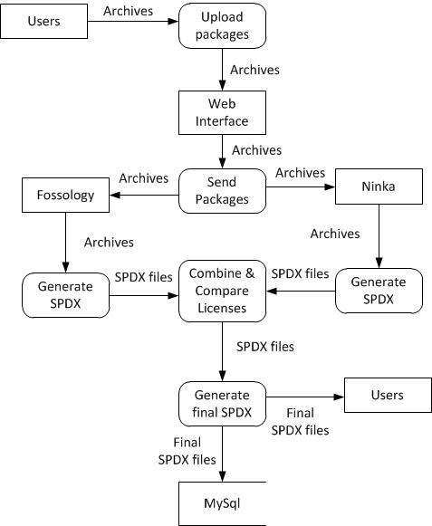.

**VI. Data Base / Data Store Structures of the System**

* A data structure that represents each file and which licenses were identified by Fossology, Ninka, and both.
* Possibly use a database to store scanned results.
  + Each entry contains the name of the file (or the SHA-1) and the license(s) identified by Fossology and Ninka.

**VII. Copyright Declarations and License Choice**

* We plan on using the CC by-SA-3.0 license

**VIII. Change Log**

|  |  |  |  |
| --- | --- | --- | --- |
| **Version** | **Revision Date** | **Revision Comment** | **Author** |
| 1.0 | 01/24/14 | Creation of System Charter, Communication Management Plan, System Service Request, Stakeholder, Distribution System, and Database Storage | Ninh Nguyen, Jordan Rauscher, Ryan Vanek |
| 1.1 | 01/28/14 | Creation of Perl Script for sending files to Ninka | Ryan Vanek |
| 1.2 | 01/29/14 | Creation of Data Flow Diagram | Ninh Nguyen, Jordan Rauscher |
| 1.3 | 01/30/14 | Creation of a Web Interface for uploading files | Jordan Rauscher |
| 1.4 | 01/31/14 | Formatting the document | Jordan Rauscher |
|  |  |  |  |
|  |  |  |  |