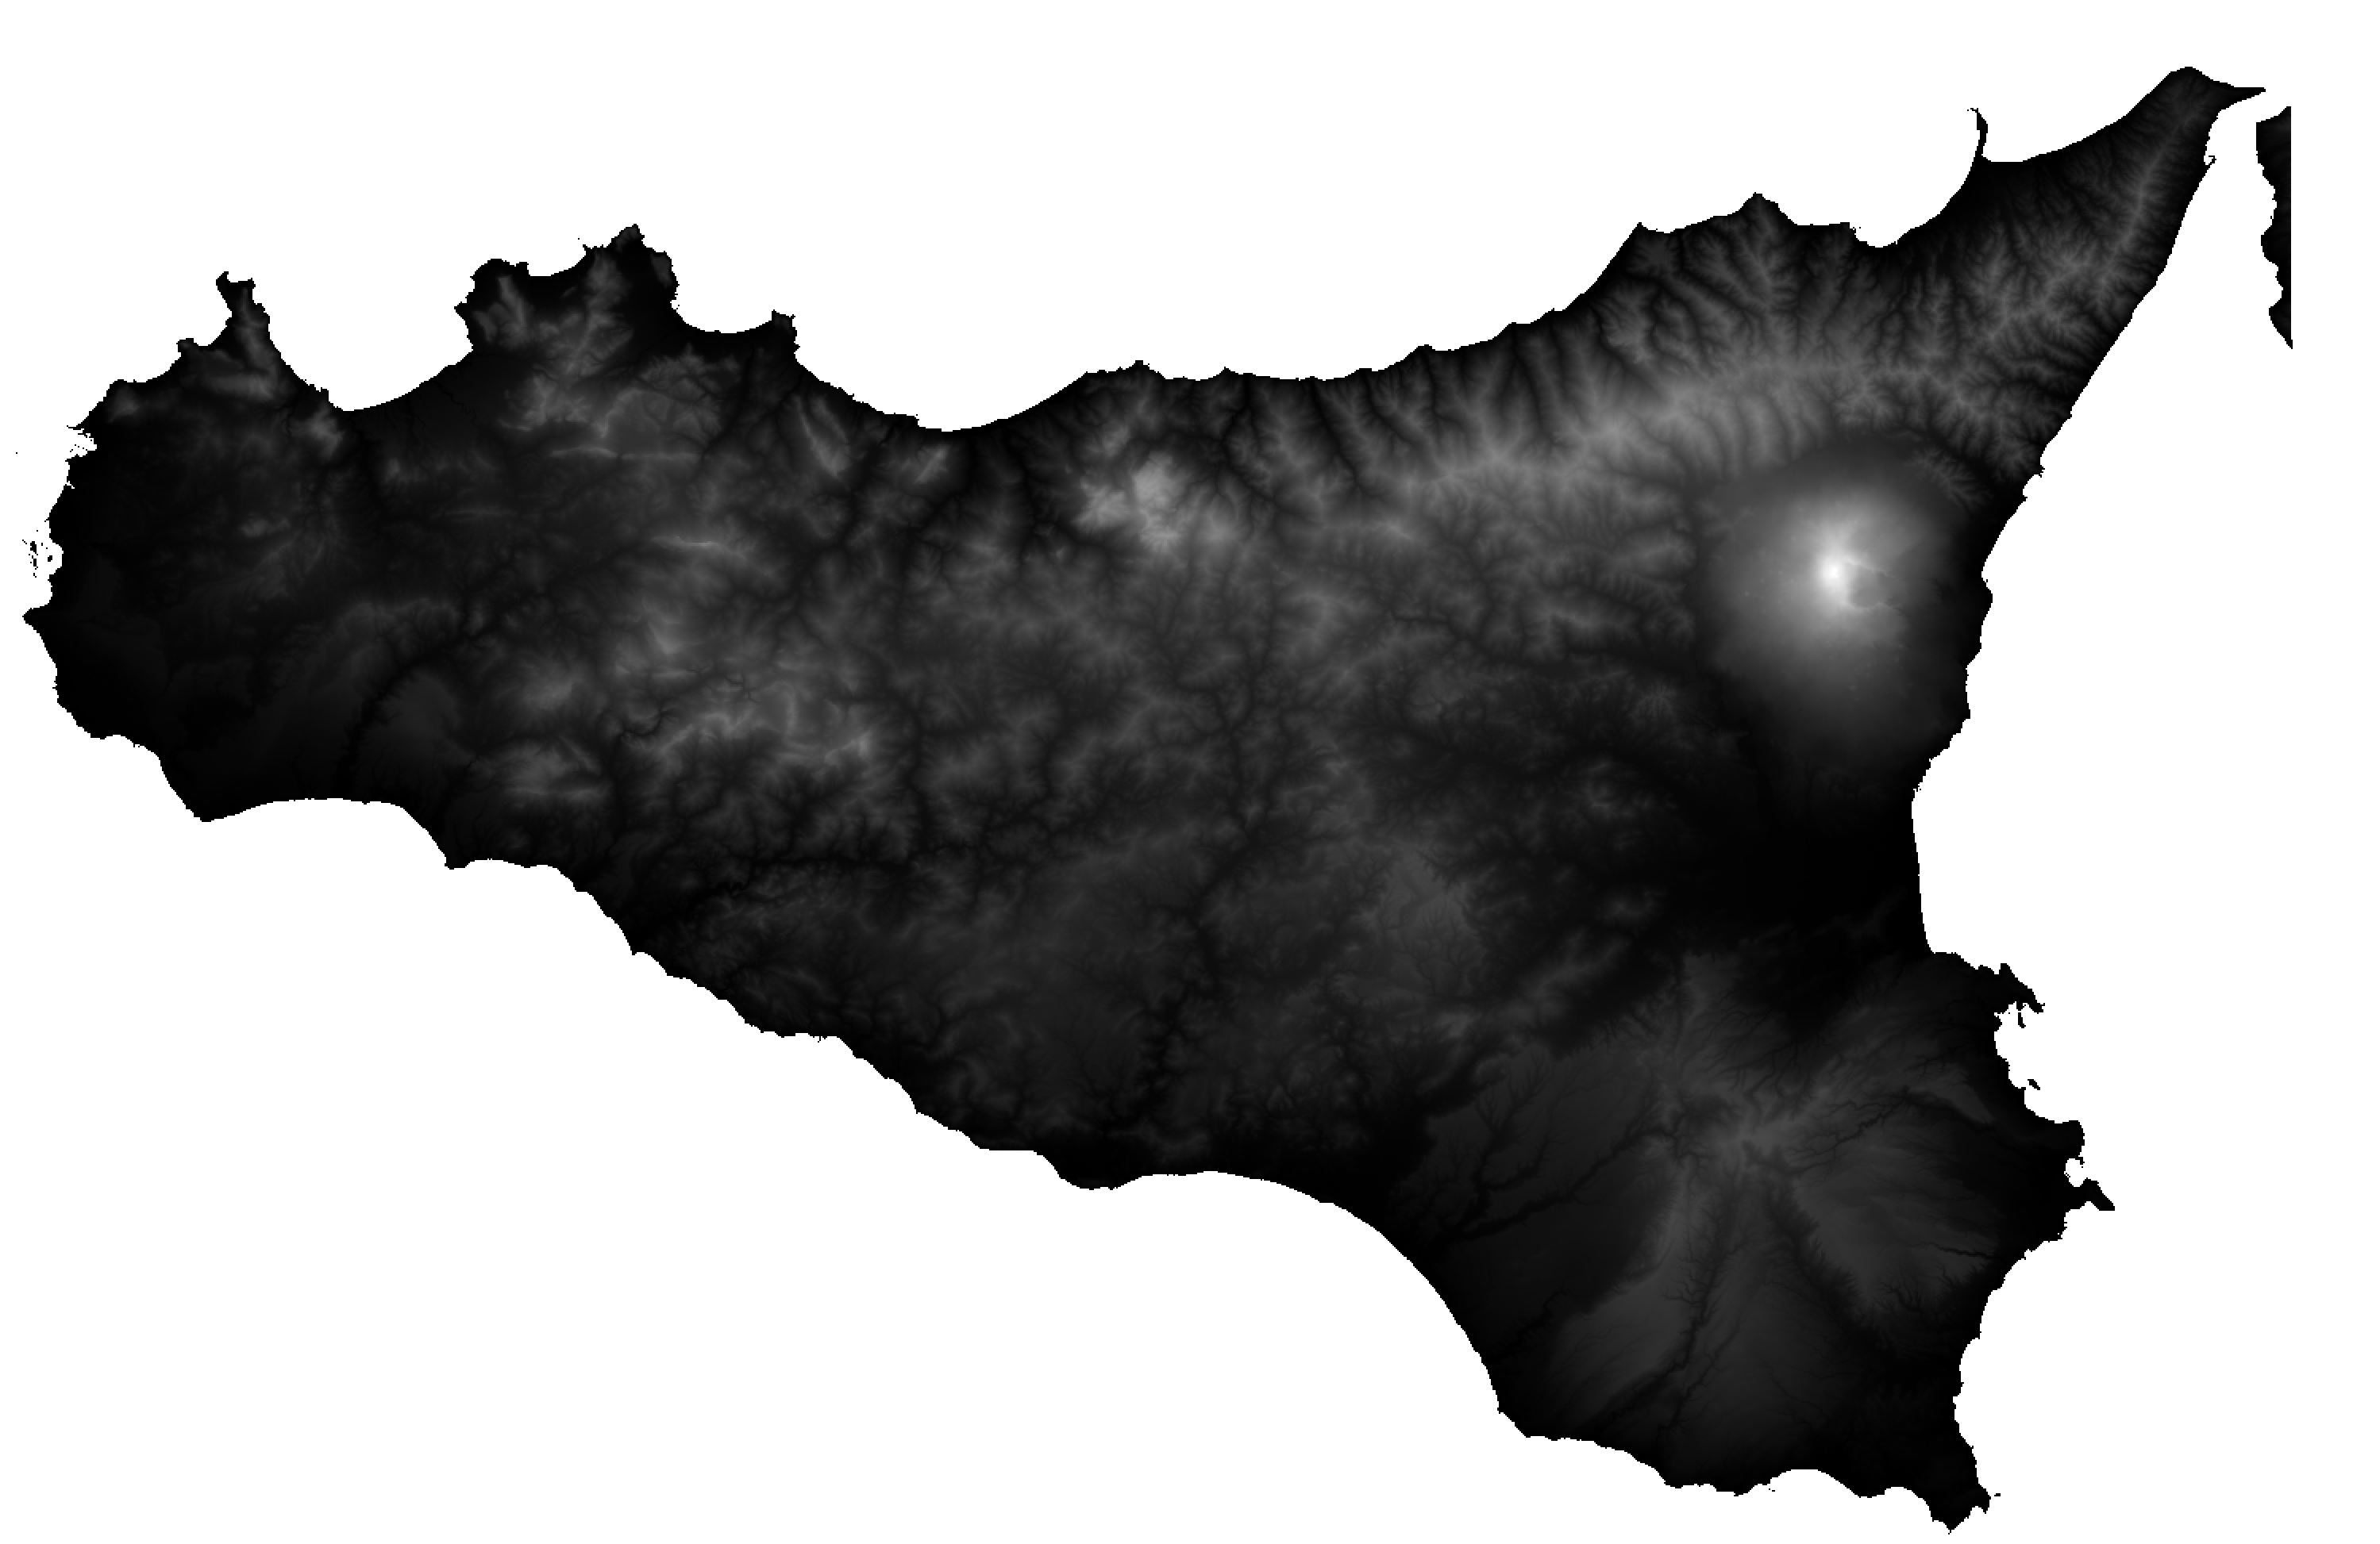

**Delineating Basin and Stream Networks from Elevation Data**

**By Jack Cook**

**Email:** [**jrc15@aber.ac.uk**](mailto:jrc15@aber.ac.uk)

**Project Email: GEOM@aber.ac.uk**



Table of Contents

Software requirements: - 3

Required Inputs: - 3

Steps to undertake processing: - 3

Additional Information: - 3

Installing QGIS 3.6: - 4

Running the Define Basin Model: - 6

Creating Source Contamination Data: - 8

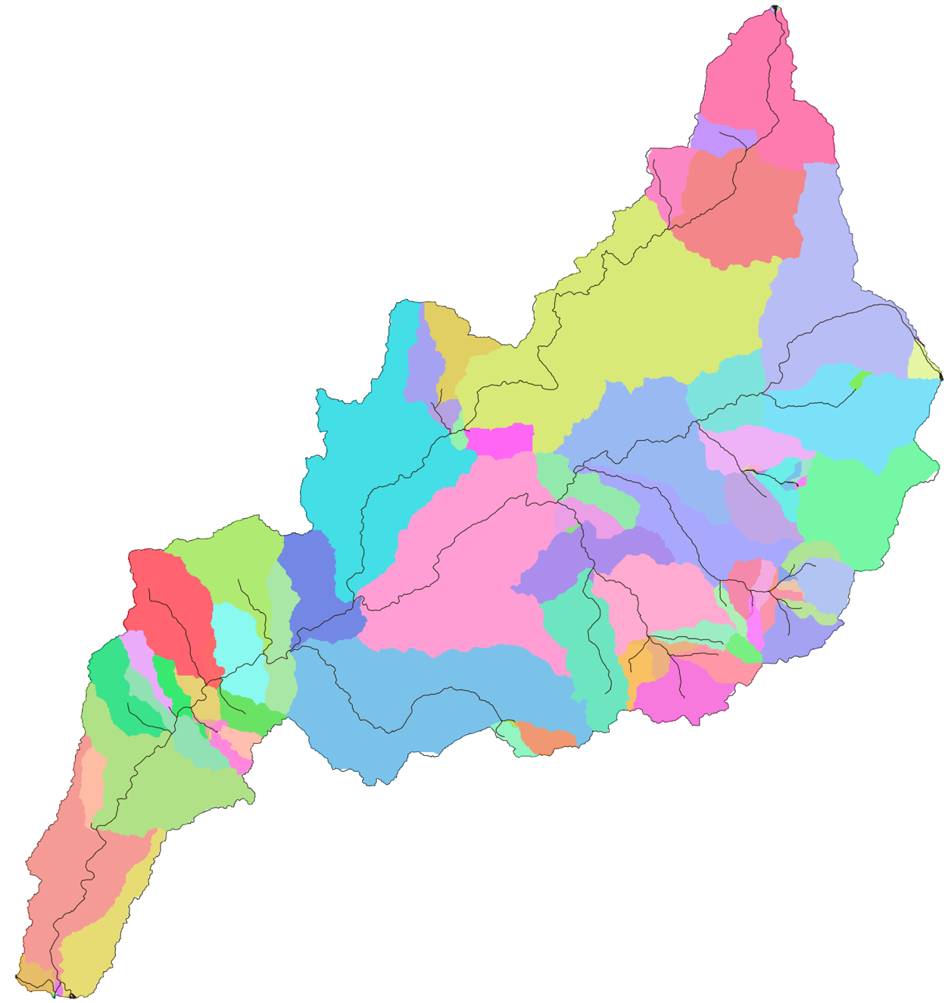

*The catchment, watershed and stream network of River Belice in Sicily.*

# Software requirements: -

* QGIS 3.6

# Required Inputs: -

1. DEM – Download from <https://land.copernicus.eu/imagery-in-situ/eu-dem>
2. Stream Outlet – Created in Step “Running the Define Basin Model”

# Steps to undertake processing: -

1. Run Define Basin model in QGIS 3.6.
2. Upload input files and run hydrological functions at: www.GEOM.aber.ac.uk

# Additional Information: -

The GEOM Project provided this tutorial and web application:-

GEOM Web Application:

[www.GEOM.aber.ac.uk](http://www.GEOM.aber.ac.uk)

GEOM Website:

<https://www.aber.ac.uk/en/dges/research/earth-observation-laboratory/geomoperation/>

Hydrological Software used for the Web Application – TauDEM:

Home Page:

<http://hydrology.usu.edu/taudem/taudem5/index.html>

Source Code:

<https://github.com/dtarb/TauDEM>

# Installing QGIS 3.6: -

This section introduces the user to the basics of the geospatial software package QGIS and includes a list of vector and raster data downloads. The current version of this program is QGIS 3.6. QGIS is an open source software package and is available to download at:

<http://www.qgis.org/en/site/forusers/download.html>

A view of the window is shown below. To download a version, simply click on the relevant platform, and click the download link, highlighted in blue. Make sure you install the 3.6 or later version of QGIS.

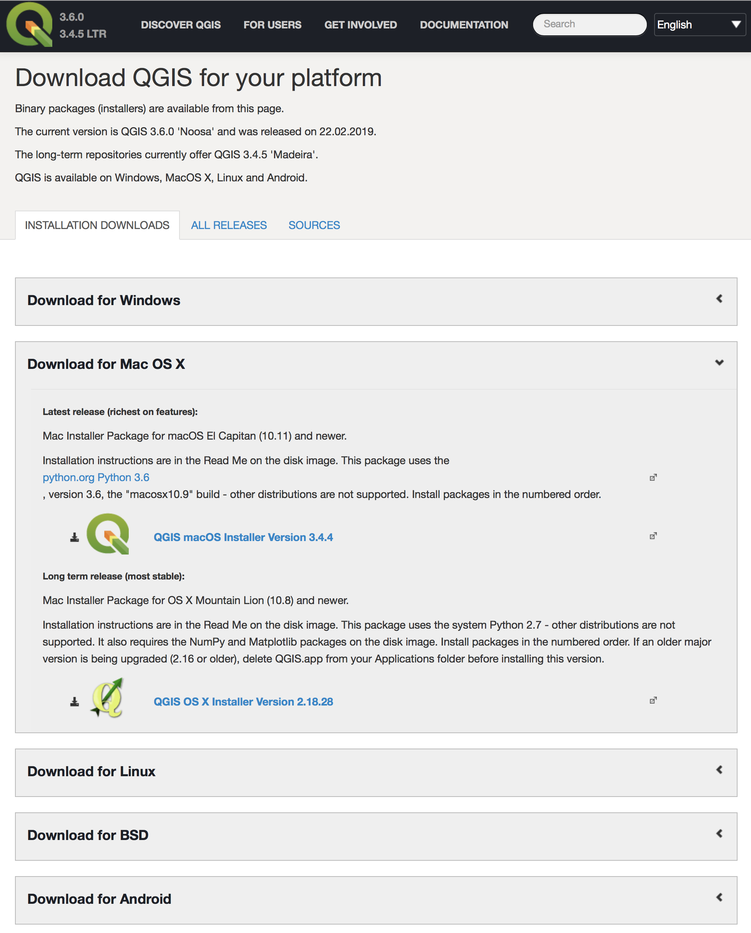

**Figure 1: How to download QGIS**

The link will open up a new tab in your Internet browser which will then download to your downloads folder. Locating the download (which should start ‘QGIS-OSGeo’) and double clicking on it should open up an installer wizard that will guide you through the steps of installing the software.



Once installed, an icon should appear on your desktop (or be locatable from the ‘Start’ search bar for Windows users), similar to that shown.

**When you launch QGIS, you should see a similar setup to that shown below:**

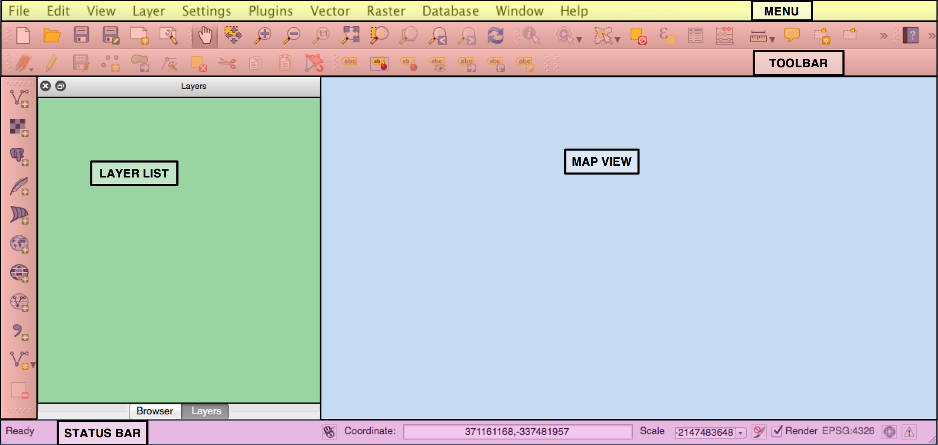

|  |  |
| --- | --- |
| **MENU** | Provides access to all the functions and plugins |
| **TOOLBAR** | Provides one-click common functions |
| **LAYER LIST** | Shows all data layers currently added to the project |
| **MAP VIEW** | Provides a dynamic visualization of the *active* data layers that can be mapped |
| **STATUS BAR** | Provides some vital information about the current project settings |

**Figure 2: Main graphical user interface of QGIS 2.0**

Macintosh HD:Users:AKilcoyne:Desktop:Fig3.tiff**Figure 3: These tools allow the user to move about in the ‘Map View’, zooming in and out and zooming to the spatial extent.**

# Running the Define Basin Model: -

1. Register and download an elevation image from <https://land.copernicus.eu/imagery-in-situ/eu-dem>.
2. Load the elevation file into QGIS.
3. 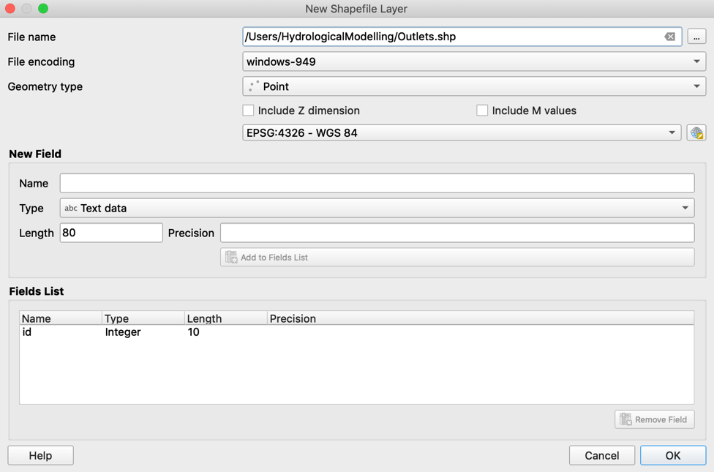Create a new Point Shapefile , navigate to the *Hydrological Modelling* folder, and name it *“Outlet.shp”. Create the* outlet point where the river mouth would be by selecting the *edit* button , then *Add point feature* *,* select the river outlet/mouth, select *save edits .*
4. Now, obtain the longitude and latitude by navigating tothe *Vector tab > Geometry tools > Add geometry attributes*. Select the *“Output.shp”* as the input layer and save the file in the *Hydrological Modelling* folder as *“Outlet.csv”.* Open the “*Output.csv”* layer and copy the Longitude and latitude.

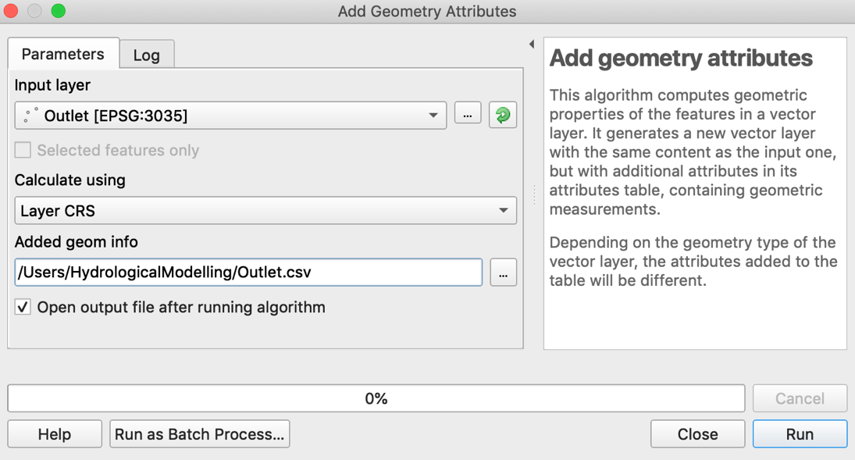

1. From the Processing toolbox, select *Models > Open Existing Model* and navigate to the Hydrological Modelling folder and select *“1-DefineBasin.model3”.*
2. 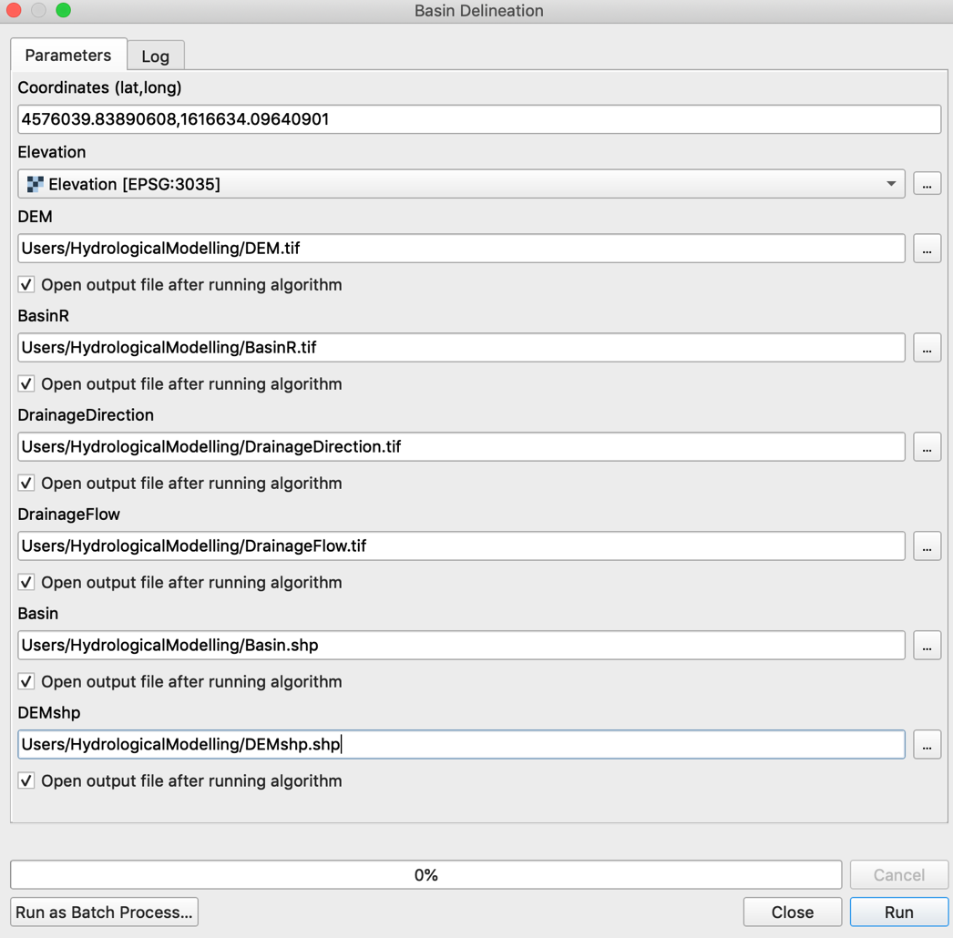Select the *Run* button  and input the longitude and latitude, ensuring a comma and no spaces separates them, then select the input elevation as the elevation file, and name the outputs as seen in the figure below. Ensure both the *Basin* and *DEMshp* outputs are saved as shapefiles (.shp).
3. View the basin output to assess whether it is correct.
4. If the model does not compute all outputs correctly, then it is probable due to the outlet point not being put correctly on a stream. Therefore, open the computed Direction flow raster, and reposition the outlet point to match areas of river flow (coloured in black). If this doesn’t work, move the outlet further upstream from the river mouth.
5. Repeat the above steps until an appropriate basin has been defined, then close QGIS.

# Creating Source Contamination Data: -

1. Based on your user knowledge, a source contamination field can be created by building a new polygon shapefile , and drawing around the area you know the contamination to be. Once done, save the polygon to an appropriate location and give it the ID value of 1.
2. This can now be used alongside your other input data in the Web App at [www.GEOM.aber.ac.uk](http://www.GEOM.aber.ac.uk)