


User Manual
Performance Monitoring and Evaluation System (PMES)

How to sign in, complete your assigned ratings, read your results, and - for administrators - set up your office, tag raters, and generate reports.
Applies to all participating Innovation Cluster offices · DSWD · Innovation Cluster

Table of Contents
Right-click and choose "Update Field" after editing headings.
1. Introduction 4
2. About the System 4
3. Objectives 5
4. System Requirements 5
5. Getting Started 6
5.2 Signing in 6
5.3 First-time registration 7
5.4 While your account is pending 7
5.5 Setting your password 7
5.6 If you forget your password 8
5.7 Automatic overnight sign-out 8
5.8 Signing out 8
6. Understanding Your Access Level 8
7. System Overview 9
Main 9
Office Administration Office Administrator 9
Central Administration Central Administration 9
Social Technology Bureau only 9
8. Your Dashboard 10
9. My Rating Tasks 10
9.1 Task statuses 10
9.2 Rater relationships 11
9.3 Finding a task 11
10. Completing an Assessment 11
10.1 Opening the form 11
10.2 The rating scale 11
10.3 Core Behavioral Competencies 12
10.4 Functional Performance and Output 12
10.5 Job Fitness 12
10.6 Saving a draft 12
10.7 Submitting 12
11. My Results 13
11.1 Results that are not yet final 13
11.2 If a deduction has been applied 13
11.3 If nothing appears 13
12. How the Score is Computed 13
12.3 How the behavioral raters are combined 14
12.4 Adjectival descriptors 14
13. Office Administration 15
13.1 Office Structure 15
13.2 Personnel Validation 15
13.3 Rater Tagging 15
Technical staff and the subordinate rater 16
Job Fitness variance referrals 16
14. Central Administration 17
14.1 Office Registry 17
14.2 Cluster Overview 18
15. Reports 18
15.1 Report catalogue 18
16. Frequently Asked Questions 19
17. Troubleshooting Guide 19
18. Security and User Responsibility 20
19. Technical Support 20
19.1 When reporting a problem 21
20. Glossary 21

1. Introduction
Why this system exists and what it replaces.
Assessing personnel fairly requires more than a form. It requires that the same instrument be applied to everyone, that each person be rated by the right set of colleagues, that scores be computed identically every time, and that the whole record be traceable afterwards. Doing that on paper or in separate spreadsheets produces exactly the problems it is meant to prevent: inconsistent forms, missing raters, arithmetic errors, and results that cannot be reconstructed.
The Innovations Performance Assessment Tool (IPAT), issued under Administrative Order No. 11, series of 2025, prescribes a single multi-rater instrument for personnel in the Innovation Cluster. It measures three domains - behaviour, output, and fitness for the job - and combines them into one numerical and adjectival rating.
The Performance Monitoring and Evaluation System (PMES) is the Innovation Cluster implementation of that instrument. It was developed and validated in the Social Technology Bureau, and following its presentation to the Undersecretary it is being adopted across all offices of the Innovation Cluster.
Unless a section says otherwise, it applies to everyone. Only the three sections written for administrators carry a marker - Office Administrator or Central Administration. If you do not hold that access, the corresponding menu items will not appear for you and those sections may be skipped.

2. About the System

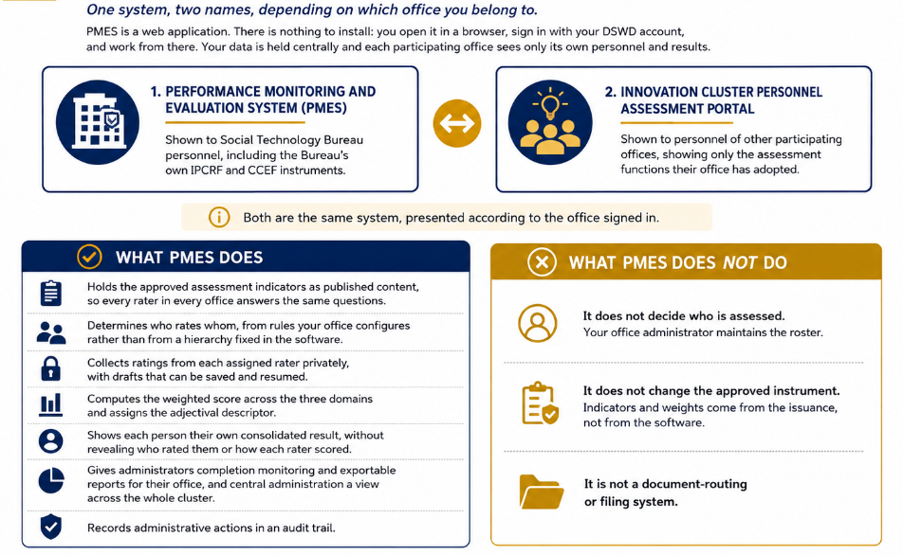

3. Objectives
What the Department intends the system to achieve.
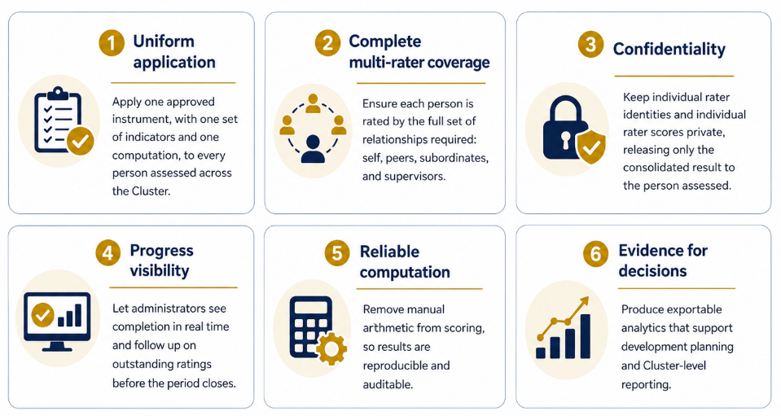

4. System Requirements
What you need in order to use PMES.
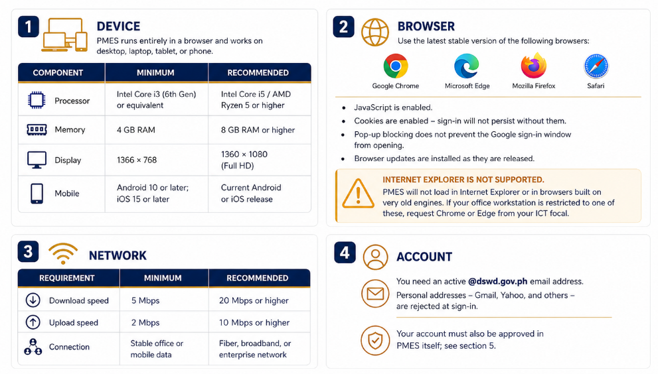

5. Getting Started
Reaching the system, registering, and signing in for the first time.

5.1 Accessing the system
Portal address
https://stb-pmes.vercel.app/
Bookmark this address. Do not reach the system through links forwarded in chat groups.

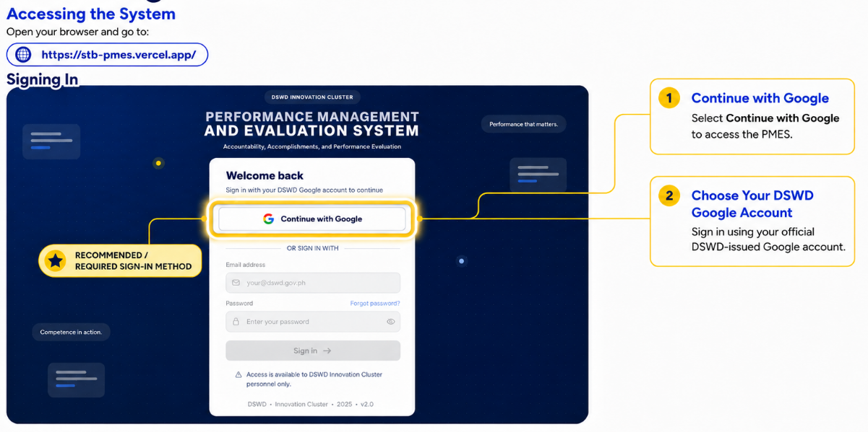

5.2 Signing in
There are two ways to sign in. Both require a DSWD address.
1. Continue with Google
Select Continue with Google and choose your DSWD-issued Google account. This is the quickest route and requires no separate password. If a permission screen appears, accept it to proceed.
2. Or sign in with email and password
Enter your @dswd.gov.ph address and the password issued to you. Select the eye icon beside the password field to check what you have typed.
3. Select Sign in
On success you are taken to your dashboard. Which dashboard you land on depends on your access level - see section 8.

5.3 First-time registration
Signing in with a DSWD account and complete the registration form:

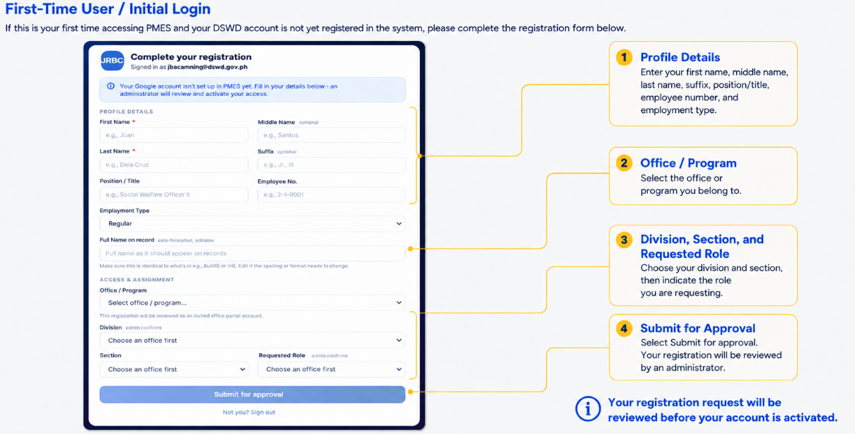

5.4 While your account is pending
Until an administrator activates your account you will see a pending screen at every sign-in. Nothing further is required from you. If it persists beyond a working day, follow up with your office administrator.

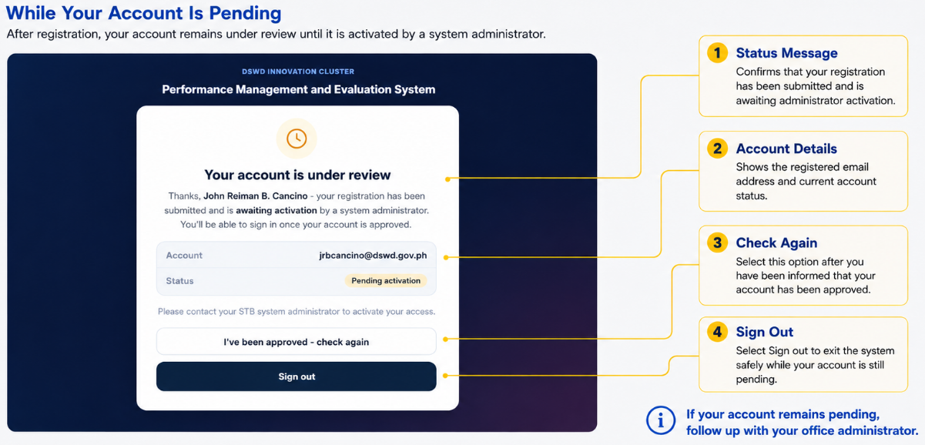

5.5 Setting your password
If an administrator created your account for you, you receive a temporary password. At your first sign-in PMES presents a password-change prompt that cannot be dismissed until you set your own password. Choose a password you do not use on any other system and do not write it down where others can see it.

5.6 If you forget your password
Password reset is administrator-assisted
PMES does not currently send self-service password reset emails. Contact your office administrator, who will issue a new temporary password. You will be required to change it at your next sign-in.
If you normally use Continue with Google, there is no PMES password to reset - recover your Google account through ICTMS instead.

5.7 Automatic overnight sign-out
Every session is signed out automatically at midnight, Philippine time, whether or not the browser was left open. This is deliberate: it prevents an unattended workstation from holding an open session overnight. If you find yourself returned to the sign-in page in the morning, this is why - sign in again and continue. Drafts you have saved are not affected.

5.8 Signing out
1. Open your profile menu
Select your name or profile icon at the top of the screen.
2. Select Sign out
You are returned to the sign-in page.
Sign out at the end of every session, particularly on a shared workstation.

6. Understanding Your Access Level
PMES shows different menus to different people. This explains which you are.
Menu items are not merely hidden by access level - the system refuses the underlying request as well. If a colleague describes a screen you cannot see, it is because your access level does not include it, not because your browser is faulty.
Access level | Who holds it | What it can do
Participating personnel | Everyone being assessed in a participating office | Complete assigned ratings, view own consolidated results, read the Assessment Library and Rating Guide, view own personal information
Office administrator | The focal person designated by each participating office | Everything above, plus: maintain the office structure and personnel roster, tag raters, monitor office completion, generate office reports
Supervisory monitor | Division Chiefs and Section Heads | Everything personnel can do, plus view the office assessment dashboard and roster for their scope
Central administration | Cluster-level administrators | Register and provision participating offices, monitor completion across the Cluster, generate Cluster-wide reports
System administrator | Designated system administrator | All of the above, plus user management, assessment content, and the audit trail

Being a supervisor is not the same as being an administrator
Supervisors rate their staff and can see completion progress, but they do not assign raters or edit the roster. Those are office administrator functions, granted separately.

7. System Overview
The modules in the left-hand menu, and who sees each.

Main
▪ Dashboard /my-dashboard
Your identity details and how many rating tasks you still have to complete.
▪ My Rating Tasks /my-tasks
Everyone you have been assigned to rate this period, with each task's status.
▪ My Results /my-results
Your own consolidated result, by assessment period.
▪ Assessment Library /library
The published indicators, so you can read them outside a rating form.
▪ Rating Guide /help
The rating scale, rater relationships, and common questions.
▪ Personal Information /my-profile
Your own record as held by the system.

Office Administration Office Administrator
▪ Office Dashboard /office-dashboard
Completion and score distribution for your office.
▪ Office Management /office-management
Two tabs: Structure (divisions, sections, roles) and Personnel (the assessment roster).
▪ Rater Tagging /rater-matrix
The rules that decide who rates whom, per role.
▪ Reports /reports
Generate and export official reports for your scope.

Central Administration Central Administration
▪ Cluster Overview /cluster-overview
Assessment progress across all participating offices.
▪ Office Registry /office-registry
Register, provision, validate, and activate participating offices.
▪ User Management /users
Approve registrations, set roles and permissions, reset passwords.
▪ Audit Trail /audit
Record of administrative actions. System administrator only.

Social Technology Bureau only
▪ IPCRF / CCEF /ipcrf
The Bureau's individual commitment and review forms.
▪ Review /review
Review queue for targets and ratings routed to you.
▪ KRA Library /kra
Master library of key result areas and success indicators.
▪ Accomplishments /accomplishments
Accomplishment entries and means of verification.
If you belong to a participating office
The Social Technology Bureau modules above will not appear for you, and the addresses will redirect back to your dashboard. This is expected - those instruments are Bureau-specific and are not part of the Cluster rollout.

8. Your Dashboard
The first screen after sign-in, and how to read it.
The dashboard answers one question: what do I still have to rate? It shows your identity as the system holds it, three counters, and a progress bar.
Element | What it shows
Identity panel | Your name, position, office, division or unit, section, and the current assessment period.
Pending | Rating tasks you have not opened or started. These need your attention.
Draft | Tasks you have saved but not submitted. These still count as outstanding.
Completed | Tasks you have submitted, shown against your total.
Progress bar | Your submitted tasks as a proportion of all tasks assigned to you this period.
Continue Rating | Takes you straight to My Rating Tasks.

If your identity details are wrong
Position, division, and section come from the roster your office administrator maintains. Ask them to correct the record - errors here also affect which rating assignments are generated for you.

Supervisors and administrators land on the Office Assessment Dashboard instead, described in section 13.4.

9. My Rating Tasks
The list of people you have been assigned to rate.
Each row is one person you must rate, in one specific relationship. You may appear more than once for the same colleague only if the instrument requires it. The list shows the person, their organizational unit, your role as rater, the task status, when it was last saved, and the action available.

9.1 Task statuses
Status | Meaning | Action shown
Pending | Not started. | Start Rating
Draft | Partly filled in and saved, but not submitted. Still outstanding. | Continue
Submitted | Final and locked. | View

9.2 Rater relationships
Your role as rater determines the weight your rating carries. It is set by your office's rater rules, not chosen by you.
Relationship | You are rating | Domains you are asked for
Self-assessment | Yourself, against the same indicators your other raters use. | Behaviour and Job Fitness
Peer | A colleague at a comparable level in your division or section. | Behaviour only
Subordinate | Someone who reports to you. | Behaviour only
Immediate Supervisor | The person you report to directly. | Behaviour and Job Fitness
Skip-Level Supervisor | The supervisor above your immediate supervisor. | Behaviour only

9.3 Finding a task
Use the status tabs - All, Pending, Draft, Submitted - to narrow the list, or the search box to find a name, position, or unit. Refresh reloads the list; the time it was last loaded is shown beside it.
Someone is missing from your list
Rating assignments are generated by your office administrator from the office's rater rules. If a person you should be rating does not appear, contact your administrator - you cannot add an assignment yourself.

10. Completing an Assessment
The rating form itself - the central task for every user.

10.1 Opening the form
From My Rating Tasks, select Start Rating or Continue on the row for the person you are rating. Confirm the name at the top of the form before you begin.
The form is organised into domains, listed down the left side. Each shows how many indicators you have answered out of the total, so you can see at a glance what remains. Depending on your rater relationship, you may not be asked for every domain.

10.2 The rating scale
Behavioural and job-fitness indicators use a four-point frequency scale. You are judging how often the behaviour is demonstrated, not forming an overall opinion of the person.
Score | Descriptor | Apply when
4 | Always | The behaviour is consistently demonstrated, with clear and repeated evidence.
3 | Frequently | The behaviour is demonstrated more often than not.
2 | Rarely | The behaviour is demonstrated only occasionally.
1 | Never | The behaviour is not demonstrated.

Rate on evidence, not impression
Rate what you have actually observed over the assessment period. Where you have not observed a behaviour at all, say so through the scale rather than awarding a middle score to avoid the question - a defaulted 3 distorts the result as much as an unfair 1.

10.3 Core Behavioral Competencies
This domain covers the HEARTWORK values. Each value carries several behavioural indicators, and you rate every indicator on the four-point scale. The indicator text is the approved wording - read it fully rather than rating from the value's title alone.
This is the longest domain. The progress bar beside it in the left-hand list shows how far through you are.

10.4 Functional Performance and Output
This domain is not rated indicator by indicator. It carries the person's final numerical rating from their individual performance commitment and review form. Where the Bureau's IPCRF module is in use the figure is synchronised automatically; otherwise the office administrator encodes it, on a scale of 1 to 5.
As an ordinary rater you will normally see this domain as read-only. If it is blank, the office administrator has not yet supplied the rating - this does not block your own submission.

10.5 Job Fitness
A short set of indicators on the same four-point scale, covering alignment between the person's qualifications, competencies, and work habits and the requirements of the position - including educational qualifications, relevant work experience, training records, and attendance and punctuality.
Only the ratee and the immediate supervisor rate this domain, in coordination with the designated HR focal, who validates the supporting records. Peers, subordinates, and the skip-level supervisor are not asked for it, and the tab will not appear in their forms. See 12.2.

10.6 Saving a draft
Save as you go, especially on the behavioural domain. Saving keeps your entries without submitting them, and the task appears as Draft so you can return to it. If your connection drops, entries saved to that point are kept; anything typed since your last save may be lost.

10.7 Submitting
1. Check every domain is complete
The left-hand list shows answered against total for each domain. Required indicators must be answered before the form will submit.
2. Review your entries
Move back through the domains and confirm each rating is what you intend.
3. Select Submit Ratings
On a phone this button is pinned to the bottom of the screen so you do not have to scroll to the end to reach it.
4. Confirm the status change
The task moves to Submitted in My Rating Tasks.
Submitting is final
A submitted rating is locked and cannot be edited. If a correction is genuinely needed, ask your office administrator to reopen the task. Reopening is recorded in the audit trail.

11. My Results
Your own consolidated result, and what is deliberately not shown.
My Results shows your overall score and adjectival descriptor for each assessment period, together with your score in each of the three domains. Where you have results from more than one period, tabs across the top let you select which period to view - this doubles as your assessment history.
Rater confidentiality
Individual rater identities and individual rater scores are never shown to the person assessed. You see only the consolidated figures. This applies to everyone, including administrators viewing their own results.

11.1 Results that are not yet final
If some of your assigned raters have not yet submitted, an amber notice states how many of the total have. The consolidated score is computed once all ratings are in, so any figure shown before that point is provisional.

11.2 If a deduction has been applied
Where the approved protocol provides for a deduction, the result carries a note to that effect. The system does not print the reasoning; ask your office administrator for an explanation of the adjustment.

11.3 If nothing appears
An empty screen means no result has been finalized for you yet. Results appear once every assigned rater has submitted and the period's result has been finalized.

12. How the Score is Computed
The arithmetic behind the number, stated plainly.
You do not need this section to complete a rating. It is here so that anyone who asks how a result was arrived at can be given a straight answer.
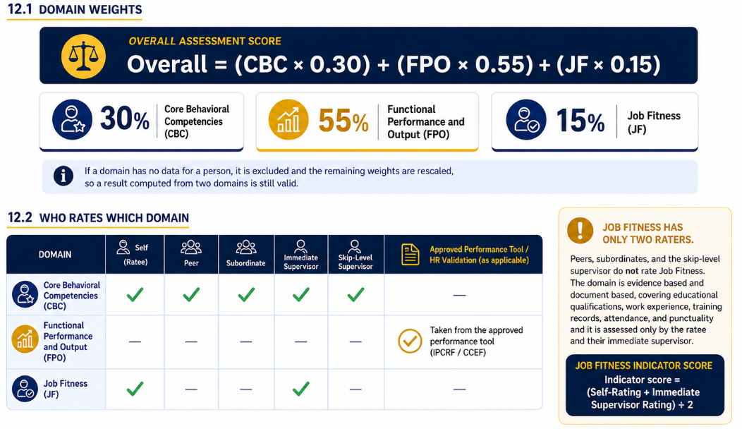
Job Fitness
The domain score is then the sum of the indicator scores divided by the number of indicators. Where the ratee's self-rating and the immediate supervisor's differ by more than the office's threshold - 1.00 point on the 1-4 scale unless the office has adopted and documented a different figure - the record is referred to the skip-level supervisor, who receives a notification. They may require additional documentation, discuss the matter with those concerned, or recommend a developmental, deployment, or performance management action.

12.3 How the behavioral raters are combined
This weighting applies to Core Behavioral Competencies only. Each indicator is scored by combining the raters at these weights, and the domain score is the average of the indicator scores.
Rater relationship | Weight | Note
Immediate Supervisor | 30% | Largest single share.
Skip-Level Supervisor | 25% | The supervisor of the ratee's immediate supervisor.
Self-assessment | 15%
Peer | 15% | A peer within the division or section.
Subordinate | 15% | Applies only where the ratee has subordinates.
Total | 100% | Five raters.

Where the ratee has no subordinates
A second peer rater from the same division or section is designated instead, and the subordinate's 15% is reassigned to them. Each of the two peers then carries 15%, for a combined peer weight of 30%. The subordinate share is never simply dropped, and one peer never carries 30% alone.

12.4 Adjectival descriptors
Final Numerical Rating | Qualitative Descriptor | General Interpretation
4.00 | Outstanding | Perfect score across all KPIs and competencies.
3.50 - 3.99 | Very Satisfactory | Exceeds expected standards and primary goals.
2.75 - 3.49 | Satisfactory | Consistently meets job expectations and targets.
2.00 - 2.74 | Needs Improvement | Inconsistent performance; meets some targets, requires coaching.
1.00 - 1.99 | Requires Immediate Intervention | Fails key criteria; performance improvement plan required.

Why the output rating uses a different scale
Behavioural and job-fitness indicators are rated 1 to 4. The performance output rating arrives from the individual performance review on a 1 to 5 scale and is converted to the same 1 to 4 basis before it is combined, so the three domains are comparable.

13. Office Administration
Setting up an office, validating its roster, tagging raters, and monitoring progress.
Office Administrator · Supervisors (view only)
Order matters
Complete these in sequence: structure, then personnel, then rater tagging. Assignments generated against an incomplete roster will have gaps, and correcting them afterwards means reopening submitted work.

13.1 Office Structure
Found under Office Management → Structure. Here you define the divisions, sections, and roles your office offers. These become the options personnel choose from when they register, so set them up before inviting anyone to register.
1. List your divisions or units
Use the names your office actually uses in its issuances, not abbreviations invented for the system.
2. Add sections under each division
Sections appear only after their parent division is selected during registration.
3. Set the roles offered at registration
These are the roles personnel may request. You still confirm each one on approval.

13.2 Personnel Validation
Found under Office Management → Personnel. This is the assessment roster: the definitive list of who is assessed in your office. Counters across the top show total personnel, active, for validation, and inactive.
1. Review those awaiting validation
Use the For Validation tab. Each entry is someone who registered and is waiting on you.
2. Check the details
Name as it should appear on records, position, division or unit, section, and role. These drive rater assignment, so correct them now rather than later.
3. Activate or correct
Activate the record, or edit it first if the person selected the wrong division or requested a role they do not hold.
4. Add anyone missing
Use Add Personnel for staff who have not registered themselves.
5. Deactivate those who have left
Set the record inactive so no assignments are generated for them.
The roster is the foundation
Every rating assignment is derived from this roster. A person listed under the wrong division will be given the wrong peers; a person missing from it will not be assessed at all.

13.3 Rater Tagging
Found at Rater Tagging. This is where you declare, for each role in your office, which roles supply that person's raters. The automated generator reads these rules - it has no built-in hierarchy of its own. A role left unconfigured produces no assignments for the personnel holding it.
For each role you configure one row per rater type:
Column | What to enter
Rater Type | The relationship being defined - self, peer, subordinate, immediate supervisor, or skip-level supervisor.
Drawn From Role(s) | Which role or roles supply that rater.
Where To Look | The scope searched - the same section, the same division, or the whole office.
If Nobody Found | What the generator should do when no eligible person exists - widen the search or leave the assignment unmade.

The counters at the top of the screen show roles configured, roles not configured, and how many personnel are affected by the gaps. Aim for zero roles not configured before generating assignments.

Technical staff and the subordinate rater
The supplied defaults give a technical staff member two peer raters and no subordinate. Under the protocol this is the correct arrangement for an office that has no administrative support staff distinct from its technical staff: where subordinate rating is not applicable, an additional peer is designated and the subordinate's 15% passes to them.
Where your office does have administrative support staff, the protocol instead names them as the subordinate rater for technical staff. To adopt that arrangement:
1. Add the role
In Office Management → Structure, add Administrative Staff to the roles offered at registration. It is not offered by default.
2. Re-tag the personnel
In Office Management →; Personnel, set your administrative support staff to that role. Until this is done they are indistinguishable from technical staff and will be drawn as peers.
3. Replace the peer rows
In Rater Tagging, for the Technical Staff role, remove the Peer1 and Peer2 rows and add a single Peer row (drawn from Technical Staff) plus a Subordinate row drawn from Administrative Staff. Set both to search the same section, falling back to the division.
Replace the peer rows - do not simply add a subordinate
Leaving Peer1 and Peer2 in place while adding a Subordinate row produces six raters where the protocol has five, and the weights would no longer total 100%. Configure exactly one peer alongside the subordinate.

Changing rater rules mid-period
Regenerating assignments after personnel have started rating invalidates work already submitted against the old arrangement. Make these changes between assessment periods wherever possible.

Job Fitness variance referrals
Where a ratee's Job Fitness self-rating and their immediate supervisor's differ by more than the office threshold, the system notifies the skip-level supervisor assigned to that person and shows the gap on the record. The referral is sent once per record, not repeatedly, and is written to the audit trail.
The threshold defaults to 1.00 point on the 1-4 scale. The protocol requires review where responses differ significantly but sets no figure, so an office may adopt a different threshold provided it records the basis - the same condition the protocol attaches to adjusted domain weights.

If no skip supervisor is assigned
A referral cannot be sent for a ratee who has no skip-level supervisor in the current period's assignments. Check the Rater Tagging coverage counters before the period opens - a role with no skip supervisor configured will silently produce no referrals.
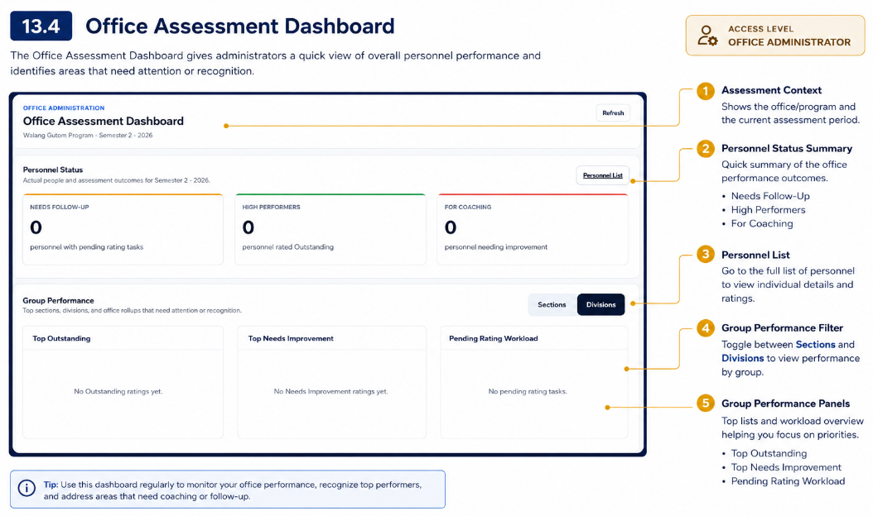

14. Central Administration
Bringing an office onto the system, and monitoring the Cluster.
Central Administration

14.1 Office Registry
The register of participating offices. Each row shows the office, its primary administrator, its office status, its portal status, and when it was last validated. Onboarding an office follows a fixed sequence:
1. Register the office
Record the office and designate its primary administrator.
2. Provision it
Create the office's own storage against the current schema.
3. Validate
Check the office's storage against the schema the system requires. Run this before activation and after any schema change.
4. Repair if needed
Adds headers the schema now requires that an older office predates. It does not touch existing data - a missing sheet or a duplicate header still needs a person to resolve it.
5. Configure registration options
Set the divisions, sections, and roles the office offers at registration, if its administrator has not.
6. Activate
Opens the office's portal to its personnel.
Validation on a live office
Validate is a read-only check and does not take a live office offline. Repair, however, writes to the office's storage - run it outside the assessment window where you can, and confirm with the office administrator first.

14.2 Cluster Overview
Assessment progress across all participating offices, in one screen: participating offices, total personnel, assessment records, offices needing attention, submitted and pending ratings, active portals, and overall Cluster completion. Beneath the counters, completion rate by office and a monitoring table showing each office's status, personnel count, rating tasks, completion, and last activity.
Offices for Attention is the field to work from - it identifies offices whose completion has stalled, so follow-up can be directed rather than sent to everyone.

15. Reports
Generating and exporting official reports.
Office Administrator · Central Administration
The Report Center offers only the reports your access level permits. Office administrators are limited to their assigned office or programme; division-level users see their own division only.
1. Choose a report
Reports are grouped by category. Each carries a short description of its scope.
2. Set the scope and period
Division where applicable, then semester and year.
3. Choose a format
PDF, Excel, or CSV. The analytics annex is available in Excel and CSV only.
4. Generate
The report is produced and added to Recent Reports, from where it can be downloaded again.

15.1 Report catalogue
Category | Report | Contents
Assessment Analytics | Undersecretary analytics | Annex-ready analytics with interpretation distribution and domain averages.
 | Bureau analytics | Bureau-wide analytics across all divisions. Requires bureau-level monitoring access.
Performance Monitoring | Division performance | Performance summary for one division over one assessment period.
 | Semestral | Consolidated semestral performance report for the selected scope and period.
 | Delayed submissions | Submissions past their expected date, for follow-up.
STB Instruments STB | IPCRF summary | Accomplishment summary drawn from IPCRF forms.
 | CCEF summary | Targets summary drawn from CCEF forms.

Analytics reports carry no individual rating content
Assessment analytics report aggregate progress and scoring only. They do not expose individual raters or their scores.

16. Frequently Asked Questions
Can I change a rating after I submit it?
No. A submitted rating is locked. If a correction is genuinely needed, ask your office administrator to reopen the task; reopening is recorded in the audit trail.
Will the person I rate see my scores?
No. Individual rater identities and individual rater scores are not shown to the person assessed. They see only the consolidated result.
What happens if I lose connection while rating?
Entries already saved as a draft are kept. Anything typed since your last save may be lost, so save periodically on the longer domains.
When will I see my own results?
Once every assigned rater has submitted and the result has been finalized for the period.
Someone I should be rating is missing from my list.
Assignments are generated by your office administrator. Contact them so the assignment can be added for the current period.
I forgot my password.
Contact your office administrator, who will issue a temporary password. You will be required to change it at your next sign-in. If you sign in with Google, recover your Google account through ICTMS instead.
I did not receive a verification code.
PMES does not send one. Sign-in requires only your DSWD account. Treat any message claiming to be a PMES code as suspicious.
Why was I signed out overnight?
Every session is signed out at midnight, Philippine time, by design. Sign in again; your saved drafts are unaffected.
A colleague can see a menu item I cannot.
Menus follow access level. See section 6. If you believe your access level is wrong, raise it with your office administrator.
Can I use PMES on my phone?
Yes. The screens adapt to narrow displays, and on the rating form the submit button stays pinned within reach.
My position or division is wrong on my dashboard.
These come from the roster your office administrator maintains. Ask them to correct the record - the same details drive your rating assignments.
Do I have to finish a rating in one sitting?
No. Save a draft and return to it. The task stays in your list as Draft until you submit.

17. Troubleshooting Guide
Issue | Likely cause | What to do
Cannot sign in | Wrong address or password, or a non-DSWD account | Confirm you are using your @dswd.gov.ph address. Ask your administrator for a temporary password if needed.
Sign-in is refused outright | Account not yet activated in PMES | Complete registration and wait for your office administrator to activate the account.
Google sign-in window does not open | Pop-ups are blocked | Allow pop-ups for the portal address and try again.
Signed out unexpectedly in the morning | Scheduled overnight sign-out | Expected behaviour. Sign in again; saved drafts are unaffected.
Blank or half-loaded screen | Cached files from an older version | Reload the page. If it persists, clear the browser cache and reopen.
Menu item missing | Access level does not include it | See section 6. Raise with your office administrator if you believe it is wrong.
“Too many requests” message | Rate limit reached from rapid repeated actions | Wait a minute, then continue. Avoid repeatedly pressing refresh or submit.
Rating will not submit | Required indicators unanswered | Check the answered-of-total count beside each domain and complete the remainder.
Rating task list is empty | Assignments not yet generated for the period | Nothing is required from you until your administrator generates them.
Results screen is empty | Not all raters have submitted, or the result is not finalized | Wait for the period to complete. Progress is shown when partial results exist.
System is slow to respond | Network conditions | Check your connection. Avoid generating large reports over a mobile hotspot.

18. Security and User Responsibility
▪ Account security
Keep your password confidential. Never share credentials or let a colleague rate on your behalf - every submission is attributed to the account that made it.
▪ Session hygiene
Sign out at the end of every session, particularly on shared workstations. Do not leave a rating form open and unattended.
▪ Data privacy
Assessment records are personal information under the Data Privacy Act. Access only what your duties require and never disclose another person's result.
▪ Rater confidentiality
Do not disclose how you rated a colleague, and do not press anyone to disclose how they rated you. Confidentiality is what makes multi-rater assessment honest.
▪ Accurate records
Administrators are responsible for the accuracy of the roster. An incorrect record produces incorrect assignments and, ultimately, an incorrect result.
▪ Official use only
Use PMES solely for official business. Administrative actions are recorded in the audit trail and are attributable.

Report anything suspicious
If you receive a message asking for your PMES password, a verification code, or directing you to a sign-in page at an address other than the official one, do not respond. Report it to your ICT focal immediately.

19. Technical Support
Who to contact, and in what order.
Most questions are resolved fastest by your own office administrator, who holds your roster, your assignments, and your account. Escalate only what they cannot resolve.
Concern | Contact | Details
Rating assignments, roster corrections, password reset, reopening a submitted task | Your office administrator | Name / local
Assessment policy, the instrument, interpretation of indicators | Social Technology Bureau | Name / local
Office onboarding, Cluster-wide monitoring and reporting | Central administration | Name / local
System faults, errors, access problems | PMES system administrator | Name / email / local
DSWD account and email concerns | ICTMS | Local

19.1 When reporting a problem
Include the following, so the issue can be reproduced rather than guessed at:
- Your name and office.
- The screen you were on and what you were trying to do.
- The exact wording of any message shown.
- The date and time it happened.
- Your browser and device.
- A screenshot, where you can take one.

20. Glossary
Term | Meaning
Assessment period | The semester and year an assessment covers. All tasks, results, and reports are scoped to one period.
CBC | Core Behavioral Competencies - the HEARTWORK values domain, weighted 30%.
FPO | Functional Performance and Output - the performance output domain, weighted 55%, carried from the individual performance review.
JF | Job Fitness - the third domain, weighted 15%.
CCEF | Contractor Commitment and Evaluation Form.
IPCRF | Individual Performance Commitment and Review Form.
Descriptor | The adjectival rating corresponding to a numerical score, from Outstanding to Requires Immediate Intervention.
HEARTWORK | The Department's core values, from which the behavioural indicators are drawn.
IPAT | Innovations Performance Assessment Tool - the instrument implemented by this system, per AO No. 11 s. 2025.
Ratee | The person being assessed.
Rater | A person assigned to assess someone, in a defined relationship.
Rater tagging | The office's configured rules determining which roles supply each rater type.
Skip-level supervisor | The supervisor above a person's immediate supervisor.

