Comparing Supervised and Unsupervised Machine Learning Across Two Cancer Datasets
James Conner
Module C Capstone - Milestone Two
1. Problem Statement and Project Description
This project compares supervised and unsupervised machine learning on two cancer datasets with very different structures. The Wisconsin breast cancer dataset contains 569 observations, 30 continuous tumor measurements, and a binary diagnosis outcome. The Brazilian cancer registry contains approximately 1.74 million records and 39 modeled predictors after preprocessing, with about 7 percent of patients recorded as deceased. Wisconsin is small, clean, and comparatively separable. Brazil is much larger, includes missing and coded registry fields, and has a strongly imbalanced outcome.
The main question is whether the same modeling and evaluation choices make sense for both datasets. A score that is useful in Wisconsin can give the wrong impression in Brazil, especially when accuracy hides poor positive-class recall or when a clustering score is driven by a very small group. I therefore focused on how scale, class balance, feature representation, and sample structure changed the results, rather than treating the largest metric as the automatic winner. The practical value is showing analysts when a strong-looking model score reflects useful structure and when it is mainly caused by imbalance, scaling, instability, or a very small cluster.
2. Data Preparation and Evaluation Strategy
Wisconsin used all 569 observations. Brazil required reproducible method-specific samples because the algorithms had very different computational costs: 10,000 rows for KNN, 120,000 for gradient boosting, 100,000 for k-means, 30,000 for DBSCAN, and 5,000 for hierarchical clustering. Every sample used random_state=42. The results show how the methods behaved on consistent samples, but the Brazil values may still vary across other samples from the full registry.
For KNN, I placed standardization inside the modeling pipeline so the mean and standard deviation were estimated separately within each training fold. This avoided using information from the held-out data during preprocessing. I used stratified train/test splits and cross-validation for tuning. ROC-AUC measured ranking performance, while PR-AUC, recall, F1, balanced accuracy, and confusion matrices showed how well the models handled the minority class. The choice to report several metrics rather than rely on a default score followed guidance that evaluation should be tied to the prediction goal and decision problem (Scikit-learn Developers, 2026d).
The clustering analyses removed the outcome and diagnosis year before fitting, selected numeric predictors, median-imputed missing values, and standardized the feature space. Outcomes were added back only after the clusters were formed so I could describe the groups without using the answer to create them. Because clustering has no labeled test target, I evaluated silhouette together with repeated-start stability, cluster sizes, cluster count, and DBSCAN noise fraction.
3. Conclusions: Breadth Across Weeks 8-11
Week 8 Breadth: K-Nearest Neighbors and Distance Metrics
KNN assigns a case according to nearby observations, so the neighborhood size, distance metric, weighting rule, and feature scale all affect the result. I tuned k, uniform versus distance weighting, and Euclidean, Manhattan, and Minkowski distance in a standardized pipeline. Wisconsin selected Euclidean distance, k=11, and distance weighting under ROC-AUC tuning, reaching cross-validated ROC-AUC 0.989 and test ROC-AUC 0.982. An F1-tuned version reached test F1 0.950. These tuning choices follow the main KNeighborsClassifier controls described in the scikit-learn nearest-neighbors documentation (Scikit-learn Developers, 2026a).
Brazil showed why the tuning metric matters. ROC-AUC tuning selected k=21 and produced test ROC-AUC 0.878, but recall was only 0.252. F1 tuning selected k=3, increased recall to 0.410, and raised F1 to 0.479, while ROC-AUC fell to 0.804. The Wisconsin train-to-test ROC-AUC change was small. Brazil dropped from 0.954 in training to 0.878 on test, so I treated KNN as a useful baseline rather than the strongest Brazil model.
Week 9 Breadth: Gradient Boosting
Gradient boosting builds trees sequentially so that each new tree focuses on errors left by the previous trees. I used GradientBoostingClassifier for Wisconsin and the more computationally efficient HistGradientBoostingClassifier for the larger Brazil sample. Wisconsin selected learning rate 0.1, depth 3, 300 estimators, and subsample 0.8. It achieved test ROC-AUC 0.998, PR-AUC 0.997, and F1 0.951. Random forest performed almost identically, which suggests that both tree ensembles were close to the performance ceiling on this dataset. The distinction between standard and histogram-based gradient boosting follows the two scikit-learn implementations described in the ensemble-methods documentation (Scikit-learn Developers, 2026b).
Brazil used average-precision tuning, early stopping, learning rate 0.05, 31 leaf nodes, and at least 50 observations per leaf. Test ROC-AUC was 0.958, PR-AUC 0.675, and F1 0.592. Lowering the decision threshold from 0.50 to about 0.325 raised F1 to 0.643. The train/test ROC-AUC values were 0.967 and 0.958, and the minimum leaf size and early stopping helped keep the model from fitting very small or sample-specific patterns. Table 1 and Figure 1 summarize these results.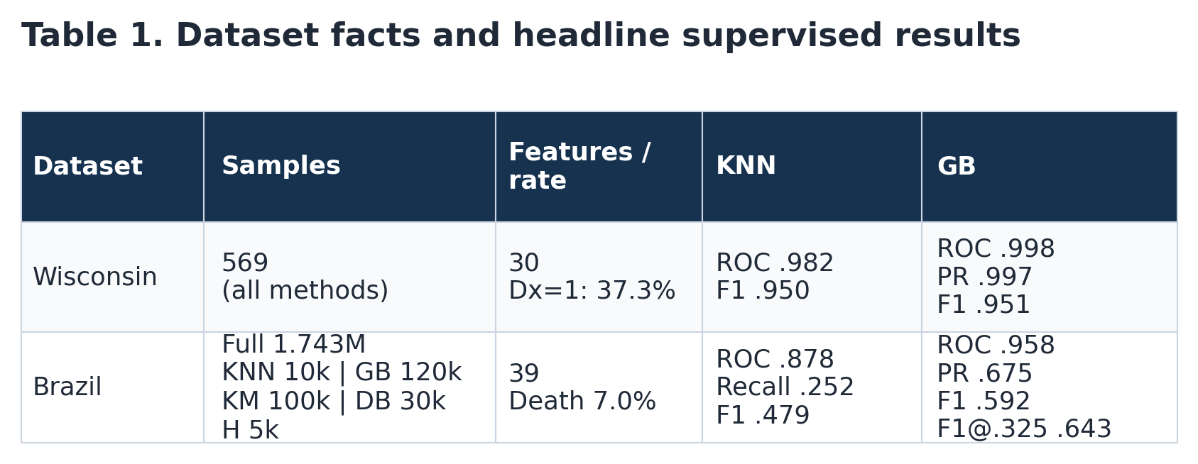
Table 1. Dataset sizes, outcome prevalence, and headline KNN and gradient-boosting results. Brazil results use reproducible method-specific samples.
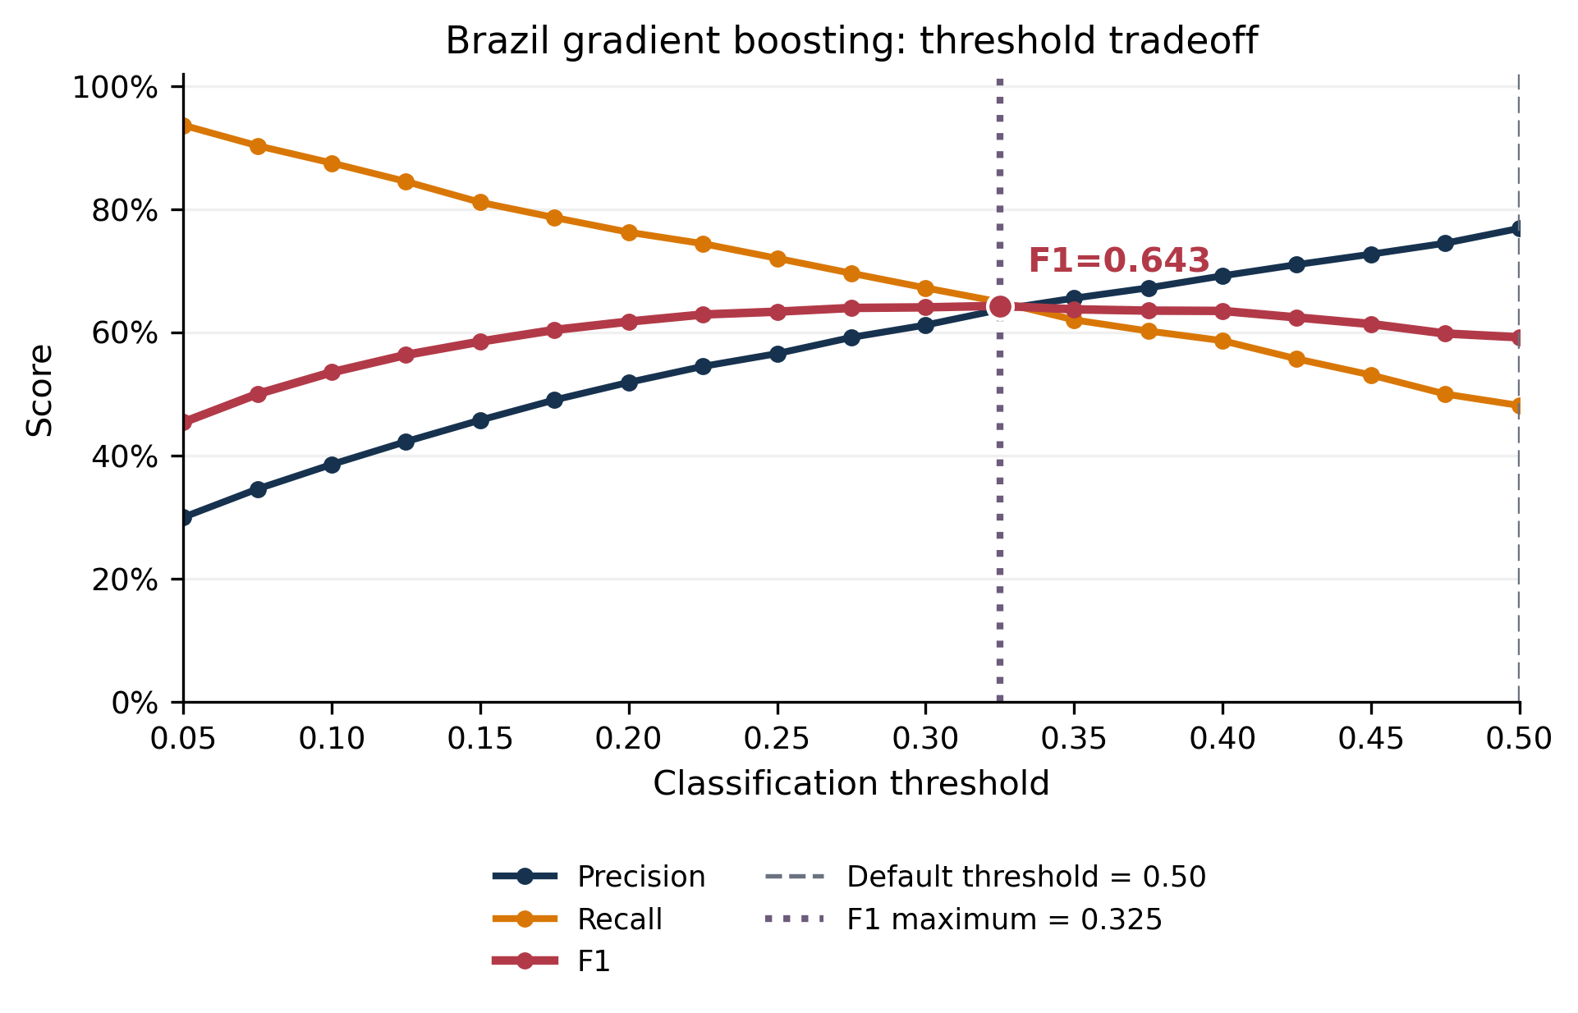
Figure 1. Precision, recall, and F1 across thresholds for Brazil gradient boosting. F1 was maximized near 0.325 rather than the default 0.50.
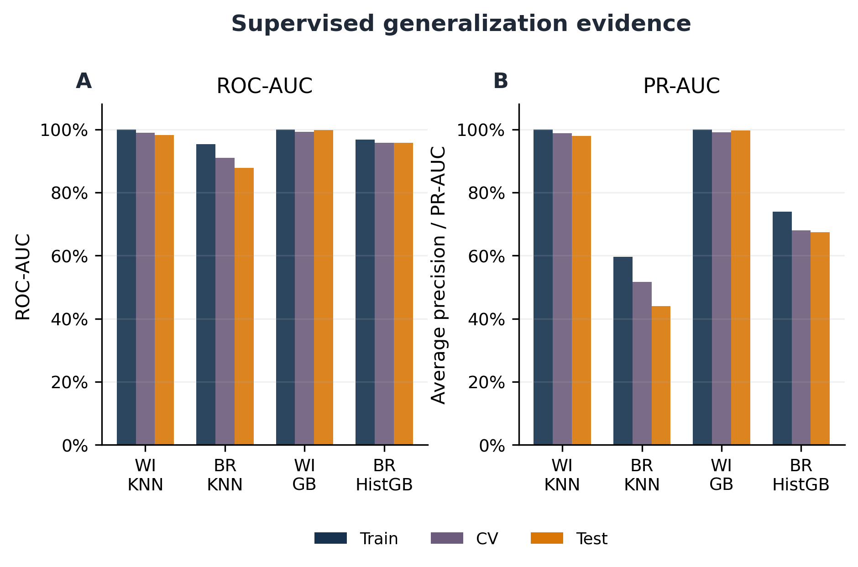
Figure 2. Train, cross-validation, and test ranking metrics for the selected supervised models. Brazil KNN showed the largest generalization decrease, while gradient boosting maintained more consistent performance.
Week 10 Breadth: K-Means and Silhouette Score
Wisconsin selected $k=2$, with silhouette 0.345 and mean ARI 0.993. Brazil selected $k=3$, with silhouette 0.195 and mean ARI 0.424. Although both solutions had outcome-associated profiles, Brazil’s weak separation and low stability limited subgroup interpretation. See depth section for more details.
Week 11 Breadth: DBSCAN and Hierarchical Agglomerative Clustering
Wisconsin DBSCAN produced silhouette 0.416 with 63.1% noise, while Brazil produced silhouette 0.541, 48.3% noise, and 63 clusters. Average-linkage hierarchical clustering reached higher silhouettes but generated 566/3 and 4,998/2 splits, showing why internal scores require cluster-size and coverage checks. See depth section for more details.
4. Conclusions: Depth Topics
I selected Week 10 k-means and silhouette score and Week 11 DBSCAN and hierarchical clustering for the depth discussion. These weeks produced the clearest examples of why an internal clustering metric needs to be checked against stability, coverage, and cluster size.
Depth Topic 1: Week 10 K-Means and Silhouette Score
K-means minimizes squared Euclidean distance to cluster centroids. As a result, changing the scale or the set of included variables changes the geometry of the problem. In Wisconsin, restricting the analysis to the ten mean measurement variables increased silhouette from 0.345 to 0.395 while retaining substantial agreement with the full standardized solution (ARI 0.848). Using all 30 variables without scaling raised silhouette to 0.697, but agreement with the standardized assignments fell to ARI 0.521 and cluster sizes changed from 189/380 to 131/438. The higher unscaled score was therefore measuring a different, scale-dominated split. The k-means, silhouette, DBSCAN, and agglomerative-clustering definitions used here were checked against the scikit-learn clustering guide (Scikit-learn Developers, 2026c).
Inertia fell each time another cluster was added, so it could not choose k by itself. For Wisconsin, silhouette declined from 0.345 at k=2 to 0.314 at k=3 and 0.280 at k=4, then dropped below 0.17 for k=5 through k=8. Brazil reached its best silhouette at k=3, but the value was only 0.195. Looking at the full tuning curves made the contrast clear: Wisconsin had a defensible broad split, while Brazil never showed strong separation across the tested values of k.
Repeated-start stability added a second check. Wisconsin assignments barely changed across random seeds, with mean ARI 0.993. Brazil had mean ARI 0.424, indicating substantial reassignment. The outcome profiles were still informative: Wisconsin clusters had sharply different diagnosis rates, and Brazil had one large low-outcome group plus two smaller groups near 17 percent deceased. I would describe those as patterns in this sample, not established risk groups, because the Brazil assignments were not stable enough. Figure 3 combines the tuning, stability, and outcome-profile evidence.
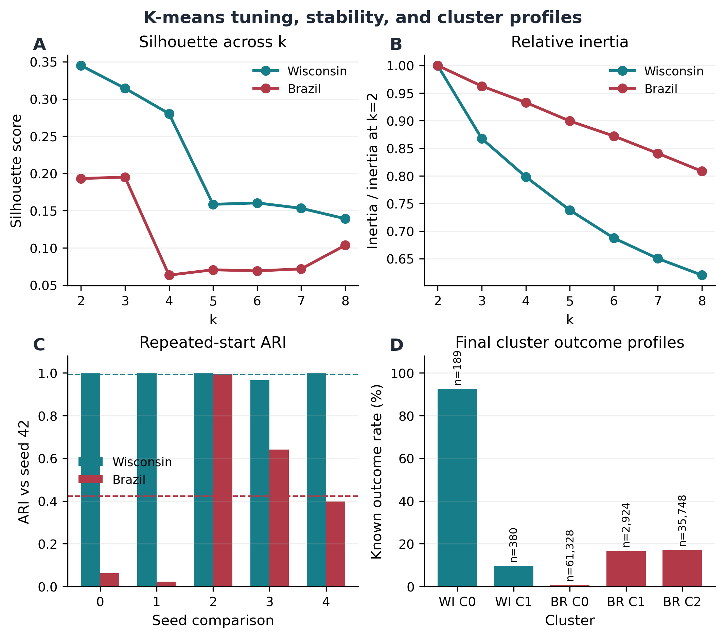
Figure 3. K-means tuning, repeated-start stability, and cluster outcome profiles for Wisconsin and Brazil.
Depth Topic 2: Week 11 DBSCAN and Hierarchical Clustering
DBSCAN defines dense regions using eps, the neighborhood radius, and min_samples, the number of nearby observations required for a core point. The Wisconsin grid showed how sensitive the method was. At eps values from 0.3 through 1.0, every tested setting labeled all observations as noise. At eps=1.7 and min_samples=10, 92.1 percent remained noise and only one cluster was retained. At eps=2.2 and min_samples=5, noise fell to 54.8 percent, but the four retained clusters had silhouette only 0.166. The selected eps=2.2 and min_samples=10 solution improved non-noise silhouette to 0.416 but still excluded 63.1 percent of the data.
Brazil had the same tradeoff at a larger scale. The selected solution had non-noise silhouette 0.541, but nearly half the observations were labeled noise, and the remaining observations were divided into 63 clusters. Silhouette was calculated only on the retained observations, so it did not reflect the missing coverage or the difficulty of interpreting that many groups. For this dataset, DBSCAN was more useful for showing that some local dense regions existed than for creating a manageable patient segmentation.
Hierarchical clustering assigned every observation, but it could create a high score by separating a few distant cases. Ward linkage gave a relatively balanced Wisconsin k=2 split of 184/385 with silhouette 0.339. Average linkage increased silhouette to 0.634 by creating a 566/3 split. At k=3, average linkage still produced a dominant group of 564 and two tiny groups of 3 and 2, even though silhouette remained 0.585. Brazil was more extreme: average linkage reached 0.876 with a 4,998/2 split. I preferred the more balanced Ward result for interpretation, even though its silhouette was lower. Figure 4 compares these internal scores with noise, cluster count, and cluster-size balance.
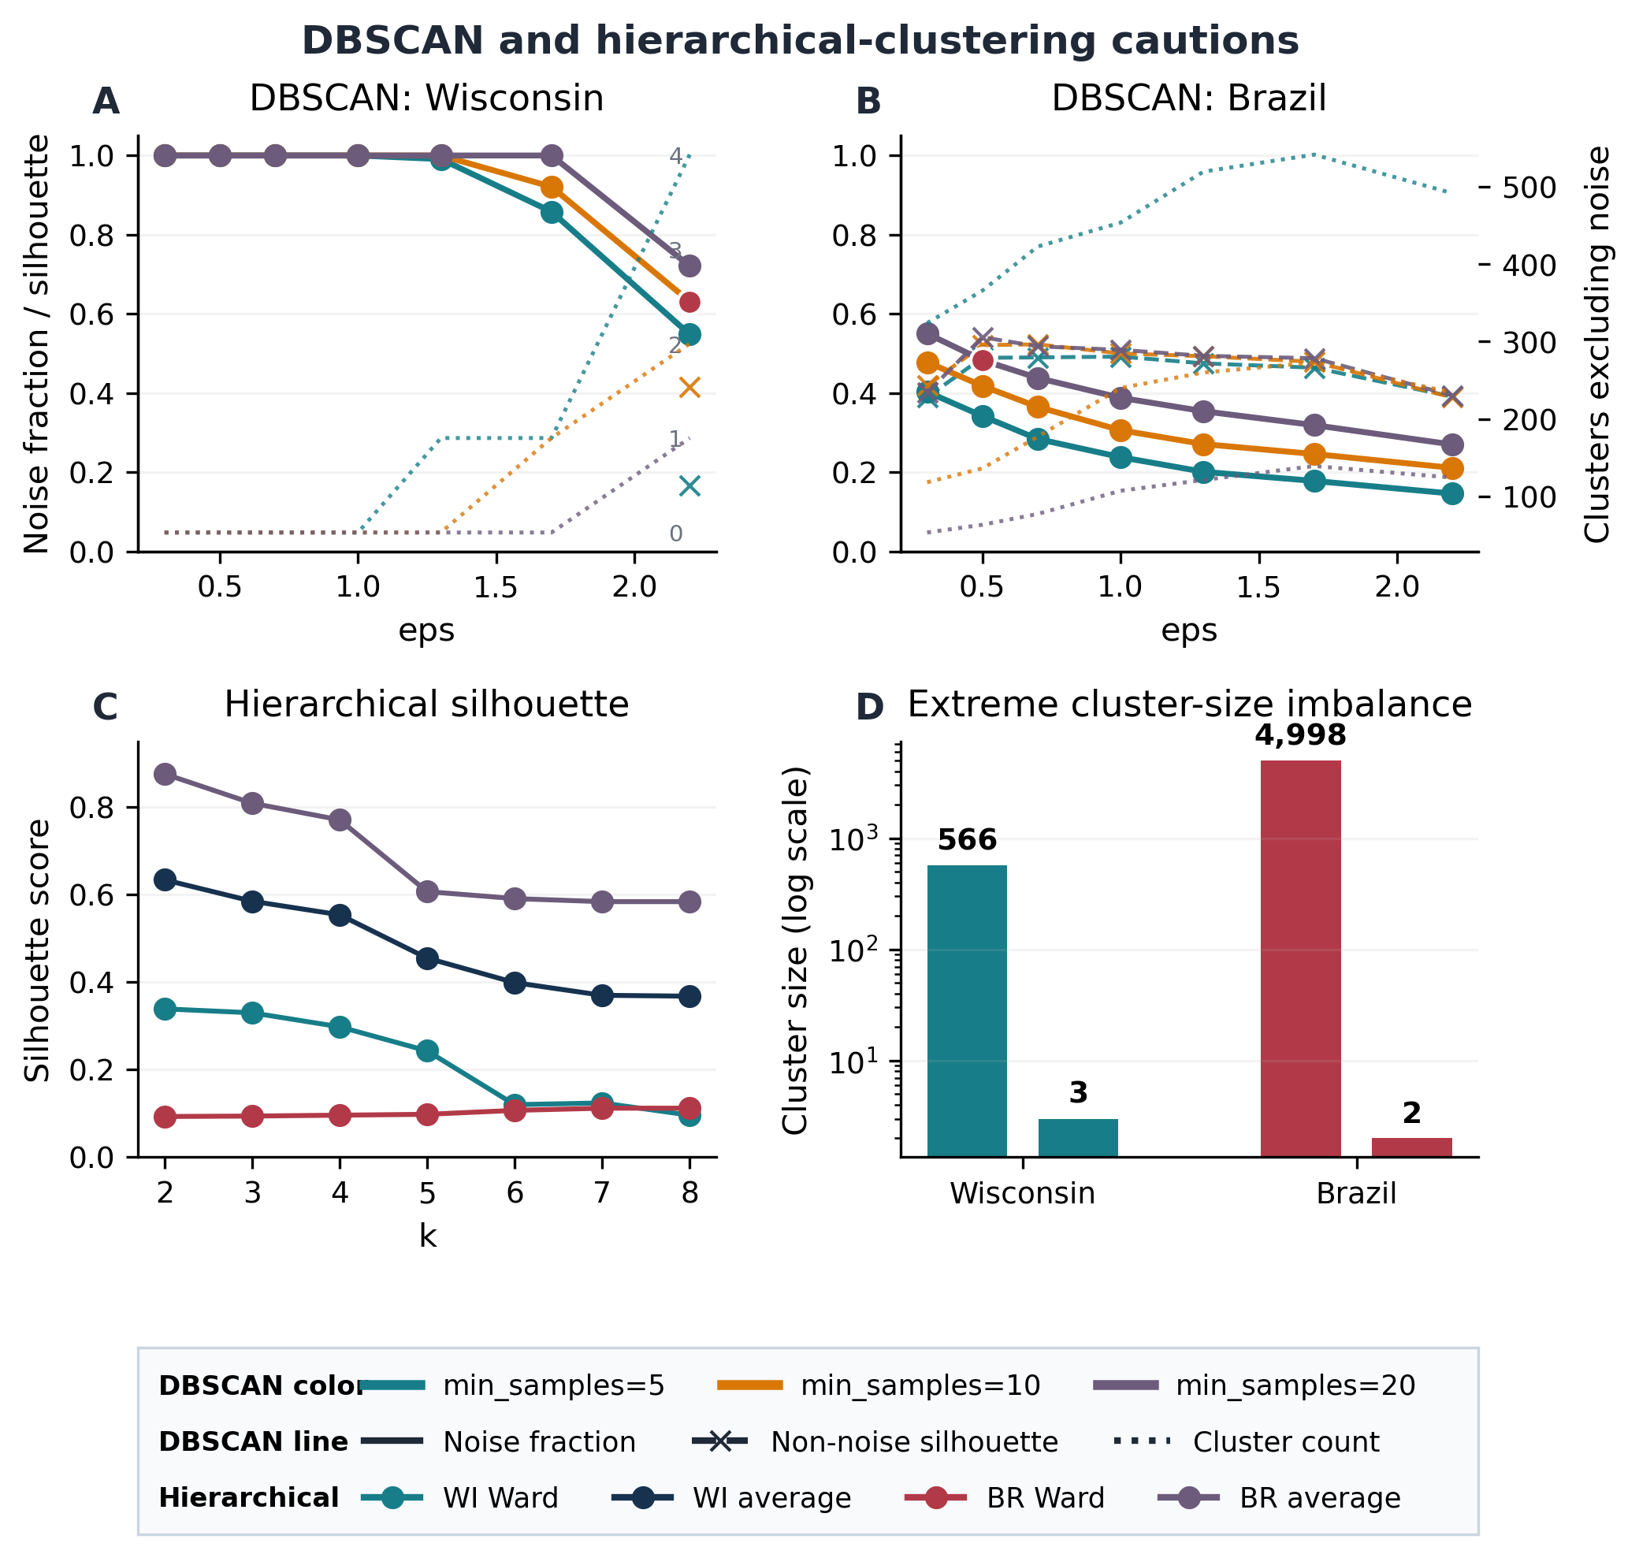
Figure 4. DBSCAN coverage and separation tradeoffs alongside hierarchical partitions showing that high silhouette can accompany extreme cluster imbalance.
5. Expected and Unexpected Results
The supervised results mostly matched what I expected from the earlier data review. Wisconsin had clean continuous predictors, no missing predictor values, and clear class separation, so both KNN and gradient boosting performed very well. Brazil's high accuracy also made sense once class balance was considered. With about 93 percent negative observations, KNN could reach 0.939 accuracy while recalling only 0.252 of the positive cases.
The clustering results were more surprising. Removing standardization from Wisconsin k-means increased silhouette to 0.697, but it also changed the assignments substantially. Brazil hierarchical clustering produced the highest silhouette in the project by separating only two observations. The threshold analysis was also useful because the default 0.50 cutoff was not the best choice for F1. These results made me rely less on a single headline score and more on the behavior that produced it.
6. Connection to Exploratory Data Analysis
EDA showed that many Wisconsin predictors were related measurements of tumor size and shape, including radius, perimeter, and area, and that they were recorded on different numeric scales. That supported standardization for KNN and clustering. It also motivated the reduced-feature k-means analysis, since all 30 columns did not represent 30 independent biological signals.
Brazil raised different problems during EDA. It contained missing values, heterogeneous registry fields, coded variables such as Age, Code.Profession, and Code.of.Morphology, and a deceased outcome near 7 percent. Those observations led to median imputation, reproducible sampling, outcome exclusion during clustering, and the use of PR-AUC, recall, F1, and balanced accuracy. EDA predicted where modeling would be difficult, but it could not determine the best threshold or whether the clusters would be stable. Those questions required the later sensitivity analyses.
7. Overall Conclusions
Across Weeks 8-11, the two datasets required different modeling choices and different ways of judging success. Wisconsin supported strong KNN and gradient boosting, and its standardized k-means solution was highly reproducible even though the silhouette was only moderate. Brazil supported useful supervised ranking, especially with histogram gradient boosting, but accuracy alone was not informative. PR-AUC, recall, F1, and threshold analysis gave a much clearer picture of positive-class performance.
The unsupervised Brazil results were much less convincing. K-means had weak separation and low stability, DBSCAN labeled nearly half the data as noise and created many clusters, and hierarchical clustering obtained a high silhouette from an almost one-cluster partition. Based on these results, I would carry gradient boosting forward as the main Brazil supervised model and validate it across additional samples or time periods. I would not carry forward a specific clustering solution without better stability, reasonable cluster sizes, and interpretable feature profiles.
For the integrated capstone, the next step would be to repeat the Brazil gradient-boosting analysis across several random samples and report how much ROC-AUC, PR-AUC, recall, and F1 vary. I would also choose the classification threshold based on the intended use of the model. A screening-oriented goal would place more weight on recall, while a smaller follow-up workload might require higher precision. For the unsupervised analyses, I would first revisit feature representation and remove or regroup coded variables that may dominate distance calculations. I would only present a final clustering result if it remained stable across samples and produced groups that could be explained using the underlying registry variables.

References
joaopedromedeiros. (n.d.). Cancer Data Brazil [Data set]. Kaggle. Retrieved March 14, 2026, from https://www.kaggle.com/datasets/joaopedromedeiros/cancer-data-brazil
Scikit-learn Developers. (2026a). Nearest neighbors. Scikit-learn user guide. Retrieved July 30, 2026, from https://scikit-learn.org/stable/modules/neighbors.html
Scikit-learn Developers. (2026b). Ensembles: Gradient boosting, random forests, bagging, voting, and stacking. Scikit-learn user guide. Retrieved July 30, 2026, from https://scikit-learn.org/stable/modules/ensemble.html
Scikit-learn Developers. (2026c). Clustering. Scikit-learn user guide. Retrieved July 30, 2026, from https://scikit-learn.org/stable/modules/clustering.html
Scikit-learn Developers. (2026d). Metrics and scoring: Quantifying the quality of predictions. Scikit-learn user guide. Retrieved July 30, 2026, from https://scikit-learn.org/stable/modules/model_evaluation.html
Wolberg, W., Mangasarian, O., Street, N., & Street, W. (1993). Breast Cancer Wisconsin (Diagnostic) [Data set]. UCI Machine Learning Repository. https://doi.org/10.24432/C5DW2B

Jupyter Notebooks: https://github.com/jamie-conner/capstone-c/tree/main/notebooks/milestone2

Appendix A. AI Use Statement
Tool used: ChatGPT Pro, GPT-5.6 Thinking, medium reasoning.

I used AI to help interpret the rubric, organize my notebook content into an outline, convert that outline into a rough draft, and review the completed draft for clarity, proofreading, figure presentation, and rubric alignment. I independently selected the datasets, wrote and ran the analyses, chose the models and tuning approaches, generated the figures and tables, evaluated the results, selected the depth topics, and made the final decisions about the paper’s conclusions and wording. I reviewed all AI-assisted language and interpretations against my notebooks and model outputs before including them.

Representative prompts included:

“Given this rubric, please create me a draft outline that I can fill in. Don’t fill it in for me.”
“I attached my notebooks with content summaries and relevant descriptions. Please put those into this outline in a bulleted format. Note any missing commentary for me to add, and don’t make anything up.”
“I filled in the major gaps in this updated bulleted outline. Refer to the rubric and turn this into a rough draft paper. Leave figure placeholders for me to add later. Use my language.”
“Please do a comprehensive review, including rubric grading, proofreading, and figure presentation. Report back with comments and do not generate an updated draft.”

