Milestone One: Machine Learning Evaluation for Cancer Classification and Outcome Modeling
James Conner
DX799 Module C: Data Science Capstone
June 28, 2026

1. Problem Statement and Project Description
Cancer-related prediction is not only a modeling problem. It is also a reliability problem shaped by data quality, feature representation, class balance, and unequal clinical error costs. This project evaluates machine learning methods for cancer-related classification and outcome modeling using two datasets with very different modeling difficulty: the Breast Cancer Wisconsin Diagnostic dataset (Wolberg et al., 1993) and a large, processed Cancer Data Brazil registry dataset (Joaopedromedeiros, n.d.). Wisconsin is a small, clean benchmark with 569 observations, 30 numeric tumor-measurement predictors, and a binary diagnosis target. Brazil is a large registry-style dataset with 1,742,813 processed observations, 40 predictors before the target, and a binary deceased outcome with severe class imbalance.
The goal is to compare how the modeling techniques from Weeks 1-6 behave across both datasets and to determine what those results imply for diagnostic workflow decision support. The practical objective is not simply to maximize one score. In healthcare settings, false negatives can be especially costly, but false positives also create follow-up burden. For that reason, this project emphasizes accuracy, recall, precision, F1, receiver operating characteristic area under the curve (ROC-AUC), precision-recall area under the curve (PR-AUC), confusion matrices, threshold behavior, and overfitting control. The two depth topics are Week 4 logistic regression, scaling, class weighting, and threshold analysis, and Week 6 decision trees and random forests.

2. Data and Exploratory Data Analysis
Exploratory data analysis (EDA) shaped the modeling plan. Wisconsin contains continuous tumor measurements such as radius, texture, perimeter, area, compactness, concavity, concave points, symmetry, and fractal dimension. These predictors are measured on different scales and are biologically related, which supports standardization, regularization, principal component regression (PCR), and partial least squares regression (PLSR). Specifically, the different feature scales supported scaling, while the correlated tumor-measurement structure supported regularization, PCR, and PLSR. Earlier EDA showed strong separation between benign and malignant cases, and the Week 1–6 models largely confirmed that Wisconsin behaves like a clean benchmark dataset.
Brazil is a more realistic stress test. Its predictors include age, morphology code, diagnostic method, tumor extension, laterality, profession code, education, marital status, rare-case indicators, and demographic or registry coding fields. Because deceased cases make up only about 7.0% of the processed dataset, accuracy alone could look strong even when a model missed many positive cases. The roughly 7% positive-class rate directly motivated PR-AUC, recall, F1, threshold tuning, and confusion matrices. EDA also supported caution around target-adjacent registry fields, since a highly predictive code may reflect leakage or documentation artifacts rather than clinically useful signal. 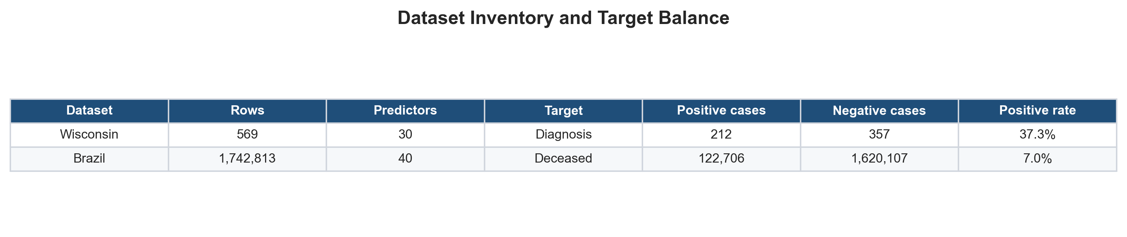

Figure 1. Dataset inventory and target balance. Wisconsin is a small, clean diagnostic benchmark, while Brazil is a very large registry-style dataset with severe positive-class imbalance.
As shown in Figure 1, the datasets differ not only in size but also in the type of modeling challenge they create. Wisconsin supports method comparison under clean conditions. Brazil tests whether evaluation remains meaningful when class imbalance and registry-code complexity make the decision problem harder.
Week 1: Polynomial and Interaction Terms. Week 1 tested whether polynomial and interaction terms improved performance beyond the original feature sets. Numerically, the full Wisconsin baseline reached ROC-AUC 0.9960, while the polynomial reduced model reached 0.9888. On Brazil, the full model reached ROC-AUC 0.9237 compared with 0.7615 for the polynomial reduced model. On both Wisconsin and Brazil, the full original feature models outperformed reduced polynomial-expanded versions. This suggests that polynomial terms captured some nonlinear signal, but removing informative original predictors cost more than the added interactions helped.
Week 2: Ridge, Lasso, and Elastic Net Penalties. Week 2 applied ridge, lasso, and elastic net concepts as penalties in logistic regression because both project targets are classification outcomes. Wisconsin performed near ceiling across penalties, with the best L2/ridge-style model reaching cross-validated ROC-AUC of 0.9960. Brazil slightly favored L1/lasso regularization with C = 0.1 and cross-validated ROC-AUC of 0.9388, although L1, L2, and elastic net performed nearly identically. Because C is inverse regularization strength, the lower Brazil C value was consistent with a noisier registry dataset that benefited from stronger regularization. The main lesson was not that one penalty dominated, but that shrinkage helped stabilize modeling in the harder dataset.
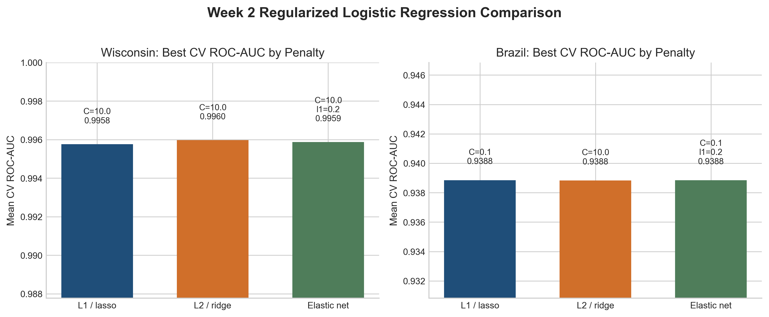
Figure 2. Week 2 regularized logistic regression comparison. Regularization choices produced similar ROC-AUC values within each dataset, suggesting that shrinkage mainly supported stability and overfitting control.

Week 3: Forward Selection, PCR, and PLSR
Week 3 compared interpretable feature selection with component-based dimensionality reduction. Wisconsin favored PLSR, with test ROC-AUC of 0.9974, while Brazil showed a closer tradeoff between forward selection and PLSR. The main lesson was that component methods helped manage correlated features, but forward selection remained useful when interpretability mattered. The main limitation was that PCR and PLSR improved dimensionality handling but reduced direct interpretability because the final predictors were components rather than original clinical or registry variables.
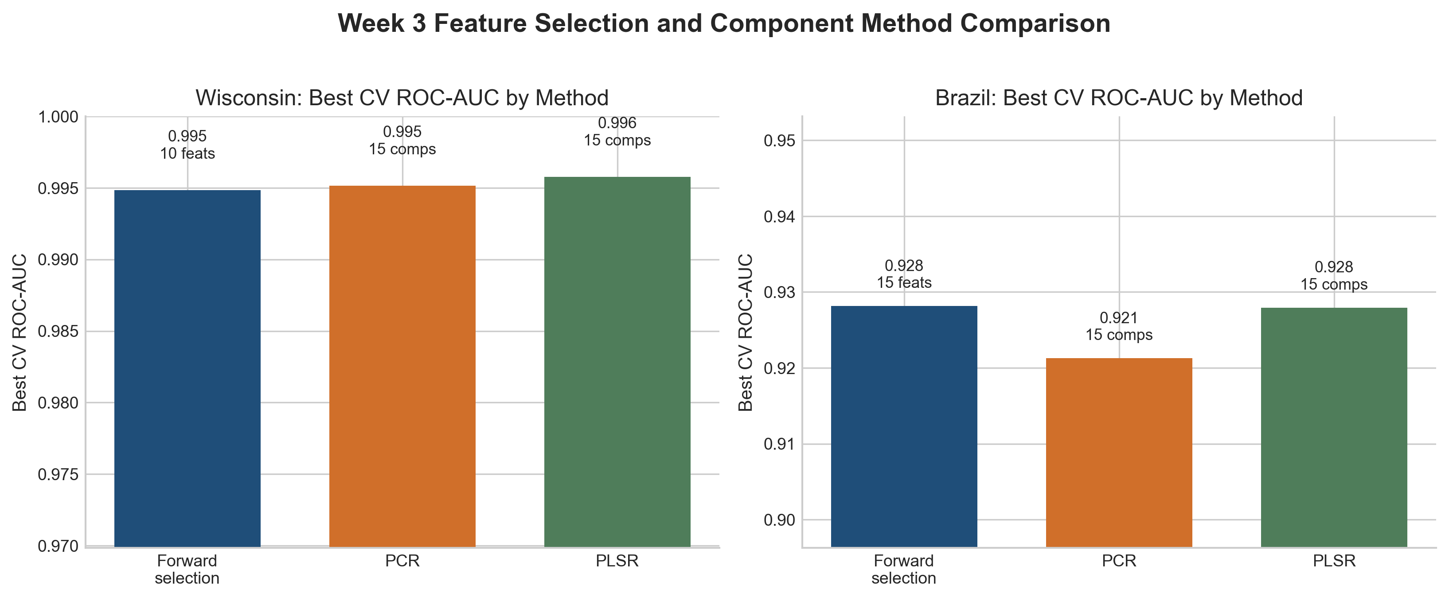
Figure 3. Week 3 comparison of forward selection, PCR, and PLSR. Component-based methods were strongest on Wisconsin, while Brazil showed a closer tradeoff between interpretability and target-informed dimension reduction.

Week 4: Logistic Regression, Scaling, Class Balance, and Thresholds
Week 4 became the first depth topic because it directly addressed metric choice and threshold behavior. Scaling improved Wisconsin recall and F1, while Brazil showed that a high-accuracy logistic model could still miss many positive cases. A balanced logistic model greatly increased recall, and the threshold analysis in Figure 4 showed the resulting precision-recall tradeoff.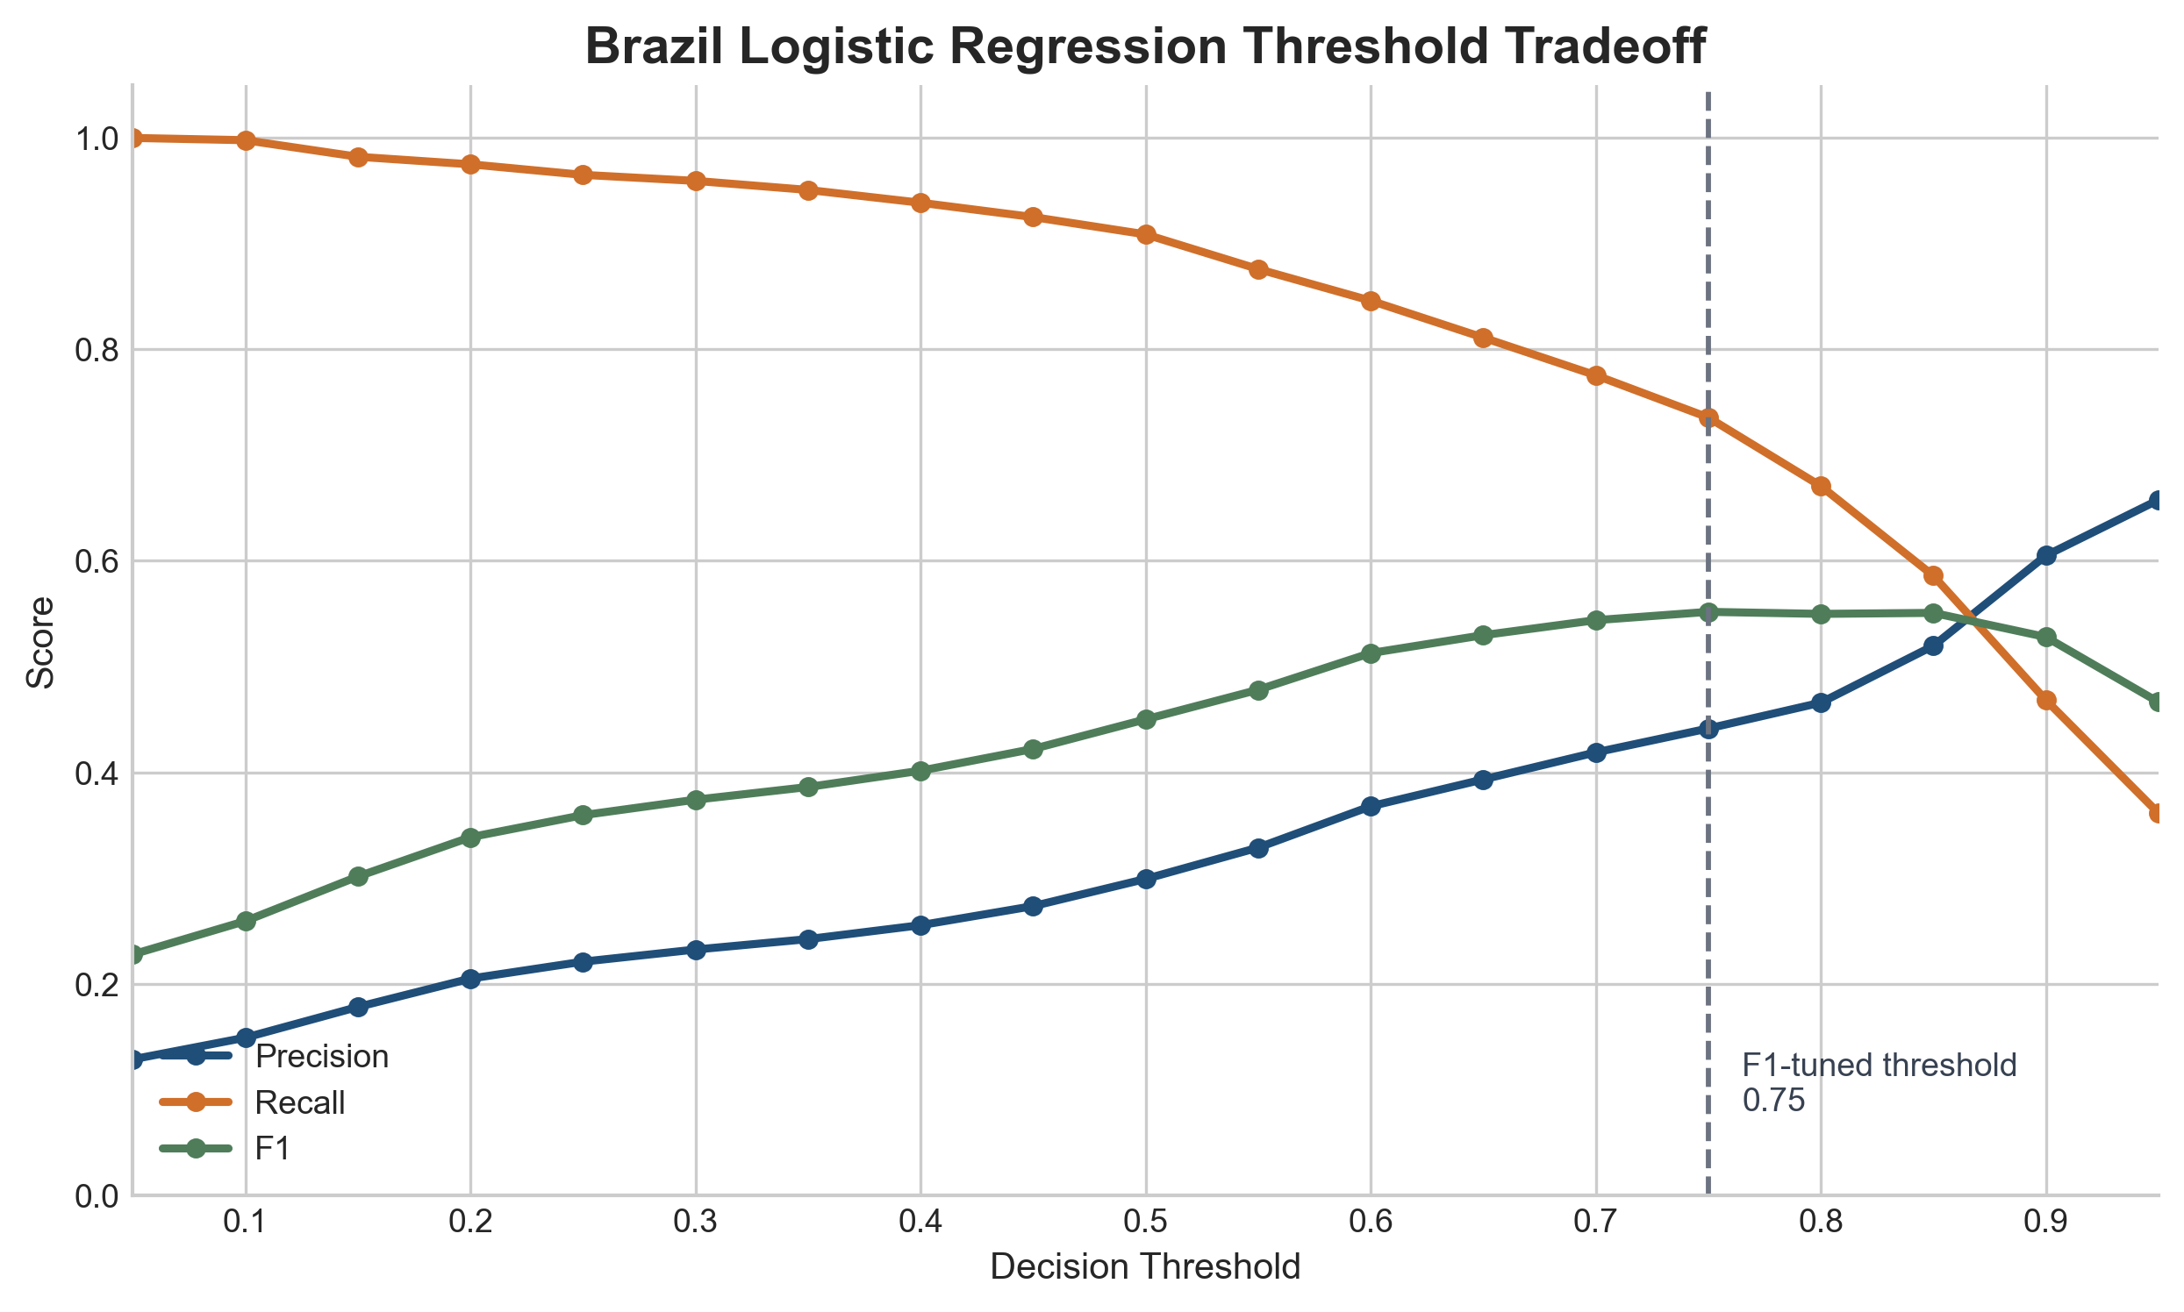
Figure 4. Brazil logistic regression threshold tradeoff. Lower thresholds improved recall but created more false positives, while the F1-tuned threshold improved precision and F1 at the cost of lower recall.
As shown in Figure 4, the default balanced threshold produced recall of 0.91, precision of 0.30, F1 of 0.45, and accuracy of 0.84. The F1-tuned threshold improved precision to 0.44, F1 to 0.55, and accuracy to 0.92, but recall fell to 0.74. False positives dropped from 2,988 to 1,306, while false negatives rose from 128 to 371.

Week 5: Support Vector Machines
Week 5 tested linear and radial basis function support vector machines using standardized predictors. Wisconsin showed little difference between the linear and nonlinear kernels, suggesting that the dataset was already highly separable after scaling. Brazil benefited more from the RBF kernel, improving ROC-AUC and PR-AUC, but default-threshold recall remained limited. On Brazil, the RBF kernel improved ROC-AUC from 0.8779 to 0.9330 and PR-AUC from 0.4584 to 0.5607, but recall remained around 0.35 at the default threshold.

Week 6: Decision Trees and Random Forests
Week 6 became the second depth topic because tree-based models capture nonlinear relationships and interactions without manually creating polynomial terms. Random forests outperformed single trees on both datasets. On Brazil, the random forest improved ROC-AUC from 0.8840 to 0.9363 and PR-AUC from 0.4648 to 0.5429, while Figure 5 shows the features most used by the fitted forest.
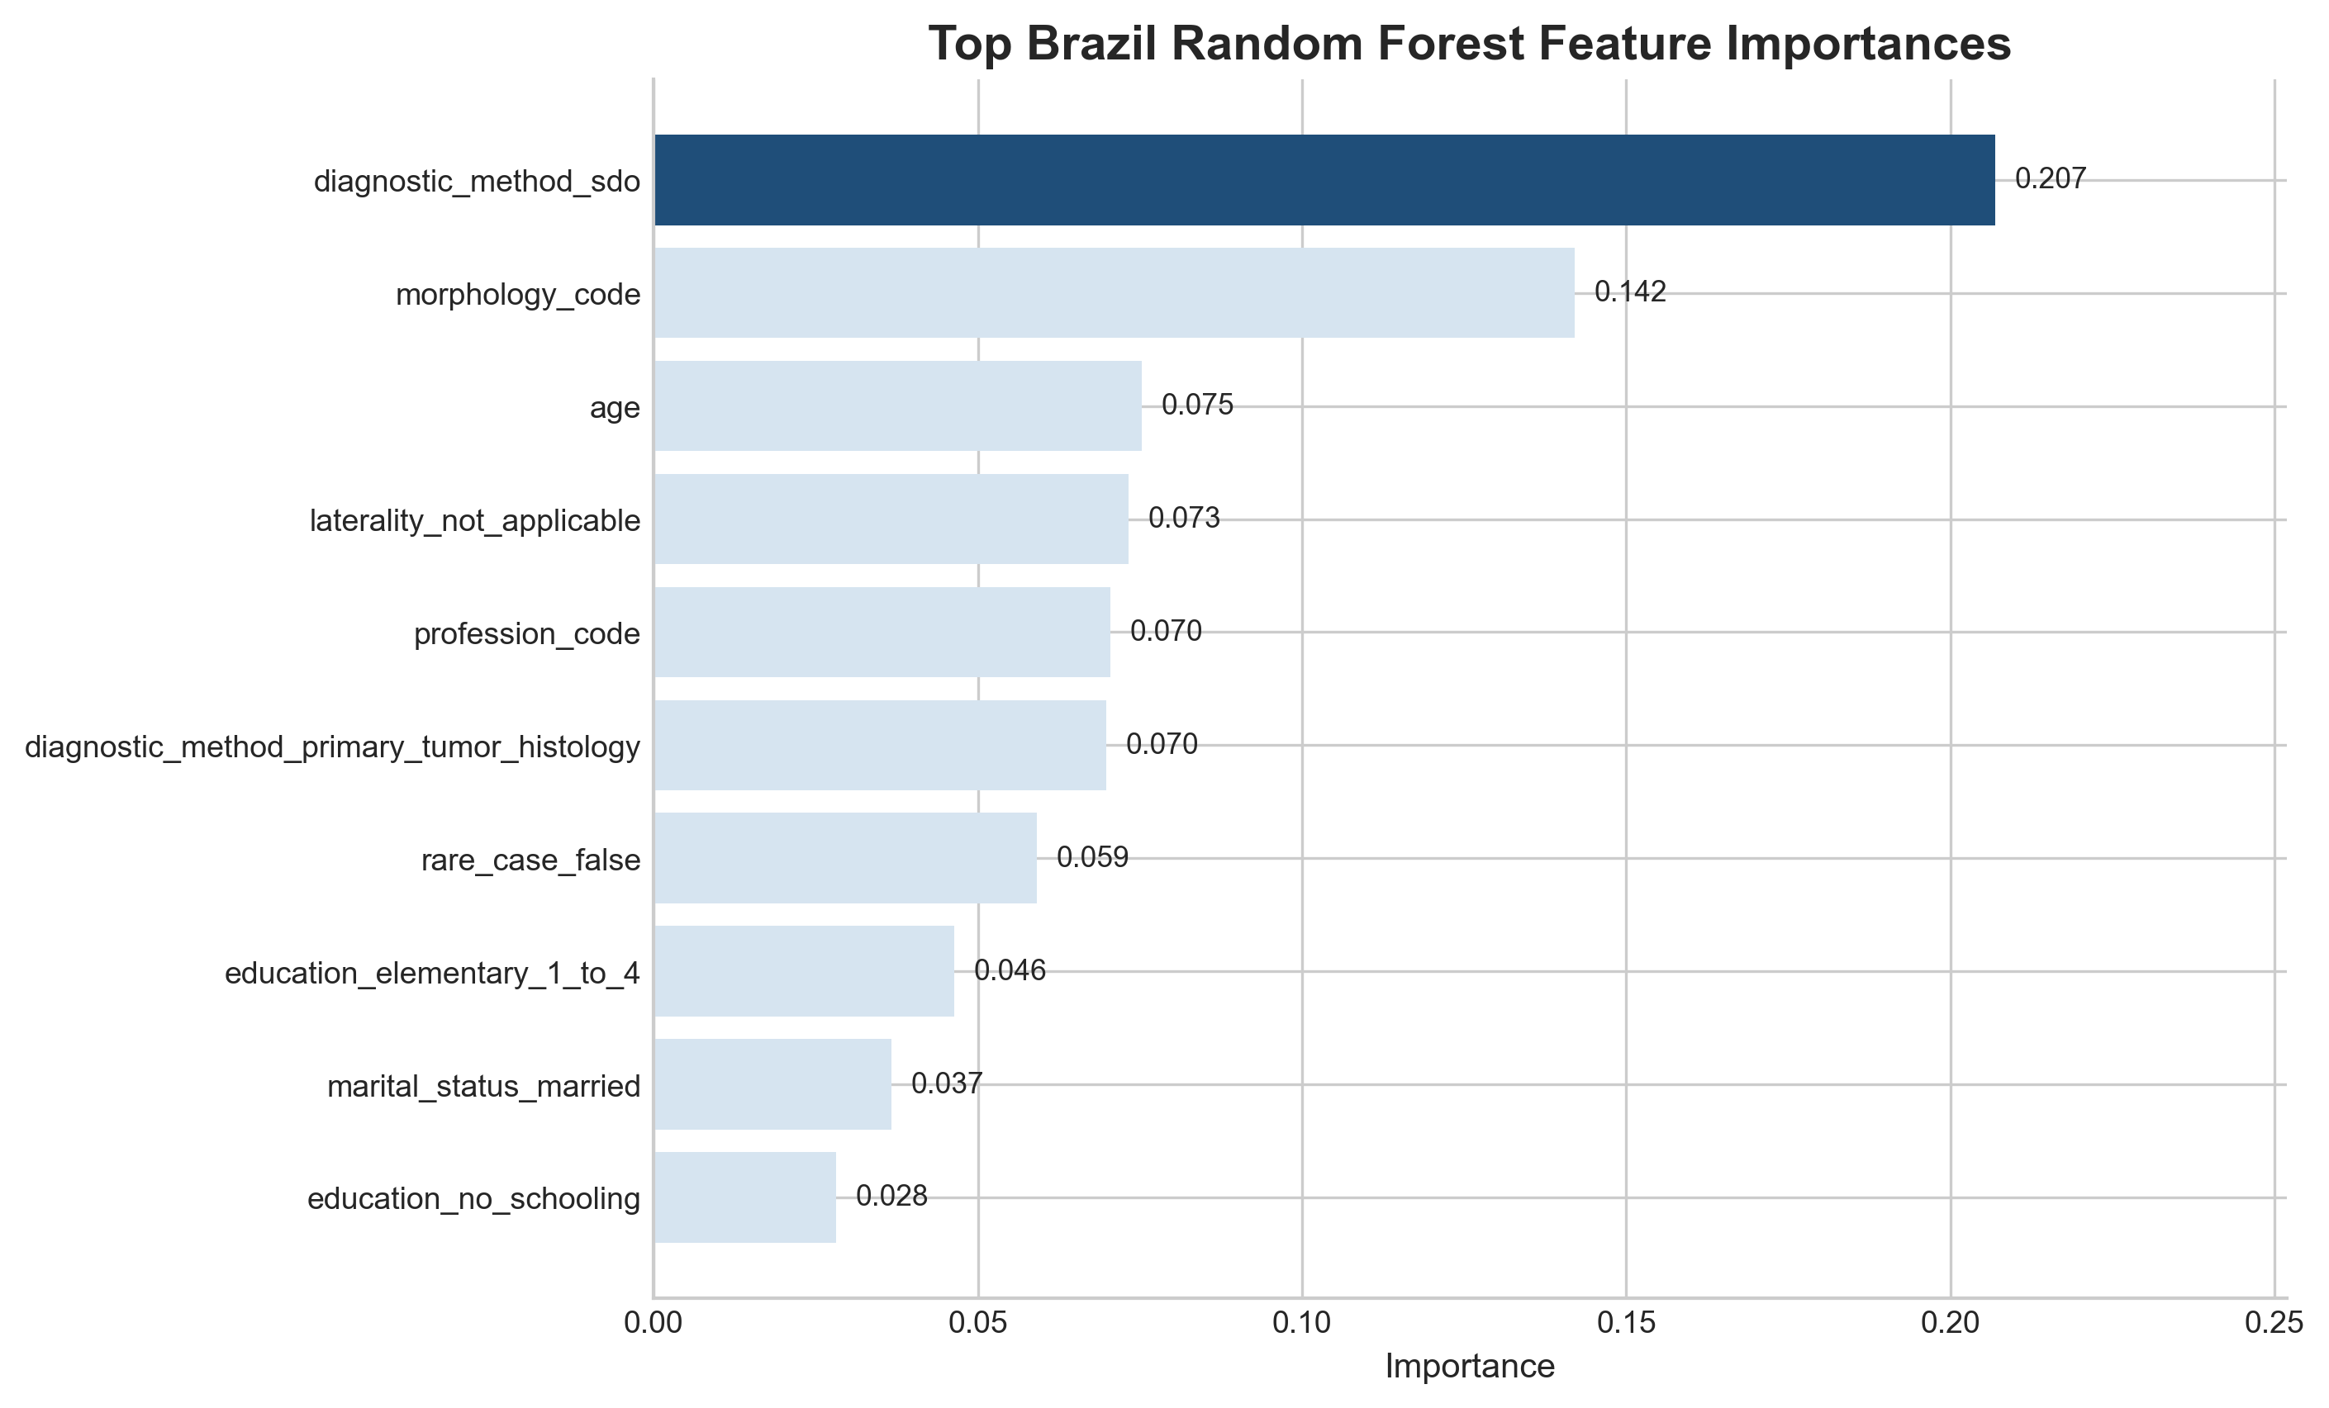
Figure 5. Brazil random forest feature importance. The fitted forest relied most heavily on diagnostic method, morphology, age, laterality coding, profession code, and other registry/demographic features. These are predictive associations, not causal claims.

4. Depth Discussion: Logistic Regression and Thresholds
Logistic regression was one of the most important methods in this milestone because it provides an interpretable probability-based baseline. The Wisconsin result showed that preprocessing matters: after scaling, recall improved from 0.8571 to 0.9286 and F1 improved from 0.9114 to 0.9512. The Brazil result was more important for the project’s thesis. Because the positive class was rare, a high-accuracy model could still miss many deceased cases. Class weighting changed the training objective by giving more weight to the minority class, while threshold tuning changed the operating point after the model produced probabilities.

The threshold analysis in Figure 4 showed that neither threshold was universally correct. The default balanced model caught more positives but created many false positives. The F1-tuned threshold reduced false alarms but missed more positive cases. If the model were used as an early warning or broad screening tool, the lower threshold might be preferable because missing positives is costly. If the model were used to prioritize limited expert review, the F1-tuned threshold might be more practical. This is why threshold selection should be treated as part of the modeling problem, not an afterthought. Methodologically, I interpret this threshold analysis as exploratory because it was performed on the held-out test set. In a production workflow, threshold selection should be done on a validation set before one final test-set evaluation.

5. Depth Discussion: Trees and Random Forests
Tree-based models addressed limitations of the earlier methods. Polynomial features can represent interactions, but they must be manually created and can rapidly increase dimensionality. Logistic regression is interpretable, but it assumes a relatively simple relationship between predictors and log-odds unless interactions or transformations are added. Trees handle nonlinear relationships and interactions more naturally by recursively splitting the feature space.
The single decision tree was useful but limited. It was more interpretable than the random forest, but it performed worse on both datasets. This is consistent with the known behavior of decision trees: they can capture nonlinear structure, but they are high-variance models and can overfit if allowed to grow too deeply. I controlled this using max_depth and min_samples_leaf. For Brazil, the tuned tree used max_depth = 5 and min_samples_leaf = 10, preventing overly specific leaves based on tiny groups of observations.
The random forest improved on the single tree by averaging many trees. On Brazil, ROC-AUC increased from 0.8840 for the decision tree to 0.9363 for the random forest, and PR-AUC increased from 0.4648 to 0.5429. The Brazil random forest had train ROC-AUC of 0.9733 and cross-validated ROC-AUC of 0.9339, which suggests some fit to training-specific patterns. However, cross-validated and test results remained stronger than the single tree, and min_samples_leaf = 5 served as an overfitting control. The forest improved nonlinear ranking performance and produced an interpretable feature-importance story, but it did not remove the need for threshold-aware evaluation.

6. Overfitting Controls
Overfitting was addressed differently across the weekly methods. Train/test splits were used so final model performance was evaluated on held-out data, and stratified splitting preserved class distribution where appropriate. Cross-validation supported model selection and hyperparameter tuning so results were not dependent on one split. Regularization controlled coefficient size in the Week 2 and Week 4 logistic models. Polynomial features were applied to reduced subsets because expanding all features would sharply increase dimensionality and variance. PCR and PLSR reduced dimensionality by replacing original predictors with a smaller number of components.
For SVMs, overfitting was controlled through C and gamma. C controls the penalty for margin violations, while gamma controls how local or flexible the RBF decision boundary becomes. For trees, max_depth and min_samples_leaf limited tree complexity. For random forests, averaging many trees reduced variance, while min_samples_leaf helped prevent tiny, overly specific terminal nodes. The Brazil random forest train ROC-AUC of 0.9733 compared with cross-validated ROC-AUC of 0.9339 showed some overfitting pressure, but the validation and test performance still supported the forest as an improvement over the single tree.

7. Metrics and Hyperparameter Tuning

Metric choice was central because Brazil was severely imbalanced. Accuracy was reported for comparison, but ROC-AUC, PR-AUC, precision, recall, F1, and confusion matrices were more important for judging positive-class performance. ROC-AUC measured ranking across thresholds, while PR-AUC, recall, and F1 were especially useful for Brazil because deceased cases were rare. Confusion matrices were most useful in Week 4 because they showed how threshold changes shifted errors between false positives and false negatives.

Hyperparameters were selected with grid search where tuning was appropriate. In regularized logistic regression, C controlled inverse regularization strength, penalty type controlled the kind of shrinkage, and l1_ratio controlled the lasso-ridge balance for elastic net. For Brazil logistic regression, class_weight="balanced" was used to test whether weighting minority-class errors improved recall. For PCR and PLSR, the number of components controlled dimensionality. For SVMs, C controlled margin flexibility and gamma controlled RBF kernel flexibility. For trees and random forests, max_depth, min_samples_leaf, and n_estimators controlled tree complexity and averaging.

8. Expected and Unexpected Results
Several results were expected. Wisconsin performed strongly across nearly every method because it is clean, numeric, and highly separable. Scaling helped logistic regression and was necessary for SVMs. Brazil accuracy was misleading because the majority class was dominant. Random forests outperformed single trees because averaging reduced variance. Other results were more interesting. Polynomial terms helped reduced feature subsets but did not outperform the full original feature sets, suggesting that feature removal hurt more than polynomial interactions helped. On Wisconsin, linear and RBF SVMs performed almost identically, even though the RBF kernel is more flexible.
The most important unexpected result came from Brazil: the balanced logistic model had similar ROC-AUC to the standard logistic model but very different recall and precision behavior. This showed that ranking performance and operating-threshold performance are not the same thing. The Brazil random forest improved ROC-AUC and PR-AUC, but default-threshold recall remained lower than the balanced logistic model. That distinction separates model ranking quality from decision-threshold behavior.

9. Conclusions
This milestone supports one main conclusion: the best model is not a single universal choice, but the model whose behavior matches the dataset and decision context. Wisconsin showed that simpler scaled and regularized models can be enough when the signal is strong and the data are clean. Brazil showed that imbalanced outcome modeling requires more careful evaluation. In that dataset, accuracy alone was not a trustworthy summary of performance.
Week 4 provided the clearest evaluation lesson. Logistic regression showed that scaling matters, class weighting changes minority-class behavior, and threshold tuning changes the practical consequences of a model. Week 6 provided the strongest nonlinear modeling lesson. Random forests improved ranking performance and produced a useful feature-importance summary, especially on Brazil, but they still required careful interpretation and did not remove the need to think about thresholds. Together, the results move the project from “which model scores highest?” to “which model behavior is safest and most useful for the workflow?” In cancer-related decision support, metrics, thresholds, and overfitting controls should be chosen around the real cost of mistakes.

References
joaopedromedeiros. (n.d.). Cancer Data Brazil [Data set]. Kaggle. Retrieved March 14, 2026, from https://www.kaggle.com/datasets/joaopedromedeiros/cancer-data-brazil
Pedregosa, F., Varoquaux, G., Gramfort, A., Michel, V., Thirion, B., Grisel, O., Blondel, M., Prettenhofer, P., Weiss, R., Dubourg, V., Vanderplas, J., Passos, A., Cournapeau, D., Brucher, M., Perrot, M., & Duchesnay, E. (2011). Scikit-learn: Machine learning in Python. Journal of Machine Learning Research, 12, 2825-2830. https://jmlr.org/papers/v12/pedregosa11a.html
Scikit-learn developers. (n.d.). Tuning the decision threshold for class prediction. Scikit-learn documentation. https://scikit-learn.org/stable/modules/classification_threshold.html
Scikit-learn developers. (n.d.). Random forests and other randomized tree ensembles. Scikit-learn documentation. https://scikit-learn.org/stable/modules/ensemble.html#forest
Wolberg, W., Mangasarian, O., Street, N., & Street, W. (1993). Breast Cancer Wisconsin (Diagnostic) [Data set]. UCI Machine Learning Repository. https://doi.org/10.24432/C5DW2B

Appendix A: AI Use

I used AI tools, primarily ChatGPT, as a support tool during this milestone. AI was used to help plan the paper structure, summarize notebook outputs, compare the draft against the rubric, identify editing priorities, revise wording for clarity, and troubleshoot formatting issues. AI was also used during notebook development for code-debugging support and to help interpret model results. I reviewed all AI output, ran the code myself, selected the final figures, interpreted the results, edited the final paper, and made the final submission decisions.

Representative AI uses included:
1. Notebook interpretation and summary
Prompt/purpose: I asked AI to summarize Week 4 logistic regression results and explain the Brazil threshold tradeoff between recall, precision, F1, false positives, and false negatives. This helped me frame why accuracy alone was not sufficient for the imbalanced Brazil dataset.
2. Rubric comparison
Prompt/purpose: I asked AI to compare my draft against the Milestone One rubric and supplemental instructions. This helped identify missing or weak areas, including the need for clearer breadth evidence, stronger metric/tuning language, and an explicit AI appendix.

3. Writing and organization support
Prompt/purpose: I asked AI to help revise sections on overfitting, metrics, hyperparameter tuning, exploratory data analysis, and expected versus unexpected results. I used these suggestions as editing support, not as a replacement for my own interpretation.
4. Figure and formatting review
Prompt/purpose: I asked AI to identify figure-caption issues, missing figure references, page-length problems, and wording inconsistencies. This helped me clean up the final document so the figures and captions better supported the analysis.
5. Code-debugging and workflow support
Prompt/purpose: I used AI for help with Python notebook organization, model comparison workflows, plotting, and interpretation of scikit-learn model outputs. I ran the notebooks myself and used the resulting outputs as the evidence for the milestone paper.
Overall, AI was used as a drafting, debugging, and review assistant. The final analysis, conclusions, edits, and submission choices were reviewed and controlled by me.

Appendix B: Notebook Appendix / Repository Link
Submitted notebooks 1-6 separately as a merged PDF.

