The genome of *Pocillopora damicornis* and comparative genomics of scleractinian corals

Abstract text here.

# Abstract

# Introduction

Scleractinian corals serve the critical ecological role of building reefs that provide billions of dollars annually in goods and services (Costanza, Groot, and Sutton 2014) and sustain high levels of biodiversity (Knowlton et al. 2010). Moreover, as basal metazoans, corals provide a model for studying the evolution of key traits such as symbiosis (Neubauer et al. 2016), immunity (Steven D. Quistad et al. 2014), and biomineralization (Takeuchi et al. 2016). However, corals are declining rapidly as ocean acidification impairs coral skeleton formation (Kleypas et al. 1999), and ocean warming disrupts their symbiosis with photosynthetic *Symbiodinium* spp. (Jokiel and Coles 1977). Understanding the genomic architecture of these traits is therefore key to understanding corals' success through evolutionary history (Bhattacharya et al. 2016) and under future climate scenarios. In particular, there is great interest in whether corals possess the genetic basis and genetic variation required to acclimatize and/or adapt to rapid climate change (Oppen et al. 2015; Dixon et al. 2015; R. A. Bay et al. 2017). Addressing these questions requires expanding genomic resources for corals, and establishes a fundamental role for comparative genomic analysis in these organisms.

Genomic resources for corals have expanded rapidly in recent years, with genomic or transcriptomic information available for at least 20 coral species (see Bhattacharya et al. (2016)). Comparative analysis of these data has identified genes that may be important in biomineralization, symbiosis, and environmental stress responses (Bhattacharya et al. 2016). However, complete genome sequences have only been analyzed and compared for two coral species, *Acropora digitifera* and *Stylophora pistillata* (Voolstra et al. 2017), which revealed extensive differences in genomic architecture and content. However, one of the main similarities noted was a highly diversified repetoire of immune-related genes, and the evolution of immune system functioning (Voolstra et al. 2017). Therefore, additional complete coral genomes and more comprehensive comparative analysis may be transformative in our understanding of the genomic content and evolutionary history of reef-building corals, as well as the importance of specific gene repertoires and diversification within coral lineages.

Here, we present the genome of *Pocillopora damicornis*, one of the most abundant and widespread reef-building corals in the Indo-Pacific. This ecologically important coral is the subject of a large body of research on speciation (J. H. Pinzón et al. 2013; Schmidt-Roach et al. 2014; Johnston et al. 2017), population genetics (J. a Stoddart 1984; J. H. Pinzón and LaJeunesse 2011; Combosch and Vollmer 2011; L. Thomas et al. 2017), symbiosis ecology (Glynn et al. 2001; McGinley et al. 2012; Cunning and Baker 2013), and reproduction (J. A. Stoddart 1983; Ward 1992; Schmidt-Roach et al. 2012), and is commonly used in experimental biology and physiology. Therefore, availability of the *P. damicornis* genome will advance a number of fields in coral biology, ecology, and evolution, and provides a direct foundation for future studies in transcriptomics, population genomics, and functional genomics.

Using this genome and other publicly available genomes of corals, Cnidarians, and basal metazoans, we provide the most comprehensive comparative genomic analysis to date in Scleractinia. In particular, we address critical questions such as: 1) what genes are specific to or diversified within scleractinians, and 2) what genes are specific to or diversified within individual coral species, and 3) what features distinguish the *P. damicornis* genome from other corals. In addressing each of these questions, we reveal a prominent role of immune-related genes and pathways, indicating that the immune pathways are fundamental to evolutionary adaptation in corals.

# Materials and Methods

## *P. damicornis* genome sequencing and assembly

The *P. damicornis* genotype used for sequencing was collected at Isla de Saboga, Panama in March 2005, and cultured indoors at the University of Miami Coral Resource Facility until the time of sampling. Genomic DNA was extracted from two fragments of this genotype in XXX 2016 using XXX protocol. DNA was delivered to Dovetail Genomics (Santa Cruz, CA, USA), where Chicago libraries were prepared and sequenced on an Illumina XXX platform, and genome scaffolds were assembled *de novo* using the HiRise software pipeline (N. H. Putnam et al. 2016). The Dovetail HiRise scaffolds were then filtered to remove those of potential non-coral origin using BLAST (Altschul et al. 1990) searches against three databases: 1) *Symbiodinium*, containing the genomes of *S. minutum* (Shoguchi et al. 2013) and *S. microadriaticum* (M. Aranda et al. 2016), 2) bacteria, containing 6954 complete bacterial genomes from NCBI, and 3) viruses, containing 2996 viral genomes from the phantome database (phantome.org; accessed 2017-03-01). Scaffolds with a BLAST hit to any of these databases with an e-value < 10-20 and a bitscore > 1000 were considered to be non-coral in origin and removed from the assembly (Baumgarten et al. 2015).

## *P. damicornis* genome annotation

The filtered assembly was analyzed for completeness using BUSCO (Simão et al. 2015) to search for 978 universal metazoan single-copy orthologs. The --long option was passed to BUSCO in order to train the *ab initio* gene prediction software Augustus (M. Stanke et al. 2004). Augustus gene prediction parameters were then used in the MAKER pipeline (M. S. Campbell et al. 2014) to annotate gene models, using as supporting evidence two RNA-seq datasets from *P. damicornis* [Mayfield?; Traylor-Knowles/Bhattacharya?] and one from closely-related *Stylophora pistillata* (Voolstra et al. 2017), and protein sequences from 20 coral species (Bhattacharya et al. 2016). Results from this initial MAKER run were used to train a second gene predictor (SNAP (Korf 2004)) prior to an iterative MAKER run to refine gene models. Predicted protein sequences were then extracted from the assembly and putative functional annotations were added by searching for homologous proteins in the Uniprot-Swissprot database (The UniProt Consortium 2017) using BLAST (E<10-5), and protein domains using InterProScan (Finn et al. 2017). Genome annotation summary statistics were generated using the Genome Annotation Generator software (Hall, DeRego, and Geib 2014).

## Comparative genomic analyses

We identified ortholog groups (gene families) among the predicted proteins of four scleractinians, two corallimorpharians, two anemones, one hydrozoan, one sponge, and one ctenophore (Table 1) using the software fastOrtho (<http://enews.patricbrc.org/fastortho/>) based on the MCL algorithm with a blastp E-value cutoff of 10-5. Based on these orthologous gene families, we defined and extracted several gene sets of interest: 1) gene families that were shared by all four corals (i.e., coral 'core' genes), 2) gene families that were present in all four corals but absent from other organisms (i.e., coral-specific genes), 3) gene families that were significantly larger in corals relative to other anthozoans (Binomial generalized linear model, FDR-adjusted *p*<0.01; i.e., coral-diversified genes), 4) gene families that were significantly larger in each coral species relative to other corals (pairwise comparisons using Fisher's exact test, FDR-adjusted *p*<0.01; i.e., coral species-specific gene family expansions), and 5) genes present in *P. damicornis* with no orthologs in any other genome (i.e., *P. damicornis*-specific genes).

## Functional characterization

Putative gene functionality was characterized using Gene Ontology (GO) analysis. GO terms were assigned to predicted *P. damicornis* protein sequences using InterProScan (Jones et al. 2014). Significantly enriched GO terms in gene sets of interest relative to the whole genome were identified using the R package topGO (Alexa and Rahnenfuhrer 2016), and significantly enriched GO terms were clustered and visualized using REVIGO (Supek et al. 2011). These analyses were implemented using custom scripts in R, Python, and Unix shell, which are available in the accompanying data repository (<http://www.github.com/jrcunning/pdam-genome>).

# Results and discussion

## Genome assembly and annotation statistics

The estimated true genome size of *P. damicornis* is 348 Mb, smaller than other coral genomes analyzed to date. The size of the final assembly produced here was 234 Mb, and likely lacks high-identity repeat content that could not be assembled. The assembly comprises 96.3% contiguous sequence, and has the highest contig N50 (28.5 kb) of any cnidarian genome assembly (Table 1). We identified 26,077 gene models, with 21,389 (82%) of these being apparently complete with start and stop codons. This number of genes is consistent with the number observed in other scleractinian and cnidarian genomes (Table 1). Among all gene models, 59.7% had identifiable homologs (E-value 10-5) in the UniProt-SwissProt database, and 83.7% contained protein domains annotated by InterProScan. In addition, 73% of genes contained identifiable homologs in at least one of the other 10 genomes analyzed here. Furthermore, a BUSCO search found that out of 978 metazoan single-copy orthologs, 865 (88.4%) were present and complete (5 of these were duplicated). An additional 28 orthologs were present but fragmented, and 85 (8.7%) were missing. Together, these statistics indicate the *P. damicornis* genome assembly is the highest quality and most complete scleractinian genome to date (Table 1).

## Coral gene content

Analysis of ortholog groups revealed genes and gene families that were shared or unique to specific scleractinian species. Comparison of the four corals (Fig. 1) identified 7,536 gene families shared by all corals, constituting putative coral 'core' genes. Each coral species also contained numerous gene families that were not shared by others, constituting species-specific genes. Since the number of shared orthologous gene families between a given pair of species is related to the evolutionary distance that separates them, the highest number of shared ortholog groups was between *P. damicornis* and *S. pistillata*, the two most closely related corals in this analysis. Indeed, a dendrogram based on the number of shared gene families relative to the total number of gene families (Snel, Bork, and Huynen 1999) reproduces the evolutionary relationships among these corals (Fukami et al. 2008) (Fig. 1).

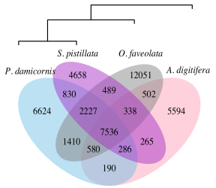

Species-specific and shared gene families across four scleractinian genomes. Numbers indicate the number of gene families, which include both single-copy genes and multi-copy gene families. Dendrogram is based on shared gene content, following Snel, Bork, and Huynen (1999).

## Coral core genes

The coral 'core' gene families (i.e., those found in all four corals) comprise 17.3% of all gene families identified among the four genomes. In *P. damicornis*, core gene family members totaled 12,147, or 46.6% of all genes. Functional profiling of this core genome in *P. damicornis* revealed significant enrichment of 44 GO terms associated with basic cellular and metabolic functions, including nucleic acid synthesis and processing, cellular signaling and transport, and lipid, carbohydrate, and protein metabolism (Fig. 2). This basic functionality explains why over 30% of these gene families are also found in all other cnidarians, and 96.3% have orthologs in at least one non-coral.

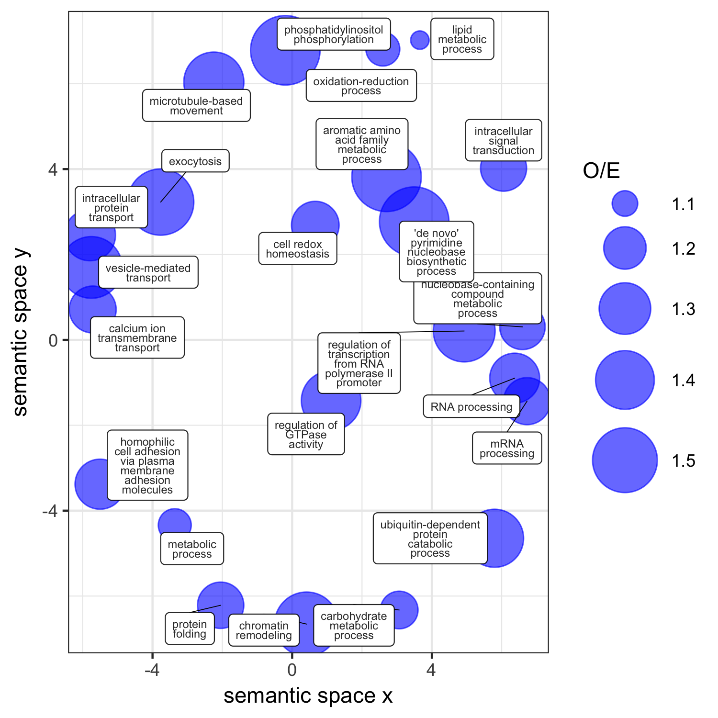

Functional profile of the core coral genome in P. damicornis. Significantly enriched GO terms (p < 0.05) within this gene set were reduced (allowed similarity = 0.4) and visualized in semantic space by REVIGO. Point size is scaled to the ratio of observed to expected (O/E) occurrences of each GO term in the coral core gene set.

## Coral-specific genes

Among the coral core gene families, 278 (3.7%) had no orthologs outside Scleractinia, indicating these may be coral-specific gene families. These coral-specific genes in *P. damicornis* (n=349) were significantly enriched for GO terms related to immune function, such as viral defense, signal transduction [GTPase-signaling=impt in immunity Mydlarz2016], and NF- $κ$ B pathway regulation (Table 2). NF- $κ$ B signaling plays a central role in innate immunity (Hatada, Krappmann, and Scheidereit 2000; Mydlarz et al. 2016), and was recently demonstrated to be conserved and responsive to immune challenge in *O. faveolata* (Williams et al. 2017). The 32 genes in this set associated with signal transduction may also represent coral-specific immune pathways; SwissProt annotations of these genes included dopamine receptors, neuropeptide receptors, G-protein coupled receptors, and tumor necrosis factor (TNF) receptor-associated factors (TRAFs). The TNF receptor superfamily in *A. digitifera* is comprised of 40 proteins, and is more diverse than any organism described thus far (Steven D. Quistad et al. 2014; S D Quistad and Traylor-Knowles 2016). That similar genes were present in each coral genome but absent from other cnidarians suggests that diversification of these signaling pathways is a common feature of corals. Indeed, *P. damicornis* contained 39 proteins with TNFR cysteine-rich domains. Finally, caveola assembly, or the formation of structures in cell membranes that anchor transmembrane proteins, may also serve an important role in signal transduction and immunity (H. H. Patel and Insel 2009). Together, these results suggest that corals as a group have evolved a diverse set of signaling genes for interacting with and responding to pathogens and the environment.

Another enriched function in the coral-specific gene set was copper ion transmembrane transport (Table 2), which may reflect an important role for delivery of copper to endosymbionts, where it is a critical component of proteins involved in photosynthesis (plastocyanin) and antioxidant activity (superoxide dismutase) (Festa and Thiele 2011). Indeed, in mycorrhizal symbioses, fungi are known to deliver copper to the photosynthetic plant partner (González-Guerrero et al. 2016). Other enriched functions in the coral-specific genes include regulation of transcription and chromatin silencing, potentially indicating coral-specific pathways of controlling gene expression.

## Coral-diversified genes

In addition to gene families that were only found in corals, there were also gene families (n=21) that were significantly larger in corals compared to corallimorphs and anemones (*p* < 0.01; Figure 3), which may indicate diversification within the scleractinian lineage. Members of these coral-diversified gene families in *P. damicornis* (n=339) were significantly enriched for 9 GO terms suggesting roles in cellular signaling and immunity (Table 2). To further investigate these 21 coral-diversified gene families, we conducted a BLAST search with representative sequences to the Uniprot-Swissprot database, and found significant similarities to proteins with known immune functions (Fig. 3). The top SwissProt hits of the coral-diversified gene families included receptors that may function in pathogen recognition, such as a C-type lectin, a G-protein-coupled receptor, and both Notch and Wnt-signaling receptors (lipoprotein receptor-related protein). Notch and Wnt signaling may play a central role in coral innate immunity (Anderson et al. 2016), particularly in wound-healing processes (DuBuc et al. 2014; Mydlarz et al. 2016). Other coral-diversified genes were similar to proteins with leucine-rich repeats involved in Ras signaling, and tetratricopeptide repeats, which may also mediate protein-protein interactions in signal transduction (Schapire, Valpuesta, and Botella 2006). Many of these tetratricopeptide repeat proteins also contained a CHAT domain related to caspases, indicating a potential role in apoptotic signaling. Poly (ADP-ribose) polymerase may also play a role in immunity as an anti-apoptotic signal transducer (Iwata et al. 2016), and Lactadherin is associated with phagocytosis and clearance of apoptotic cells (Ait-Oufella et al. 2007). Several of the other coral-diversified gene families were similar to genes that were differentially expressed in corals in response to stress or immune challenges, including the HSP70 co-chaperone sacsin (Weiss et al. 2013, Mayfield et al. (2017)), the oligopeptide transporter solute carrier family 15 (Moya et al. 2016), and NFX1-type zinc finger protein (DeSalvo et al. 2008, Weiss et al. (2013)). Some of the coral-diversified gene families may also play roles in the coral skeletal organic matrix, where calcification takes place. These were similar to calcium ion channels (e.g., polycystins) and cell adhesion proteins (e.g., coadhesin), that have previously been identified as components of the skeletal organic matrix with potential roles in biomineralization (Ramos-Silva et al. 2013; Takeuchi et al. 2016). We also found significant similarities between coral-diversified genes and a histone demethylation protein, potentially indicating an important role of histone modification in regulating gene expression, which could drive phenotypic plasticity and epigenetic inheritance in corals (Putnam, Davidson, and Gates 2016).

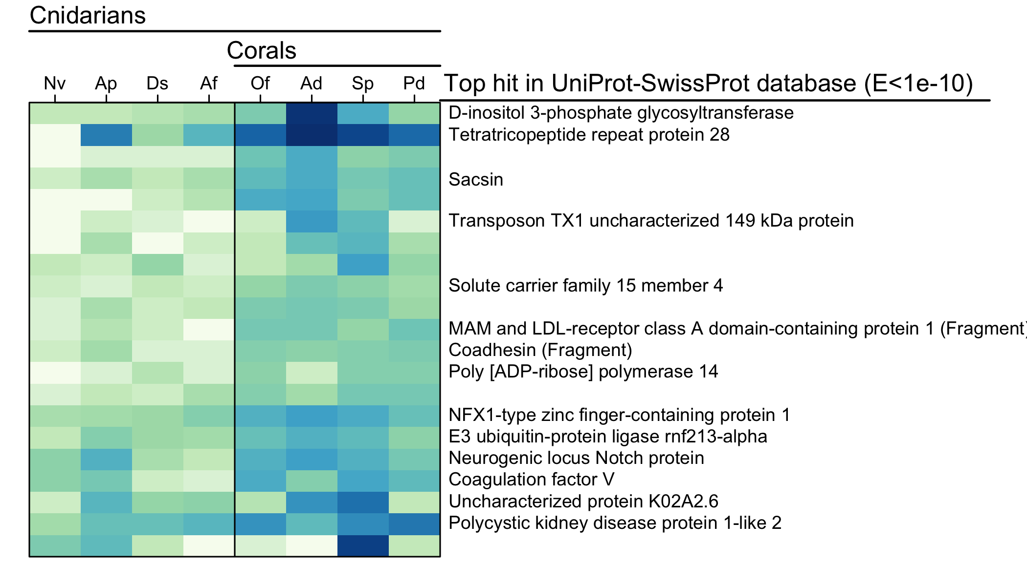

## Coral species-specific gene family expansions

The number of gene families in all corals decreased exponentially as gene family size increased, consistent with patterns of gene family size in other organisms (M. A. Huynen and Nimwegen 1998) (Fig. 5). *P. damicornis* had smaller gene families overall, and the fewest large gene families (n=3 with size>32, max size=75). The most large gene families were observed in *A. digitifera* (n=25 with size>32, max size=255), consistent with the comparative analysis of *A. digitifera* and *S. pistillata* performed by (Voolstra et al. 2017). However, statistical comparison of gene family sizes across the four coral species, which accounts for differences in total genome size, indicated that *S. pistillata* had the most significantly expanded gene families relative to other corals (n=15), followed by *A. digitifera* (n=10). *O. faveolata* only had one gene family that was significantly expanded, while *P. damicornis* had none.

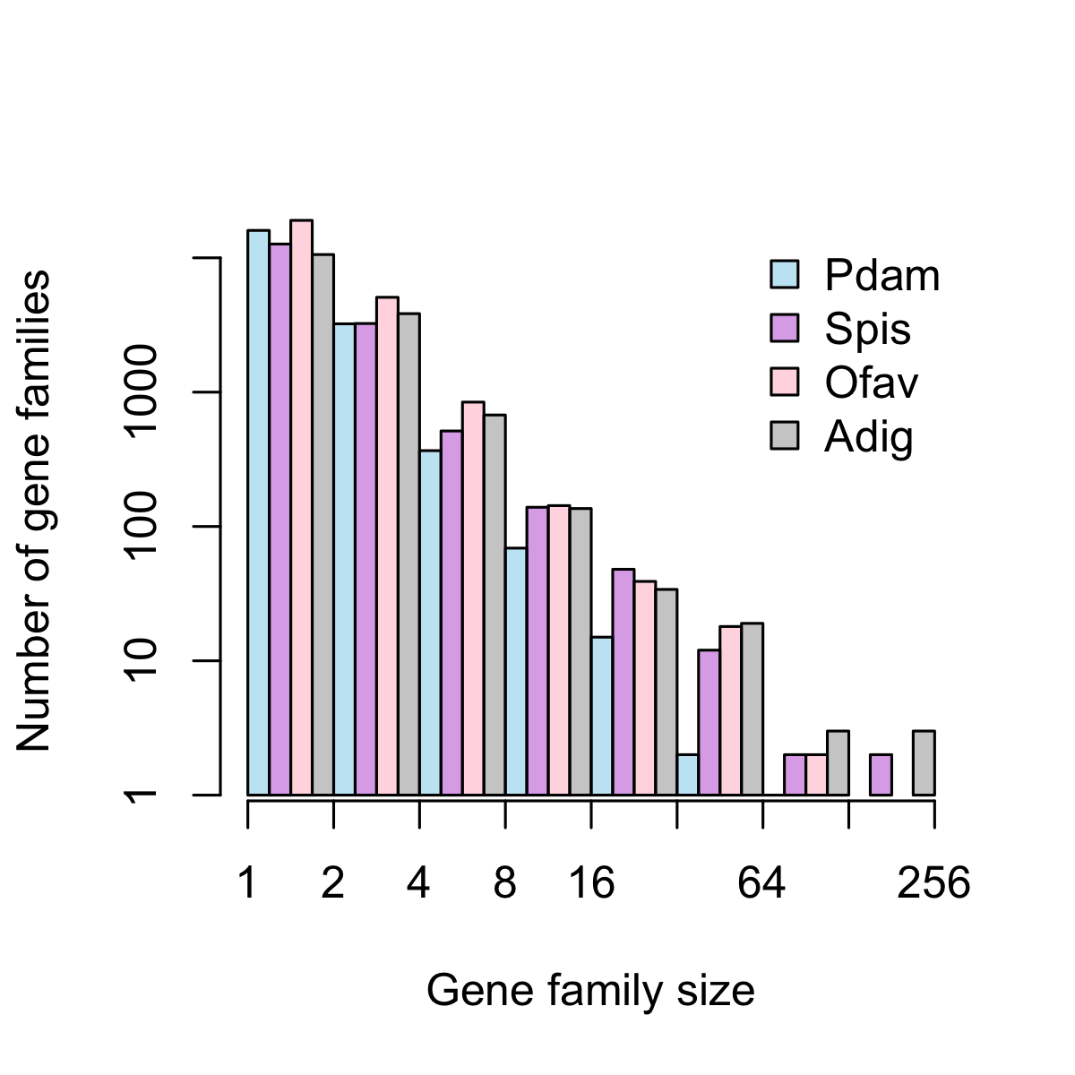

Gene family size distribution in four coral genomes. Pdam=P. damicornis, Spis=S. pistillata, Ofav=O. faveolata, Adig=A. digitifera. Bars represent the total number of gene families in a given size class using exponential binning, with each interval open on the left (i.e., the first interval contains gene families of size 1, the second interval contains gene families of size 2 and 3, etc.).

Lineage-specific gene family expansion may represent an important mechanism of molecular evolution driving adaptation, or may reflect the presence of 'genomic parasites' that propagate across the genome (P. Schiffer et al. 2016). We did find several inflated gene families with transposase or reverse transcriptase domains, suggesting they may be transposable elements. However, several other inflated gene families had putative functional roles in interactions with the environment, including in signaling and immunity (Table S1). In *A. digitifera*, the largest expanded gene family was similar to NOD-like receptors (NLRs), which are cytoplasmic pattern recognition receptors that play a key role in pathogen detection and immune activation (Kanneganti, Lamkanfi, and Núñez 2007). Characterized by the presence of NACHT domains, NLR genes have been found to be highly diversified, yet highly variable in number, in the genomes of different cnidarians (Hamada et al. 2013) and other species (P. Schiffer et al. 2016). The lineage-specific expansion of this family in *A. digitifera* is consistent with these observations, and may represent adaptation to a new pathogen environment (Stein et al. 2007), or to species-specific symbiotic interactions with a range of microbial eukaryotes and prokaryotes (Mydlarz et al. 2016). Another expanded gene family in *A. digitifera* was similar to ephrin-like receptors, which may mediate signaling cascades and cell-cell communication (Kullander and Klein 2002). In *S. pistillata*, one expanded gene family was similar to tachylectin-2, a pattern recognition receptor that has been identified in many Cnidarians (Mydlarz et al. 2016). In the coral *Oculina*, a tachylectin-2 homolog was found to be under selection, providing more evidence that such genes are involved in adaptive evolution (Hayes, Eytan, and Hellberg 2010). The one significantly expanded gene family in *O. faveolata* did not have a strong hit in the SwissProt database, but did contain a caspase-like domain, suggesting a role in apoptotic signaling. ECM/skeletal organic matrix associated proteins, including CUB-domain containing protein expanded in *A. digitifera*, and collagen-like protein in *S. pistillata*.

## *P. damicornis*-specific genes

Although the *P. damicornis* genome did not contain any gene families that were significantly expanded relative to the other corals, it did contain numerous genes (n=6966) for which no orthologs were found in other genomes. These *P. damicornis*-specific genes were significantly enriched for 11 GO terms. The most significantly enriched GO terms in the Pdam-specific genes were G-protein coupled receptor signaling pathway, bioluminescence, activation of NF-kappaB-inducing kinase, positive regulation of JNK cascade, and signal transduction. This again suggests major roles for immunity.

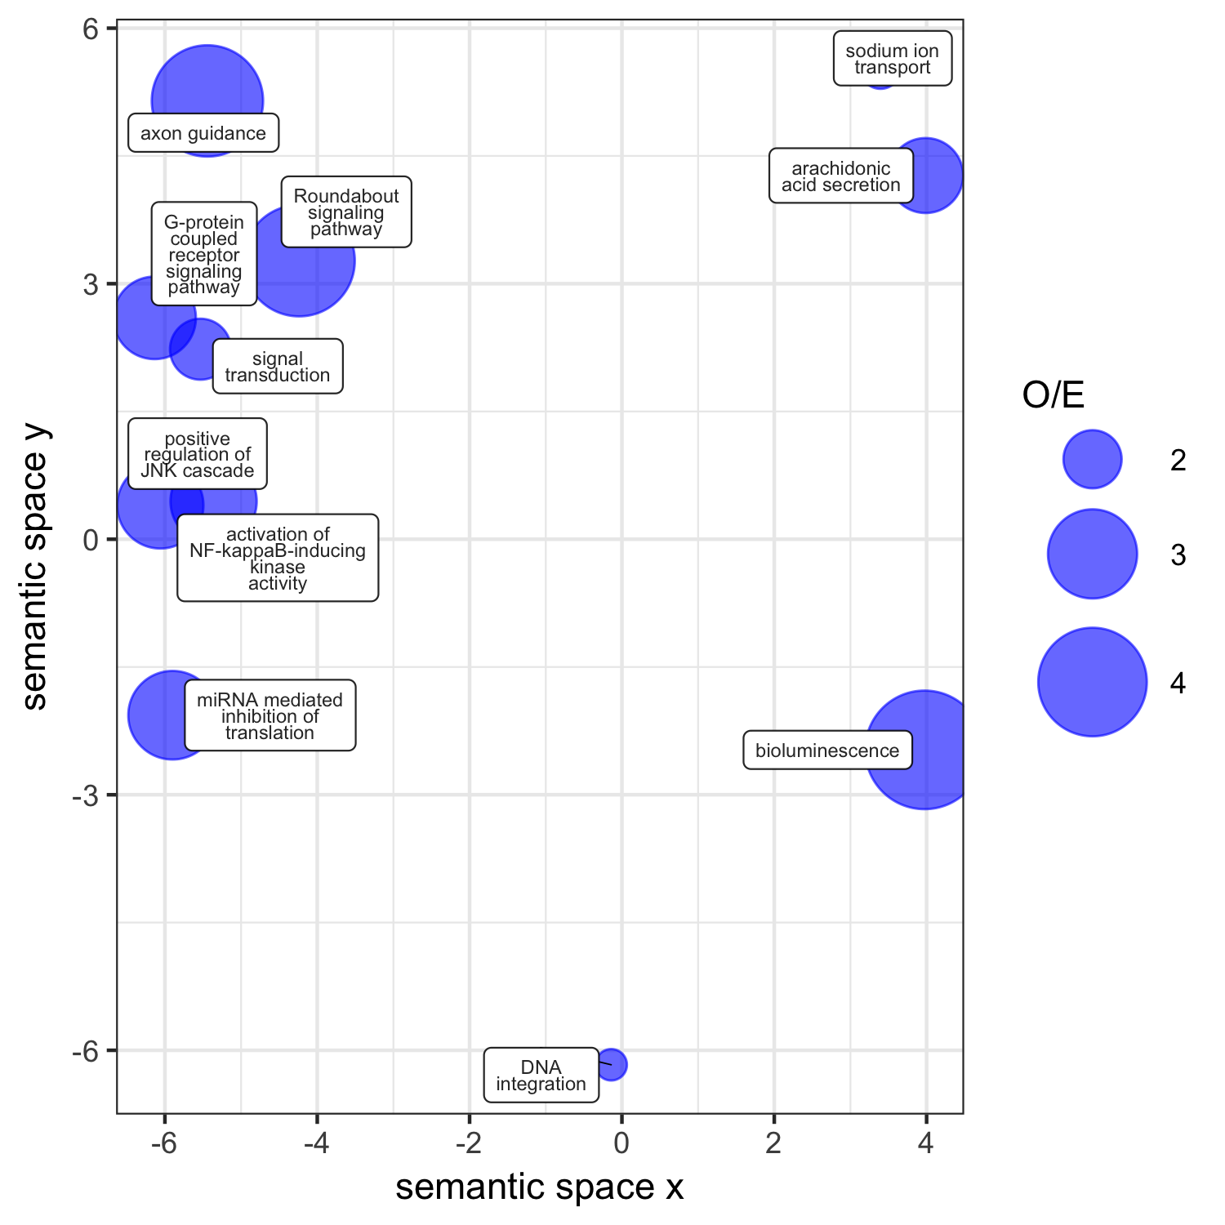

Functional profile of the gene families only found in P. damicornis. Significantly enriched GO terms (p < 0.05) within this gene set were visualized in semantic space by REVIGO. Point size is scaled to the ratio of observed to expected (O/E) occurrences of each GO term in the coral core gene set.

## Conclusions

•Overall, through this comparative genomic analysis of cnidarian genomes, we identified that the most prominent features of gene diversification in corals is with immune-related functionality. This is not surprising, given that immune pathways govern both the interactions with the environment, with pathogens, and with symbiotic microbial eukaryotes and prokaryotes. Indeed, the factors placing high selection pressure on corals, and which are responsible for most coral mortality worldwide, are bleaching and disease, both of which involve dysfunction of the immune system.

•Together, these genes that were found in all four coral genomes but none of the others analyzed reveal unique evolutionary adaptations in corals. The putative functional roles of these gene families in innate immunity emphasizes the critical role of immune functionality in corals, which likely mediate their symbiotic interactions with *Symbiodinium*, and their ability to deal with both pathogens and environmental stress.

•These gene families, diversified in corals relative to other cnidarians, reveal additional features of the unique evolutionary history of corals, and reveal that significant expansion of genes relating to immunity and biomineralization are important.

•"The functional categories most prone to lineage-specific expansion are structural proteins, enzymes involved in an organism's response to pathogens and environmental stress, and various components of signaling pathways" (Lespinet et al. 2002). These results are consistent with this generalization, and indicate that different coral species have evolved unique species-specific ways of adapting immune pathways to response to niche-specific selection pressures.

•Overall, extraordinary diversification of innate immune repertoire in corals. Some appear to be shared among corals, potentially evolving in a common ancestor, while others are species-specific, indicating corals are continuing to evolve novel immune-related functionality. Clearly, immune functionality is extremely important in corals, as it may regulate their symbiotic interactions with Symbiodinium (including symbiosis establishment and breakdown in response to stress), as well as their ability to resist pathogen invasion.

# Acknowledgements

# References

Ait-Oufella, Hafid, Kiyoka Kinugawa, Joffrey Zoll, Tabassome Simon, Jacques Boddaert, Silvia Heeneman, Olivier Blanc-Brude, et al. 2007. “Lactadherin deficiency leads to apoptotic cell accumulation and accelerated atherosclerosis in mice.” *Circulation* 115 (16): 2168–77. doi:[10.1161/CIRCULATIONAHA.106.662080](https://doi.org/10.1161/CIRCULATIONAHA.106.662080).

Alexa, Adrian, and Jorg Rahnenfuhrer. 2016. “topGO: Enrichment Analysis for Gene Ontology. R package version 2.24.0.”

Altschul, Stephen F, Warren Gish, Webb Miller, Eugene W Myers, and David J Lipman. 1990. “Basic local alignment search tool. - PubMed - NCBI.” *J. Mol. Biol.* 215 (3). National Center for Biotechnology Information, National Library of Medicine, National Institutes of Health, Bethesda, MD 20894.: 403–10. [http://linkinghub.elsevier.com/retrieve/pii/S0022283605803602 papers3://publication/uuid/ABAD235C-2FD6-4AD7-8E80-8A6AA4054634](http://linkinghub.elsevier.com/retrieve/pii/S0022283605803602%20papers3://publication/uuid/ABAD235C-2FD6-4AD7-8E80-8A6AA4054634).

Anderson, David A, Marcus E Walz, Ernesto Weil, Peter Tonellato, and Matthew C Smith. 2016. “RNA-Seq of the Caribbean reef-building coral Orbicella faveolata (Scleractinia-Merulinidae) under bleaching and disease stress expands models of coral innate immunity.” *PeerJ* 4 (1). PeerJ Inc.: e1616. [https://peerj.com/articles/1616 papers3://publication/doi/10.7717/peerj.1616](https://peerj.com/articles/1616%20papers3://publication/doi/10.7717/peerj.1616).

Aranda, M, Y Li, Y J Liew, S Baumgarten, O Simakov, M C Wilson, J Piel, et al. 2016. “Genomes of coral dinoflagellate symbionts highlight evolutionary adaptations conducive to a symbiotic lifestyle.” *Sci. Rep.* 6 (December). Nature Publishing Group: 39734. [http://www.nature.com/srep/2016/161222/srep39734/full/srep39734.html papers3://publication/doi/10.1038/srep39734](http://www.nature.com/srep/2016/161222/srep39734/full/srep39734.html%20papers3://publication/doi/10.1038/srep39734).

Baumgarten, Sebastian, Oleg Simakov, Lisl Y Esherick, Yi Jin Liew, Erik M Lehnert, Craig T Michell, Yong Li, et al. 2015. “The genome of Aiptasia, a sea anemone model for coral symbiosis.” *PNAS*, August. National Acad Sciences, 201513318–62. [http://www.pnas.org/lookup/doi/10.1073/pnas.1513318112 papers3://publication/doi/10.1073/pnas.1513318112](http://www.pnas.org/lookup/doi/10.1073/pnas.1513318112%20papers3://publication/doi/10.1073/pnas.1513318112).

Bay, Rachael A, Noah H Rose, Cheryl A Logan, and Stephen R Palumbi. 2017. “Genomic models predict successful coral adaptation if future ocean warming rates are reduced,” 1–10. doi:[10.1126/sciadv.1701413](https://doi.org/10.1126/sciadv.1701413).

Bhattacharya, Debashish, Shobhit Agrawal, Manuel Aranda, Sebastian Baumgarten, Mahdi Belcaid, Jeana L Drake, Douglas Erwin, et al. 2016. “Comparative genomics explains the evolutionary success of reef-forming corals.” *Elife* 5 (May). Department of Ecology, Evolution; Natural Resources, Rutgers University, New Brunswick, United States.: eLife Sciences Publications Limited: e13288. [http://elifesciences.org/lookup/doi/10.7554/eLife.13288 papers3://publication/doi/10.7554/eLife.13288](http://elifesciences.org/lookup/doi/10.7554/eLife.13288%20papers3://publication/doi/10.7554/eLife.13288).

Campbell, Michael S, Carson Holt, Barry Moore, and Mark Yandell. 2014. “Genome Annotation and Curation Using MAKER and MAKER-P.” *Curr. Protoc. Bioinforma.* 48 (December). Eccles Institute of Human Genetics, University of Utah, Salt Lake City, Utah.: John Wiley & Sons, Inc.: 4.11.1–39. [http://doi.wiley.com/10.1002/0471250953.bi0411s48 papers3://publication/doi/10.1002/0471250953.bi0411s48](http://doi.wiley.com/10.1002/0471250953.bi0411s48%20papers3://publication/doi/10.1002/0471250953.bi0411s48).

Chapman, Jarrod a, Ewen F Kirkness, Oleg Simakov, Steven E Hampson, Therese Mitros, Thomas Weinmaier, Thomas Rattei, et al. 2010. “The dynamic genome of Hydra.” *Nature* 464 (7288): 592–6. doi:[10.1038/nature08830](https://doi.org/10.1038/nature08830).

Combosch, David J, and Steven V Vollmer. 2011. “Population Genetics of an Ecosystem-Defining Reef Coral Pocillopora damicornis in the Tropical Eastern Pacific.” *PLoS One* 6 (8). Public Library of Science: e21200. [http://dx.plos.org/10.1371/journal.pone.0021200.pdf papers3://publication/uuid/92329624-4E44-4C01-820E-28A202FF2C7F](http://dx.plos.org/10.1371/journal.pone.0021200.pdf%20papers3://publication/uuid/92329624-4E44-4C01-820E-28A202FF2C7F).

Costanza, R, R de Groot, and P Sutton. 2014. “Changes in the global value of ecosystem services.” *Glob. Environ. Chang.* 26 (January): 152–58. [http://linkinghub.elsevier.com/retrieve/pii/S0959378014000685 papers3://publication/doi/10.1016/j.gloenvcha.2014.04.002](http://linkinghub.elsevier.com/retrieve/pii/S0959378014000685%20papers3://publication/doi/10.1016/j.gloenvcha.2014.04.002).

Cunning, Ross, and Andrew C Baker. 2013. “Excess algal symbionts increase the susceptibility of reef corals to bleaching.” *Nat. Clim. Chang.* 3 (3). Nature Publishing Group: 259–62. doi:[10.1038/nclimate1711](https://doi.org/10.1038/nclimate1711).

DeSalvo, Michael K, Christian R Voolstra, S Sunagawa, Jodi A Schwarz, Jonathon H Stillman, Mary Alice Coffroth, Alina M Szmant, and Monica Medina. 2008. “Differential gene expression during thermal stress and bleaching in the Caribbean coral Montastraea faveolata.” *Mol. Ecol.* 17 (17). Univ Calif, Sch Nat Sci, Merced, CA 95344 USA: 3952–71. [http://www3.interscience.wiley.com/journal/120848380/abstract papers3://publication/doi/10.1111/j.1365-294X.2008.03879.x](http://www3.interscience.wiley.com/journal/120848380/abstract%20papers3://publication/doi/10.1111/j.1365-294X.2008.03879.x).

Dixon, Groves B, Sarah W Davies, Galina V Aglyamova, Eli Meyer, Line K Bay, and Mikhail V Matz. 2015. “Genomic determinants of coral heat tolerance across latitudes.” *Science (80-. ).* 348 (6242). Department of Integrative Biology, University of Texas at Austin, 205 W. 24th Street C0990, Austin, TX 78712, USA.: American Association for the Advancement of Science: 1460–2. doi:[10.1126/science.1261224](https://doi.org/10.1126/science.1261224).

DuBuc, Timothy Q, Nikki Traylor-Knowles, Mark Q Martindale, GC Gurtner, S Werner, Y Barrandon, MT Longaker, et al. 2014. “Initiating a regenerative response; cellular and molecular features of wound healing in the cnidarian Nematostella vectensis.” *BMC Biol.* 12 (1): 24. doi:[10.1186/1741-7007-12-24](https://doi.org/10.1186/1741-7007-12-24).

Festa, Richard A, and Dennis J Thiele. 2011. “Copper: an Essential Metal in Biology.” *Curr. Biol.* 21: R877–R883. doi:[10.1016/j.cub.2011.09.040](https://doi.org/10.1016/j.cub.2011.09.040).

Finn, Robert D, Teresa K Attwood, Patricia C Babbitt, Alex Bateman, Peer Bork, Alan J Bridge, Hsin-Yu Chang, et al. 2017. “InterPro in 2017—beyond protein family and domain annotations.” *Nucleic Acids Res.* 45 (D1). Oxford University Press: D190–D199. [https://academic.oup.com/nar/article-lookup/doi/10.1093/nar/gkw1107 papers3://publication/doi/10.1093/nar/gkw1107](https://academic.oup.com/nar/article-lookup/doi/10.1093/nar/gkw1107%20papers3://publication/doi/10.1093/nar/gkw1107).

Fukami, H, Chaolun Allen Chen, A F Budd, A Collins, C C Wallace, Y-Y Chuang, Chienhsun Chen, et al. 2008. “Mitochondrial and nuclear genes suggest that stony corals are monophyletic but most families of stony corals are not (Order Scleractinia, Class anthozoa, phylum cnidaria).” *PLoS One* 3 (9). Public Library of Science. [http://www.scopus.com/scopus/record/display.url?fedsrfIntegrator=MEKPAPERS-SCOCIT{\&}origin=fedsrf{\&}view=basic{\&}eid=2-s2.0-52449129525 papers3://publication/uuid/73BB683C-0C57-45F2-B783-EA0E9877D7AD](http://www.scopus.com/scopus/record/display.url?fedsrfIntegrator=MEKPAPERS-SCOCIT%7b\&%7dorigin=fedsrf%7b\&%7dview=basic%7b\&%7deid=2-s2.0-52449129525%20papers3://publication/uuid/73BB683C-0C57-45F2-B783-EA0E9877D7AD).

Glynn, Peter W, Juan L Maté, Andrew C Baker, and M O Calderón. 2001. “Coral bleaching and mortality in Panama and Ecuador during the 1997-1998 El Ni{ñ}o-Southern Oscillation event: Spatial/temporal patterns and comparisons with the 1982-1983 event.” *Bull. Mar. Sci.* 69 (1): 79–109.

González-Guerrero, Manuel, Viviana Escudero, Ángela Saéz, and Manuel Tejada-Jiménez. 2016. “Transition Metal Transport in Plants and Associated Endosymbionts: Arbuscular Mycorrhizal Fungi and Rhizobia.” *Front. Plant Sci.* 7 (July): 1–21. doi:[10.3389/fpls.2016.01088](https://doi.org/10.3389/fpls.2016.01088).

Hall, B., T. DeRego, and S. Geib. 2014. “GAG: the Genome Annotation Generator.” [http://genomeannotation.github.io/GAG papers3://publication/uuid/06EC7449-9A15-413F-B86E-005B3D486650](http://genomeannotation.github.io/GAG%20papers3://publication/uuid/06EC7449-9A15-413F-B86E-005B3D486650).

Hamada, Mayuko, Eiichi Shoguchi, Chuya Shinzato, Takeshi Kawashima, David J. Miller, and Nori Satoh. 2013. “The complex NOD-like receptor repertoire of the coral acropora digitifera includes novel domain combinations.” *Mol. Biol. Evol.* 30 (1): 167–76. doi:[10.1093/molbev/mss213](https://doi.org/10.1093/molbev/mss213).

Hatada, Eunice N, Daniel Krappmann, and Claus Scheidereit. 2000. “NF-kB and the innate immune response.” *Curr. Opin. Immunol.* 12: 52–58.

Hayes, Marshall L., Ron I. Eytan, and Michael E. Hellberg. 2010. “High amino acid diversity and positive selection at a putative coral immunity gene (tachylectin-2).” *BMC Evol. Biol.* 10 (1). doi:[10.1186/1471-2148-10-150](https://doi.org/10.1186/1471-2148-10-150).

Huynen, M. A., and E. van Nimwegen. 1998. “The frequency distribution of gene family sizes in complete genomes.” *Mol. Biol. Evol.* 15 (5): 583–89. doi:[10.1093/oxfordjournals.molbev.a025959](https://doi.org/10.1093/oxfordjournals.molbev.a025959).

Iwata, Hiroshi, Claudia Goettsch, Amitabh Sharma, Piero Ricchiuto, Wilson Wen Bin Goh, Arda Halu, Iwao Yamada, et al. 2016. “PARP9 and PARP14 cross-regulate macrophage activation via STAT1 ADP-ribosylation.” *Nat. Commun.* 7. doi:[10.1038/ncomms12849](https://doi.org/10.1038/ncomms12849).

Johnston, Erika C., Zac H. Forsman, Jean-François Flot, Sebastian Schmidt-Roach, Jorge H. Pinzón, Ingrid S. S. Knapp, and Robert J. Toonen. 2017. “A genomic glance through the fog of plasticity and diversification in Pocillopora.” *Sci. Rep.* 7 (1): 5991. doi:[10.1038/s41598-017-06085-3](https://doi.org/10.1038/s41598-017-06085-3).

Jokiel, P L, and S L Coles. 1977. “Effects of temperature on the mortality and growth of Hawaiian reef corals.” *Mar. Biol.* 43 (3). Springer Science $∖$ mathplus Business Media: 201–8. doi:[10.1007/bf00402312](https://doi.org/10.1007/bf00402312).

Jones, Philip, David Binns, Hsin Yu Chang, Matthew Fraser, Weizhong Li, Craig McAnulla, Hamish McWilliam, et al. 2014. “InterProScan 5: Genome-scale protein function classification.” *Bioinformatics* 30 (9): 1236–40. doi:[10.1093/bioinformatics/btu031](https://doi.org/10.1093/bioinformatics/btu031).

Kanneganti, Thirumala Devi, Mohamed Lamkanfi, and Gabriel Núñez. 2007. “Intracellular NOD-like Receptors in Host Defense and Disease.” *Immunity* 27 (4): 549–59. doi:[10.1016/j.immuni.2007.10.002](https://doi.org/10.1016/j.immuni.2007.10.002).

Kleypas, Joan A, Robert W Buddemeier, D Archer, Jean-Pierre Gattuso, Chris Langdon, and B N Opdyke. 1999. “Geochemical consequences of increased atmospheric carbon dioxide on coral reefs.” *Science (80-. ).* 284 (5411). American Association for the Advancement of Science: 118–20. [http://www.scopus.com/inward/record.url?partnerID=yv4JPVwI{\&}eid=2-s2.0-0033515744{\&}md5=b8c037c7a3c204e96489f57f1a96fc1f papers3://publication/uuid/0D610CB2-D4D7-4B62-9738-1B7E86C80E04](http://www.scopus.com/inward/record.url?partnerID=yv4JPVwI%7b\&%7deid=2-s2.0-0033515744%7b\&%7dmd5=b8c037c7a3c204e96489f57f1a96fc1f%20papers3://publication/uuid/0D610CB2-D4D7-4B62-9738-1B7E86C80E04).

Knowlton, Nancy, Russell E. Brainard, Rebecca Fisher, Megan Moews, Laetitia Plaisance, and M. Julian Caley. 2010. “Coral Reef Biodiversity.” *Life World’s Ocean. Divers. Distrib. Abundance*, 65–78. doi:[10.1002/9781444325508.ch4](https://doi.org/10.1002/9781444325508.ch4).

Korf, Ian. 2004. “Gene finding in novel genomes.” *BMC Bioinformatics* 5: 59. doi:[10.1186/1471-2105-5-59](https://doi.org/10.1186/1471-2105-5-59).

Kullander, Klas, and Rüdiger Klein. 2002. “Mechanisms and functions of Eph and ephrin signalling.” *Nat. Rev. Mol. Cell Biol.* 3 (7): 475–86. doi:[10.1038/nrm856](https://doi.org/10.1038/nrm856).

Lespinet, Olivier, Yuri I. Wolf, Eugene V. Koonin, and L. Aravind. 2002. “The role of lineage-specific gene family expansion in the evolution of eukaryotes.” *Genome Res.* 12 (7): 1048–59. doi:[10.1101/gr.174302](https://doi.org/10.1101/gr.174302).

Mayfield, Anderson B, Yi-Jyun Chen, Chi-Yu Lu, and Chii-Shiarng Chen. 2017. “The proteomic response of the reef coral Pocillopora acuta to experimentally elevated temperatures.” *PeerJPreprints*. doi:[10.7287/peerj.preprints.3252v1](https://doi.org/10.7287/peerj.preprints.3252v1).

McGinley, M P, M D Aschaffenburg, D T Pettay, R T Smith, T C LaJeunesse, and M E Warner. 2012. “Symbiodinium spp. in colonies of eastern Pacific Pocillopora spp. are highly stable despite the prevalence of low-abundance background populations.” *Mar. Ecol. Prog. Ser.* 462 (August). Inter-Research Science Center: 1–7. doi:[10.3354/meps09914](https://doi.org/10.3354/meps09914).

Moya, Aurelie, Ella L. Howes, Thomas Lacoue-Labarthe, Sylvain Forêt, Bishoy Hanna, Mónica Medina, Philip L. Munday, et al. 2016. “Near-future pH conditions severely impact calcification, metabolism and the nervous system in the pteropod Heliconoides inflatus.” *Glob. Chang. Biol.* 22 (12): 3888–3900. doi:[10.1111/gcb.13350](https://doi.org/10.1111/gcb.13350).

Mydlarz, Laura D., Lauren Fuess, Whitney Mann, Jorge H. Pinzón, and Deborah J. Gochfeld. 2016. “Cnidarian Immunity: From Genomes to Phenomes.” In *Cnidaria, Past, Present Futur.*, edited by Stefano Goffredo and Zvy Dubinsky, 441–66. Cham: Springer International Publishing. doi:[10.1007/978-3-319-31305-4_28](https://doi.org/10.1007/978-3-319-31305-4_28).

Neubauer, Emilie F., Angela Z. Poole, Virginia M. Weis, and Simon K. Davy. 2016. “The scavenger receptor repertoire in six cnidarian species and its putative role in cnidarian-dinoflagellate symbiosis.” *PeerJ* 4: e2692. doi:[10.7717/peerj.2692](https://doi.org/10.7717/peerj.2692).

Oppen, Madeleine J H van, James K Oliver, Hollie M Putnam, and Ruth D Gates. 2015. “Building coral reef resilience through assisted evolution.” *Proc. Natl. Acad. Sci.* 112 (8). Proceedings of the National Academy of Sciences: 2307–13. doi:[10.1073/pnas.1422301112](https://doi.org/10.1073/pnas.1422301112).

Patel, Hemal H, and Paul A Insel. 2009. “Lipid rafts and caveolae and their role in compartmentation of redox signaling.” *Antioxid. Redox Signal.* 11 (6): 1357–72. doi:[10.1089/ars.2008.2365](https://doi.org/10.1089/ars.2008.2365).

Pinzón, Jorge H, and Todd C LaJeunesse. 2011. “Species delimitation of common reef corals in the genus Pocillopora using nucleotide sequence phylogenies, population genetics and symbiosis ecology.” *Mol. Ecol.* 20 (January): 311–25. [http://onlinelibrary.wiley.com/doi/10.1111/j.1365-294X.2010.04939.x/pdf papers3://publication/uuid/EA7906B2-73F3-42B0-8CF7-4012B89FC86C](http://onlinelibrary.wiley.com/doi/10.1111/j.1365-294X.2010.04939.x/pdf%20papers3://publication/uuid/EA7906B2-73F3-42B0-8CF7-4012B89FC86C).

Pinzón, Jorge H, Eugenia M Sampayo, Evelyn F Cox, Leonard J Chauka, Chaolun Allen Chen, Christian R Voolstra, and Todd C LaJeunesse. 2013. “Blind to morphology: genetics identifies several widespread ecologically common species and few endemics among Indo-Pacific cauliflower corals.” Edited by Christine Maggs. *J. Biogeogr.* 40 (8): 1–20. [http://doi.wiley.com/10.1111/jbi.12110 papers3://publication/doi/10.1111/jbi.12110](http://doi.wiley.com/10.1111/jbi.12110%20papers3://publication/doi/10.1111/jbi.12110).

Prada, Carlos, Bishoy Hanna, Ann F. Budd, Cheryl M. Woodley, Jeremy Schmutz, Jane Grimwood, Roberto Iglesias-Prieto, et al. 2016. “Empty Niches after Extinctions Increase Population Sizes of Modern Corals.” *Curr. Biol.* 26 (23): 3190–4. doi:[10.1016/j.cub.2016.09.039](https://doi.org/10.1016/j.cub.2016.09.039).

Putnam, Hollie M, Jennifer M Davidson, and Ruth D Gates. 2016. “Ocean acidification influences host DNA methylation and phenotypic plasticity in environmentally susceptible corals.” *Evol. Appl.* 9 (9): 1165–78. [http://onlinelibrary.wiley.com/doi/10.1111/eva.12408/full papers3://publication/doi/10.1111/eva.12408](http://onlinelibrary.wiley.com/doi/10.1111/eva.12408/full%20papers3://publication/doi/10.1111/eva.12408).

Putnam, Nicholas H, Brendan L O’Connell, Jonathan C Stites, Brandon J Rice, Marco Blanchette, Robert Calef, Christopher J Troll, et al. 2016. “Chromosome-scale shotgun assembly using an in vitro method for long-range linkage.” *Genome Res.* 26 (3). Dovetail Genomics LLC, Santa Cruz, California 95060, USA; Cold Spring Harbor Laboratory Press: 342–50. [http://genome.cshlp.org/lookup/doi/10.1101/gr.193474.115 papers3://publication/doi/10.1101/gr.193474.115](http://genome.cshlp.org/lookup/doi/10.1101/gr.193474.115%20papers3://publication/doi/10.1101/gr.193474.115).

Putnam, Nicholas H, Mansi Srivastava, Uffe Hellsten, Bill Dirks, Jarrod Chapman, Asaf Salamov, Astrid Terry, et al. 2007. “Sea anemone genome reveals ancestral eumetazoan gene repertoire and genomic organization.” *Science* 317 (5834): 86–94. doi:[10.1126/science.1139158](https://doi.org/10.1126/science.1139158).

Quistad, S D, and N Traylor-Knowles. 2016. “Precambrian origins of the TNFR superfamily.” *Cell Death Discov.* 2 (May). The Author(s): 16058. doi:[10.1038/cddiscovery.2016.58](https://doi.org/10.1038/cddiscovery.2016.58).

Quistad, Steven D., Aleksandr Stotland, Katie L. Barott, Cameron A. Smurthwaite, Brett Jameson Hilton, Juris A. Grasis, Roland Wolkowicz, and Forest L. Rohwer. 2014. “Evolution of TNF-induced apoptosis reveals 550 My of functional conservation.” *Proc. Natl. Acad. Sci.* 111 (26). National Acad Sciences: 9567–72. doi:[10.1073/pnas.1405912111](https://doi.org/10.1073/pnas.1405912111).

Ramos-Silva, Paula, Jaap Kaandorp, Lotte Huisman, Benjamin Marie, Isabelle Zanella-Cl??on, Nathalie Guichard, David J. Miller, and Fr??d??ric Marin. 2013. “The skeletal proteome of the coral acropora millepora: The evolution of calcification by co-option and domain shuffling.” *Mol. Biol. Evol.* 30 (9): 2099–2112. doi:[10.1093/molbev/mst109](https://doi.org/10.1093/molbev/mst109).

Ryan, J F, K Pang, C E Schnitzler, A D Nguyen, R T Moreland, D K Simmons, B J Koch, et al. 2013. “The genome of the ctenophore Mnemiopsis leidyi and its implications for cell type evolution.” *Science (80-. ).* 342 (6164): 1242592. doi:[10.1126/science.1242592](https://doi.org/10.1126/science.1242592).

Schapire, A. L., V. Valpuesta, and M. A. Botella. 2006. “TPR proteins in plant hormone signaling.” *Plant Signal. Behav.* 1 (5): 229–30.

Schiffer, Philipp, Jan Gravemeyer, Martina Rauscher, and Thomas Wiehe. 2016. “Ultra Large Gene Families: A Matter of Adaptation or Genomic Parasites?” *Life* 6 (3): 32. doi:[10.3390/life6030032](https://doi.org/10.3390/life6030032).

Schmidt-Roach, Sebastian, K J Miller, Petra Lundgren, and Nikos Andreakis. 2014. “With eyes wide open: a revision of species within and closely related to the Pocillopora damicornis species complex (Scleractinia; Pocilloporidae) using morphology ….” *Zool. J. Linn. Soc.*, January. [http://onlinelibrary.wiley.com/doi/10.1111/zoj.12092/full papers3://publication/uuid/FF435743-7FC4-4CB3-A64F-75A1885F1F1B](http://onlinelibrary.wiley.com/doi/10.1111/zoj.12092/full%20papers3://publication/uuid/FF435743-7FC4-4CB3-A64F-75A1885F1F1B).

Schmidt-Roach, Sebastian, Karen J Miller, Erika Woolsey, Gabriele Gerlach, and Andrew H Baird. 2012. “Broadcast Spawning by Pocillopora Species on the Great Barrier Reef.” *PLoS One* 7 (12). Public Library of Science: e50847. [http://www.plosone.org/article/info{\%}3Adoi{\%}2F10.1371{\%}2Fjournal.pone.0050847 papers3://publication/doi/10.1371/journal.pone.0050847](http://www.plosone.org/article/info%7b\%25%7d3Adoi%7b\%25%7d2F10.1371%7b\%25%7d2Fjournal.pone.0050847%20papers3://publication/doi/10.1371/journal.pone.0050847).

Shinzato, Chuya, Eiichi Shoguchi, Takeshi Kawashima, Mayuko Hamada, Kanako Hisata, Makiko Tanaka, Manabu Fujie, et al. 2011. “Using the Acropora digitifera genome to understand coral responses to environmental change.” *Nature* 476 (7360). Marine Genomics Unit, Okinawa Institute of Science; Technology Promotion Corporation, Onna, Okinawa 904-0412, Japan.: Nature Publishing Group: 320–23. [http://eutils.ncbi.nlm.nih.gov/entrez/eutils/elink.fcgi?dbfrom=pubmed{\&}id=21785439{\&}retmode=ref{\&}cmd=prlinks papers3://publication/doi/10.1038/nature10249](http://eutils.ncbi.nlm.nih.gov/entrez/eutils/elink.fcgi?dbfrom=pubmed%7b\&%7did=21785439%7b\&%7dretmode=ref%7b\&%7dcmd=prlinks%20papers3://publication/doi/10.1038/nature10249).

Shoguchi, Eiichi, Chuya Shinzato, Takeshi Kawashima, Fuki Gyoja, Sutada Mungpakdee, Ryo Koyanagi, Takeshi Takeuchi, et al. 2013. “Draft Assembly of the Symbiodinium minutum Nuclear Genome Reveals Dinoflagellate Gene Structure.” *Curr. Biol.* 23 (15). Elsevier: 1399–1408. [http://dx.doi.org/10.1016/j.cub.2013.05.062 papers3://publication/doi/10.1016/j.cub.2013.05.062](http://dx.doi.org/10.1016/j.cub.2013.05.062%20papers3://publication/doi/10.1016/j.cub.2013.05.062).

Simão, Felipe A, Robert M Waterhouse, Panagiotis Ioannidis, Evgenia V Kriventseva, and Evgeny M Zdobnov. 2015. “BUSCO: assessing genome assembly and annotation completeness with single-copy orthologs.” *Bioinformatics* 31 (19). Oxford University Press: 3210–2. [https://academic.oup.com/bioinformatics/article-lookup/doi/10.1093/bioinformatics/btv351 papers3://publication/doi/10.1093/bioinformatics/btv351](https://academic.oup.com/bioinformatics/article-lookup/doi/10.1093/bioinformatics/btv351%20papers3://publication/doi/10.1093/bioinformatics/btv351).

Snel, B, P Bork, and M a Huynen. 1999. “Genome phylogeny based on gene content.” *Nat. Genet.* 21 (1): 108–10. doi:[10.1038/5052](https://doi.org/10.1038/5052).

Srivastava, Mansi, Oleg Simakov, Jarrod Chapman, Bryony Fahey, Marie E A Gauthier, Therese Mitros, Gemma S Richards, et al. 2010. “The Amphimedon queenslandica genome and the evolution of animal complexity.” *Nature* 466 (7307). Nature Publishing Group: 720–26. doi:[10.1038/nature09201](https://doi.org/10.1038/nature09201).

Stanke, M, R Steinkamp, S Waack, and B Morgenstern. 2004. “AUGUSTUS: a web server for gene finding in eukaryotes.” *Nucleic Acids Res.* 32 (Web Server issue). University of Göttingen, Institut für Mikrobiologie und Genetik, Goldschmidtstrasse 1, 37077 Göttingen, Germany. mstanke@gwdg.de: Oxford University Press: W309–W312. [https://academic.oup.com/nar/article-lookup/doi/10.1093/nar/gkh379 papers3://publication/doi/10.1093/nar/gkh379](https://academic.oup.com/nar/article-lookup/doi/10.1093/nar/gkh379%20papers3://publication/doi/10.1093/nar/gkh379).

Stein, Cornelia, Mario Caccamo, Gavin Laird, and Maria Leptin. 2007. “Conservation and divergence of gene families encoding components of innate immune response systems in zebrafish.” *Genome Biol.* 8 (11): R251. doi:[10.1186/gb-2007-8-11-r251](https://doi.org/10.1186/gb-2007-8-11-r251).

Stoddart, J a. 1984. “Genetical structure within populations of the corals Pocillopora damicornis.” *Mar. Biol.* 81: 19–30.

Stoddart, J. A. 1983. “Asexual production of planulae in the coral Pocillopora damicornis.” *Mar. Biol.* 76 (3): 279–84. doi:[10.1007/BF00393029](https://doi.org/10.1007/BF00393029).

Supek, Fran, Matko Bošnjak, Nives Škunca, and Tomislav Šmuc. 2011. “Revigo summarizes and visualizes long lists of gene ontology terms.” *PLoS One* 6 (7). doi:[10.1371/journal.pone.0021800](https://doi.org/10.1371/journal.pone.0021800).

Takeuchi, Takeshi, Lixy Yamada, Chuya Shinzato, Hitoshi Sawada, and Noriyuki Satoh. 2016. “Stepwise evolution of coral biomineralization revealed with genome-wide proteomics and transcriptomics.” *PLoS One* 11 (6). doi:[10.1371/journal.pone.0156424](https://doi.org/10.1371/journal.pone.0156424).

The UniProt Consortium. 2017. “UniProt: the universal protein knowledgebase.” *Nucleic Acids Res.* 45 (D1). Oxford University Press: D158–D169. [https://academic.oup.com/nar/article-lookup/doi/10.1093/nar/gkw1099 papers3://publication/doi/10.1093/nar/gkw1099](https://academic.oup.com/nar/article-lookup/doi/10.1093/nar/gkw1099%20papers3://publication/doi/10.1093/nar/gkw1099).

Thomas, Luke, W. Jason Kennington, Richard D. Evans, Gary A. Kendrick, and Michael Stat. 2017. “Restricted gene flow and local adaptation highlight the vulnerability of high-latitude reefs to rapid environmental change.” *Glob. Chang. Biol.* 23 (6): 2197–2205. doi:[10.1111/gcb.13639](https://doi.org/10.1111/gcb.13639).

Voolstra, Christian R, Yong Li, Yi Jin Liew, and Sebastian Baumgarten. 2017. “Comparative analysis of the genomes of Stylophora pistillata and Acropora digitifera provides evidence for extensive differences between species of corals.”

Wang, Xin, Yi Jin Liew, Yong Li, Didier Zoccola, Sylvie Tambutte, and Manuel Aranda. 2017. “Draft genomes of the corallimorpharians Amplexidiscus fenestrafer and Discosoma sp.” *Mol. Ecol. Resour.* 2017 (March): doi: 10.1111/1755–0998.12680. doi:[10.1111/1755-0998.12680](https://doi.org/10.1111/1755-0998.12680).

Ward, S. 1992. “Evidence for broadcast spawning as well as brooding in the scleractinian coral Pocillopora damicornis.” *Mar. Biol.* 112 (4): 641–46. doi:[10.1007/BF00346182](https://doi.org/10.1007/BF00346182).

Weiss, Yvonne, Sylvain Forêt, David C. Hayward, Tracy Ainsworth, Rob King, Eldon E. Ball, and David J. Miller. 2013. “The acute transcriptional response of the coral Acropora millepora to immune challenge: Expression of GiMAP/IAN genes links the innate immune responses of corals with those of mammals and plants.” *BMC Genomics* 14 (1). doi:[10.1186/1471-2164-14-400](https://doi.org/10.1186/1471-2164-14-400).

Williams, Leah M., Lauren E. Fuess, Joseph J. Brennan, Katelyn M. Mansfield, Erick Salas-Rodriguez, Julianne Welsh, Jake Awtry, et al. 2017. “A conserved toll-like receptor-to-NF- $κ$ B signaling pathway in the endangered coral Orbicella faveolata.” *Dev. Comp. Immunol.* Elsevier Ltd. doi:[10.1016/j.dci.2017.10.016](https://doi.org/10.1016/j.dci.2017.10.016).