My homework

John Doe

June 15, 2015

## STAT LEARNING 2  
## HOMEWORK 4, Problem 5

# Read in necessary libraries  
library(ggplot2)  
library(magrittr)  
library(R.matlab)  
library(geometry)  
library(dplyr)  
  
  
# Set the working directory  
setwd("C:/Users/jrdha/OneDrive/Desktop/USU_Fa2018/Moon__SLDM2/hw4/Problem5")  
  
  
# This function kicks off the recursive subGradient function.  
# It takes as arguments: max_Iter (max number of iterations), predictors  
# (dataframe of input features), response (dataframe containing values of  
# responses), lambda (used for calculation of regularization term).  
# The function returns optimized theta vector (weights, b).  
initSubGradient <- function(max_Iter, predictors, response, lambda){  
 b = 1  
 ws = rep(0, ncol(predictors) - 1)  
 inittheta <- c(b, ws)  
   
 # Dataframe to store info from iterations  
 iteration_Info <- data.frame(numItr = double(0), objFun = double(0),   
 w1 = double(0), w2 = double(0), b = double(0))  
   
 # call subGradient function  
 theta <- subGradient(theta = inittheta, num_Iter = 1, max_Iter = max_Iter,   
 xs = predictors, y = response,  
 lambda = lambda, iteration_Info = iteration_Info)  
 return(theta)  
}  
  
  
# This function (recursively) performs the calculations to determine optimal value  
# of theta or calls itself again.  
# the initSubGradient function.  
# Takes as arguments: theta (vector of weights and b), num_Iter and max_Iter (are  
# self-explanatory), xs (dataframe containing input data), y (dataframe containing  
# response data), lambda (regularization parameter), iteration_Info (dataframe  
# that stores parameter estimates and value of objective function).  
subGradient <- function(theta, num_Iter, max_Iter, xs, y, lambda, iteration_Info){  
   
 # Alpha is the step size, n is the number of instances in preds  
 alpha <- 100/num_Iter  
 n <- nrow(preds)  
   
 # Either retunr optimized theta and iteration info, or keep going  
 if(num_Iter > max_Iter){  
 return(list("theta" = theta, "iteration_Info" = iteration_Info))  
 } else {  
 print(paste("Iteration: ", num_Iter))  
   
 u <- double(length(theta))  
 for(i in 1:nrow(xs)){  
 # calculate gradient  
 grad <- calcGrad(b = theta[1], w = theta[2:length(theta)],   
 yi = as.numeric(y$Y[i]), xi = as.numeric(xs[i,]),   
 n = n, lambda = lambda)  
 # Update u  
 u <- u + grad  
 }  
   
 # Having calculated gradient, take a step in the opposite direction  
 theta.1 <- theta - (alpha * u)  
   
 # calculate value of objective function  
 objFctn_val <- calc_objFctn(preds = xs, resp = y, theta = theta.1, lambda = lambda)  
   
 # This row will be added to the bottom of the iteration_Info dataframe  
 hnew <- data.frame(numItr = num_Iter, objFun = objFctn_val, b = theta.1[1],   
 w1 = theta.1[2], w2 = theta.1[3])  
   
 iteration_Info <- rbind(iteration_Info, hnew)  
 num_Iter <- num_Iter + 1  
   
 return(subGradient(theta = theta.1, num_Iter = num_Iter, max_Iter = max_Iter,   
 xs = xs, y = y, lambda = lambda, iteration_Info = iteration_Info))  
 }  
}  
  
  
# This function kicks of the recursive stochSubGradient function.  
# It takes as arguments: max_Iter, predictors, response, and lambda (we've seen  
# all of these before, so I won't re-explain what they are).  
# It returns the optimal value of the theta vector.  
initStochSubGradient <- function(max_Iter, predictors, response, lambda){  
   
 # Initial guesses for theta (b and the weights)  
 b = 1  
 ws = rep(0, ncol(predictors) - 1)   
 inittheta <- c(b, ws)  
   
 # Initialize the iteration_Info data frame  
 iteration_Info <- data.frame(numItr = double(0), objFun = double(0),   
 w1 = double(0), w2 = double(0), b = double(0))  
   
 # Recursion of stochSubGradient() begins  
 theta <- stochSubGradient(theta = inittheta, num_Iter = 1, max_Iter = max_Iter,   
 xs = predictors, y = response,  
 lambda = lambda, iteration_Info = iteration_Info)  
 return(theta)  
}  
  
  
# This recursive function calls the subGradient function.   
# Takes as arguments all the things we know and love: theta vector, num_Iter,  
# max_Iter, xs, y, lambda, and iteration_Info dataframe.  
# This function either returns the optimal value of theta, or calls itself again  
# depending on how many iterations have taken place.  
stochSubGradient <- function(theta, num_Iter, max_Iter, xs, y, lambda, iteration_Info){  
   
 # Set the step size, how many predictor instances there are, and recommended  
 # minibatch size  
 alpha <- 100/num_Iter  
 n <- nrow(preds)  
 m <- 1  
   
 # The use of the sample() function below will be how we randomly sample  
 if(num_Iter > max_Iter){  
 return(list("theta" = theta, "iteration_Info" = iteration_Info))  
 } else {  
 print(paste("Iteration Number: ", num_Iter))  
 index <- 1:n  
 rand.index <- sample(index, n)  
 for(i in rand.index){  
 grad <- calcGrad(b = theta[1], w = theta[2:length(theta)],  
 yi = as.numeric(y$Y[i]), xi = as.numeric(xs[i,]),  
 n = 1, lambda = lambda)  
 theta <- theta - (alpha * grad) # Move in opposite direction of subGrad  
 # to update theta.  
 }  
 theta.1 <- theta  
   
 # Calculate the (current) value of the objective function.  
 objFctn_val <- calc_objFctn(preds = xs, resp = y, theta = theta.1, lambda = lambda)  
   
 # This row will be added to the bottom of the iteration_Info dataframe  
 hnew <- data.frame(numItr = num_Iter, objFun = objFctn_val, b = theta.1[1],   
 w1 = theta.1[2], w2 = theta.1[3])  
   
 iteration_Info <- rbind(iteration_Info, hnew)  
 num_Iter <- num_Iter + 1  
 return(subGradient(theta = theta.1, num_Iter = num_Iter, max_Iter = max_Iter, xs = xs, y = y, lambda = lambda, iteration_Info = iteration_Info))  
 }  
}  
  
  
# This function calculates the gradient.  
# Takes as arguments: w (weights vector), b (part of theta, intercept term),   
# yi (response), xi (vector containing predictor instance), n (num of instances),  
# lambda (same parameter for calculating regularization penalty term).  
# Returns the subGradient.  
calcGrad <- function(w, b, yi, xi, n, lambda){  
  
 wvec <- c(0, w)  
 term <- 1 - (yi * (dot(wvec, xi) + b))  
 if(term >= 0){  
 gradJi <- (1/n)*(-yi*xi) + (lambda/n)*wvec  
 } else {  
 gradJi <- (lambda/n)*wvec  
 }  
 sg <- (gradJi)  
 return(sg)  
}  
  
  
# Calculates the value of the objective function for given inputs.  
# Takes as arguments: preds (predictor data), resp (response value), theta (same  
# vector of weights and b), lambad (same regularization penalty parameter).  
calc_objFctn <- function(preds, resp, theta, lambda){  
  
 n <- nrow(preds)  
 b <- theta[1]  
 w <- theta[2:length(theta)]  
 wvec <- c(0, w)  
 val_Summation <- 0  
 for(i in 1:n){  
 yi = as.numeric(resp$Y[i])  
 xi = as.numeric(preds[i,])  
 m1 <- 0  
 m2 <- 1 - yi*(dot(wvec, xi) + b)  
 term <- max(m1, m2)  
 val_Summation <- val_Summation + term  
 }  
 val_objFctn <- 1/n * (val_Summation) + (lambda/2)*dot(w,w)  
 return(val_objFctn)  
}  
  
  
# This function plots the values of the objective functions against the iteration  
# number for that given value of J.  
# Takes as arguments the iteration_Info dataframe for plotting, and a title.  
# Output is the plot described above.  
plot_objFctn_vals <- function(iteration_Info, title){  
 plot(iteration_Info$numItr, iteration_Info$objFun, xlab = "Iteration Number",   
 ylab = "value of Objective Function J", type = 'o',  
 main = title)  
}  
  
  
#===============================================================================  
#== Implementing the defined functions to solve the given problem ==============  
#===============================================================================  
  
givenData <- R.matlab::readMat("nuclear.mat") %>% lapply(t) %>% lapply(as_tibble)  
colnames(givenData[[1]]) <- sprintf("X_%s",seq(1:ncol(givenData[[1]])))  
colnames(givenData[[2]]) <- c("Y")  
givenData <- bind_cols(givenData) %>% select(Y, everything())  
  
# givenData <- slice(givenData, 1:300)  
preds <- select(givenData, X_1, X_2)  
X0 <- rep(1, nrow(givenData))  
preds <- cbind(X0, preds)  
resp <- select(givenData, Y)  
resp$Y <- as.numeric(resp$Y)  
  
  
#=== Results of implementing subGradient method ================================  
  
# Seems to flatten out after about 35 iterations, chose a fairly small value of lambda.  
subGrad_results <- initSubGradient(max_Iter = 35, predictors = preds, response = resp, lambda = 0.001)

## [1] "Iteration: 1"  
## [1] "Iteration: 2"  
## [1] "Iteration: 3"  
## [1] "Iteration: 4"  
## [1] "Iteration: 5"  
## [1] "Iteration: 6"  
## [1] "Iteration: 7"  
## [1] "Iteration: 8"  
## [1] "Iteration: 9"  
## [1] "Iteration: 10"  
## [1] "Iteration: 11"  
## [1] "Iteration: 12"  
## [1] "Iteration: 13"  
## [1] "Iteration: 14"  
## [1] "Iteration: 15"  
## [1] "Iteration: 16"  
## [1] "Iteration: 17"  
## [1] "Iteration: 18"  
## [1] "Iteration: 19"  
## [1] "Iteration: 20"  
## [1] "Iteration: 21"  
## [1] "Iteration: 22"  
## [1] "Iteration: 23"  
## [1] "Iteration: 24"  
## [1] "Iteration: 25"  
## [1] "Iteration: 26"  
## [1] "Iteration: 27"  
## [1] "Iteration: 28"  
## [1] "Iteration: 29"  
## [1] "Iteration: 30"  
## [1] "Iteration: 31"  
## [1] "Iteration: 32"  
## [1] "Iteration: 33"  
## [1] "Iteration: 34"  
## [1] "Iteration: 35"

plot_objFctn_vals(subGrad_results$iteration_Info, title = "SubGradient Descent Method Results")

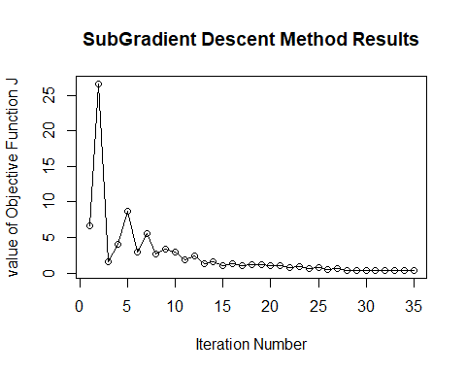

b <- subGrad_results$theta[1]  
w1 <- subGrad_results$theta[2]  
w2 <- subGrad_results$theta[3]  
  
slopeVal <- w1/-w2  
interceptVal <- b/-w2  
  
# Gets mad if not converted to the factor data type  
givenData$Y <- as.factor(givenData$Y)  
  
ggplot(data = givenData, aes(x = X_1, y = X_2, color = Y)) +   
 geom_point() +   
 scale_color_manual(values=c("-1" = "turquoise", "1" = "magenta")) +   
 geom_abline(slope = slopeVal, intercept = interceptVal, lwd = 1) +  
 xlab("Values of X1") +  
 ylab("Values of X2") +   
 ggtitle("Separation using SubGradient Method")

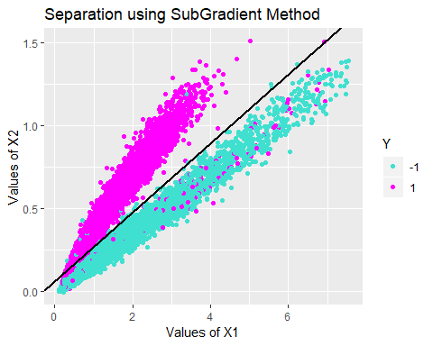

#=== Results of implementing stochSubGradient method ===========================  
# This one took a lot more iterations to converge as compared to subGradient method.  
stoch_subGrad_results <- initStochSubGradient(max_Iter = 100, predictors = preds,   
 response = resp, lambda = 0.001)

## [1] "Iteration Number: 1"  
## [1] "Iteration: 2"  
## [1] "Iteration: 3"  
## [1] "Iteration: 4"  
## [1] "Iteration: 5"  
## [1] "Iteration: 6"  
## [1] "Iteration: 7"  
## [1] "Iteration: 8"  
## [1] "Iteration: 9"  
## [1] "Iteration: 10"  
## [1] "Iteration: 11"  
## [1] "Iteration: 12"  
## [1] "Iteration: 13"  
## [1] "Iteration: 14"  
## [1] "Iteration: 15"  
## [1] "Iteration: 16"  
## [1] "Iteration: 17"  
## [1] "Iteration: 18"  
## [1] "Iteration: 19"  
## [1] "Iteration: 20"  
## [1] "Iteration: 21"  
## [1] "Iteration: 22"  
## [1] "Iteration: 23"  
## [1] "Iteration: 24"  
## [1] "Iteration: 25"  
## [1] "Iteration: 26"  
## [1] "Iteration: 27"  
## [1] "Iteration: 28"  
## [1] "Iteration: 29"  
## [1] "Iteration: 30"  
## [1] "Iteration: 31"  
## [1] "Iteration: 32"  
## [1] "Iteration: 33"  
## [1] "Iteration: 34"  
## [1] "Iteration: 35"  
## [1] "Iteration: 36"  
## [1] "Iteration: 37"  
## [1] "Iteration: 38"  
## [1] "Iteration: 39"  
## [1] "Iteration: 40"  
## [1] "Iteration: 41"  
## [1] "Iteration: 42"  
## [1] "Iteration: 43"  
## [1] "Iteration: 44"  
## [1] "Iteration: 45"  
## [1] "Iteration: 46"  
## [1] "Iteration: 47"  
## [1] "Iteration: 48"  
## [1] "Iteration: 49"  
## [1] "Iteration: 50"  
## [1] "Iteration: 51"  
## [1] "Iteration: 52"  
## [1] "Iteration: 53"  
## [1] "Iteration: 54"  
## [1] "Iteration: 55"  
## [1] "Iteration: 56"  
## [1] "Iteration: 57"  
## [1] "Iteration: 58"  
## [1] "Iteration: 59"  
## [1] "Iteration: 60"  
## [1] "Iteration: 61"  
## [1] "Iteration: 62"  
## [1] "Iteration: 63"  
## [1] "Iteration: 64"  
## [1] "Iteration: 65"  
## [1] "Iteration: 66"  
## [1] "Iteration: 67"  
## [1] "Iteration: 68"  
## [1] "Iteration: 69"  
## [1] "Iteration: 70"  
## [1] "Iteration: 71"  
## [1] "Iteration: 72"  
## [1] "Iteration: 73"  
## [1] "Iteration: 74"  
## [1] "Iteration: 75"  
## [1] "Iteration: 76"  
## [1] "Iteration: 77"  
## [1] "Iteration: 78"  
## [1] "Iteration: 79"  
## [1] "Iteration: 80"  
## [1] "Iteration: 81"  
## [1] "Iteration: 82"  
## [1] "Iteration: 83"  
## [1] "Iteration: 84"  
## [1] "Iteration: 85"  
## [1] "Iteration: 86"  
## [1] "Iteration: 87"  
## [1] "Iteration: 88"  
## [1] "Iteration: 89"  
## [1] "Iteration: 90"  
## [1] "Iteration: 91"  
## [1] "Iteration: 92"  
## [1] "Iteration: 93"  
## [1] "Iteration: 94"  
## [1] "Iteration: 95"  
## [1] "Iteration: 96"  
## [1] "Iteration: 97"  
## [1] "Iteration: 98"  
## [1] "Iteration: 99"  
## [1] "Iteration: 100"

plot_objFctn_vals(stoch_subGrad_results$iteration_Info, title = "Stochastic SubGradient Descent Method Results")

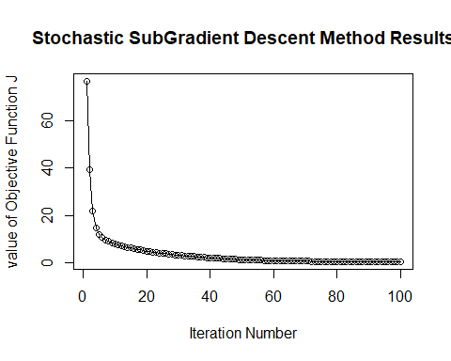

b <- stoch_subGrad_results$theta[1]  
w1 <- stoch_subGrad_results$theta[2]  
w2 <- stoch_subGrad_results$theta[3]  
  
slopeVal <- w1/-w2  
interceptVal <- b/-w2  
  
plot(preds$X_1, preds$X_2)  
abline(a = interceptVal, b = slopeVal)

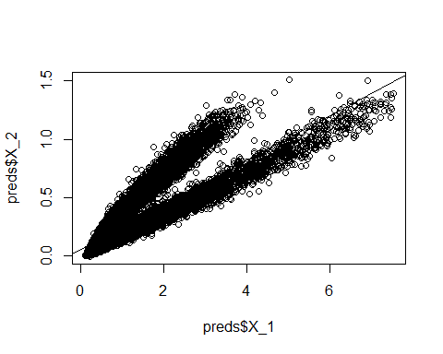

# Again, have to change this data type to factor or it'll get mad  
givenData$Y <- as.factor(givenData$Y)  
  
ggplot(data = givenData, aes(x = X_1, y = X_2, color = Y)) +   
 geom_point() +   
 scale_color_manual(values=c("-1" = "turquoise", "1" = "magenta")) +   
 geom_abline(slope = slopeVal, intercept = interceptVal, lwd = 1) +  
 xlab("Values of X1") +  
 ylab("Values of X2") +   
 ggtitle("Separation using Stochastic SubGradient Method")

