- Drag and drop:
  - COLUMN 1: O₂, CO₂ + nitrogen, O₂ + CO₂, expired anesthesia gas
  - COLUMN 2: inhalation gas overdose, air embolism, hypoxic mixture, circuit disconnect

- Drag and drop: Why would a patient need a blood transfusion?
  - COLUMN 1: altitude, CAD, sepsis, uterine rupture
  - COLUMN 2: can’t increase CO, body isn’t able to use the available O₂, less O₂ is available, massive blood loss

*Uterine rupture = massive blood loss
CAD = can’t increase CO (would not be good in patient with CAD)
Sepsis = body can’t use available O2? Makes sense since septic shock patients will have a high SvO2 d/t ↓ O2 extraction/utilization
Altitude = less O2 available at higher altitudes*

- Drag and drop: Which ASA classification goes with which patient?
  - ASA 2 = 17 year old male with remote history of exercise asthma
  - ASA 1 = 47 year old female with history of PONV
  - ASA 4 = liver transplant patient in acute liver failure due to rejection
  - ASA3 = CAD patient with history of inferior infarct and current HgbA1C of 12

- Why would you need a new cardiology consult before surgery? Select 3
  - high degree AV block
  - chronic a-fib
  - hypotension
  - acute decompensated HF
  - last answer was obvious

- The patient’s BP is 120/80 according to the A-line that is leveled at their heart. The NIBP cuff is on the opposite arm and raised 20 cm in the air. Calculate the BP pressure difference:
  - 105/65 *1 cm = 0.75 mmHg*

- Side effects of acute marijuana intoxication: Select 2
  - hypotension
  - increased CO
  - psychosis

- S/S of hyperparathyroidism:
  - hypotension
  - prolonged QT
  - psychosis
  - nausea

*I don’t remember the actual answers, but first two have to do w/ hypocalcemia; they were asking s/s of hypercalcemia*

- The patient starts to have grand mal seizures after an intra-arterial injection during an interscalene block. What do you give to stop the seizures?
  - propofol
  - versed
  - ketamine

*Intralipids weren’t an option*

- Why do you not give succinylcholine to male pediatric patients?
  - Duchenne muscular dystrophy

- What medication do you give if a pediatric patient goes into hyperkalemic cardiac arrest after being administered succinylcholine?
  - calcium
  - atropine
  - epi
  - ?

- Closing volumes for geriatrics, laparoscopic surgery, and OB patients

- SATA geriatrics:
  - increased lung compliance
  - decreased chest wall compliance
  - decreased lung compliance
  - increased chest wall compliance

- What is a LATE sign of acute epiglottitis?
  - drooling
  - trouble swallowing
  - stridor
  - wheezing

- What valve prevents one cylinder from filling another cylinder?
  - Check valve

- What valve prevents fire from the cylinder when it empties too fast?
  - Cylinder valve

- What would make the proportioning system not work?
  - adding a 3rd and 4th gas
  - O2 cylinder empty
  - ?
  - ?

- What is indicative of ischemia during a CEA?
  - NIRS 45%
  - SSEP decreased 50%
  - bilateral decrease in something
  - ?

- Which medications do not cross the placenta?
- Heparin, insulin, all NMBDs, and glycopyrrolate

- The quaternary amide chain of NMBDs offers what benefits? Select 3
  - doesn’t cross placenta
  - doesn’t have CNS effects
  - ??

*I don’t remember the rest, but it has to do with it not crossing*

- Drag and drop: Negative side effects of anesthesia gas
  - COLUMN 1: desflurane, sevoflurane, nitrous oxide, isoflurane
  - COLUMN 2: carbon monoxide, fluoride metabolites, something about accessory pathway, inactivation of methionine synthase

- Autonomic dysfunction in DM patients: Which one isn’t true?
  - aspiration with induction
  - orthostatic hypotension
  - increased risk of injury w/ PNB
  - something else to do w/ autonomic system

- The onset of action of intrathecal opioids is due to?
  - lipid solubility
  - ionization
  - ?
  - ?

- What determines the spread of local anesthetic in an epidural? Select 2
  - level of injection
  - position during injection
  - volume
  - ?

* With epidurals, the most important controllable factors are: volume, level of injection, and dose
With spinals, the most important controllable factors are: baracity, position after injection, dose, and site of injection*

- What would decrease a Right-to-Left shunt?
  - acidosis
  - have FiO2 set at lowest setting
  - increased SVR
  - something else that increased PVR

- This pic was labeled ABCD: Which one is a Whitacre?
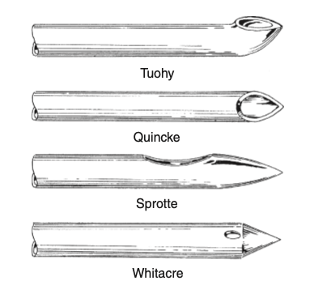

- The estimated plasma volume of an obese patient is:
  - 10 mL/kg
  - 20 mL/kg
  - 40 mL/kg
  - 50 mL/kg

- What is the benefit of adding hyaluronidase to and eye block?
  - prevent bleeding
  - prevent hematoma
  - increase spread of block
  - prolong eye akinesis

- What nerve would be blocked by a dentist that would keep a patient from mastication?
  - mandibular
  - maxillary
  - superficial trigeminal
  - ?
- Which disease of thrombocytopenia is an autoimmune disease with increased IgG that destroys platelets:
  - ITP
  - HIT
  - DIC
  - autosomal dominant thrombocytopenia

- Which IVF do you not put thru a fluid warmer?
  - LR → has lactate and calcium
  - Plasmalyte → acetate, gluconate, mag
  - 0.45% NS
  - D5W → glucose

- Which drug, taken together with an Alpha-2 receptor med, would prevent the normal effects of clonidine as an antihypertensive agent?
  - TCA
  - rifampin
  - ?
  - ?

- Which is the wrong use of a bair hugger?
  - placed on patient's legs when you have aortic clamp on
  - pediatric patient who is normotensive
  - bair hugger on patient w/o the blanket
  - bair hugger over the site that you did a PNB

*Do not warm the lower body when the cross clamp is on. It leads to ↑ injury to ischemic tissue distal to the cross clamp*

- What increases renin release?
  - listed all the adrenergic receptors
  - Beta 1

- The placement of which device would cause the most stimulation of the CV system?
  - bite block
  - OPA
  - NPA
  - LMA

- What type of ETT is used for cleft palate repair?
  - Nasal RAE
  - oral RAE
  - armored
  - rigid ETT

- Fill in the blank: Calculate the coronary perfusion pressure when given SBP/DBP and PAOP

- What medication works as an NMDA antagonist?
  - tramadol (probably the correct answer)
  - ketamine wasn’t an option

- You’re doing a MAC/moderate sedation case. Which med would cause anti-analgesia effects?
  - fentanyl
  - ketamine
  - propofol
  - methohexital

- Why is morphine more potent/effective in elderly?
  - decreased muscle mass
  - increased receptor binding
  - decreased volume of distribution
  - something I can’t remember

- What is the primary determinant of overall cerebral blood flow?
  - arterial pressure
  - PaO2
  - PaCO₂
  - CSF

- What fluid does the CRNA manipulate to control the ICP?
  - intravascular
  - intracellular
  - CSF

- Which nerve do you monitor during a mastoidectomy?
  - facial
  - trigeminal
  - vagus
  - glossopharyngeal

- Hot spot: Which phase of the cardiac action potential occurs when Na+ channels close and K+ channels open?
  - Phase 1

- Which drug causes the GREATEST increase in SSEPs?
  - propofol
  - ketamine
  - etomidate

- Drag and drop: EEG waveforms (alpha, beta, gamma)
  - COLUMN 1: alpha, beta, gamma
  - COLUMN 2: higher level thinking, bored and chilling, then maybe asleep

* Alpha → associated with awake but restful state with eyes closed (occurs with eyes closed during deep relaxation)
Beta → associated with awake mental stimulation and “light” anesthesia (normal awake consciousness, alertness, logic, and critical thinking)
Gamma → wide-awake and concentrating, high level of information processing (high-level information processing)
Theta → associated with general anesthesia and children during normal sleep (light sleep)
Delta → associated with general anesthesia, deep sleep, and brain ischemia or injury (high amplitude, associated with deep sleep) *

- Picture of a flow/volume loop: What happened to cause this change? Select 2
  - bronchoconstriction
  - pneumoperitoneum released
  - Trendelenburg position
  - obstructive disease
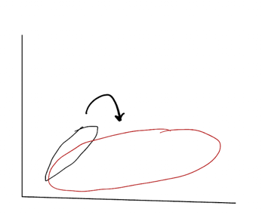
- What is causing the appearance of this EtCO2 waveform? Select 2
  - patient breathing through a Mapleson circuit with inadequate FGF
  - exhausted soda lime
  - rebreathing
  - faulty inspiratory/expiratory valve
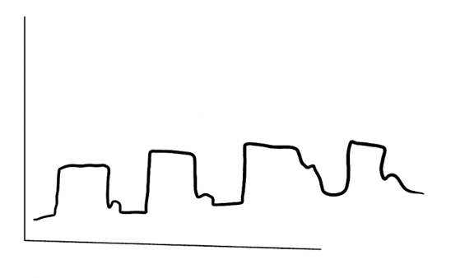
*Not returning to baseline = rebreathing
Widened beta angle = incompetent inspiratory valve*

- What would cause hypoglycemia?
  - Beta Blocker
  - Alpha-2 stimulation
  - anticholinergic
  - ??

- The patient is in the lateral position for a right nephrectomy. SATA related to positioning:
  - pulse ox on dependent arm
  - head flexed
  - kidney roll position
  - axillary roll position

- What is the best preventative measure to keep the patient from sliding while in reverse T-burg?
  - strap head to top of table
  - strap bilateral arms to table,
  - abd/chest strap
  - footboard

- Which uses the Beer-Lambert law? Select 2
  - art line transducer
  - CVP transducer
  - 2 things that used light

- SATA: Why would your patient be slow to wake up after a GA with gas?
  - hypothermic
  - acidotic
  - ?

- What are the best management strategies for the trauma patient?
  - keep them HTN
  - initiate MTP?
  - warm the OR
  - ??

- Drag and drop: Pediatric airway questions x2
  - Treacher-Collins = choanal atresia
  - Klippel-Feil = neck issues
  - Pierre-Robin = cleft palate
  - Trisomy-21 = big tongue
- What to do if a cerebral aneurysm bursts?
  - nitroprusside
  - mannitol
  - Neosynephrine
  - ??

*Fluid resuscitation to maintain normovolemia, controlled hypotension (SNP, Cleviprex, Esmolol), dextrose free IVF
MAP goals between 40-50 mmHg to facilitate surgical control of bleeding*

- Drag and drop: Laryngeal nerve functions

- Drag and drop: Pain definitions
  - transmission
  - transduction
  - modulation

- What is the limiting factor of jet ventilation?
  - provider hand fatigue
  - continuous 50 psi O2
  - CO2 retention
  - ?

- What increases in pregnancy?
  - fibrinogen
  - hbg
  - ?

- What is the best lead to monitor for ST elevation?
  - V5
  - II
  - ??

- Ethical question: It was basically asking what the Stanford OR emergency manual prevents
  - human error
  - system error
  - ??

- Why would we do autologous hemodilution preoperatively?
  - prevent human blood transfusion error
  - increase tissue oxygenation
  - decrease mass of blood loss
  - ??

- What are the side effects of a rapid IVP of protamine? Select 3
  - increased PIP
  - increased PVR
  - hypotension

- What does epinephrine do? Select 2
  - decrease histamine
  - bronchoconstriction
  - bronchodilates

- What is the best indicator of renal function?
  - Creatinine clearance
- You’re doing anesthesia on patient with 80% burns. What is the best thing to do?
  - have blood in the room
  - cancel surgery if patient loses 1.5 L of their blood volume
  - Actively warm blood administered once the patients temp reaches 35.5

- Which medication interferes with lidocaine metabolism?
  - cimetidine

- Which meds would you give an obese patient with OSA? Select 2
  - fentanyl
  - alfentanil
  - Dilaudid – active metabolite
  - morphine – active metabolite

- Which kid do you need a cardiology consult, or maybe EKG?
  - gastroschisis
  - omphalocele
  - ??

- Drag and drop: S/S of hyponatremia
  - COLUMN 1: 110, 120, 125, 130
  - COLUMN 2: nonspecific symptoms, malaise, seizures, lethargy

*130 = nonspecific , 125 = malaise, 120 = lethargy, 110 = seizures
It was pretty easy to put it in progressing order without knowing anything about hyponatremia. Can’t really remember the wording, but you could just put it in order of their level of consciousness*

- Which of the following are blood-saving strategies? Select 3
  - cell saver
  - EPO
  - fibrinolytics
  - acute normovolemic hemodilution
  - ?

- What is a benefit of using albumin over a crystalloid?
  - colloid pressure
  - urine output
  - cerebral edema
  - ?

- What stimulates the posterior pituitary to release its hormones?
  - indirect stimulation from supraoptic nucleus
  - direct stimulation from the supraoptic nucleus
  - in response to hormones that the adenohypophysis releases
  - ?

- Hypertrophic obstructive cardiomyopathy management:
  - Increase HR
  - Increase Contractility
  - Reduce afterload
  - Increase preload

- Which nerve provides sensory innervation to the medial upper arm?
  - intercostobrachial
- Which medication best preserves renal blood flow?
  - fenoldopam
  - nitroglycerine
  - nitroprusside
  - Neosynephrine

- Hot spot: Picture of the Wigger diagram. Where does the aortic valve open?

- Hot Spot: Where not to put an axillary roll

- Fill in the blank: What is the maximum volume that can be placed in the bronchial lumen of the double lumen tube?
  - 3 mL?
  - 1-2 mL

- Fill in the blank: What is the maximum psi that can be safely administered during jet ventilation?
  - 50 psi

- Fill in the blank: What is the minimum SBP required to diagnose a patient with severe preeclampsia?
  - 160 mmHg

- Picture of an arterial waveform on top of a respiratory waveform (looked like pulsus paradoxus). What condition would cause this picture?
  - Cardiac tamponade
  - Mitral regurgitation
  - Aortic stenosis

- What conditions would increase the size of zone 1?
  - Decreased CO
  - PE
  - PEEP

- Anesthetic management of 2-year-old patient post TBI?
  - Maintain cerebral perfusion pressure > 40 mmHg
  - Keep blood glucose < 200
  - Maintain SBP > 120 mmHg
  - Other answer didn’t make sense

- What would cause this capnography waveform?
  - Decreased FGF in a Bain circuit
  - Exhausted soda lime
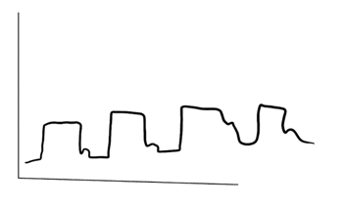

- What will the capnography waveform show with an incompetent inspiratory valve?
  - Increased rebreathing
  - Something with the slope of phase 4 (increased beta angle)

- What is the least cardiotoxic local anesthetic?
  - Bupivacaine
  - Ropivacaine
  - Levobupivacaine
  - Lidocaine

- What are components in the intermediate system?
  - Hanger yoke
  - Second oxygen pressure regulator
  - Check valve
  - O2 flush valve

- What would you suspect with a patient with central sleep apnea?
  - Decreased sensitization to chemoreceptors
  - Respiratory insufficiency
  - Airway obstruction

- Matching chemotherapeutic agents with their adverse effects:
  - Bleomycin = pulmonary fibrosis
  - Doxorubicin = cardiac toxicity
  - Vincristine = autonomic neuropathy
  - Cisplatin = hemolytic cystitis

- What changes in the geriatric population?
  - Decreased alveolar-arterial gradient
  - PaO2 pressure tension

- How would you treat a tet spell with a Tetralogy of Fallot patient?
  - IV fluid bolus
  - Phenylephrine

- What is the closest FiO2 to 0.5?
  - 4 L/min via NC
  - 5 L/min via NC
  - 6-7 L/min via simple mask
  - 8-10 L/min via non-rebreather

- What effects epidural spread the most?
  - Volume
  - Level of injection

- Where do you place the NIBP for mediastinoscopy?
  - Left arm
  - Right arm
  - Left leg
  - Right arm

- What is the most common complication of mediastinoscopy?
  - Hemorrhage
  - Pneumothorax

- What condition would cause your patient to have an elevated alkaline phosphatase?
  - Cholestasis

- What is the primarily regulator of the thyroid?
  - Adenohypophysis
  - Neurohypophysis
  - Hypothalamus

- Rank the amount of heat loss in the OR from most to least:
  - Radiation > Convection > Evaporation > Conduction

- How to improve patient safety in the operating room?
  - Use of checklists
  - Electronic medical records

- When CO2 reacts with soda lime, what kind of reaction is taking place?
  - Alkalinization
  - Neutralization
  - Oxidation
  - Reduction

- How to avoid bullae in surgery? Select 2
  - FiO2 < 30
  - Maintain spontaneous ventilation
  - Maintain PIP < 15

- What nerve would be blocked by a dentist that wants to inhibit mastication?
  - Mandibular (the most inferior branch of the trigeminal nerve)

- During a posterior fossa surgery in the sitting position, what condition would lead to spinal cord ischemia?
  - Excessive neck flexion
  - HTN

- A patient arrives to the PACU and has increased tachypnea, tachycardia, and hypotension?
  - Pulmonary embolism
  - Atelectasis
  - Pneumothorax

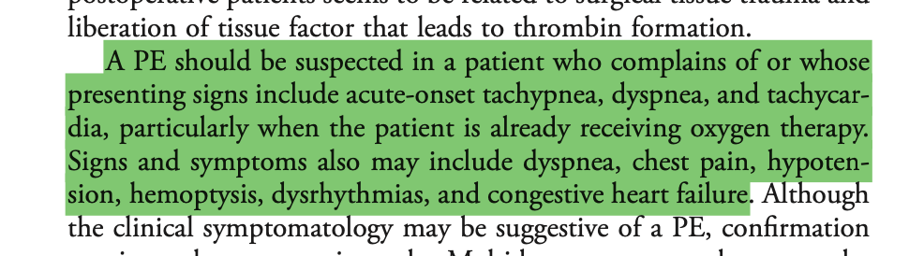

- When are the only two incidents that the O2 analyzer will not detect a hypoxic mixture?
  - Something downstream the flowmeter (will detect per apex)
  - Wrong connection with the pipeline (will detect per apex)

- When does the fail-safe turn off?
  - When the pressure regulator senses less than < 30 PSI

- What sign would you suspect in the PACU with a patient with late respiratory depression from neuraxial anesthetic?
  - Sedation
  - Dementia
  - Confusion

- What will a patient with ascites display?
  - decreased oncotic pressure, decreased protein binding, decreased effective volume

- Match the receptors:
  - M2 = decreased conduction velocity
  - Beta-2 = increases insulin release
  - Beta-1 = increases renin release
  - Alpha-1 = some sort of contraction

- What number is used when describing laminar and turbulent flow?
  - Reynolds

- Stimulation of which receptor would decrease insulin release?
  - Alpha-2

- What is the most likely adverse effect in dental office?
  - Human error

- What is the first thing you will do when performing a machine check in the morning?
  - Turn manual switch on
  - perform a low-pressure check
  - high-pressure check
  - check O2 pipeline pressure

- During a lower abdominal surgery with excessive retraction, what nerves are most likely to injured? Select 2
  - femoral
  - obturator
  - sciatic
  - peroneal

- Which patient would need a cardiac workup prior to surgery?
  - Chronic a-fib patient with HR 104
  - Patient who is anxious with ST of 102
  - asymptomatic patient with HR 56
  - second-degree type 2 AV block

- How do you maintain oxygenation during one-lung ventilation?
  - HPV

- Fill in the blank: What is the dose for dantrolene?
  - 2.5 mg/kg

- What is the minimum amount of time that a patient with a history of MH is required to stay in PACU?
  - 30 min
  - 60 min (I’m pretty sure its 1-4 hours)
  - 90 min
  - 120 min

- Hyperventilation with cause: Select 3
  - Hypercalcemia
  - Cerebral vascular resistance
  - Increased blood flow
- What are the characteristics of a CO2 laser?
  - Long wavelength (10,600 nm)
  - Emits light in the infrared spectrum
  - The light emitted is strongly absorbed by water
  - Associated with minimal blood loss
  - Superficial tissue penetration (vaporization of cells occurs within the first 100 to 200 mcm of the irradiated surface)
  - Tissue penetration is less than 0.5 mm
  - It is used by a wide variety of surgical specialties
  - Good for airway surgeries (shallow depth of burn and extreme precision)
  - It will burn the cornea and/or sclera if used near the eye
  - Eye protection can be any clear glass or plastic that surrounds the face

- Antihypertensives matching:
  - Nicardipine = preserves cerebral blood flow
  - Nitroprusside = preserves cardiac output
  - Nitroglycerin = preserves myocardial perfusion

- Which medication would you not give to a patient with Alzheimer's?
  - Atropine

- Match the patient with the ASA class:
  - ASA 1 = 42 year old with PONV
  - ASA 2 = 17 year old with remote exercise induced asthma
  - ASA 3 = (obvious)
  - ASA 4 = (obvious)

- What causes the migration of the ETT towards the vocal cords?
  - Thyroidectomy with neck extension

- According to Poiseuille’s law, what parameter would decrease flow?
  - Increased blood viscosity

- Rank the local anesthetics according to their duration of action from shortest to longest:
  - Chloroprocaine > Procaine > Lidocaine > Ropivacaine

- Stimulation of the Beta-2 receptor will result in: Select 2
  - Hyperglycemia
  - Decrease airway resistance

- Where to put pressure for Larson’s maneuver?
  - Weird options because they didn’t have anterior to ramus of mandible or posterior mastoid process
  - Pressure to styloid process behind the posterior ramus of the mandible and anterior to the mastoid process.
  - Behind the lobule of the pinna of each ear.

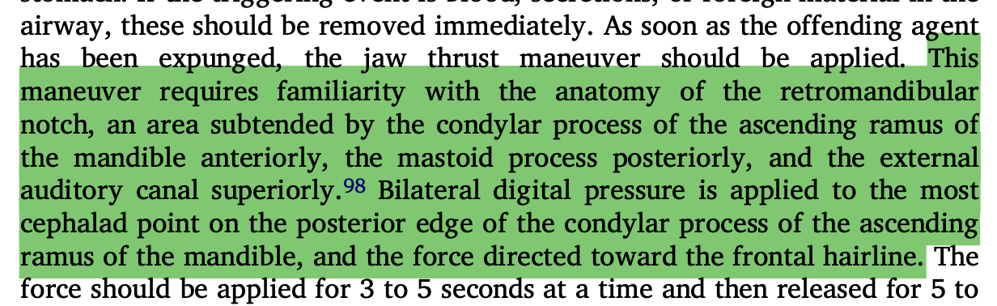

- TEG Picture: Mine was fibrinolysis
- TEG picture hot spot. Select the image associated with hypercoagulation. I picked the fat one with the small tampon string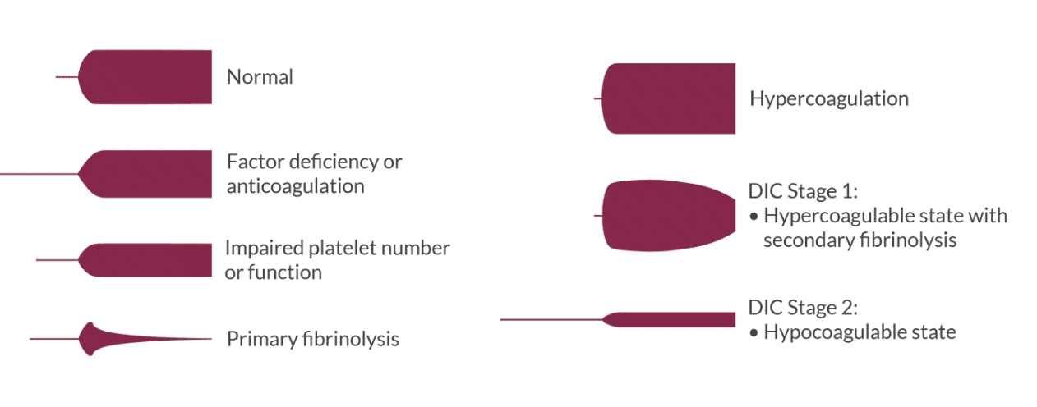
- What cranial nerves should be assessed after a CEA?
  - Vagus
  - Abducens
  - Hypoglossal
  - (can’t remember the last one)

- Ankle block picture. Which nerve is being blocked?

*Mine was the posterior tibial nerve. They had the medial malleolus labeled and the needle was behind the medial malleolus*

- Tramadol decreases the reuptake of: Select 2
  - Norepinephrine
  - Serotonin

- Side effect of thiazide diuretics:
  - Hypercalcemia
- An awake, spontaneously breathing patient with a closed chest is laying in the lateral decubitus position. The V/Q ratio would:
  - be unchanged
  - decrease from nondependent to dependent lung
  - increase from nondependent to dependent lung

- What diuretic is the best choice for a patient with chronic kidney disease?
  - Amiloride
  - Metolazone
  - Torsemide
  - Chlorothiazide

- What is the mechanism of action of sulfonylureas?
  - Stimulate insulin secretion from beta cells (wasn’t this exact wording, but it said something about pancreas beta cell)
  - Slow the digestion of carbohydrates from GI tract
  - Inhibit gluconeogenesis and glycogenolysis in the liver – metformin
  - Decrease peripheral insulin resistance – metformin

- What post-conceptual age has the LOWEST risk of retinopathy of prematurity?
  - 38 weeks
  - 44 weeks
  - 50 weeks
  - 55 weeks

- Which of the following are true regarding intraoperative hypothermia? Select 3
  - Prolonged bleeding
  - Residual NMB
  - Delayed emergence from volatile anesthetics
- Medication matching:
  - Lovenox = anticoagulant
  - TXA = antifibrinolytic
  - NSAIDs = antiplatelets
  - Can’t remember the last one, but it was obvious

- Which drug class necessitates an increased dose for the geriatric patient?
  - Sedative hypnotics
  - Volatile anesthetics
  - Anticholinergics (a decreased PNS tone in geriatric patients = ↑ dose requirements)
  - Anticholinesterases

- Which of these is the LEAST likely reason for a decreased local anesthetic epidural dose in a healthy parturient?
  - Increased metabolism of LA’s
  - Venous engorgement of epidural space
  - Decreased epidural volume
  - Increased sensitivity to LA’s

- What is the most likely reason for a geriatric patient to hypoventilate / become apneic in the PACU?
  - Decreased sensitivity of central chemoreceptor
  - Can’t remember the other answers

- What 4 things must be identified to determine malpractice? Select 4
  - 4 D’s of malpractice → Duty, Dereliction of duty, Damages, Direct cause of damages

- Picture of a Grade I Cormack-Lehane view: What grade view do you see here?

- Six elements of informed consent:
- Diagnosis
- Determination of the capacity of the patient to consent
- Disclosure of the nature of the procedure including risks, benefits, and estimation of the likelihood of outcomes
- Alternatives to the proposed treatment including their risks and outcomes
- Comprehension of relevant information
- Consent obtained without coercion or duress

- Capsaicin is used to treat what kind of pain?
  - Neuropathic
  - Inflammatory
  - Visceral
  - Psychogenic

- Which two inhibitory neurotransmitters participate in the modulation of pain perception?
  - GABA
  - Glycine

- What type of LMA requires minimal head manipulation and can be used for a blind intubation?
  - FastTrach
  - Supreme
  - ProSeal
  - Classic

- What is the maximum dose of tumescent lidocaine that a 72-kg patient can safely receive?
  - 55 mg/kg

- Picture of an epidural ultrasound: Identify the ligamentum flavum
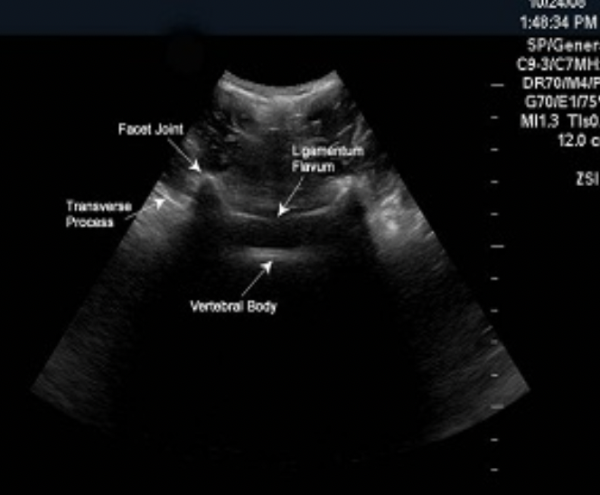

- What is in EMLA cream? Select 2
  - Lidocaine
  - Procaine
  - Prilocaine
  - Benzocaine

- What are the most common S/S of fat embolism syndrome? Select 3
  - Tachypnea
  - Changes in mental status
  - Petechial rash

- The compressive effects of a prolonged pneumoperitoneum would cause:
  - decreased urinary output

- Central sleep apnea:
  - Cessation of respiratory effort
  - Cheyne stokes breathing (10-second pauses between breaths)
  - Possible defect of chemoreceptors or brainstem respiratory control center

- Obesity hypoventilation syndrome (Pickwickian):
  - BMI > 30, awake PaCO2 > 45 mmHg, dysfunctional breathing during sleep
  - Respiratory acidosis, polycythemia, pulmonary HTN, right heart failure

- Geriatric respiratory changes:
  - Decrease in vital capacity (VC)
  - Decrease in inspiratory reserve volume (IRV) and expiratory reserve volume (ERV)
  - Decrease in lung elasticity (elastic recoil)
  - Decrease in chest wall compliance
  - Decreased response to hypercarbia and hypoxia
  - Decrease in FVC and FEV₁
  - Decrease in resting arterial oxygen tension (PaO2)
  - Decrease in protective airway reflexes (coughing and swallowing)
  - Increase in residual volume (RV)
  - Increase in functional residual capacity (FRC)
  - Increase in minute ventilation
  - Increase in lung compliance
  - Increase in dead space
  - Increase in closing volume (CV) and closing capacity (CV + RV)
  - Increase in A-a gradient
  - Increase in V/Q mismatch
  - No change in TLC
- Alpha-2 receptor activation = ↓ insulin release

- Beta-2 receptor activation = ↑ insulin release

- Beta-1 receptor activation = ↑ renin release

