Pysal Quantum GIS Plugin Documentation


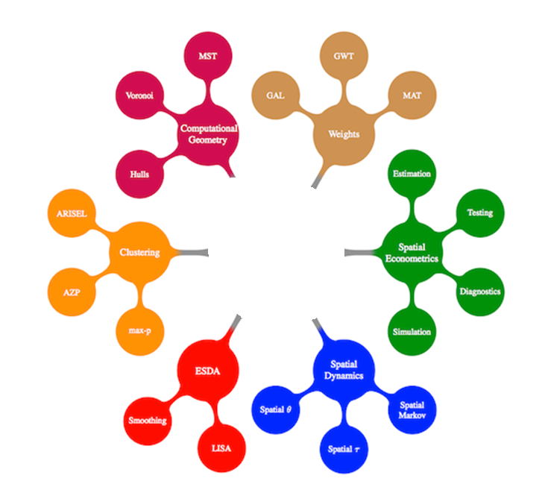

Contact: pysal.org
Created by: Xing Kang (Xing.Kang@asu.edu), Michael Palmer (palmermd@asu.edu), Yan-ting Liau (yliau@asu.edu), Ngoc Nguyen Hong (Ngoc.Hong.Nguyen@asu.edu)

Dec, 2011

1. Plugin Structure
1.1 Plugin Design
This Quantum GIS (QGIS) Plugin implements several of the PySAL features through a PyQT4 GUI. In expectation of a complete PySAL plugin with many options, the plugin was attached to the QGIS MenuBar to make its methods more accessible to users. The PySAL tree diagram was used to organize our Plugin. Each branch was given a Submenu and each node became an action (Figure 1). Thus figure one shows the highlighted path in the figure 2.
The plugin can read saved shapefiles and implement any PySAL method with them and save the outputs to a user-specified file. The plugin also loads the current layer files into a drop-down menu.
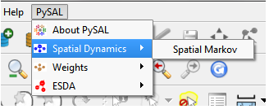 | 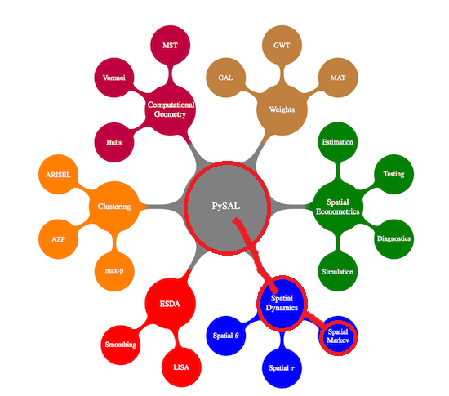
Figure 1: QGIS Plugin Design | Figure 2: PySAL Tree Diagram
1.2 Module Plugin Selections
Based on the above design, we decide to start from certain parts of PySAL for implementations. PySAL is built in six categories of functionality, handling basic data operations, such as spatial weights and computational geometry, data exploration, such as clustering methods and exploratory spatial data analysis (ESDA), and spatial modeling, such as spatial dynamics and spatial econometrics. Therefore, we select one module from each of functionality as our start point. In other words, we choose Weights, Moran’ I, Getis Ord and Spatial Markov from categories of Weights, ESDA and Spatial Dynamics to design GUI Plugin in QGIS.

2. Weights Module
2.1 Concepts
In the area of Spatial Analysis, the concept of spatial weights is defined in the form of a two-dimensional matrix, used to measure the adjacency or neighborhood relationship between geo-objects. The (i, j) element in the matrix represents intensity of interaction between object i and j, and a larger value implies closer relationship.
Depending on selection of classifying feature, spatial weights can be categorized into several types, including contiguity based and distance based weights. Contiguity based weights is commonly applied to deal with polygon datasets, and two polygons could be regarded as neighbors if they share mutual boundaries such as boundary lines or corner points. Specifically, if only polygons with mutual boundary lines are accounted, the generated weights matrix is usually called rook based matrix. On the other hand, if polygons with either mutual boundary lines or corner points can both be considered as neighbors, we could obtain queen based weights matrix as a result. An illustrative explanation of rook and queen constraints can be seen in the figure below.
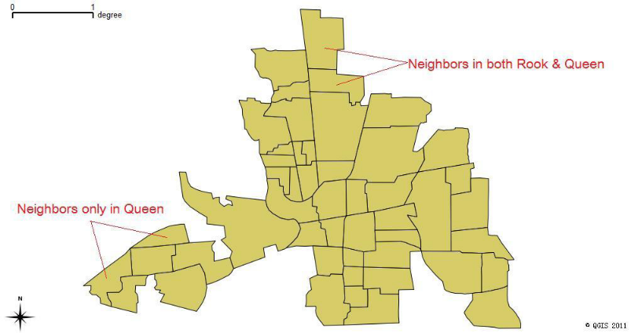
In the case of distance based weights, the geodesic distance between objects becomes the major factor in determining value of weights. In practice, researchers have proposed several commonly used constraints, such as threshold distance, K nearest neighbors, inverse distance, etc. Despite the difference in calculating elements of weights matrix, the following general rule always hold – objects with further distance tend to have weaker neighboring relationship or interaction between them.
2.2 Implementation Details
Spatial weights creation is the major functionality implemented in this module. Specifically, distance-based weight measures can be calculated from either shapefile dataset, as well as active layers currently imported in QGIS. Three types of constraints are provided for convenience, including threshold distance, K nearest neighbor, and inverse distance. However, contiguity based weights are only supported when using shapefile instead of QGIS layer in the plugin, as a result of lacking corresponding function calls in PySAL. As to geometric datatypes, both point and polygon datasets are supported (in the case of polygons, their centroids are applied for calculation). The user interface is shown in the following screenshot.
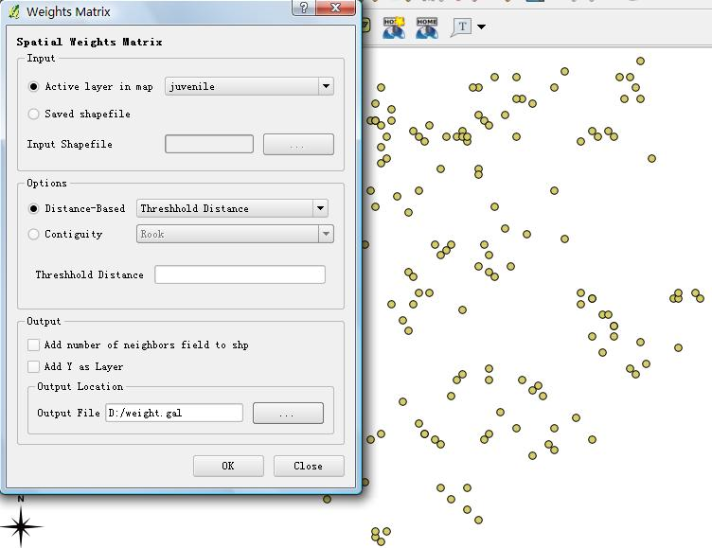
As can be seen in the screenshot, users can specify whether to input active layer or shapefile by clicking the corresponding radio button in the Input panel. After that, in the Options panel it is necessary to select the intended weights type and constraints. Depending on the constraint, users also need to manually fill the attribute value. Finally, the output location needs to be specified before the plugin starts to create spatial weights object in memory and save the output file on hard-disk.
3. Spatial Autocorrelation Module
3.1 Statistics Methods
3.1.1 Moran’s I
Moran’s I is one of the indicators to measure spatial autocorrelation. Its null hypothesis is: “there is no spatial clustering of the values associated with the geographic feature in the study area.” When p-value is smaller and z-value is larger over the thresholds after estimating the population, it will reject the null hypothesis and show the positive spatial autocorrelation or negative spatial autocorrelation.
The results display in two forms which are positive spatial autocorrelation and negative spatial autocorrelation. The value of the first one is approaching 1 and means any two points of the values have positive relations or similarity. The value of the last one is close to -1 and means that any two points have dissimilarity with each other. If there are no relations between any two points, the value shows random distributions which the value is near 0 and means that any two points distribute independently almost without relations with others.

The equation is given as:
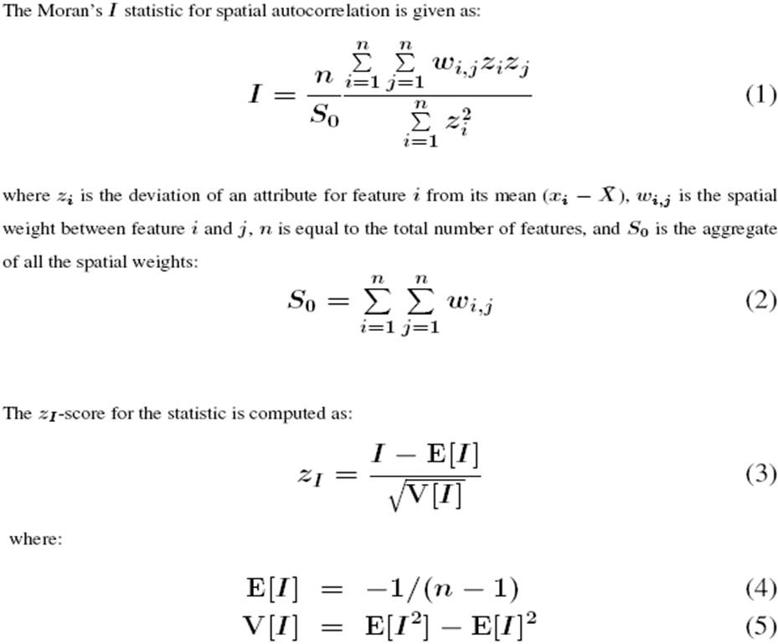
where: W_{ij} is a spatial weight of any two points, i and j
S_{o} is the whole spatial weights
Z_{i} and Z_{j} are the deviation between any i or j point and mean (x_{i}-X) or (x_{j}-X)

3.2 GUI Design
The GUI design has three parts: input file which is from active layer of shapefile in map or saved shapefile, input spatial weights and output a .csv file. The first part can import any shapefile from the hard discs and then choose any column for further calculation from the combobox of “select column”. Input spatial weights can import spatial weights file from either saved file in the hard discs or create a new one by clicking “create” button. Output side can export the calculation results of Moran’s I value and estimated population values, i.e. expected value, variance, standard deviation, z-value and p-value under two population assumptions, the normality assumption and the randomization assumption.

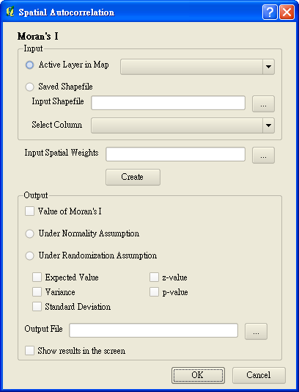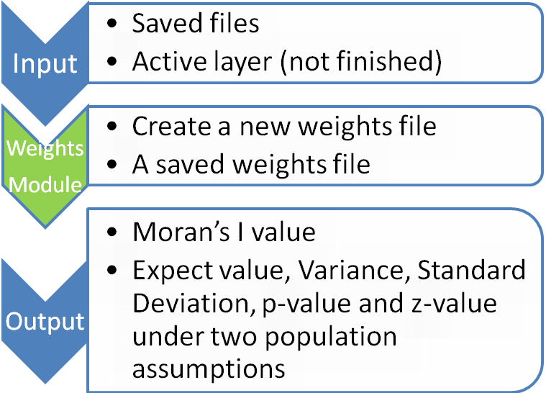
3.3 Output
The output form has two parts which show the selected column and its values. The below figures are one of the sample.
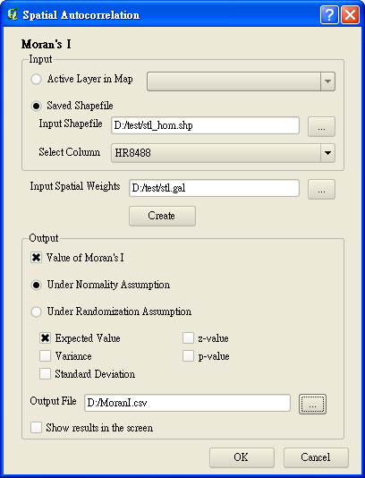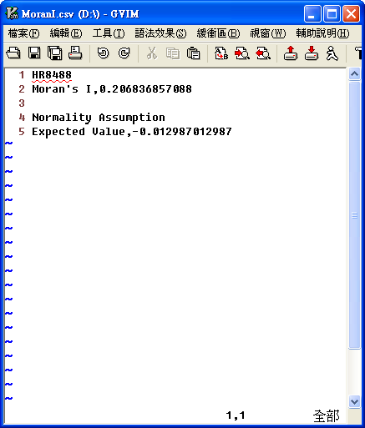
4. Spatial Dynamics Module
4.1 Statistics Methods
4.1.1 Spatial Markov
Spatial Markov can analyze the evolutions of spatial phenomena over space and time. The basic concept is that any change in specific time from the initial situation (P_{t}) equals to the first situation that multiply to the transition probabilities of next stages (M^{b}). That is to say, after the first situation, transition probability matrix will multiply along with time, so the final result will not relate to the initial situation. The equation is given as:
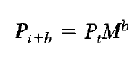
4.2 GUI Design
The GUI design has three parts: input file which is from active layer in map or saved .csv file, input spatial weights and output a .csv file. The first part can import any .csv file from the hard discs and then choose the start year and the end year for further calculation from the two comboboxes. Input spatial weights can import spatial weights file from either saved file in the hard discs or create a new one by clicking “create” button. Output side can export the calculation results of global transition probability matrix.
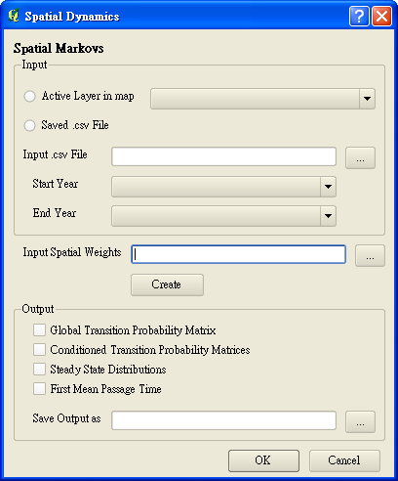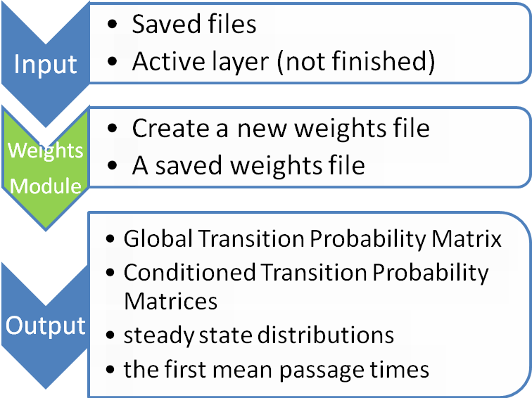
4.3 Output
The current finished part is only for exporting global transition probability matrix. The below figures are one of the sample.
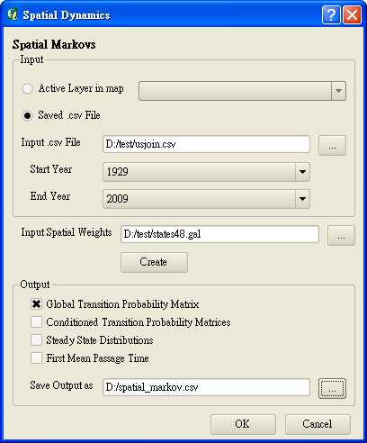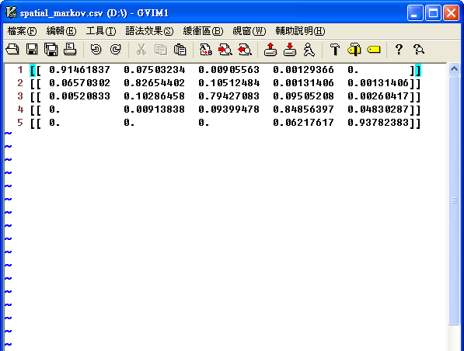
5. Further improvement
5.1 Active Layer
Until now, though the part from saved files can run PySAL’s module functions, the part from active layer need to further improve and let it work.

5.2 Import Weights module
Our current process needs two steps to create the new weights file and then import from the saved weights. It should be a way to simplify the steps.
5.3 Show results in the screen or Add in shapefiles
After calculation, we intend to design new windows to display the results with some explanations as the below figure or add some attributes from calculated results in the current active shapefiles.
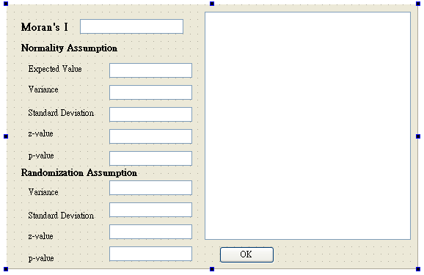
6. Manifest
PysalPlugin\
- <DIR> about
- This folder contains the UI and code for the About dialogbox and also the Error Dialogbox that is shown for ImportErrors
- <DIR> getis_ord
- This folder contains the UI and code for the Getis Ord method. It contains errors.
- pysal idea list.txt
- pysalplugin.py
- This is the main class of our plugin
- pysalplugin.pyc
- Requirements of our plugins.txt
- <DIR> resources
- This folder contains the icons used by the plugin
- resources.py
- resources.pyc
- resources.qrc
- The Qt resource system is a platform-independent mechanism for storing binary files in the application's executable. This is useful if your application always needs a certain set of files (icons, translation files, etc.) and you don't want to run the risk of losing the files. -http://doc.qt.nokia.com/latest/resources.html
- <DIR> spatial_autocorrelation
- Contains the UI and code for the spatial autocorrelation dialogbox
- <DIR> spatial_dynamics
- Contains the UI and code for the spatialdynamics dialogbox
- <DIR> weights
- Contains the UI and code for the weights dialogbox
- __init__.py
- The starting point of the plugin. Contains general info, version, name and main class.
- __init__.pyc

PysalPlugin\Weights\
- ui_weights.py
- The ui_weights.ui file is used to generate a python script with PYUIC4.exe
- ui_weights.pyc
- ui_weights.ui
- QT User Interface file. This can be edited with QTEditor
- weightsdialog.py
- This python script is for the weights dialogbox and imports the UI. This is the main class for Weights
- weightsdialog.pyc
- __init__.py
- Each subfolder must have __init__.py for python to look for our files in it.

PysalPlugin\Spatial Autocorrelation\
- ui_spatial_autocorrelation.py
- The spatial_autocorrelation.ui file is used to generate a python script with PYUIC4.exe
- ui_spatial_autocorrelation.pyc
- spatial_autocorrelation.ui
- QT User Interface file. This can be edited with QTEditor
- spatial_autocorrelationdialog.py
- This python script is for the spatial_autocorrelation dialogbox and imports the UI. This is the main class for Spatial Autocorrelation
- spatial_autocorrelationdialog.pyc
- __init__.py
- <DIR> weights
- Copy from the weights module

PysalPlugin\Spatial Dynamics\
- ui_ spatial_dynamics.py
- The spatial_dynamics.ui file is used to generate a python script with PYUIC4.exe
- ui_ spatial_dynamics.pyc
- spatial_dynamics.ui
- QT User Interface file. This can be edited with QTEditor
- spatial_dynamicsdialog.py
- This python script is for the spatial_dynamics dialogbox and imports the UI. This is the main class for Spatial Dynamics
- spatial_dynamicsdialog.pyc
- __init__.py
- <DIR> weights
- Copy from the weights module

Rey, Sergio J. and Luc Anselin. (2010) PySAL: A Python Library of Spatial Analytical Methods. In M. Fischer and A. Getis (eds.) Handbook of Applied Spatial Analysis: Software Tools, Methods and Applications. Springer, Berlin.
ArcGIS Help: How Spatial Autocorrelation: Moran's I (Spatial Statistics) works / http://resources.esri.com/help/9.3/ArcGISengine/java/Gp_ToolRef/Spatial_Statistics_tools/how_spatial_autocorrelation_colon_moran_s_i_spatial_statistics_works.htm (derived in 12/10/2011)
Rey, Sergio J.. (2011) pysal Documentation Release 1.2.0.
Rey, Sergio J.. (2001) Spatial empirics for economic growth and convergence. Geographical Analysis 33(3): 195-214.

