1 K-means Clustering

(1) Select K points as the initial centroids
(2) Repeat
(3) Form K clusters by assigning all points to the closet centroid
Recompute the centroid of each cluster
(4) Until The centroids don’t change

2 Hierarchical Clustering

(1) Compute the proximity matrix
(2) Let each data point be a cluster
(3) Repeat
(4) Merge the two closest clusters
(5) Update the proximity matrix
(6) Until only a single cluster remains
Key operation is the computation of the proximity of two clusters
- Different approaches to defining the distance between clusters distinguish the different algorithms

3 Automatic Zoning Problem

The aim is to aggregate the N vectors in X to form a partition of a study area into K zones.
- 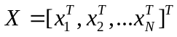, ,,…, 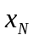 are N vectors of dimension n represent the b.s.u. (basic spatial unit) data;
- 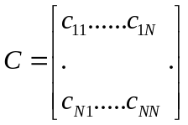, 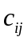=1 if b.s.u. i and j are contiguous and may be included in the same zone, otherwise =0.
- 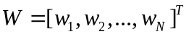, 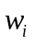 is the zone to which  is assigned, 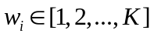.
- 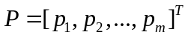, a model is used on the zone data with m independent variables, 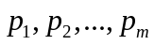.

Step 1. Assume that there is an initial classification W of N b.s.u. into K disjoint zones. (For example, k-means clustering)
Step 2. Make a list of zones, Z = [1, 2,. . ., K].
Step 3. If Z is empty then go to Step 10, else randomly select and remove a zone k from Z.
Step 4. Make a list of b.s.u. contiguous to zone k but not members of it, B = [1, 2,..., L], 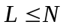.
Step 5. If B is empty then go to Step 3, else randomly select and remove a b.s.u. j from B, set q = 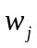, and set = k.
Step 6. If the remaining b.s.u. in zone q are contiguous then go to Step 7, else set = q and return to Step 5.
Step 7. Calculate model parameters P*, P* =f(W*; X), if desired, and evaluate F(W*, P*; X, C).
Step 8. If the new value for F is an improvement over the previous best value then go to Step 9, else set = q and return to Step 5.
Step 9. Extend B to account for any increase in the number of b.s.u. contiguous to zone k and return to Step 5.
Step 10. Signal end of iteration.
Repeat Steps 2-10 until the change in F over a whole iteration is less than a specified tolerance

