Pysal Quantum GIS Plugin Documentation


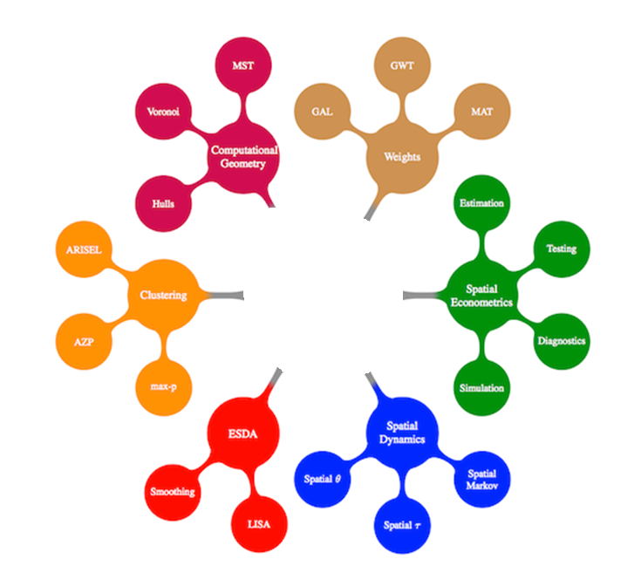

Contact: pysal.org
Plugin Created by: Xing Kang (Xing.Kang@asu.edu), Michael Palmer (palmermd@asu.edu), Yan-ting Liau (yliau@asu.edu), Ngoc Nguyen Hong (Ngoc.Hong.Nguyen@asu.edu)

Dec, 2011

1. Plugin Structure
1.1 Motivations

1.2 Plugin Design
This QGIS Plugin implements several of the PySAL features through a PyQT4 GUI. In expectation of a complete PySAL plugin with many options, the plugin was attached to the QGIS MenuBar to make its methods more accessible to users. The PySAL tree diagram was used to organize our Plugin. Each branch was given a Submenu and each node became an action (Figure 1). Thus figure one shows the highlighted path in the figure 2.
The plugin can read saved shapefiles and implement any PySAL method with them and save the outputs to a user-specified file. The plugin also loads the current layer files into a drop-down menu.
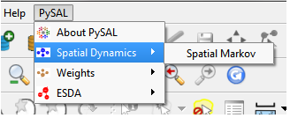 | 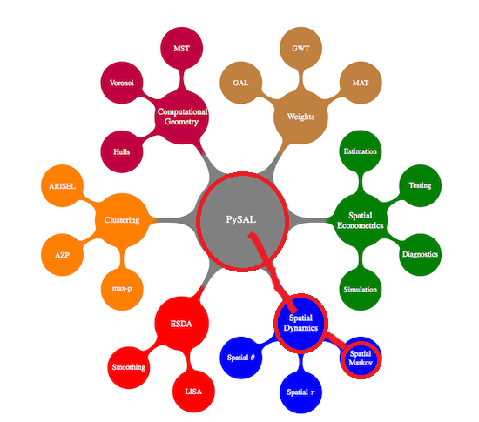
Figure 1: QGIS Plugin Design | Figure 2: PySAL Tree Diagram
1.3 Module Plugin Selections

2. Weights Module
For Spatial weights, Distance-based measures can be calculated from the centroids but contiguity based weights are not possible with the plugin right now. The weights dialog contains several placeholders for output. Checkboxes to “add Y to map” or “add number of neighbors field to shapefile” have not been implemented.

3. Spatial Autocorrelation Module
3.1 Statistics Methods
3.1.1 Moran’s I

3.2 GUI Design

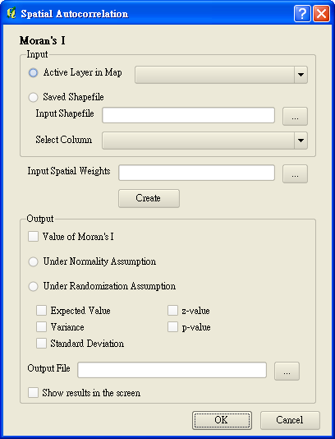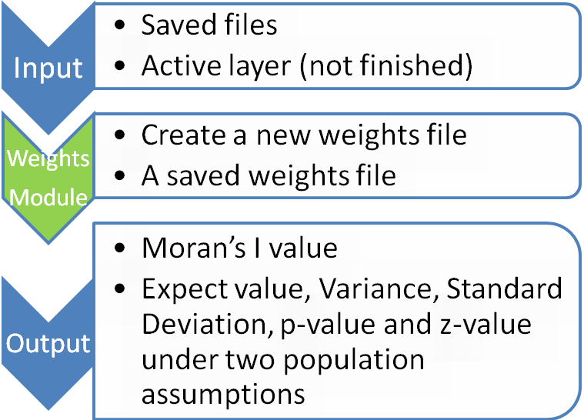

3.3 Output

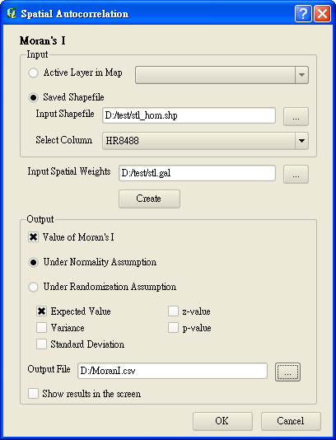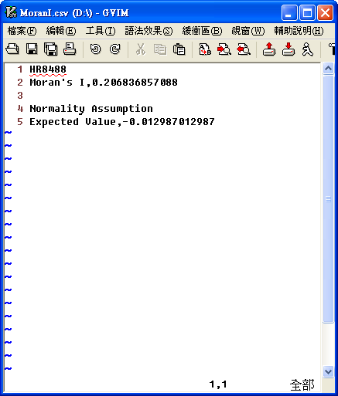
4. Spatial Dynamics Module
4.1 Statistics Methods
4.1.1 Spatial Markov

4.2 GUI Design

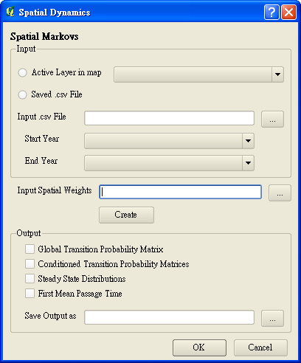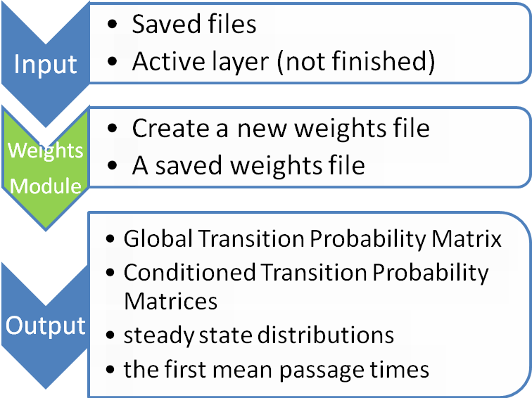

4.3 Output

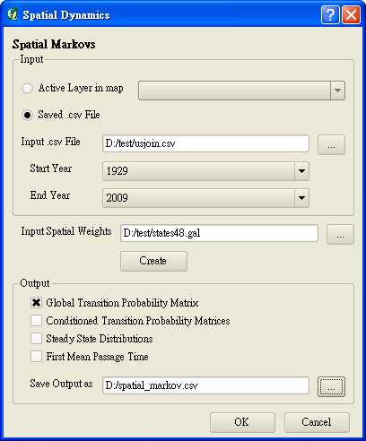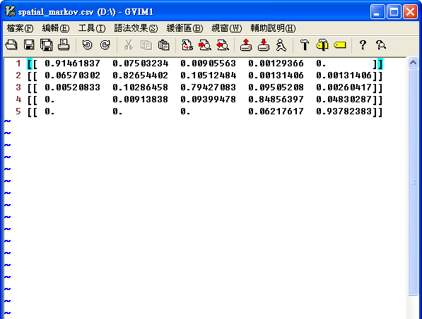
5. Further improvement
5.1 Active Layer

5.2 Import Weights module

5.3 Show results and simple explanations in the screen

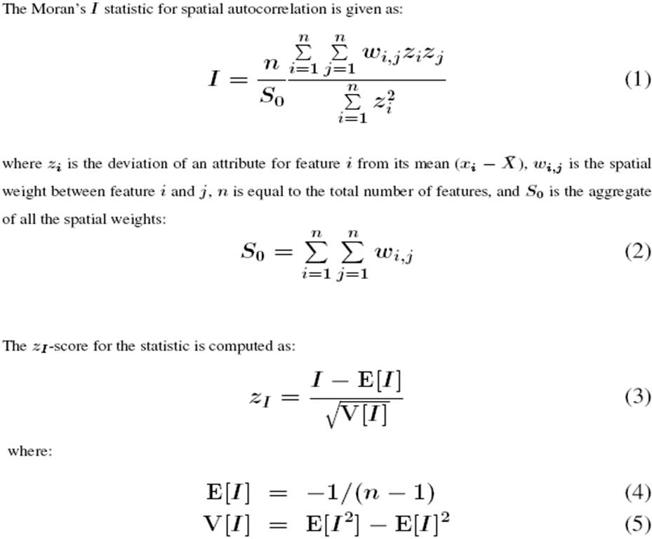
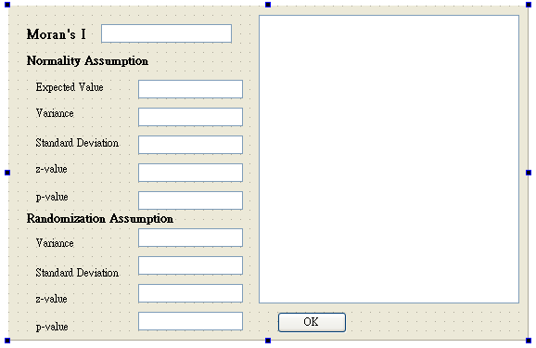
6. Manifest
PysalPlugin\
- <DIR> about
- This folder contains the UI and code for the About dialogbox and also the Error Dialogbox that is shown for ImportErrors
- <DIR> getis_ord
- This folder contains the UI and code for the Getis Ord method. It contains errors.
- pysal idea list.txt
- pysalplugin.py
- This is the main class of our plugin
- pysalplugin.pyc
- Requirements of our plugins.txt
- <DIR> resources
- This folder contains the icons used by the plugin
- resources.py
- resources.pyc
- resources.qrc
- The Qt resource system is a platform-independent mechanism for storing binary files in the application's executable. This is useful if your application always needs a certain set of files (icons, translation files, etc.) and you don't want to run the risk of losing the files. -http://doc.qt.nokia.com/latest/resources.html
- <DIR> spatial_autocorrelation
- Contains the UI and code for the spatial autocorrelation dialogbox
- <DIR> spatial_dynamics
- Contains the UI and code for the spatialdynamics dialogbox
- <DIR> weights
- Contains the UI and code for the weights dialogbox
- __init__.py
- The starting point of the plugin. Contains general info, version, name and main class.
- __init__.pyc

PysalPlugin\Weights\
- ui_weights.py
- The ui_weights.ui file is used to generate a python script with PYUIC4.exe
- ui_weights.pyc
- ui_weights.ui
- QT User Interface file. This can be edited with QTEditor
- weightsdialog.py
- This python script is for the weights dialogbox and imports the UI. This is the main class for Weights
- weightsdialog.pyc
- __init__.py
- Each subfolder must have __init__.py for python to look for our files in it.

PysalPlugin\Spatial Autocorrelation\
- ui_spatial_autocorrelation.py
- The spatial_autocorrelation.ui file is used to generate a python script with PYUIC4.exe
- ui_spatial_autocorrelation.pyc
- spatial_autocorrelation.ui
- QT User Interface file. This can be edited with QTEditor
- spatial_autocorrelationdialog.py
- This python script is for the spatial_autocorrelation dialogbox and imports the UI. This is the main class for Spatial Autocorrelation
- spatial_autocorrelationdialog.pyc
- __init__.py
- <DIR> weights
- Copy from the weights module

PysalPlugin\Spatial Dynamics\
- ui_ spatial_dynamics.py
- The spatial_dynamics.ui file is used to generate a python script with PYUIC4.exe
- ui_ spatial_dynamics.pyc
- spatial_dynamics.ui
- QT User Interface file. This can be edited with QTEditor
- spatial_dynamicsdialog.py
- This python script is for the spatial_dynamics dialogbox and imports the UI. This is the main class for Spatial Dynamics
- spatial_dynamicsdialog.pyc
- __init__.py
- <DIR> weights
- Copy from the weights module

