Jared Parkinson

CS362 Summer 2017

**Quiz 2 week 4-5**

**Overview:**

**inputChar: // Possible random values from 32 to 125**

In my inputChar function, I simply generate a random integer between 32(space) and 125(bracket). I then assign that value to a character and return the character. This effectively gives me a very large portion of random ASCII characters to work with while sticking to the range needed. I found that this part of the program ran almost instantaneously. In other words, it ran so fast that it wasn’t really visible in the printouts by the time the program ended. While it did go fast, I believe it was a good random range to deal with.

**inputString: // Letters required to be from e-t (ASCII 101-116)**

In my inputString function, I simply do a for loop and generate random integers between the letters e and t (ASCII 101-116). This gives me a range of 15 characters that will continually generate until the error situation has been met. After testing this quite a few times, I believe this to be a great range of characters to generate a string with and fulfil this test.

I was able to have this finish 3 times under 30 seconds. Below are some statistics about the runs. The times below are rough estimates of time running. Using these 4 tests as a base, I can safely say that the grader will not have to wait too long for this test to fail, but I believe is still meets the requirements of testing enough random variables to fit the bill as a random tester.

**Run 1:**

**~4 seconds, ~196,000 iterations**

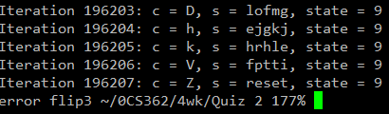

**Run 2:**

**~30 seconds, ~1,985,000 iterations**

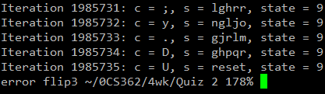

**<next page>**

**Run 3:**

**~12 seconds, ~559,000 iterations**

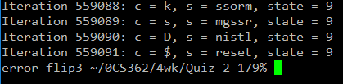

**Run 4:**

**~42 seconds, 2.25 million runs**

