Software paper for submission to the Journal of Open Research Software

To complete this template, please replace the blue text with your own. The paper has three main sections: (1) Overview; (2) Availability; (3) Reuse potential.

Please submit the completed paper to: editor.jors@ubiquitypress.com

(1) Overview

Title
AvoPlot: An extensible scientific plotting tool based on matplotlib

Paper Authors
1. Peters, Nial

Paper Author Roles and Affiliations
1. Geography Department, Cambridge University, UK

Abstract
AvoPlot is a simple to use graphical plotting program written in Python and making extensive use of the matplotlib plotting library. It can be found at http://code.google.com/p/avoplot/. In addition to providing a user-friendly interface to the powerful capabilities of the matplotlib library, it also offers users the possibility of extending its functionality by creating plug-ins. These can import specific types of data into the interface and also provide new tools for manipulating it. In this respect, AvoPlot is a convenient platform for researchers to build their own data analysis tools on top of, as well as being a useful standalone program.

Keywords
plotting, data visualisation

Introduction
The software was originally designed as a real-time visualisation program for monitoring sulphur dioxide emissions from volcanoes. However, with several different projects under way in our group which all required a different set of data manipulation tools but a similar interface to interact with them, it soon became clear that a more generic solution would be extremely useful; AvoPlot was created to fill this role.

There are already many open-source plotting programs available, however, none of these (at least that the author is aware of) address the same problems as AvoPlot. Spreadsheet programs such as OpenOffice Calc [1] and Gnumeric [2] cannot load arbitrary data types, and also lack good data navigation tools (panning, zooming etc.) for their plots. The plot viewer built into matplotlib [3], provides good data navigation tools, but has very few graphical facilities for editing plot parameters. The Veusz [4] program has a comprehensive graphical interface for creating and editing plots, as well as providing a plug-in interface to allow users to load arbitrary data types and define new analysis functions. However, Veusz includes its own plotting backend which is unlikely to be as familiar to developers as matplotlib. Furthermore, the scope for writing complex plugins is far more limited than in AvoPlot.

Essentially, AvoPlot aims to achieve two things:
- To provide a simple and intuitive graphical user interface for the matplotlib plotting library, with tools for importing common data formats.
- To provide an extensible platform that researchers can easily customise to suit their specific data visualisation and analysis requirements.

At the time of writing, AvoPlot is still at an early stage of development. However, it is already being used as a visualisation and analysis tool by several members of the Cambridge Volcanology Group [5] and the Mount Erebus Volcano Observatory [6]. Plug-ins for working with differential optical absorption spectroscopy (DOAS) data and Fourier transform infrared (FTIR) spectra are currently under development and will be published in due course.

Implementation and architecture
The software is written in pure Python [7]. Graphical interface elements are implemented using wxPython [8] and plots are created and displayed using matplotlib and its wx-agg backend.

The software consists of two major components; the user interface (UI) and the plug-in system. The UI provides a generic graphical interface to much of matplotlib's functionality, allowing users to change plot parameters (such as line styles, colours etc.) without needing to write any code. It also allows users to interact with any plug-ins that have been installed. An overview of the UI is shown in Figure 1.

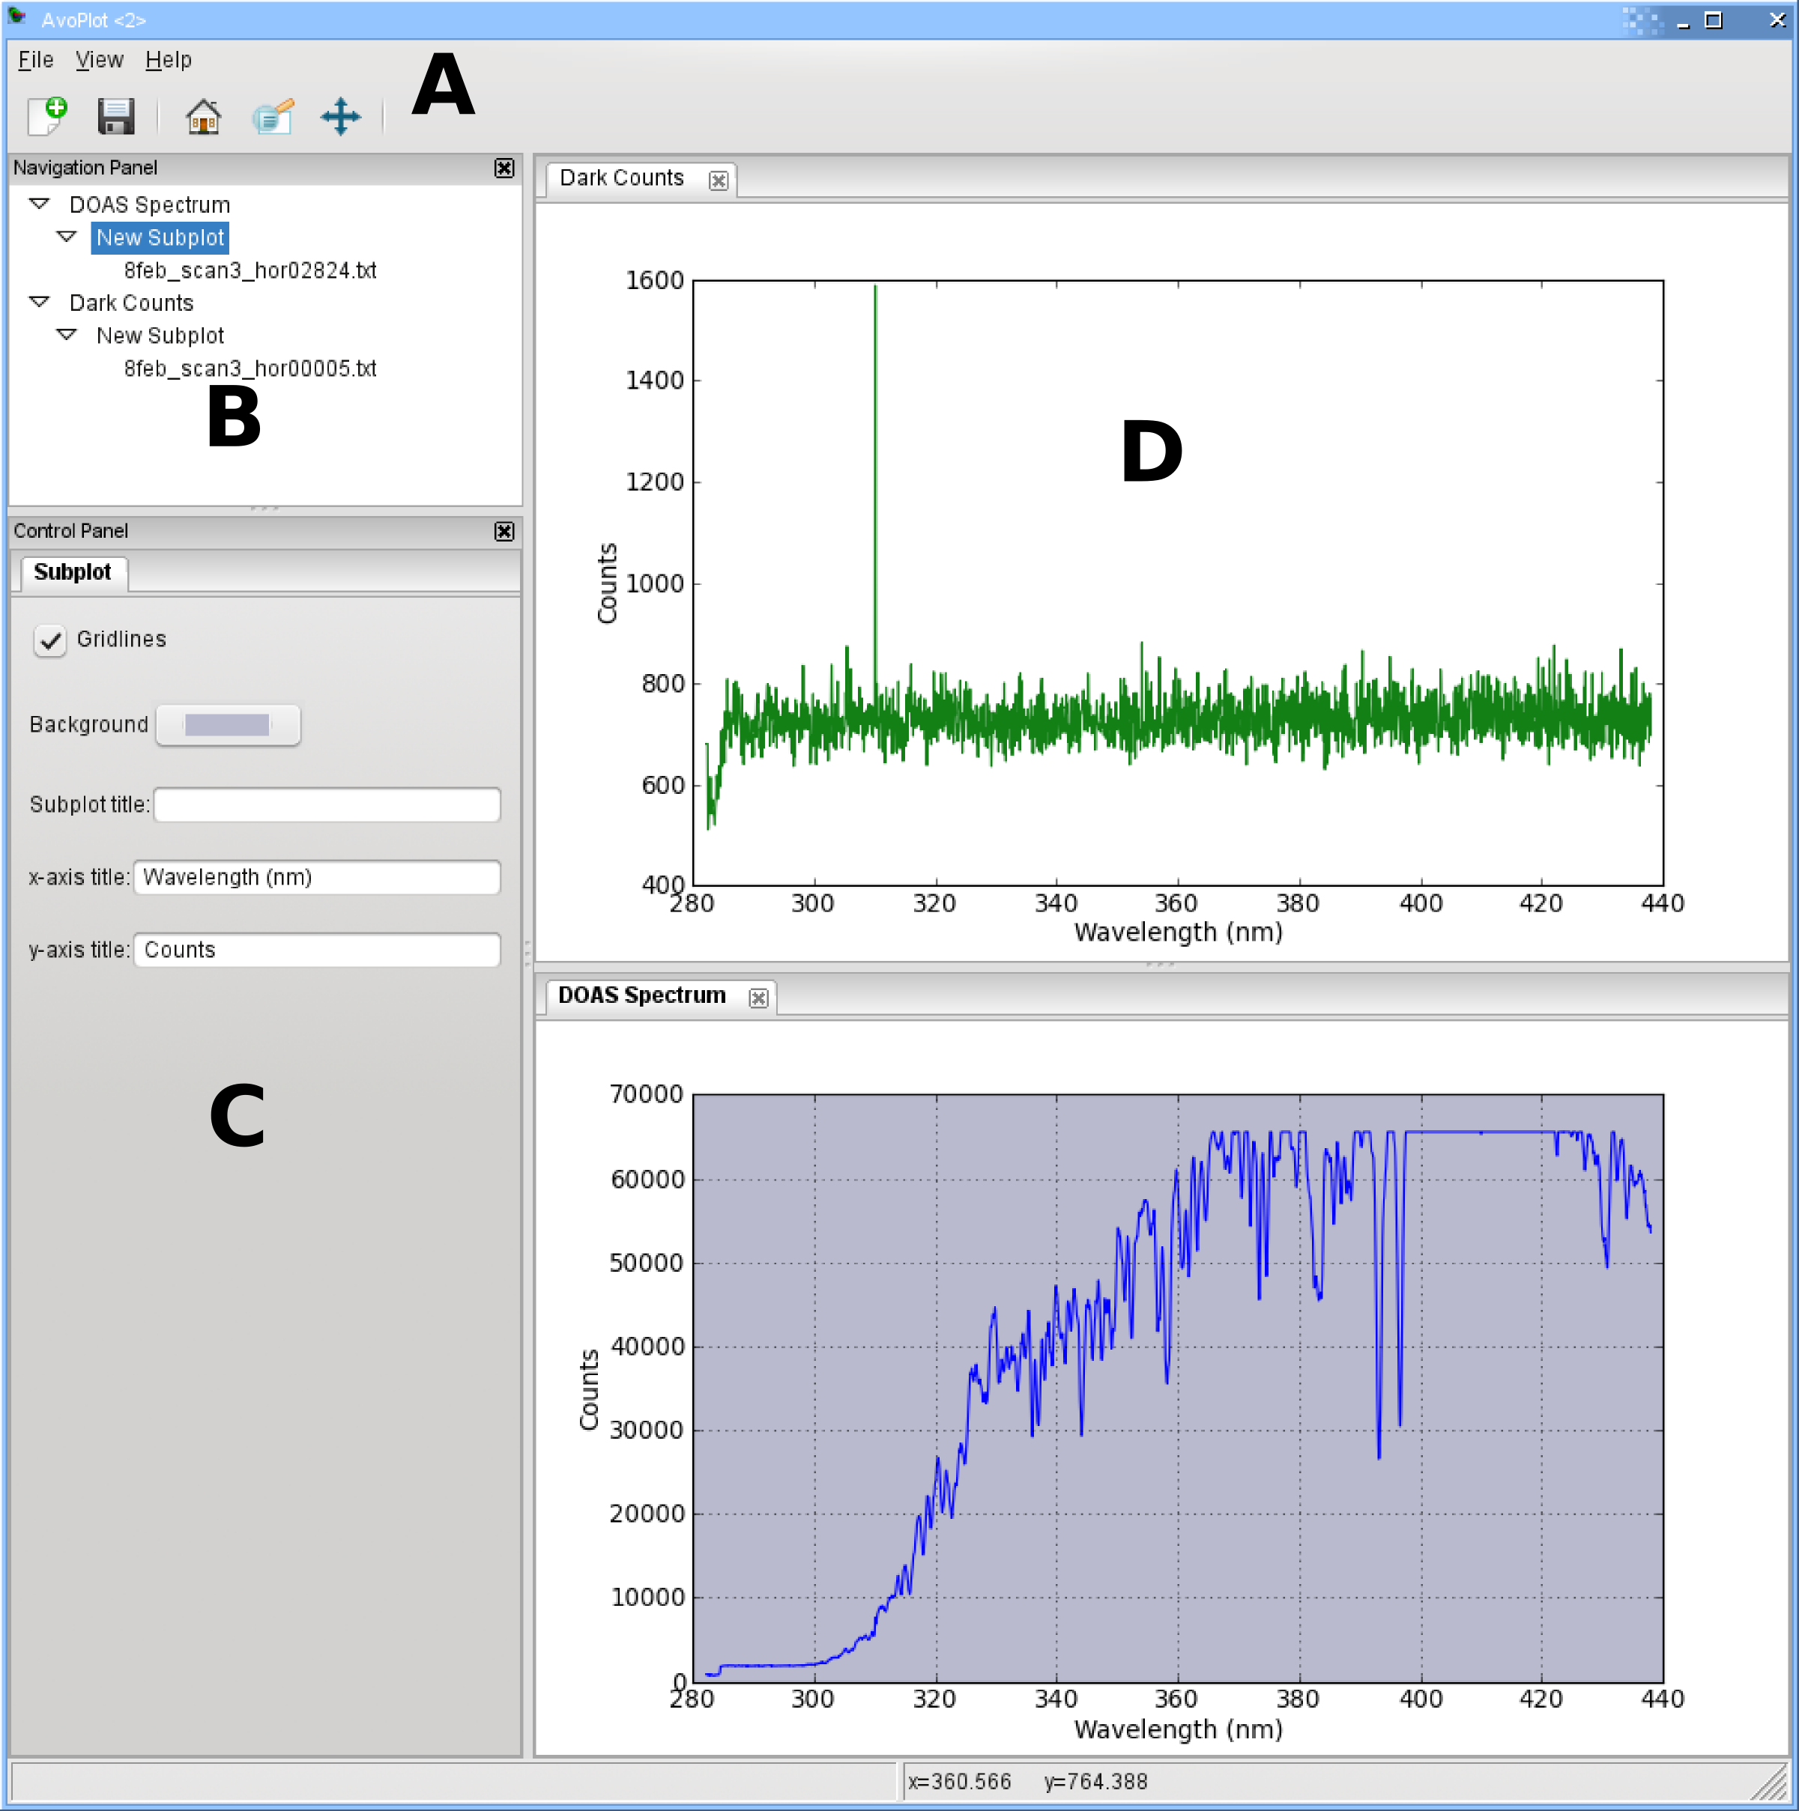

Figure 1. Screen-shot of the AvoPlot user interface showing its main components. A) Toolbar providing the “standard” matplotlib pan and zoom controls, as well as the possibility to save plots as image files. B) Navigation panel allowing selection of different plots, axes and data series. C) Control panel providing controls for editing plot properties such as axis titles, line styles etc. Any tools provided by the plug-in for the currently selected plot are also displayed here under a different tab. D) Tabbed plot window with a variable number of panes allowing multiple plots to be viewed simultaneously.

The plug-in system is intended to give developers a simple way both to import their specific data into the UI, and to provide tools for manipulating it. Details of how to write plug-ins are given in the AvoPlot documentation which can be found in the “doc” folder of the source distribution, or online as part of the software archive. Furthermore, example plug-ins can be found in the “examples” folder of the source distribution.

AvoPlot comes with a simple file import plug-in which will be installed automatically. Currently, this can only load text files containing columns of numerical data. However, it will be extended in future releases to support other file types such as CSV, Excel spreadsheets etc.

Quality control
Functional testing has been carried out on both Linux and Microsoft Windows (XP and 7) using Python 2.7.

(2) Availability

Operating system
The software has been successfully tested on Linux and Microsoft Windows (XP and 7). There is no reason why it will not run on any system that can run Python, although no guarantees are made to this effect.

Programming language
Python (>=2.6, currently untested on 3.x)

Additional system requirements
NA

Dependencies
1. wxPython (>=2.8.10)
2. Numpy (>= 1.4)
3. matplotlib (>=1.2)
4. python-magic (>= 0.4.3)

List of contributors
- Nial Peters – coding, testing.
- Yves Mousallam – artwork.
- Kayla Iacovino – testing.

Software location:
Archive (e.g. institutional repository, general repository) (required)
Name: Google Code
Persistent identifier: http://code.google.com/p/avoplot/
Licence: GNU General Public License version 3
Publisher: Nial Peters
Date published: 10/03/13

Language
English

(3) Reuse potential
As a standalone program, AvoPlot provides an easy to use, generic plotting tool capable of producing publication quality figures. Although the current feature set is relatively limited, future development will focus on exposing more of matplotlib's functionality through AvoPlot's UI. This will give users access to matplotlib's extensive capabilities without requiring them to write Python scripts. In this respect, the program has a high reuse potential “as is”.

However, the main reuse potential for AvoPlot comes from its plug-in based architecture. With just a few lines of relatively simple code, researchers can write a plug-in that will plot their specific data set in the AvoPlot UI. They can then take advantage of a feature-rich plot editing environment to customise their plot without having to edit or run scripts. Furthermore, AvoPlot plug-ins are distributed using Python's distutils system, making it simple for other researchers (who may have no programming experience) to install plug-ins written by their peers. This immediately provides them with a familiar, graphical interface with which to work with scientific data sets that may be in a format difficult to import with mainstream plotting programs.

In addition to data import, AvoPlot plug-ins also allow researchers to easily integrate their own data manipulation and analysis tools into the AvoPlot UI. The aim is to encourage researchers to make analysis tools that they create user-friendly and accessible for others who may not be programmers. AvoPlot achieves this by providing a framework which enables researchers to easily incorporate their analysis tools into its graphical user interface without them having to write extensive UI code of their own.

Acknowledgements

The author wishes to thank his supervisor Prof. Clive Oppenheimer for his support of the project.

Funding statement
Much of the initial development was conducted whilst on fieldwork supported by the Royal Geographical Society (with IBG) with a Geographical Fieldwork Grant, and support from Antofagasta plc via the University of Cambridge Centre for Latin American Studies.

References

[1] ‘Apache OpenOffice Calc’. [Online]. Available: http://www.openoffice.org/product/calc.html. [Accessed: 19-Jul-2013].
[2] ‘GNOME Office / Gnumeric - Welcome to Gnumeric!’ [Online]. Available: https://projects.gnome.org/gnumeric/. [Accessed: 19-Jul-2013].
[3] J. D. Hunter, ‘Matplotlib: A 2D graphics environment’, Comput. Sci. Eng., vol. 9, no. 3, pp. 90–95, 2007.
[4] ‘Veusz - A Scientific Plotting Package’. [Online]. Available: http://home.gna.org/veusz/. [Accessed: 19-Jul-2013].
[5] ‘CVG – Cambridge Volcanology Group | Undertaking pioneering research into the processes, monitoring, and impacts of volcanism’. [Online]. Available: http://www.volcano.group.cam.ac.uk/. [Accessed: 18-Jul-2013].
[6] ‘MEVO | Mount Erebus Volcano Observatory’. [Online]. Available: http://erebus.nmt.edu/. [Accessed: 18-Jul-2013].
[7] Python. Python Software Foundation, http://www.python.org, 2013.
[8] R. Dunn, wxpython: wxwindows for python. http://www.wxpython.org. 2003.

Copyright Notice
Authors who publish with this journal agree to the following terms:

Authors retain copyright and grant the journal right of first publication with the work simultaneously licensed under a Creative Commons Attribution LicenseCreative Commons Attribution License that allows others to share the work with an acknowledgement of the work's authorship and initial publication in this journal.

Authors are able to enter into separate, additional contractual arrangements for the non-exclusive distribution of the journal's published version of the work (e.g., post it to an institutional repository or publish it in a book), with an acknowledgement of its initial publication in this journal.

By submitting this paper you agree to the terms of this Copyright Notice, which will apply to this submission if and when it is published by this journal.

