Notes and conclusions from last meeting: 13. April 2011
Extend the modeling tool with the following features (prioritized)
- Build importer/parser of existing NAV source code to the model
- Extend metamodel if usefull
- Button, bundle parser with DSL
- Deployment / Packaging
Last chance for start writing is 1. june
Until next meeting 4. May 5 pm: Import og skriveplan (sende skriveplan til Andrzej og Helge inden mødet)

What has happened to the Modeling Tool since the last meeting?
The meta model has been extended to reflect existing tables and fields and differentiate them from new tables and fields.
The domain elements of the metamodel now consist of
- Existing Table and New Table that inherit from Table
- Existing Field and New Field that inherit from Field
- Existing Table has Existing Field and New field
- New Table has New Field only

A separate tool for parsing existing NAV code to the model has been created.

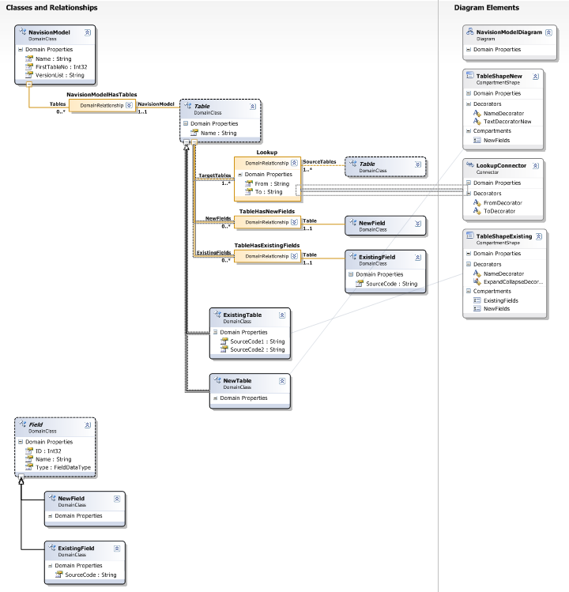

Existing Table and Existing Field has domain properties to hold NAV source code.

Example
Exporting the Customer table from Navision to text format
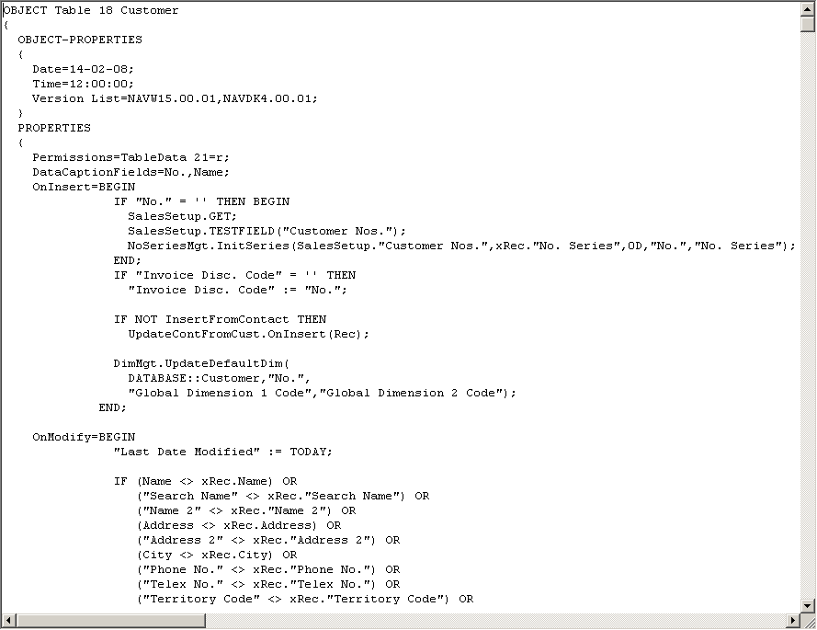

Run it though the parser results in this model xml file
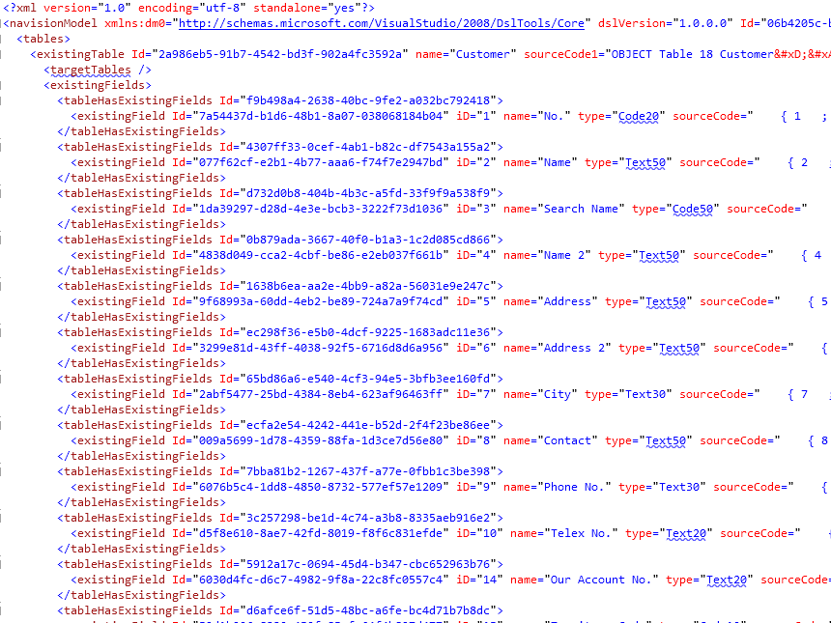

Which can be opened with the DSL and it will render the Customer table as this.
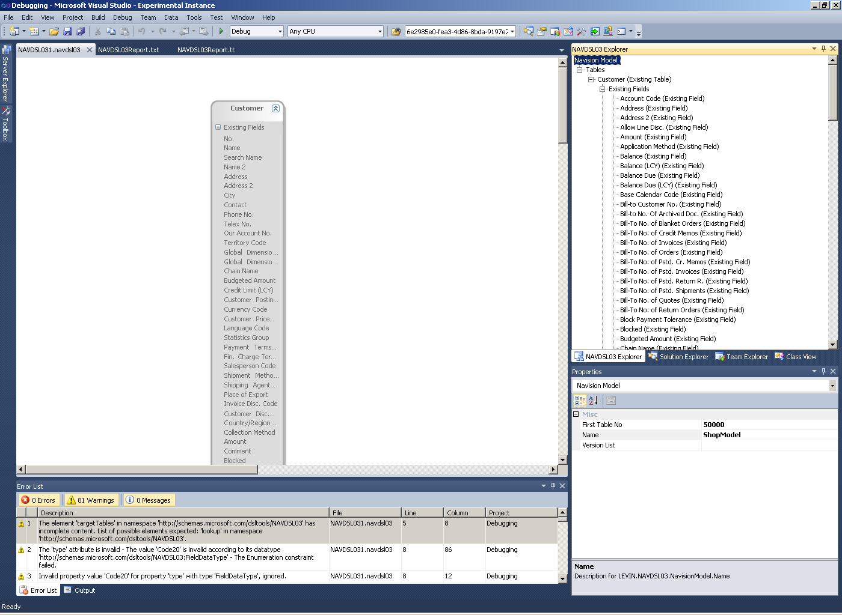

Collapsing the Existing Fields compartment and adding a New Field:
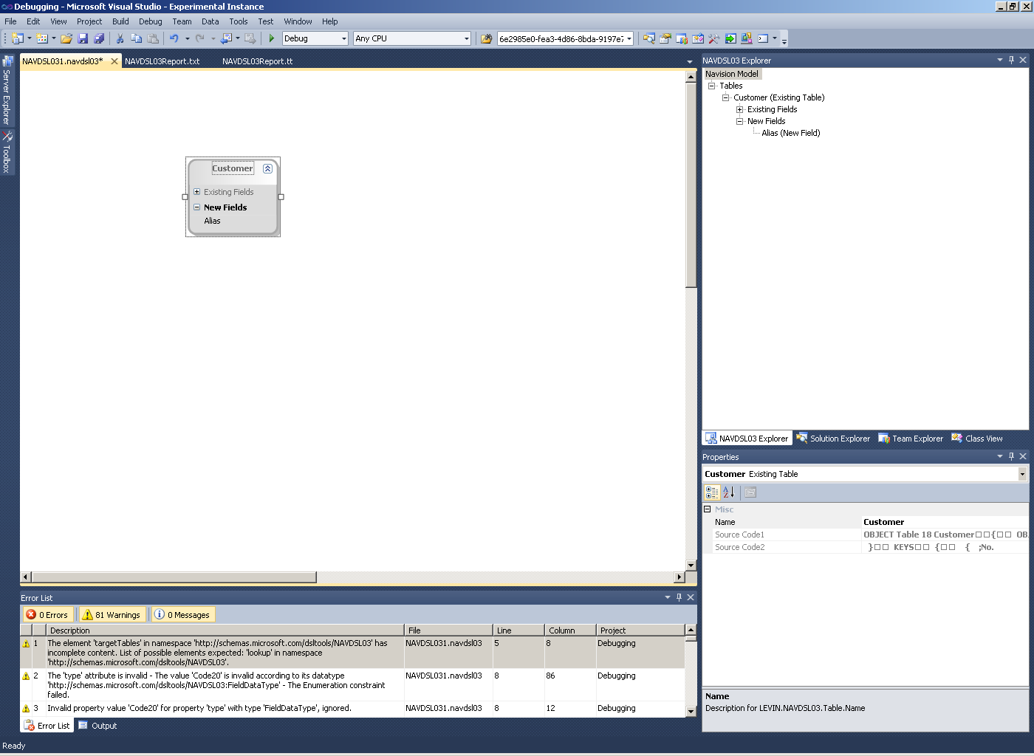

Add new a new table with a few fields and add a Lookup
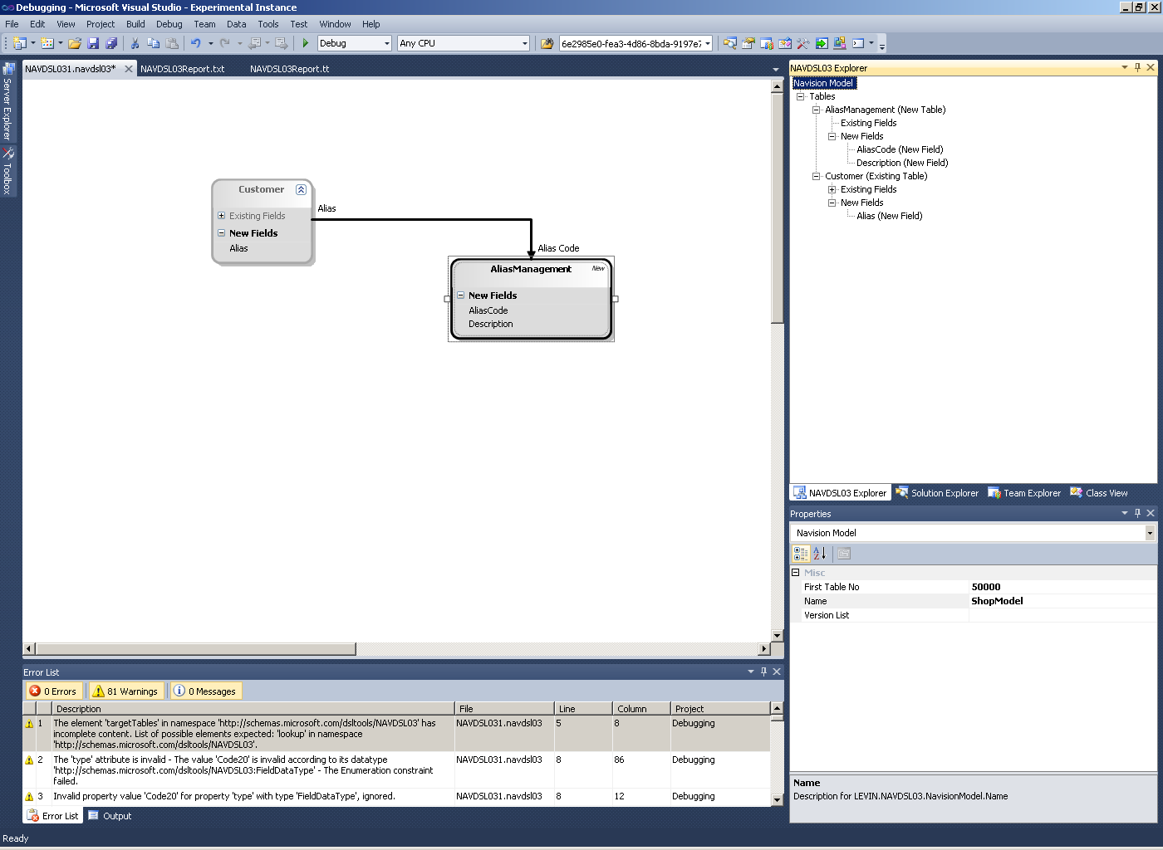

Run the model through the Code Generator.
The result is NAV code for the existing Customer table with code for new field and the Lookup injected into the existing NAV code:
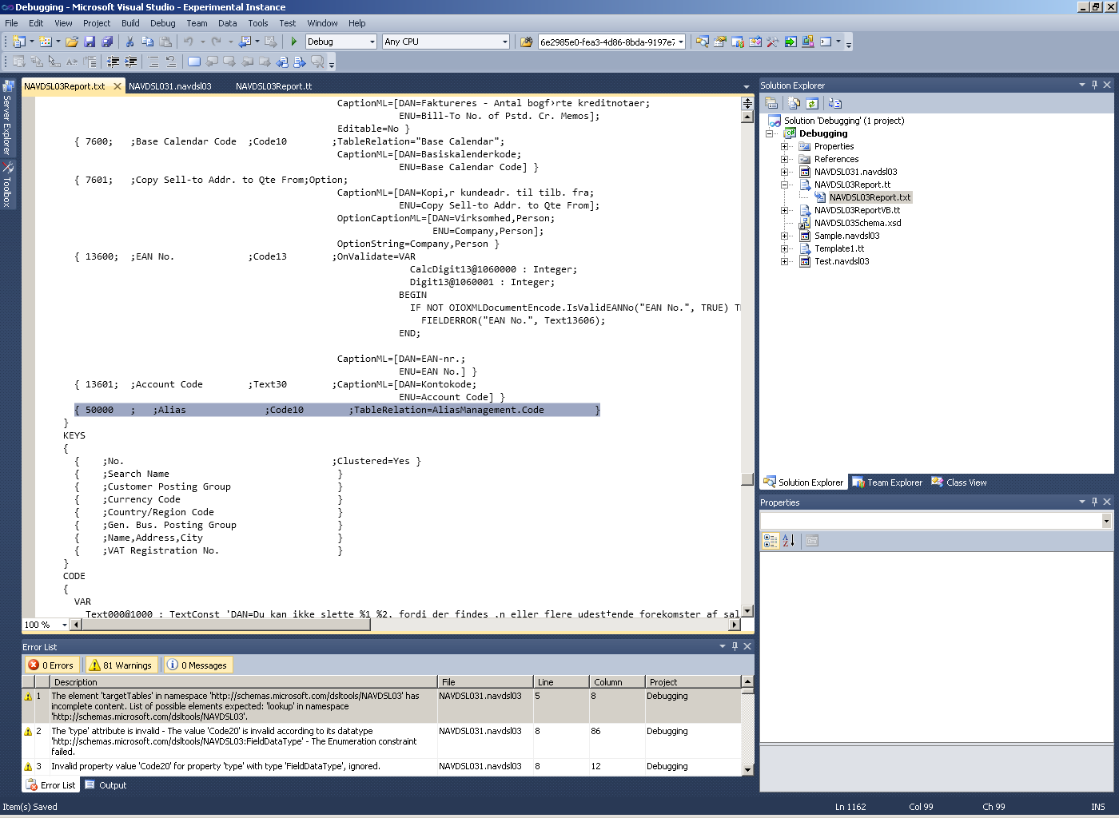

And NAV code for the new table and the card form and the list form as well:
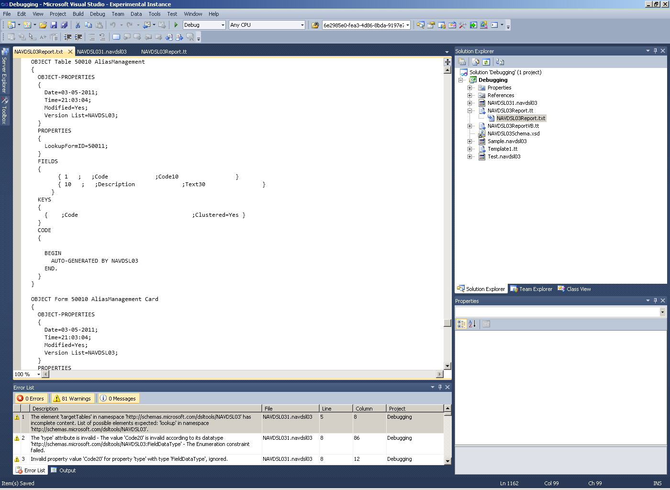

The generated NAV source code file can be imported into Navision and compiled.
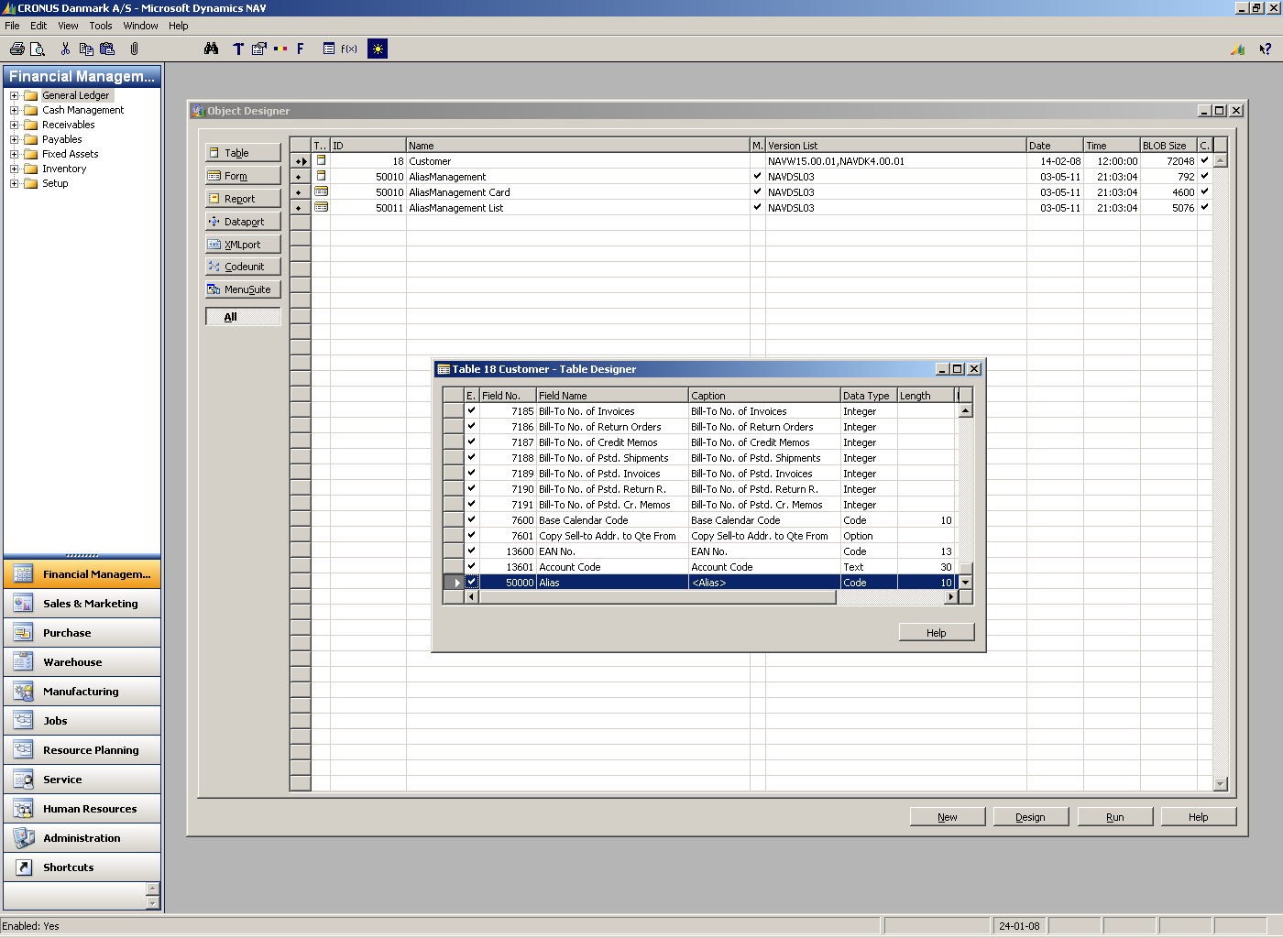

Run the Alias Management Card form
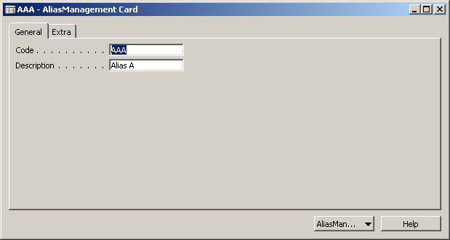

Run the Customer table and “lookup” the Alias code
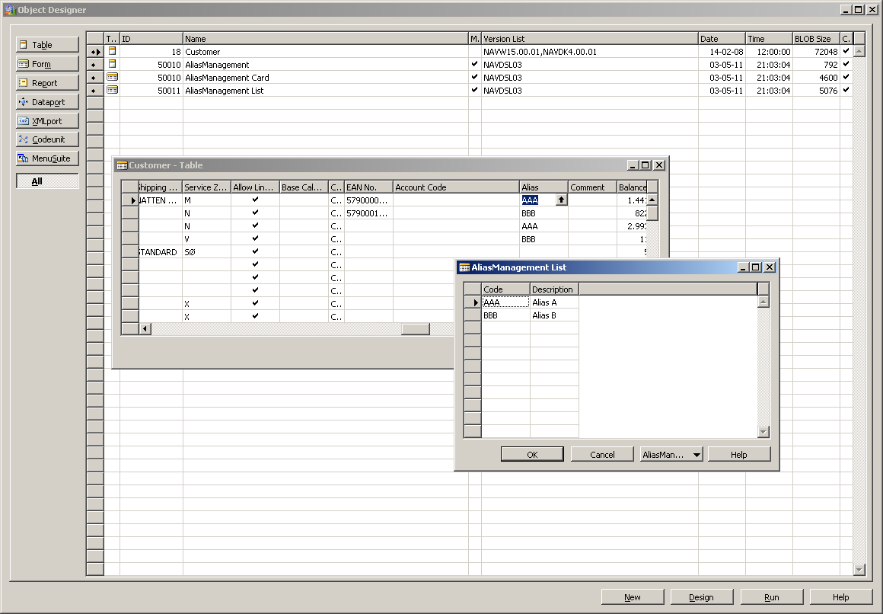
The new Alias field of the Customer table is not available through the Customer Card nor the Customer List as no NAV code for forms is generated for existing tables.

Outstanding issues:

Parser
To-do: Must be able to capture lookups from Existing fields in Existing tables within the NAV source code file.
To-do: Would be nice if I could find a way to manipulate the model directly in the "In Memory Store" instead of going through the model xml file.

DSL
To-do: Would be nice to be able to model lookups between fields (instead of between tables as of now)
To-do: Validations must be defined and implemented.
To-do: Must be able to prevent the user from deleting existing tables, fields and lookups
To-do: Must be able to prevent the user from adding existing fields to existing fields

Code Generator
To-do: Would be nice to be able to generate Form code for existing tables.

General:
To-do: Bundle the Parser with the DSL and the Code Generator in a nice package.
To-do: Installation and deployment.

Writing Plan

Introduction

Present interviews
Present and argue for chosen requirments

Present theory
- Modeling theory
- Code Generation theory

Present and argue for chosen modelling tool
present and argue for chosen Code generation Theory/Method/Strategy

Present and argue for meta model design
Present and argue for presentation layer design
Present and argue for code generation algoritm

Helge: Give Example like above

Present how to model selected Navision features derived from interviws

Present second round of interview

Conclusion﻿

