Breanna Stewart
2025 Season Performance Analysis
New York Liberty Basketball Operations

Executive Summary
This report provides a comprehensive analysis of Breanna Stewart's shooting performance during the 2025 WNBA regular season. The analysis examines overall efficiency, shot selection patterns, situational performance, and provides data-driven recommendations for the 2026 season.

Season Statistics Overview
Metric | Value | League Comparison
Total Field Goal Attempts | 408 | High Volume
Field Goal Percentage | 46.1% | Above Avg (43.9%)
2-Point Percentage | 52.0% | Above Avg (49.8%)
3-Point Percentage | 24.1% | Below Avg (33.8%)
Clutch FG% (Last 5 min Q4) | 54.1% | Above Avg (42.0%)

Performance by Quarter
Q1 | Q2 | Q3 | Q4
46.7% (135 FGA) | 45.1% (91 FGA) | 46.1% (102 FGA) | 46.3% (80 FGA)

Shot Distribution Analysis
The shot chart below illustrates Breanna's shot locations throughout the 2025 season. Green markers indicate made shots, while red markers indicate misses. This visualization reveals shooting tendencies and efficiency across different court zones.
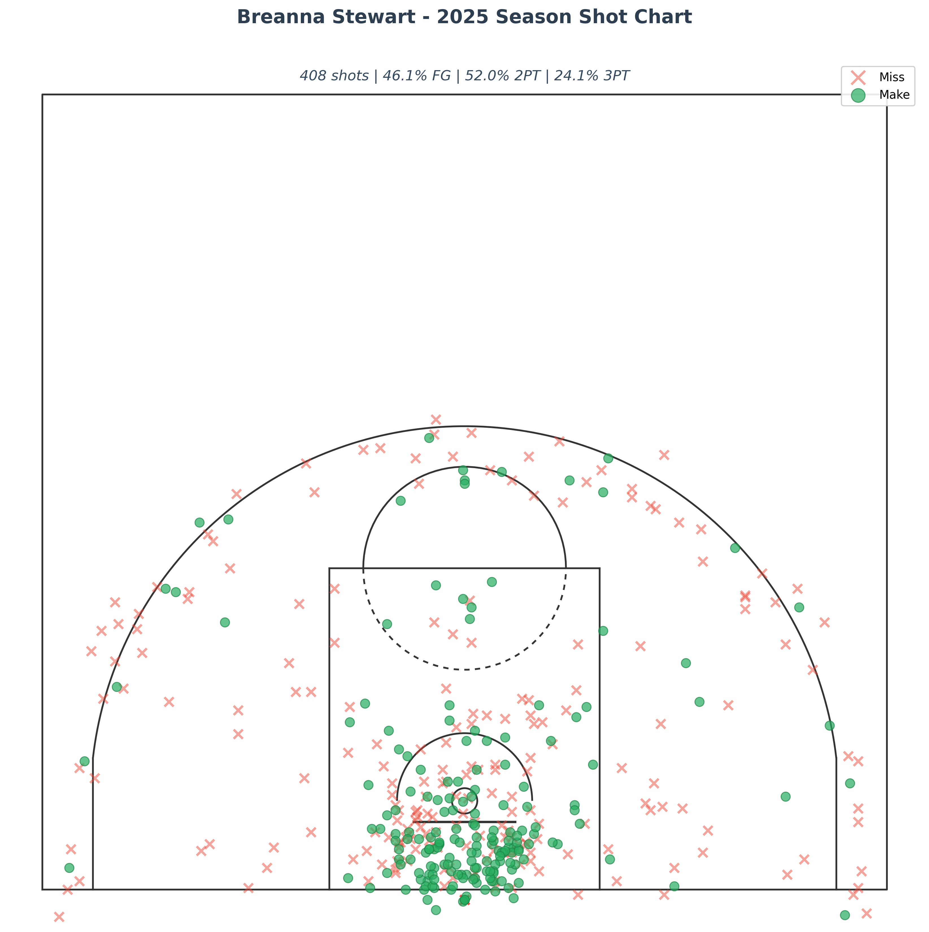

Clutch Performance Analysis
Breanna attempted 37 shots in clutch situations (last 5 minutes of 4th quarter in close games), converting 20 for a 54.1% field goal percentage.
This represents a POSITIVE differential of 8.0 percentage points compared to overall season efficiency.

Key Observations
- Shot volume: 408 attempts across 31 games (avg 13.2 FGA/game)
- Shot selection: 21.3% of attempts from 3-point range
- More efficient inside the arc (52.0% 2PT vs 24.1% 3PT)
- Q1 was strongest quarter (46.7% FG)

Development Recommendations for 2026
Based on Breanna's 2025 performance data, the following areas present opportunities for development and optimization:
- Shot Selection: Three-point efficiency (24.1%) is significantly below two-point efficiency (52.0%). Recommend working with coaching staff to identify higher-quality three-point looks or increasing paint touches where Breanna is more efficient. Focus on catch-and-shoot opportunities vs. off-the-dribble attempts.
- Late-Game Execution: Clutch performance (54.1%) exceeds season average by 8.0 points—demonstrating excellent composure under pressure. This is a competitive advantage to leverage in critical possessions. Consider increased usage in late-game situations.
- Film Study Focus: Conduct detailed review of missed shots by court location to identify mechanical adjustments or defensive coverage patterns. Pay particular attention to sequences where efficiency deviated significantly from season averages.
- Off-Season Development: Work with player development staff to create targeted shooting workouts that replicate game conditions in lower-efficiency zones. Incorporate decision-making drills that emphasize shot quality assessment under time pressure.

Report generated using official WNBA Stats API data

