Sabrina Ionescu
2025 Season Performance Analysis
New York Liberty Basketball Operations

Executive Summary
This report provides a comprehensive analysis of Sabrina Ionescu's shooting performance during the 2025 WNBA regular season. The analysis examines overall efficiency, shot selection patterns, situational performance, and provides data-driven recommendations for the 2026 season.

Season Statistics Overview
Metric | Value | League Comparison
Total Field Goal Attempts | 573 | High Volume
Field Goal Percentage | 40.1% | Below Avg (43.9%)
2-Point Percentage | 49.3% | Below Avg (49.8%)
3-Point Percentage | 29.9% | Below Avg (33.8%)
Clutch FG% (Last 5 min Q4) | 35.4% | Below Avg (42.0%)

Performance by Quarter
Q1 | Q2 | Q3 | Q4
43.3% (150 FGA) | 37.4% (147 FGA) | 42.6% (141 FGA) | 37.0% (135 FGA)

Shot Distribution Analysis
The shot chart below illustrates Sabrina's shot locations throughout the 2025 season. Green markers indicate made shots, while red markers indicate misses. This visualization reveals shooting tendencies and efficiency across different court zones.
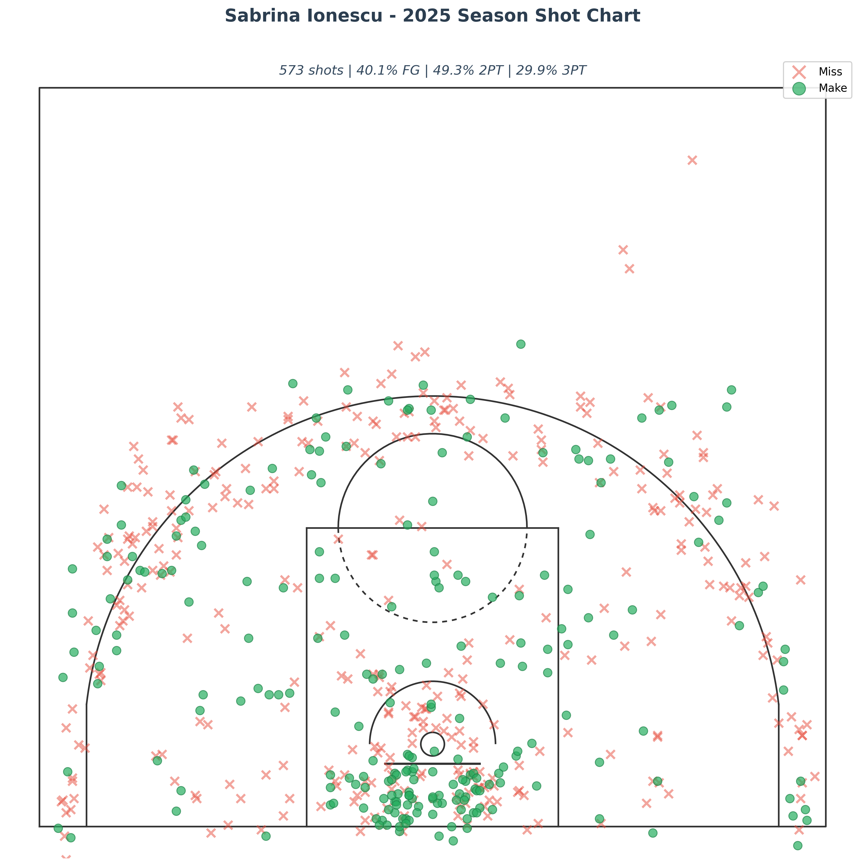

Clutch Performance Analysis
Sabrina attempted 79 shots in clutch situations (last 5 minutes of 4th quarter in close games), converting 28 for a 35.4% field goal percentage.
This represents a NEGATIVE differential of 4.7 percentage points compared to overall season efficiency. This isn’t uncommon for primary ball-handlers facing increased defensive attention. Film study would reveal whether defenses are showing two to the ball or whether different play designs could create higher-quality looks.

Key Observations
- Shot volume: 573 attempts across 38 games (avg 15.1 FGA/game)
- Shot selection: 47.3% of attempts from 3-point range
- More efficient inside the arc (49.3% 2PT vs 29.9% 3PT)
- Q1 was strongest quarter (43.3% FG)

Development Recommendations for 2026
Based on Sabrina's 2025 performance data, here are key considerations for optimizing her offensive impact:
- Shot Selection & Play Design: Sabrina's two-point efficiency (49.3%) significantly outpaces her three-point shooting (29.9%). This presents two potential development paths:
- Traditional approach: Work on three-point mechanics and shot selection to bring that percentage up closer to league average (33.8%)
- Strengths-based approach: Lean into her ability to get downhill. Design more actions that get her attacking the paint where she's nearly 50%, using drives to collapse defenses and create for others
Both philosophies are valid—the choice depends on team offensive system and what film reveals about defensive coverages she's facing. Is she taking contested pull-up threes because that's what defenses are giving? Or could different play calls create higher-quality looks?

- Film Study Focus: The next step is detailed film breakdown to understand the why behind the numbers:
      - Are defenses showing two to the ball and daring role players to beat them?
      - Is the roller open when she's pulling from deep?
      - What types of three-point attempts are highest percentage (catch-and-shoot vs. off-the-dribble)?
      - How do defensive coverages change in clutch situations?
      - This would inform whether adjustments should focus on shot mechanics, play design, or shot selection decision-making.

- Off-Season Development: Off-season work could emphasize:
      - Game-speed shooting workouts that replicate high-pressure decision points
      - Film sessions analyzing when to attack vs. when to shoot
      - Working with coaching staff to identify actions that consistently generate her highest-quality looks

Context matters: As the franchise cornerstone and primary initiator, Sabrina's role is critical. The goal isn't reducing her decision-making—it's optimizing shot quality while maintaining her as the engine of the offense. Film study paired with this statistical foundation would create a targeted development plan that respects her talent level while addressing efficiency opportunities.

Report generated using official WNBA Stats API data

