Jonquel Jones
2025 Season Performance Analysis
New York Liberty Basketball Operations

Executive Summary
This report provides a comprehensive analysis of Jonquel Jones's shooting performance during the 2025 WNBA regular season. The analysis examines overall efficiency, shot selection patterns, situational performance, and provides data-driven recommendations for the 2026 season.

Season Statistics Overview
Metric | Value | League Comparison
Total Field Goal Attempts | 306 | Moderate Volume
Field Goal Percentage | 49.0% | Above Avg (43.9%)
2-Point Percentage | 53.6% | Above Avg (49.8%)
3-Point Percentage | 42.4% | Above Avg (33.8%)
Clutch FG% (Last 5 min Q4) | 55.6% | Above Avg (42.0%)

Performance by Quarter
Q1 | Q2 | Q3 | Q4
56.7% (97 FGA) | 39.4% (66 FGA) | 41.5% (82 FGA) | 57.4% (61 FGA)

Shot Distribution Analysis
The shot chart below illustrates Jonquel's shot locations throughout the 2025 season. Green markers indicate made shots, while red markers indicate misses. This visualization reveals shooting tendencies and efficiency across different court zones.
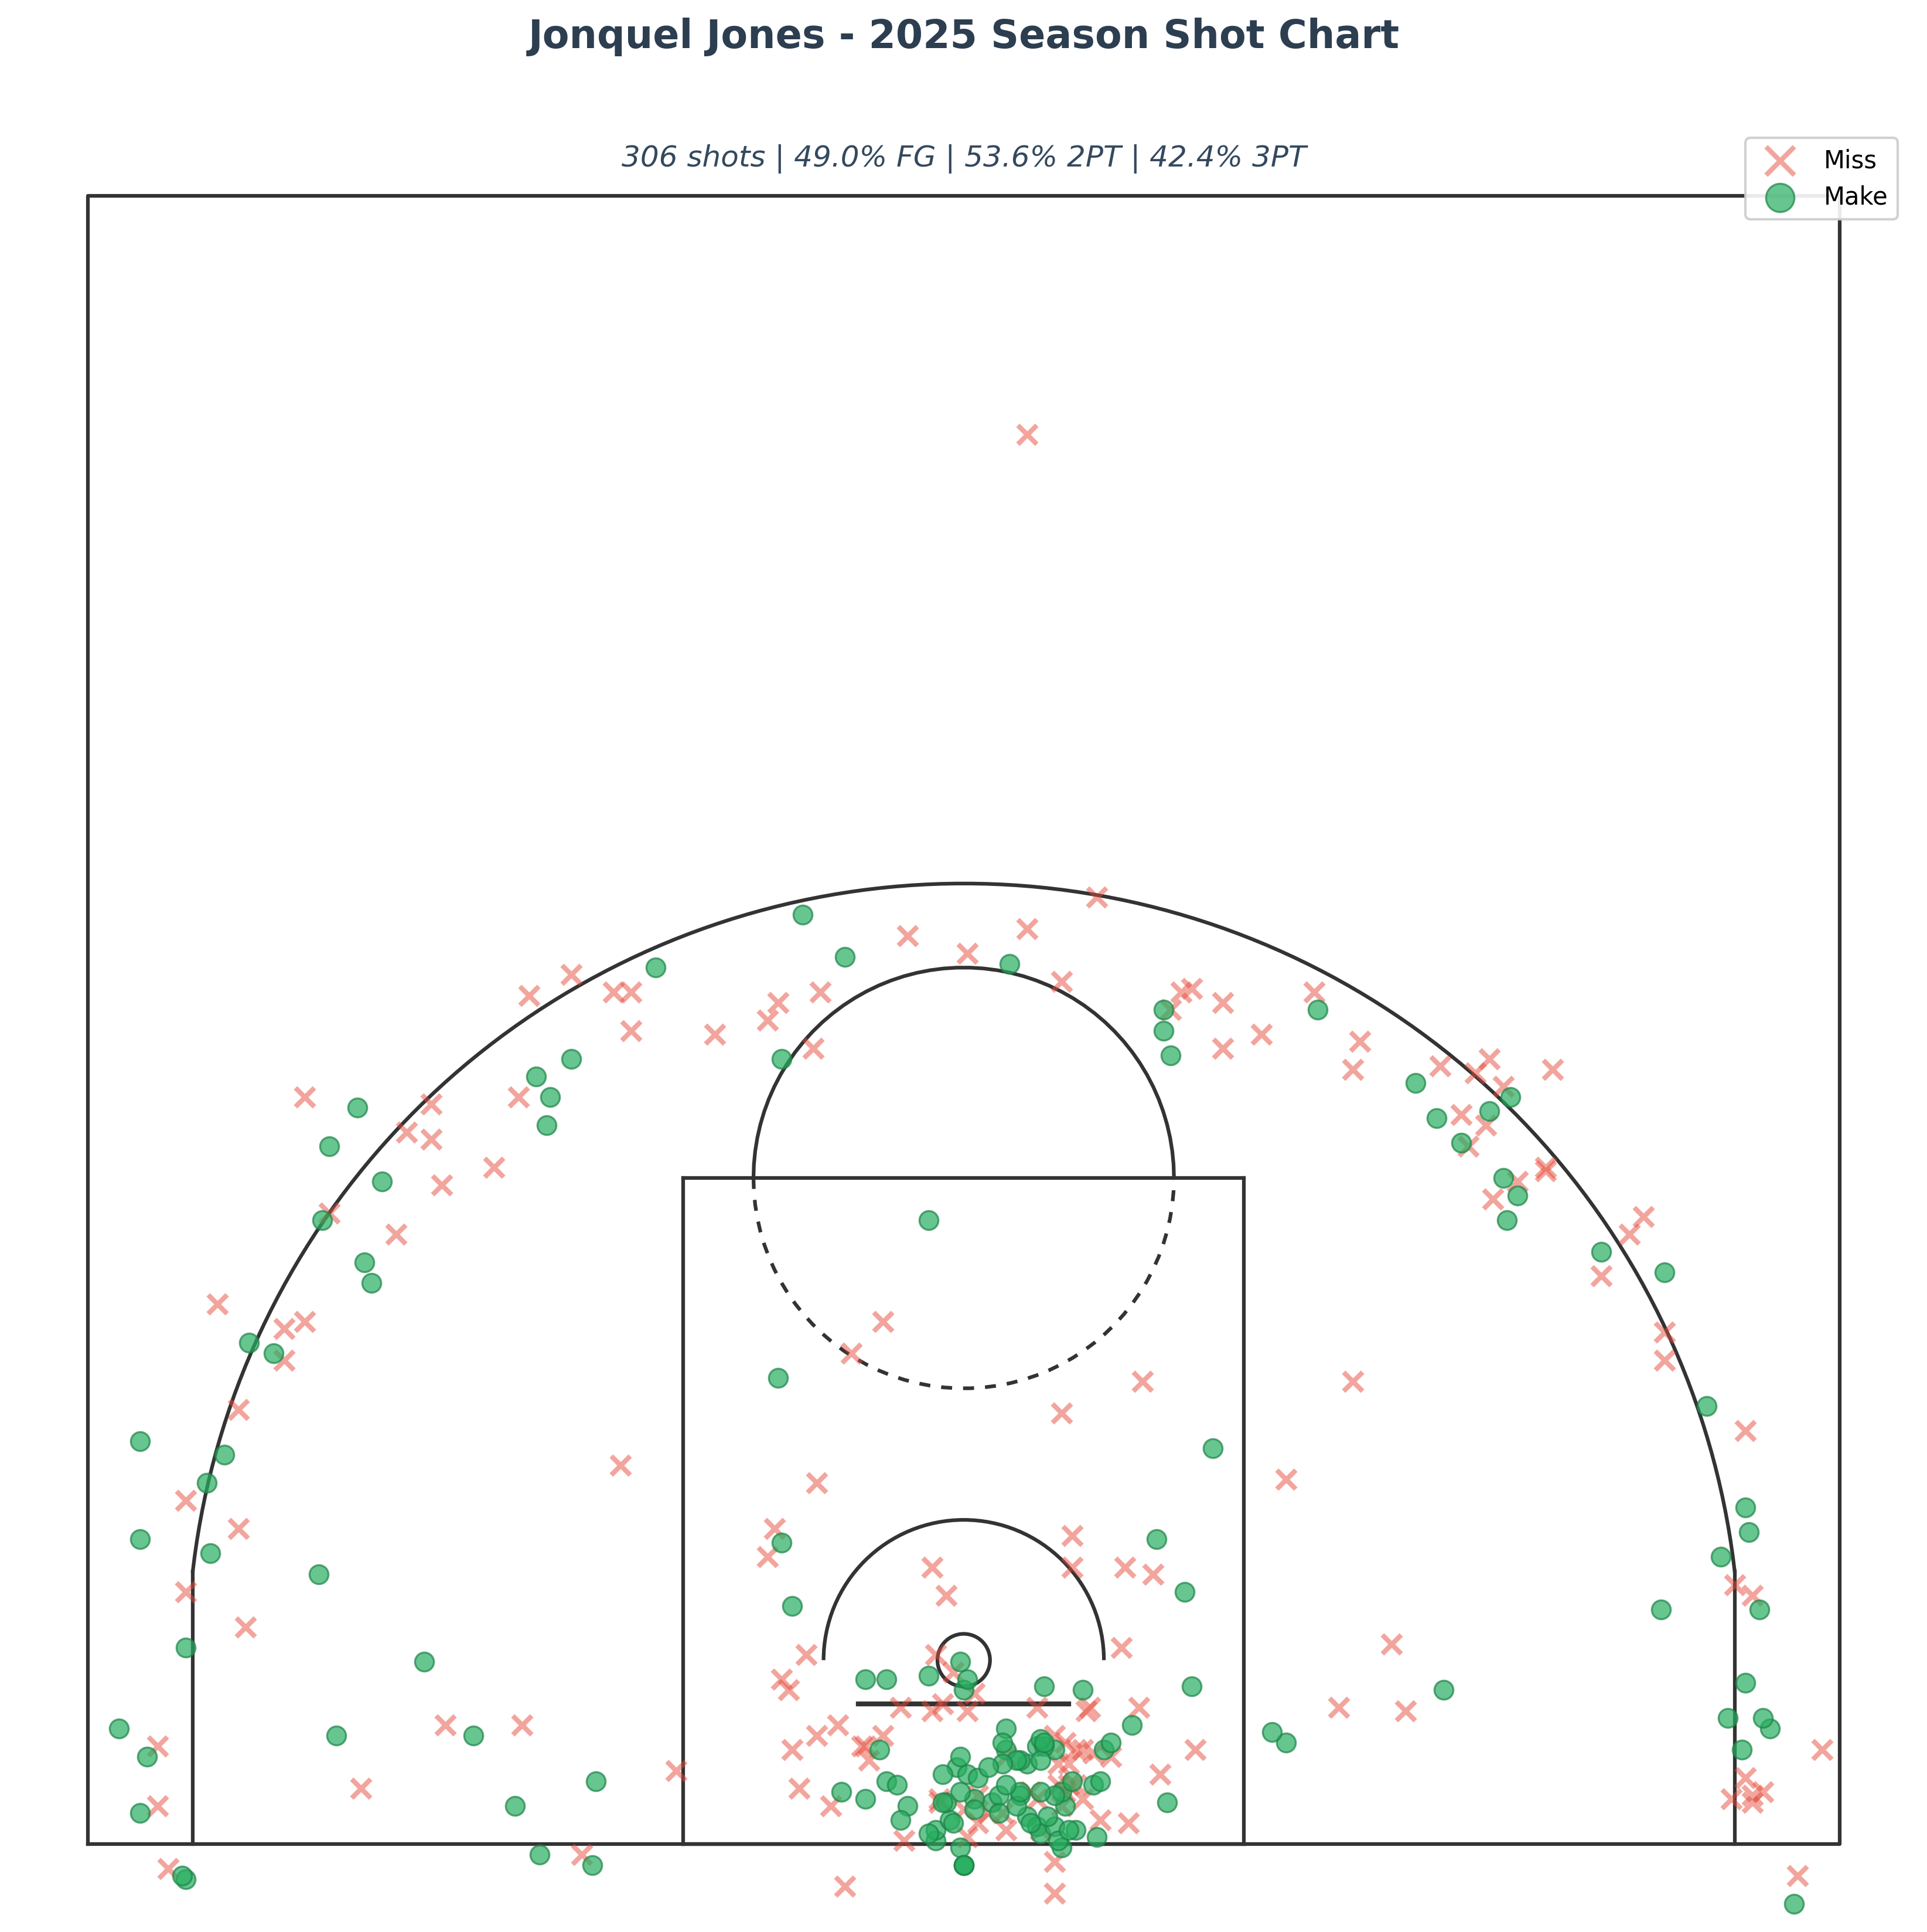

Clutch Performance Analysis
Jonquel attempted 27 shots in clutch situations (last 5 minutes of 4th quarter in close games), converting 15 for a 55.6% field goal percentage.
Most players' efficiency drops in Q4 due to fatigue and defensive intensity. Jones's spikes to 57.4%. She's one of the rare players who gets better as the game goes on.

Key Observations
- Shot volume: 306 attempts across 31 games (avg 9.9 FGA/game)
- Shot selection: 40.8% of attempts from 3-point range
- More efficient inside the arc (53.6% 2PT vs 42.4% 3PT)
- Q4 was strongest quarter (57.4% FG)

Development Recommendations for 2026
Based on Jonquel's 2025 performance data, the following areas present opportunities for development and optimization:
Jones's versatility creates several offensive options:
- Spain pick-and-rolls with Sabrina (elite shooter rolling out)
- Flare screens for catch-and-shoot threes
- Post-ups against smaller guards who switch onto her
- Late-clock bailout option (high efficiency, low turnover risk)
Film study would identify which defensive coverages create the best opportunities for each action.
Final note: Jones gives you a low-risk, high-reward clutch option. She's not going to demand the ball or force bad shots—but when you need a bucket and defenses are loading up on Sabrina, JJ's efficiency suggests she should be in the conversation.

Report generated using official WNBA Stats API data

