**Nonlinear Photonic Quantum Computer**

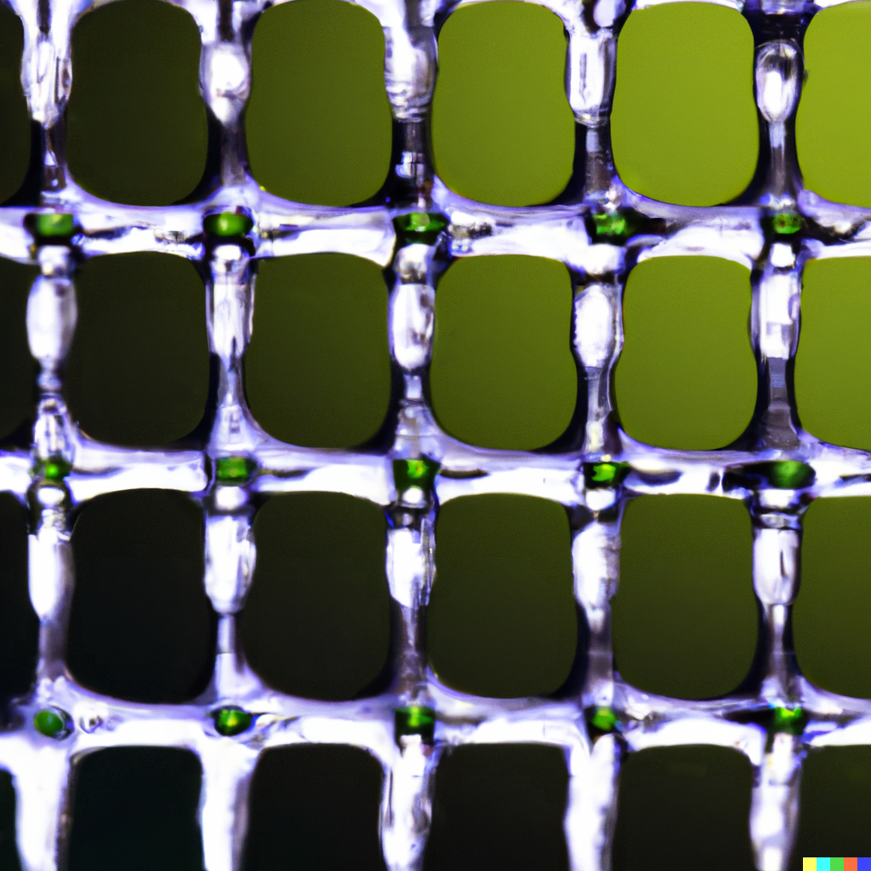

*Overview:* The Nonlinear Photonic Quantum Computer (NPQC) is a state-of-the-art quantum computing system designed to harness the power of photonic qubits trapped within dynamic optical traps. This advanced system not only generates qubits but also performs complex quantum calculations, leveraging entangled photon pairs created at different frequencies. The NPQC is designed to be compatible with a wide range of quantum devices and laboratory setups, making it an essential tool for researchers in the field of quantum computing and photonics.

*Engineering Compatibility*

**Modularity and Scalability:** The NPQC is designed to be modular and scalable, enabling seamless integration into various experimental setups. The system is also compatible with a variety of quantum devices, including Multi-Frequency SPDC Sources, quantum gates, qubit preparation and measurement subsystems, and quantum state tomography tools.

**User-Friendly Interface:** The NPQC features an intuitive graphical interface for simplified operation and management. Researchers can easily control the system and make real-time adjustments.

**Safety Features:** To ensure safe and secure operation, the NPQC incorporates safety interlocks and emergency shutdown procedures, adhering to safety standards and quantum experimentation guidelines.

*Scientific Compatibility*

**Versatile Quantum Calculations and Teleportation:** The NPQC supports a wide range of quantum calculations and teleportation experiments, including parallel frequency entanglement, frequency selection, target location, real-time coordination, teleportation execution, and quantum state analysis.

**Scalable Standing Wave Mechanism:** The shape of the optical trap, which holds photonic qubits, is determined by the standing wave of light created within the integrated photonic circuit. This standing wave of light is produced by interfering two light waves traveling in opposite directions. The interference pattern generates a high-intensity region at the center of the trap, effectively trapping photons.

The optical trap's mathematical description involves the superposition of electric fields (E1 and E2) of interfering light waves. The intensity (I) of the standing wave of light results from the superposition of E1 and E2. Constructive interference creates a high-intensity region at the trap's center. The trap's shape depends on light wavelength and the angle between interfering waves, forming a standing wave pattern. The optical lattice field is a periodic potential energy field created by the standing wave, trapping photons due to lower potential energy at the center. The mathematical equation for the optical lattice field is: V(x, y, z) = -α(|E1|^2 + |E2|^2 + 2Re(E1E2^*)).

In theory, a trap that can hold an infinite number of photons is possible. However, practical limitations include:

* **Intensity of Light Waves:** The integrated photonic circuit has a threshold for light wave intensity it can handle without damage.
* **Size of the Trap:** Increasing trap size affects stability and can lead to instability.
* **Environmental Noise and Decoherence:** Noise and decoherence can cause photons to escape from the trap.

Researchers are actively developing materials, fabrication techniques, and AI algorithms to create traps capable of holding more photons, alongside quantum error correction codes tailored for photonic qubits.

*Components*

1. **Entanglement Control Interface:**
   * User-friendly graphical interface for managing entanglement processes.
   * Selection of specific frequencies and target locations within the nonlinear crystal.
2. **Frequency Coordination Algorithm:**
   * A sophisticated algorithm that synchronizes entangled photon pairs across different frequencies.
   * Optimization of entanglement based on frequency characteristics.
3. **Teleportation Module:**
   * Integration of a dedicated teleportation module.
   * Includes quantum gates, qubit preparation, and measurement subsystems.
   * Responsible for executing teleportation operations.
4. **Quantum State Verification:**
   * Advanced quantum state tomography tools for verifying the fidelity of teleported quantum states.
   * Real-time assessment and adjustments.
5. **Safety and Compliance Features:**
   * Incorporation of safety interlocks, emergency shutdown procedures, and compliance measures.

*Functionalities*

1. **Multi-frequency Operation:** The system can generate and synchronize entangled photon pairs at multiple frequencies, facilitating long-distance quantum teleportation and exploration of unique entanglement properties.
2. **Parallel Frequency Qubit Generation:** The NPQC generates qubits in parallel at different frequencies, saturating the electromagnetic spectrum. This approach allows qubits to be created at multiple energy levels for comprehensive quantum state coverage.
3. **Tailored Qubit Pumping:** Researchers have precise control over qubits generated by the NPQC, selectively pumping them to desired energy levels for tailored gate calculations with exceptional accuracy and efficiency.
4. **Dynamic Gate Operations:** The NPQC revolutionizes gate calculations with dynamic operations, leveraging AI algorithms to adjust coherence parameters in real-time. This adaptive approach enhances gate stability and performance, even in complex quantum systems.
5. **Parallel Frequency Entanglement:**
   * Simultaneous entanglement of photon pairs at multiple frequencies.
   * Achieve entanglement at distinct energy levels across the spectrum.
6. **Frequency Selection:**
   * Choose specific frequency bands from Multi-Frequency SPDC Sources.
   * Flexibility to target entangled photon pairs at different energy levels.
7. **Target Location:**
   * Define target locations within the nonlinear crystal for entanglement and teleportation.
   * Simultaneous selection of multiple locations.
8. **Quantum Calculations:**
   * Perform complex quantum calculations using entangled qubits generated by the system.
   * Utilize the NPQC as a powerful quantum computing platform.
9. **Quantum State Analysis:**
   * Perform quantum state analysis within the control system.
   * Assess the quality and fidelity of teleported quantum states.
10. **Safety Management:**
    * Enforce safety protocols and ethical guidelines throughout the teleportation and computation processes.

*Array of Actuators and Sensors*

**Array of Actuators and Sensors for Frequency Entanglement:** The qubits generated by the NPQC resemble an array of actuators and sensors, providing precise control and measurement of quantum states. This array achieves frequency entanglement, optimizing photon pair entanglement based on frequency packing. Key components include:

1. **Actuator Array (Not Limited to Coils):** Versatile actuators form an array or matrix, delivering precise control over the entanglement process. Dynamic adjustments and synchronization of entangled photon pairs are facilitated.
2. **Max Packing (Actuator Frequency):** Serving as the primary actuator, this component enables synchronization of photon pairs across specific frequencies.
3. **Multiple Frequencies per Actuator:** Each actuator has the capability to manage multiple frequencies, enhancing entanglement versatility.
4. **Multiple Packing Ranges Separated by Frequency:** The system segments the spectrum into multiple packing ranges, each separated by frequency. This segmentation enables fine-tuned entanglement control.

*AI Stabilization of Photons*

**Matrix of Actuators and Sensors for Photon Stabilization:** AI stabilization of photons in the NPQC utilizes a matrix of actuators and sensors for precise control and measurement. This advanced system ensures the stability of photons within the optical traps, enabling accurate quantum calculations and teleportation. Key components and mathematical equations include:

1. **Actuator Array:** The array of actuators provides dynamic control over the intensity of the standing wave of light that creates the optical lattice field.
2. **Sensor Matrix:** Sensors measure the position and momentum of the photons trapped within the optical lattice field, providing essential data for stabilization.
3. **AI Algorithm:** The AI algorithm analyzes sensor data and determines how to adjust the actuators to stabilize the photons in the trap.

The mathematical equation for AI stabilization is: A = K(S - D), with A as actuator values, K as the gain matrix, S as sensor values, and D as desired sensor values. The gain matrix K is learned from sensor data to optimize photon stabilization. Iterative actuator updates lead to photon stability: A_t+1 = A_t + K(S_t - D).

*Effect of Faster-Than-Light Speed in Plasma:* In addition to its advanced capabilities, the NPQC operates in a plasma vacuum environment, allowing for the potential of superluminal (faster-than-light) effects within the plasma medium. This phenomenon can lead to unique quantum interactions and behaviors, further expanding the horizons of quantum experimentation.

*Why Designed for Electromagnetic Radiation Beyond Visible Light Spectrum*

1. **Minimizing Brightness:**
   * Utilize frequencies beyond the visible light spectrum to minimize unwanted brightness.
   * Establish a controlled experimental environment.
2. **Specialized Research:**
   * Cater to research requiring specific non-visible frequencies with unique quantum properties.
   * Tailor the system for specialized experiments.
3. **Enhanced Precision:**
   * Focus on non-visible frequencies enhances precision in coordination, teleportation, and quantum calculations.
   * Meets nuanced requirements of quantum experiments.

*Relationship Between Speed of Light and Frequency*

* The speed of light (c) and frequency (f) are related by the equation: c = λf
  + c is the speed of light in a vacuum.
  + λ (lambda) is the wavelength of the electromagnetic wave.

*Amount of Entanglement vs. Frequency in Nonlinear Crystals*

| **Frequency Range** | **Amount of Entanglement** |
| --- | --- |
| Visible and Near-Infrared Frequencies (400 nm - 800 nm) | High |
| Ultraviolet Frequencies (< 400 nm) | High |
| Mid-Infrared and Infrared Frequencies (800 nm - 2.5 µm) | Moderate |
| Far-Infrared and Terahertz Frequencies (2.5 µm - 1 mm) | Moderate to Low |
| Microwave and Radio Frequencies (1 mm - 100 cm) | Low |
| Terahertz Frequencies (1 THz - 10 THz) | Very High |
| Optical Frequencies (Hundreds of THz) | Very High |

*Versatility Across All Entanglement Methods:* The Nonlinear Photonic Quantum Computer is adaptable and compatible with various entanglement methods used in quantum experiments, emphasizing its versatility and applicability across different experimental setups and techniques.

*Conclusion:* The Nonlinear Photonic Quantum Computer is an advanced and pioneering solution for conducting quantum calculations and teleportation experiments, harnessing the unique properties of entangled photon pairs generated at different frequencies. Particularly, it excels in the electromagnetic radiation spectrum beyond the visible light range and in a plasma vacuum environment. This system empowers researchers to perform complex quantum calculations and teleport quantum states with precision and control, opening up new possibilities for quantum computing, communication, and quantum information processing. With its user-friendly interface, real-time coordination, and safety features, it is a valuable tool for the advancement of quantum technology.

*Hierarchical Chamber Allocation Mechanism:* The key mechanism to maximize the ideal amount of qubits in a scalable electric field chamber-based photonic quantum light source is to use a hierarchical design. This design consists of a series of smaller chambers, each of which contains a smaller number of qubits. The chambers are connected to each other by optical fibers, allowing for efficient qubit distribution.

The density of the qubits in the chambers can be increased by using smaller chambers. This is because the density of a set of objects is defined as the number of objects divided by the volume that they occupy. By using smaller chambers, the same number of qubits can be accommodated in a smaller volume, which increases the density.

The density of the qubits can be calculated using the following equation:

Density = (Number of smaller chambers) / (Volume of larger chamber)

For example, if the larger chamber has a volume of 1 cubic centimeter (cm³) and there are 100 smaller chambers, each with a volume of 0.01 cm³, then the density of the qubits is 100 chambers per cm³.

It is important to note that the density of the qubits is not the only factor that affects the performance of the quantum computer. Other factors, such as the uniformity of the electric field and the entanglement of the qubits, also play a role. However, increasing the density of the qubits is one way to improve the performance of the quantum computer.

Here is a summary of the mechanism, including the density of the qubits:

* The chambers are arranged in a tree-like structure, with each chamber having a number of child chambers.
* The electrodes in each chamber are positioned in such a way that they create a uniform electric field in the chamber.
* The chambers are connected to each other by optical fibers.
* A computer is used to control the power supply to each chamber and the optical fibers to direct the qubits to the desired chambers.
* The density of the qubits can be increased by using smaller chambers.

This mechanism allows for a large number of qubits to be accommodated while still maintaining a uniform electric field and a high density of qubits. This is important for maximizing the performance of the quantum computer.