DARTalyze

# Overview

DARTalyze are 2 python based scripts that produce either:

1. Extracted ion chromatograms of targeted ions analyzed by DART in excel format.
2. The largest ‘base peaks’ which occur in the raw file

This script relies on freely available ‘Anaconda modules’ to monitor the intensity of multiple ions over time

# Requirements

* Install anaconda (<https://docs.continuum.io/anaconda/install>) onto PC that will be used to analyze .raw data
* Install Proteowizard (<http://proteowizard.sourceforge.net/downloads.shtml>) in order to convert the Thermo® .Raw files into text based files
* Required files
  + DARTalyze.py
  + dtyc..(key file)

# Building working directory

* Make a folder on Desktop which will be the working folder
* In this new folder,
  + make a folder called ‘raw files’
  + Make 2 folders: Nontargeted and Targeted
  + Paste/move/download “Target_DARTalyze.py” and Target_input into the Targeted
  + Paste/move/download “Non-Target_DARTalyze.py” and Non-Target_input into theNontargeted folder



# Converting the files

Convert the Thermo® .raw file to a ‘text’ file using Proteowizard (MSconvert). Use the ‘peak picking’ filter

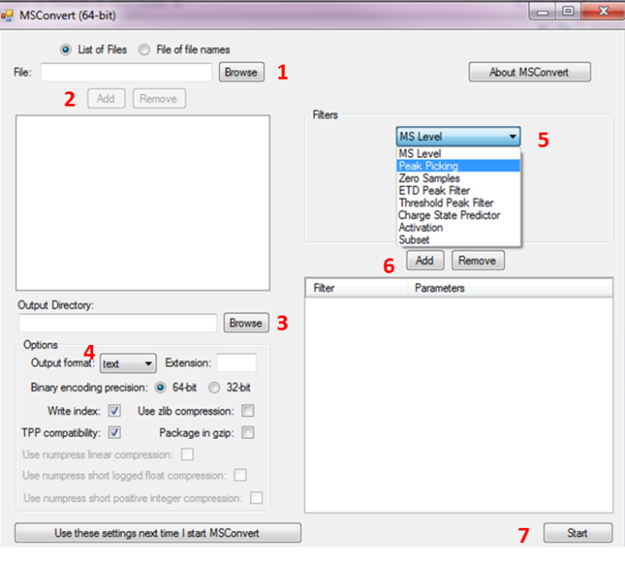

1. Browse in the raw file(s)
2. Click ‘Add’
3. Select the output folder. Preferably, into the ‘raw files’ folder of the DARTalyzer script
4. Select ‘text’ under Output forma
5. Choose ‘Peak Picking’ under the Filters option
6. Click the ‘Add’ button below
7. Click Start

**Move the converted file into the ‘raw files’ folder of the DARTalyzer**

# Running DARTalyze

### Input file

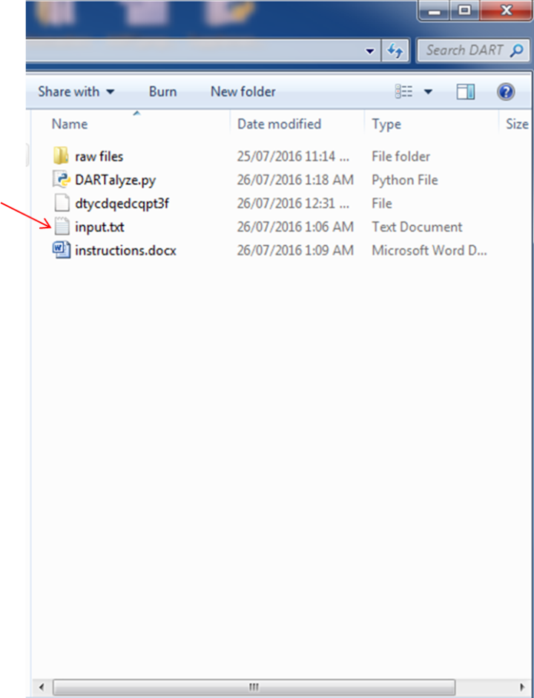

Open the ‘input.txt’ file in a text editor (i.e notepad)

Below the prompts, input the: **raw file name, mass accuracy, output file,**

Input the top *X* ion m/z that will be monitored.

Below the ‘**List all masses to be excluded’** line, record the m/z of all ions to be excluded.

**Save the file**

### Run the file

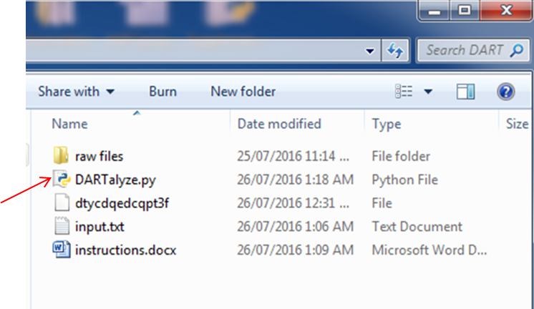

Double click on the **“DARTalyze.py”** file

* A new “output.xlsx” file should appear containing the data

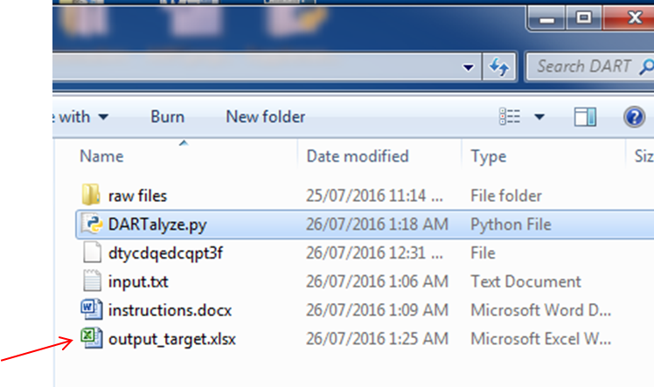

* Open the output file (.xlsx) to view the data.

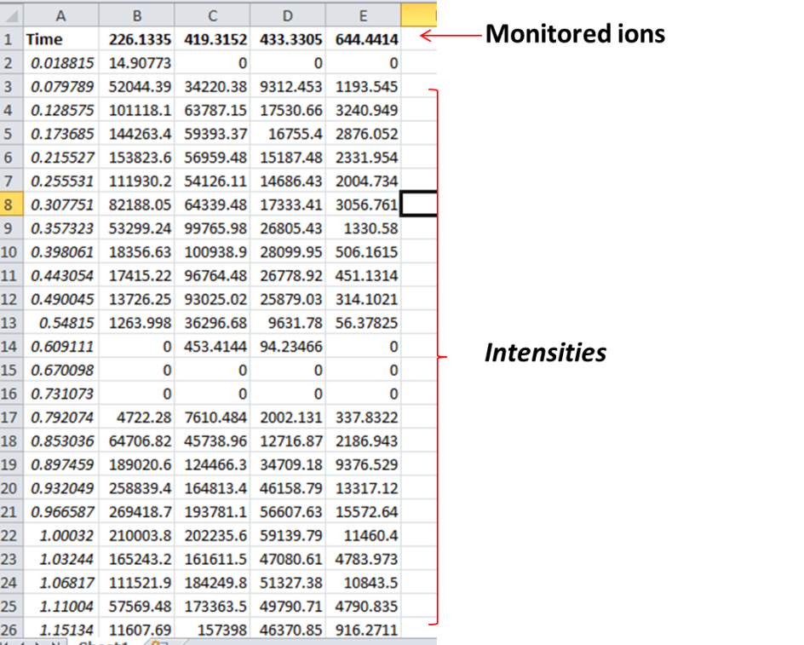

* The data can now be visualized using standard excel practice

