Selectivity Calculator for HRMS

# Overview

This selectivity calculator program contains two scripts:

1. mz_Signal_tabulator.py : pulls all mz signals from raw files and places them in a common .csv files
2. Selectivity_Calculator.py: Calculates the selectivity of precursors and product ions in the “Analyte_list.csv” file based on the complete collection of signals in the MS and MS/MS filters

This script relies on freely available ‘Anaconda modules’

# Requirements

* Install anaconda (<https://docs.continuum.io/anaconda/install>) onto PC that will be used to analyze .raw data
* Install Proteowizard (<http://proteowizard.sourceforge.net/downloads.shtml>) in order to convert the Thermo® .Raw files into text based files

# Converting the files

Convert the Thermo® .raw file to a ‘text’ file using Proteowizard (MSconvert). Use the ‘peak picking’ filter

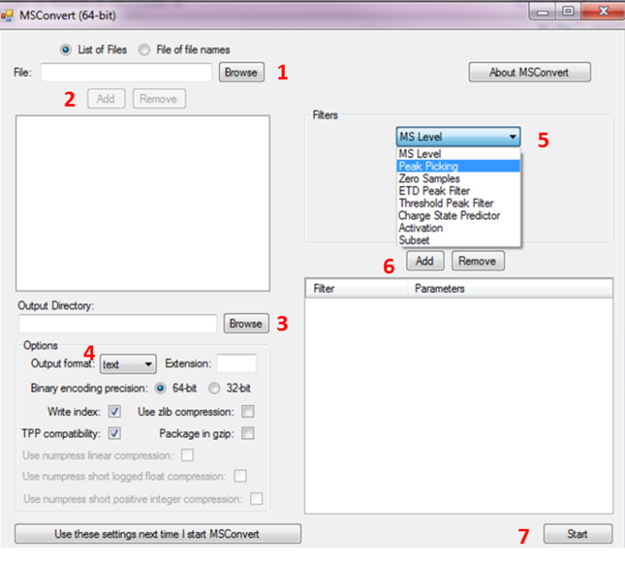

1. Browse in the raw file(s)
2. Click ‘Add’
3. Select the output folder.
4. Select ‘text’ under Output format
5. Choose ‘Peak Picking’ under the Filters option
6. Click the ‘Add’ button below
7. Click Start

# Tabulating all m/z signals in samples

Open the ‘File_list.txt” file in a text editor (i.e notepad)

Input the: **raw file name and location**.

**Save the file**

### Run the mz_Signal_tabulator.py

The script will generate two possible .csv files. fullMS.csv contains all the mz signals in the single stage and allMS2.csv which contains all product ions detected in the MS2 filters

# Calculate selectivity

Open the ‘Analyte_list.csv’ file and input the required information under each column.

Note: do not include commas in names. Ensure that the number of product ions corresponds to the number of entries in each row.

### Run the Selectivity_Calculator.py

This produces an output .csv file that contains the precursor and product ions with their corresponding selectivities in the row immediately following it.