These are resources you can use to develop your classroom activities and examples of best practices. They are based on actual documents used at Eagle Connections at Tallahassee Community College (FL), and were shared as a example during the Tips from Faculty: Engaging Students with Intellectual Disabilities Enrolled in College Courses webinar, presented on November 3, 2021 for Think College.

Presenter Bios & Contact information

Shakonda Diggs is an Associate Professor at Tallahassee Community College in Tallahassee, FL for the Student Life Skills area within the Division of Social Sciences. She began with the college in 2008 as an Academic Advisor. Shakonda became a faculty member in 2016 and is currently in her fifth year seeking tenure. She received her undergraduate degree from Florida State University in Rehabilitation Services and graduate degree from Troy State University in Counseling and Psychology. Shakonda was certified in PK-12 Guidance and worked in the public-school system for over five years as a Guidance Counselor. As a counselor, Shakonda worked closely with the exceptional education students administering assessments, testing and counsel. As a faculty member, she has worked with the Eagle Connections program for the past four years.

Contact information:
Email: shakonda.diggs@tcc.fl.edu
Phone: 850-201-6597

Patrick McDermott is a Professor and Program chair at Tallahassee Community College in Tallahassee, FL for the Student Life Skills area within the Division of Social Sciences. He has been with the college since 2002 and has been with the Eagle Connections program since it started in 2011. Patrick earned his undergraduate degree from Flagler College and a masters degree from Florida State University. He is currently pursuing a doctoral degree from St. Thomas University in Innovation and Leadership and will be done next year with a focus on experiential learning and college/career readiness.

Contact information:
Email: patrick.mcdemott@tcc.fl.edu
Phone: 850-201-8482

Table of Contents

TCC Eagle Connections Employment Credential 3
Eagle Connections Academic Agreement 4
Example- Academic Agreement- A student’s 1st draft 5
Example- Academic Agreement- Final version based 1st draft and meetings 6
Faculty Eample 1 - Academic Agreement 9
Faculty Example 2- Academic Agreement 11
Example Syllabus- SLS 1510 13
Example Revised EC Pacing/ Schedule- SLS 1510 23
Example Parts of Syllabus- SLS 2261 28
Example of Part of Calendar- SLS 2261 30
Example of Modified Calendar- SLS 2261 32

TCC Eagle Connections Employment Credential
(33 hours total)
Required Core Course (21 hours total)
___SLS1510 College Success (3)
___SLS2261 Student Leadership Development (3)
___SPC1017 Interpersonal Communication (3)
___HSC1100 Concepts of Positive Living (3)
___CGS1030 Computer Basics (3)
___ENC1101 College Composition (3)
___IDS2941 Programs Internship (3)*
___Life Skills Sessions (each semester)
Electives (12 hours total)
Student are encouraged to take all 12 credits from a single Pathway
Pathway in Arts, Humanities, Communication and Design
___SPC2608 Public Speaking (3)
___ENC0017 Integrated Reading & Writing I (4)
___ENC0027 Integrated Reading & Writing II (4)
___LIT2000 Introduction to Literature (3)
___CRW2001 Creative Writing (3)
___ENL2000 British Literature (3)
___LIT2323 Multicultural Mythology (3)
___PGY1800C Digital Photography (3)
___ART1300c Drawing Foundations/Drawing I (3)
___ART2500c Painting I (3)
___ART1340c Beginning Illustration (3)
___ARH2000 Art Appreciation (3)
___FIL2000 Film Appreciation (3)
___FIL1031 History of Film I (3)
___FIL2032 History of Film II (3)
___MMC1540 Media Aesthetics (3)
___HUM2020 Introduction to the Humanities (3)
___THE2000 Theatre Appreciation (3)
___TPP2250 Introduction to Musical Theatre (3)
___MUH2011 Introduction to Music History (3)
___MUL2010 Music Appreciation (3)
___HUM2525 American Music Tradition- Jazz (3)
___MUN2830 African Drum & Dance (3)
Pathway in Business
___GEB1011 Introduction to Business (3)
___MAR1350 Marketing the Individual (3)
___MNA1161 Intro to Customer Service (3)
___SBM2000 Intro to Entrepreneurship (3)
___LEI1000 Intro to Recreation and Leisure (3)
___CGS1000 Intro to Computer Tech (3)
___GRA2140 Web Page Design (3)
Pathway in Science, Technology, Engineering and Math
___EVR1001 Intro to Environmental Sciences (3)
___ECS1000 Earth and its Environment (3)
___OCE1001 Introduction to Oceanography (3)
___GLY1030 Environmental Geology (3)
___PSC1121 Introduction to Physical Sciences (3)
___AST1002 Intro to Astronomy (3)
___PHY1020 Energy & its Environ. Effect (3)
___HUN1201 Science of Nutrition (3)
___HSC1171 Stress Management (3) online
___EET1084C Introduction to Electronics (3)
___CGS1000 Intro to Computer Tech (3) online
___GRA2140 Web Page Design (3)
___EGS1002 Introduction to Engineering Tech (3)
___DIG 2000 Introduction to Digital Media (3)
___STA2023 Introductory Statistics (3)
___MAT0018 Foundations for College Math I (4)
___MAT0028 Foundations for College Math II (4)
Pathway in Social and Behavioral Sciences and Human Sciences
___ANT2140 Introduction to Archaeology (3)
___ANT2000 Introduction to Anthropology (3)
___ANT2410 Intro to Cultural Anthropology (3)
___ANT2511 Intro to Physical Anthropology (3)
___SYG1000 Principles of Sociology (3)
___PSY2012 General Psychology (3)
___AMH2010 History of the US I (3)
___AMH2020 History of the US II (3)
___WOH2012 History of Civilization I (3)
___WOH2022 History of Civilization II (3)
___CHD2220 Child Development (3)
___CLP1001 Psychology of Personal & Social Adjustment (3)
Pathway in Education (mostly online)
___EEC1308 Introduction of the Young Child (3)
___EEC1312 Creative Exp. for Young Children (3)
___EEC1300 Cognitive Exp. for Young Children (3)
___EEC2401 Home, School Development, Education and Management (3)
___EDF1005 Intro to the Teaching Profession (3)
___EME2040 Intro to Tech for Educators (3)
*IDS2941: Work-based employment may be used as approved by Eagle Connections and TCC staff.
**Other electives may be selected as approved by the student and their support system and Eagle Connections and TCC staff, and based on the student's strengths, needs and abilities.
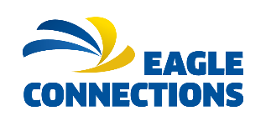

Eagle Connections Academic Agreement Suggested Grade: _____
Semester: | Course:
Student Name: | Faculty Name:
ID Number: | Faculty Email:
Student Email: | Faculty Phone #:

List 3-5 objectives (from the syllabus) below to be the learning goals for the student.
Course Objectives to be met by the student: | List resources available to help the student complete the objective. | List how the student will demonstrate understanding and successful completion of the objective.
1.

2.

3.

4.

5.

A mid-term meeting should be scheduled to assess how the student is progressing and offer guidance as needed. Students are auditing the course and do not receive credit or a GPA. However, they are expected to participate and complete the course objectives listed above to show Satisfactory Academic Progress. Please make copies for the instructor, student, and mentor.
Instructor Signature: | Date:
Student Signature: | Date:
Mentor Signature: | Date:
Mentor Name:
Mentor Contact Info:

Eagle Connections Academic Agreement
Suggested Grade: _____

Semester: Fall2020 | Course: SLS1510(94)College Success
Student Name: xxxx xxxx | Faculty Name: Mcdermott
ID Number: | Faculty Email:Mcdermop@tcc.fl.edu
Student Email: | Faculty Phone #:
List 3-5 objectives (from the syllabus) below to be the learning goals for the student.
Course Objectives to be met by the student: | List in-class and on-campus resources available to help the student complete the objective. | List how the student will demonstrate understanding and successful completion of the objective.
1.I Will Apply My Interests, critical thinking, and Imaginative Skills To Study Evaluate And Synthesize Ideas | Emal Prefacer MIcdermott  Library | Reading class matterial
2.I will demonstrate reading and writing skills by ethically locating information by using reliabl sources | Bookes  On line articles | Use computer to find information
3.Students will find operate and or utilize digital tools for academic and professional purposws | canvas | Check canvas everyday
4.I will put effort into maintaining healthy relationships in college, at home,and in the work place. I will assess the consequences of my behavior choices. | Counseling | Communication  Quality time
A mid-term meeting should be scheduled to assess how the student is progressing and offer guidance as needed. Students are auditing the course. However, they are expected to participate and complete the course objectives listed above to show Satisfactory Academic Progress. Please make copies for the instructor, student, and mentor.

Preliminary Agreement by a student without edits

Eagle Connections Academic Agreement (Final version 9/11/2020)
Suggested Grade: _____

Semester: Fall 2020 (20211) | Course: SLS1510-College Success (# 94)
Student Name: XXXX XXXX | Faculty Name: Patrick D. McDermott
ID Number: XXXXXX | Faculty Email: mcdermop@tcc.fl.edu
Student Email: XXXX@mymail.tcc.fl.edu | Faculty Phone #: (850) 201-8482
List 3-5 objectives (from the syllabus) below to be the learning goals for the student.
Course Objectives to be met by the student: | List in-class and on-campus resources available to help the student complete the objective. | List how the student will demonstrate understanding and successful completion of the objective.
Course- Level:  Apply critical thinking skills to analyze personal, academic and career goals and to create a plan to achieve them.  (I Will Apply My Interests, critical thinking, and Imaginative Skills To Study Evaluate And Synthesize Ideas) | Email Professor McDermott  Library  Web lessons | Reading class materials  Goal project  Growth Mindset DB  Midterm- Will be ENC 1101 Summary Response.  Final exam- Will be ENC 1101 Final Reflection.  “Why” statement  Career Project- Mr. McDermott will develop one for you.  Myers Briggs  Time Management Assignment
Social Science level:  Students will demonstrate effective information literacy skills by locating information using appropriate tools, in an ethical manner, from sources which are reliable, relevant and authoritative, such that the process expands and deepens their understanding of the subject matter.  General Education level:  Students will demonstrate effective information literacy skills by locating, evaluating, and effectively and ethically using information to achieve an academic or professional purpose.  (I will demonstrate reading and writing skills by ethically locating information by using reliable sources) | Books  On line articles  Myers Briggs  Learning Styles  VARK  Meeting with Professor McDermott and Professor Rizza weekly or as more if needed | Reading class materials  Use computer to find information—this is web class  Myers-Briggs and Learning styles assessment  Career Project- Mr. McDermott will develop one for you.  Midterm- Will be ENC 1101 Summary Response.  Final exam- Will be ENC 1101 Final Reflection.  Will me with ENC 1101- Professor Rizza’s class as well
Digital Focus level (all cover area):  Students will find, operate and/or utilize digital tools for academic and professional purposes.  Students will use digital tool(s) to create, modify, and/or organize content.  Students will use digital tool(s) and/or communicate content effectively.  (I will find operate and or utilize digital tools for academic and professional purpose.) | Canvas  Web lessons- both SLS 1510 and ENC 1101  Zoom meeting with Professor McDermott and Professor Rizza (ENC 1101) | Check canvas everyday  This class is a web-based course so all learning outcomes with covered throughout the whole course.
Course- Level:  Apply critical thinking skills to evaluate strategies for maintaining healthy relationships in college, at home and in the workplace.  (I will put effort into maintaining healthy relationships in college, at home, and in the work place. I will assess the consequences of my behavior choices). | Counseling / Website  Web lessons | Communication/ Certain discussion boards/ chapter outlines  Quality time  Career Project- Mr. McDermott will develop one for you.  Time Management Assignment  Goal project
**McDermott Added as all students need to cover**  Social Science level:  Students will demonstrate an understanding of diverse perspectives and their influence on individual, social, historical, and political events or on cultural expression. |  | Culture/Diversity Assignment
A mid-term meeting should be scheduled to assess how the student is progressing and offer guidance as needed. Students are auditing the course. However, they are expected to participate and complete the course objectives listed above to show Satisfactory Academic Progress. Please make copies for the instructor, student, and mentor.
Instructor Signature:  Patrick D. McDermott | Date:  September 11, 2020
Student Signature: XXX XXXX | Date
Mentor Signature: | Date:
Mentor Name: Mentor abc1

Mentor Contact Info: mentorabc@tcc.fl.edu

Example of Final Agreement linked/collaborated with SLS 1510 course and ENC 1101 course

Eagle Connections Academic Agreement- Faculty Example 1
Suggested Grade: _____

Semester: Spring 2021 (20212) | Course: SLS 2261- Dynamics of Leadership
Student Name: XXXX XXXX | Faculty Name: Patrick D. McDermott
ID Number: XXXXX | Faculty Email: mcdermop@tcc.fl.edu
Student Email: XXXX@mymail.tcc.fl.edu | Faculty Phone #: 850.201.8482

List 3-5 objectives (from the syllabus) below to be the learning goals for the student.
Course Objectives to be met by the student: | List resources available to help the student complete the objective. | List how the student will demonstrate understanding and successful completion of the objective.
Course- Level:  Student will select appropriate critical thinking skills to analyze principles and philosophies of past and current leadership theories, select a theory, and apply the principles of that theory to create their own leadership philosophy statement.  (Leadership vision, Leadership concepts and Leadership theories) | Lectures  TCC Career Center  TCC Online  Textbook | Chapter 1 assignments  Leadership Vision for herself and one for her future business  Discussion board- Communities  Strengths Quest Assessment/ Myers- Briggs  Chapter outlines- will map out which ones needed to do.  Group Leadership Theory video in class activity
Course- Level:  The student will analyze how diversity affects group dynamics and learning.  (Dealing with Conflict, Making decisions) | TCC Online- help with Canvas  Textbook  Assignments | Discussion board- Communities and conflict  Group Chapter 9 assignment  Conflict Assignment- we will chat.  Chapter outlines- will map out which ones needed to do.  In class discussions and lecture
Course- Level:  Student will evaluate how application of leadership skills impacts development of effective civic engagement practices.  (Leadership vision, Leadership concepts, Making decisions) | TCC Online- help with Canvas  Textbook  Assignment | Chapter 1and 2 assignments  Case study (we will chat)  Leadership Vision for herself and one for her future business  Chapter outlines- will map out which ones needed to do.
General Education level:  Students will demonstrate an understanding of diverse perspectives and their  influence on individual, social, historical, and political events or on cultural expression.  (Dealing with Conflict, Making decisions) | Same as above | Diversity Activity in class  In class discussions and lecture  Take home – Exam- Movie Assignment  Group Chapter 9 assignment
Social Science level:  Student will apply social science theories and research findings to individual and group experiences.  (Dealing with Conflict, making decisions, Dealing with Change, Leadership theories)  Ethics and Decision making) | Same as above | Take home – Exam- Movie Assignment  Ethics assignment  Chapter outlines- will map out which ones needed to do.  Strengths Quest Assessment/ Myers- Briggs
QEP Level:  - Student will find, operate, and/or utilize digital tools for academic and professional purpose  - Student will use digital tools to create, modify, and/or organize content  - Student will use digital tools and/or communicate content effectively  (Networking, LinkedIn and NACE) | TCC Career Center | Resume (instead of LinkedIn)  Strengths Quest Assessment/ Myers- Briggs
A mid-term meeting should be scheduled to assess how the student is progressing and offer guidance as needed. Students are auditing the course and do not receive credit or a GPA. However, they are expected to participate and complete the course objectives listed above to show Satisfactory Academic Progress. Please make copies for the instructor, student, and mentor.
Instructor Signature:  Patrick D. McDermott | Date:  January 26, 2021
Student Signature: | Date:
Mentor Signature: | Date:
Mentor Name: Mentor ABC
Mentor Contact Info:

Eagle Connections Academic Agreement- Faculty Example 2
Suggested Grade: _____

Semester: Spring 2021 | Course: SLS 2261- Dynamics of Leadership
Student Name: John Doe | Faculty Name: Shakonda Murray Diggs
ID Number: D12345678 | Faculty Email: diggss@tcc.fl.edu
Student Email: doej2021@mymail.tcc.fl.edu | Faculty Phone #: 850.201.6597
List 3-5 objectives (from the syllabus) below to be the learning goals for the student.
Course Objectives to be met by the student: | List resources available to help the student complete the objective. | List how the student will demonstrate understanding and successful completion of the objective.
Course- Level:  Student will select appropriate critical thinking skills to analyze principles and philosophies of past and current leadership theories, select a theory, and apply the principles of that theory to create their own leadership philosophy statement. | Workshops  Lectures  TCC Career Center  LinkedIn- clips  TCC Online  Textbook | Discussion board- 1 and Chapter Assignments  Create Resume  Discussion board- Communities  Growth Mindset assessment  Civic Engagement PowerPoint  VIA Assessment  Myers- Briggs and Learning Styles
Course- Level:  The student will analyze how diversity affects group dynamics and learning. | TCC Online- help with Canvas  Textbook | Discussion board-  All Chapters- group assignment  In class assignments  In class discussions and lecture each
Course- Level:  Student will evaluate how application of leadership skills impacts development of effective civic engagement practices. | Same as above | Chapter Questionnaire  Case Study  Chapter Quiz  In class discussions
General Education level:  Students will demonstrate an understanding of diverse perspectives and their  influence on individual, social, historical, and political events or on cultural expression. | Same as above | Chapter Questionnaires  In class discussions and lecture  Case Study  Exam 1 and 2
Social Science level:  Student will apply social science theories and research findings to individual and group experiences. | Same as above | Case Study  VIA Assessment/ Myers- Briggs and Learning Styles
QEP Level:  - Student will find, operate, and/or utilize digital tools for academic and professional purpose  - Student will use digital tools to create, modify, and/or organize content  - Student will use digital tools and/or communicate content effectively | TCC Career Center | Resume  VIA Assessment/ Myers- Briggs and Learning Styles
A mid-term meeting should be scheduled to assess how the student is progressing and offer guidance as needed. Students are auditing the course and do not receive credit or a GPA. However, they are expected to participate and complete the course objectives listed above to show Satisfactory Academic Progress. Please make copies for the instructor, student, and mentor.
Instructor Signature:  Shakonda Murray Diggs | Date:  1/21/2021
Student Signature:  Joe Doe | Date:  1/21/2021
Mentor Signature:  Happy Mentor | Date:  1/21/2021
Mentor Name:
Happy Mentor
Mentor Contact Info:
happyme@tcc.fl.edu

Note: For the course, a mentor is added to the Canvas shell. This method gives the mentor access to the join the class Zooms within Canvas.

Example Syllabus- SLS 1510

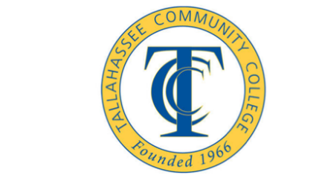

Syllabus

SLS1510 – College Success and Career Development
Main term- August 24th to December 11th
Last Day to withdraw- Tuesday, November 3rd


Name: Mr. Patrick McDermott, Professor
Email: mcdermop@tcc.fl.edu
Phone Number: 850.201.8482
Office Location:
HSS 213 on campus but will be using the Zoom link
https://tccfl.zoom.us/j/94124909780
Meeting ID: 941 2490 9780

Office Hours
https://tccfl.zoom.us/j/94124909780
Meeting ID: 941 2490 9780


Mon.- 11:00am to 12:00pm- see link above- Zoom

Tues.- 11:00am to 2:00pm- see link above- Zoom

Wed.- 11:00am to 12:00pm- see link above- Zoom

Thurs.-11:00am to 2:30pm (virtual- not via zoom)

Online Discussion Board and CANVAS- Office Hours or by appointment.
I can be contacted via email or phone and will respond.

Course Description

SLS 1510- College Success (3 credit hours) FA SP SU
This course is designed to build and reinforce skills necessary for college and career success. Topics include: motivation, goal setting, learning styles, time management techniques, test-taking skills, classrooms skills. The course also covers topics such as wellness, interpersonal relationships, financial management, conflict resolution and choosing a Meta-major.

Course Prerequisites
There are no prerequisites for this course.
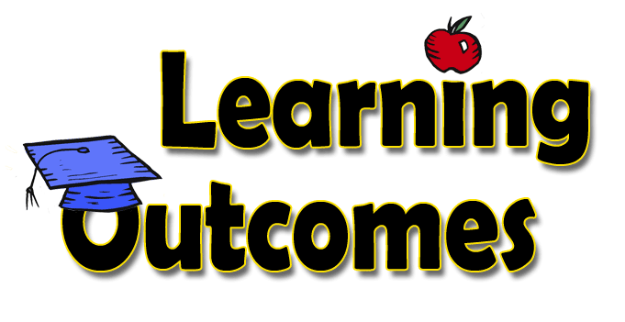

General Education Learning Outcomes
- Student will apply critical and creative thinking skills to analyze, evaluate, and synthesize ideas.
- Students will demonstrate an understanding of diverse perspectives and their influence on individual, social, historical, and political events or on cultural expression.
- Students will demonstrate effective information literacy skills by locating, evaluating, and effectively and ethically using information to achieve an academic or professional purpose.

Social Science Learning Outcomes
- Students will analyze various social science concepts to demonstrate an understanding of social, cultural and political structures.
- Students will compare and contrast the findings from various social science specializations to explain diverse perspectives and their influence on social, cultural, political and economic global events.
- Students will apply social science theories and research findings to individual and group experiences.
- Students will demonstrate effective information literacy skills by locating information using appropriate tools, in an ethical manner, from sources which are reliable, relevant and authoritative, such that the process expands and deepens their understanding of the subject matter.

Digital Focus Learning Outcomes
- Students will find, operate and/or utilize digital tools for academic and professional purposes.
- Students will use digital tool(s) to create, modify, and/or organize content.
- Students will use digital tool(s) and/or communicate content effectively

Course Learning Outcomes
The goal of this course is to assist students in learning academic, personal, and career skills, which will help them to be successful in college and in the world of work. The following learning outcomes will be addressed by this course through lectures, classroom activities, assignments, projects, and assessments:

- Evaluate their classroom and study strategies, apply active learning techniques and create a systematic approach to learning in a variety of academic disciplines
- Apply critical thinking skills to analyze personal, academic and career goals and to create a plan to achieve them.
- Locate, evaluate and use information ethically to demonstrate knowledge of their meta-major, degree program and career.
- Analyze how diversity affects group dynamics.
- Apply critical thinking skills to evaluate strategies for maintaining healthy relationships in college, at home and in the workplace. Students will also assess the consequences of their behavior choices.

Structure of the Course (Weekly Navigation)
Each week of this course will include any combination of a lesson, an assignment, and discussion board posting. Some weeks you will have additional responsibilities, such as preparing your career activity or taking a test or quiz.
You will need to setup a regular system of logging into Canvas on a weekly basis, reviewing your instructions for the week, and following each step carefully to earn full credit.
The first step you will take in this course is to go to the Course Calendar, print it out, and use it as a weekly checklist.
Your weekly work will be posted on Mondays and due the following Sunday, which gives you seven days to complete any work for that week.
You will log into Canvas, click on the left-side menu under "Modules" to find the folders for each week. Everything you need will be located under Modules.
Be sure to note your professor’s weekly office hours and access your lessons and assignments before the time your professor is available for the week. That way if you have any questions you can reach your professor during office hours before your work is due.

Required Text and Materials
Shushan, A Pocket Guide to College Success, 3ed New York, NY: Macmillan Publishing, Inc. (ISBN: 978131919200763 or 1319200761).

Technology Resources:
- Reliable access to the internet - This is important as "my internet went down" is not an excuse for not turning in your work. A backup plan if your usual internet access is unavailable. (I.e. Can you go to a neighbor’s house or to the learning commons for access to the internet.)
- Access to a Webcam - You must have access to a webcam to use the Honorlock software for online testing.
- Internet Browser - Google Chrome is recommended.
- Access to your TCC Eaglenet/CANVAS course site on a regular basis - If you do not have internet access at home, please become familiar with the computer resources on campus.
- A Canvas APP is available for download on your phone.
- YouTube
- TCC Student ID Card You will also need to obtain a Student ID card to access TCC resources (e.g. Library, computer labs, Learning Commons, Testing Center). You can obtain your Student ID card at the Cashiers Office once you have paid for your courses.

Technical Skill Requirements:
- Typing Skills - you will be completing discussion board posts and activities online. If you are not a good typist make sure you give yourself extra time to compete assignments. The expectation is that proper grammar and punctuation is used.
- Microsoft Word and PowerPoint - we will be using Word to complete some of your assignments so basic knowledge of this tool is important.
- Canvas - the entire course is delivered using Canvas so you will need to know how to navigate Canvas, download assignments and upload to the assignment links, complete discussion board posts and quizzes.
- TCC One Drive – this is a designated are for document storage. It is an excellent location to store your work.
- File Format – documents need to be turned in in a format that I can see. If you are using a Mac please save our documents in a PDF or .doc, or .pptx format. I cannot read a .pages document.
- Webcam – this will be used to take your tests using the Honorlock software.
- File Management skills – Assignments will be typed and uploaded to Canvas. TCC uses Microsoft Office If you are a Mac User, you will need to save your work as a PDF document or as a .doc before submitting the assignment to Canvas.

Communication with Professor:
Please check your TCC email on a daily basis for class correspondence.
For general course related questions/comments your professor can be reached by email or phone. You may also come by in person during scheduled office hours, or schedule an appointment. Office hours are listed at the top of the syllabus. You will receive a response to your all emails or calls within 24 hours, Monday through Friday.
Please use your TCC account when emailing me. Include your first and last name, the course, and your question.
There will be no required synchronous iChat class sessions for this online course. In other words there is no set time that we will meet as a group.

Syllabus Disclaimer

Changes to this syllabus will be made at the professor’s discretion. You will be informed about any change through a course announcement and email.

Online Communication or “Netiquette” Guidelines
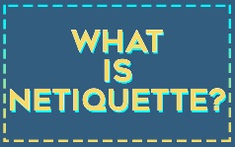
In the online classroom, you communicate with your classmates and professor in writing through the public discussion forums, email, and sometimes chat sessions. Online manners are generally known as "netiquette."
As a general rule, you should adhere to the same classroom conduct that you would in a traditional face-to-face course. However, the key to netiquette is to remember that the people with whom you are communicating cannot see you, read your body language or hear the tone of your voice.
Below are some examples of proper netiquette:
- Avoid writing messages in all capital letters. THIS IS GENERALLY UNDERSTOOD AS SHOUTING.
- There are no verbal or facial cues in our discussion areas so be aware that what you type may not be what your classmates may think you are trying to convey. The use of ?!!!? or ???? may be viewed as anger or aggression.
- Be careful what you put in writing. Even if you are writing an email message to one person, assume that anyone could read it. Though you may send an email to a single person, it is very easy to forward a message to hundreds or thousands of people.
- When responding to messages, use "Reply to All" only when you really intend to reply to all.
- Spelling, grammar, and punctuation matter. Online courses demand the same standard of academic communication as face-to-face courses.
- Keep your questions and comments relevant to the discussion topic. Do NOT reply to students who post a comment or question that is off topic. The professor will address off topic comments and questions.
- Use humor with care and avoid sarcasm. In the absence of nonverbal cues such as facial expressions and voice inflections, the context for your comments may be lost, and your message may be misinterpreted.
- Refrain from using shorthand "emoji’s" on the discussion board. These should be reserved for informal communication with other students.
- Avoid unkindly public criticism of others. Publicly criticizing others in an inappropriate way is known as "flaming."
- Never use profanity in any area of an online course. Transcripts of online course communications are savable. What you write online never goes away!
- Treat the other students in a polite and respectful manner. Model the same standards of behavior online you would follow in a face-to-face discussion.

Your professor reserves the right to remove posts that are not collegial in nature and/or do not meet netiquette guidelines. (Adapted from Quality Matters)

Online Proctored Testing
This online (web-based) course requires proctored testing. All exams will be proctored by Honorlock, an online proctoring service that allows you to take your exams in any location where you can access a computer, an internet connection, and a webcam. It is recommended that you select a quiet location free from distraction.
Honorlock is available 24/7. You do not need to create an account or schedule a time to use Honorlock. Honorlock is part of the Canvas site. Make sure you are using Google Chrome as your browser. Sign into Canvas and select your course and click on your exam. You will be prompted to add the Honorlock Chrome Extension; this step is required. The software requires that you take a picture, show your ID, and scan your room. Honorlock will be recording you VIA webcam, as well as recording your screen. The system can detect any attempts to use a search-engine to look up answers. Behavior that will be flagged includes people entering your room, talking during the test, looking around the room. Your professor will be notified. The professor can view the tapes and will determine if there is any indication of cheating. If you are suspected of cheating, you will be referred to Judicial Affairs.
- Honorlock Student Guide (same guide that is in Canvas when you start the test)
- Honorlock Video for Students (overview of how to use Honorlock)
- Proper Room Scan (shows students how to do a proper room scan)
- honorlock.com/support (students can test your system here and contact support)

Honorlock Technical Support
When you enter your exam a live-chat will be on the bottom-right hand of your screen during the entire exam, in case you need technical support. Also, you can call the Honorlock Technical Support line at (855) 828-4004.

Grading Policy
TCC’s Writing to Learn Mission Statement:
Writing is the responsibility of the student and the entire academic community. Writing is an indispensable part of the process of discovering ideas and constructing knowledge. Writing, reading, and critical thinking skills are interrelated, and therefore, central to learning within all disciplines. There is a significant writing component to this course. It is expected that you will use college level writing in all assignments. The use of proper grammar, punctuation and writing is required on all assignments.

Assignments
Students may be given assignments throughout the semester to aid in the understanding of material presented in the textbook and online lessons. Successful students read their chapters and review their assignments early in the week. Begin assignments well before the due date. Submit assignments before the due date to avoid missing an assignment. Work is due Sunday nights at 11:59pm EST unless noted on the calendar.
Assignments | Points
Assignments and Quizzes | 190 pts
Goal Outline Project | 54 pts
Career Research Project (2 parts) | 60 pts
Discussion Board Posts | 136 pts
Midterm Exam | 80 pts
Final Exam | 80 pts
Total Points | 600 pts

Discussion board guidelines
- Review the information on plagiarism under Policies; you are expected to write your posting in your own words and cite appropriately.
- Please review the Netiquette section of the syllabus
- Interactive work with your classmates prepares you for the work today’s workforce. Practicing this important skill, prepares students to work with others to accomplish a task.
- Read all postings and respond to at least two of your classmates. If you see someone has not received a response to their posting, please respond to them before posting to anyone else.
- There is a detailed rubric attached to the discussion board assignments.
- Plan to begin your discussion board post early. It will take at the minimum of one (1) hour to fully complete the discussion board post.

Course reflections guidelines
Course reflections are written assignments, usually 1-3 pages. These assignments use standard college writing. These assignments require critical thinking. Prepare to create a rough draft and revisions to ensure an excellent grade. Proof read your work. You might also want to have an additional person proofread your work. Remember that you can access writing assistance on the 2nd floor of the Learning Commons.

Goal outline project information
This assignment will give students the opportunity to develop and map out a Career, Academic, Personal or Social goal. Begin this assignment early as it has several parts to complete.

Career/Pathways Research Project information
Students will have the opportunity to engage in career and major exploration activities. The project may include:
- Myers-Briggs Type Assessment (Jung Assessment)
- Career Coach Assessment – This is an online assessment available through the TCC Career Center.
- One-page reflection on these two assessments
- Research on a major
- Research on a career
- Discussion board post on soft skills

Exams
Exams are given throughout the semester. The format can include, but not be limited to fill-in-the-blank, matching, multiple-choice, true/false, and short answer questions. There are two exams, including the final exam.

Course grading scale
Grading Scale | Grade
600 - 540 | A
539 - 480 | B
479 - 420 | C
419 - 360 | D
359 and below | F

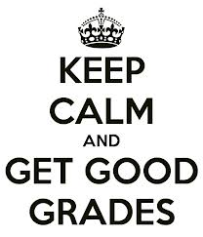

To satisfy the requirements of Tallahassee Community College and the State Board of Education Rule 6A-10.030 each student must complete the course with a grade of C or better and “demonstrate college level writing skills through multiple assignments.”
College Policies
All college policies concerning withdrawal deadlines, incomplete, audits, academic dishonesty and other policies are in effect for this course. All students are advised to be aware of and to carefully follow these guidelines located in the TCC Student Handbook and TCC Catalogue.
- Withdrawal policy- You are responsible for withdrawing yourself by the withdrawal deadline. The withdrawal deadline for this course is November 3rd . You will not be administratively withdrawn from the course.

Student Conduct and Discipline Philosophy
Tallahassee Community College has established regulations which are considered necessary to preserve and maintain an environment conducive to learning, to insure the safety and welfare of members of the college community, to encourage students in the development and practice of good citizenship and self-discipline, and to protect property and equipment of the college. Every student who accepts enrollment assumes the responsibility to become familiar with and to abide by college regulations and acceptable standards of conduct. The standards of conduct expected of students and other members of the college community are defined in the Tallahassee Community College Student Handbook.

Honor Code
As part of the Tallahassee Community College family, students, faculty, and staff commit to uphold the highest standards of academic honesty, personal integrity, and respect for myself and others as essential components of academic and personal growth.

Academic Dishonesty/Section 5. Offenses
Disciplinary action may be initiated by TCC through the Student Judicial office and sanctions imposed against any student or student organization found responsible for committing the prohibited forms of conduct defined in section 5 of the student conduct code, which can be found in the Student Handbook. Offenses include: academic dishonesty, computer misuse and cyberbullying. For more information, refer to the Student Handbook, page 76.

Online Attendance/ Late Submission Policy
Attendance and participation are two of the most significant factors that promote student success. Attendance in the online environment equates to active participation and engagement. Students are responsible for completion of all assigned work by the due date. Submission of assigned work counts as weekly attendance in the course. It is imperative that you make every effort to follow the class pacing schedule/calendar and submit weekly assignments when they are due. If you have an extenuating circumstance that prevents you from completing your weekly assignments, please contact your professor to make arrangements for late submissions prior to the due date.
Please Note: The Federal Government requires Tallahassee Community College faculty to verify a student has attended beyond the 60% point in the term. For students to continue receiving their financial aid, we need confirmation of student class attendance during various attendance windows. An online student has "attended" class if he/she has

- Submitted an academic assignment
- Taken an exam, interactive tutorial, or a computer-based instruction
- Participated in an online discussion that is academically-related
- Interacted online with faculty about subject matter or to ask course-related questions

Late Submissions: No late submissions without the approval of the professor.
Grades on assignments are final. Once an assignment (paper, exam, report, discussion boards, etc.) is turned in, it will be graded and that grade is final. I do not accept re-submissions for revised grading. If you would like feedback BEFORE you turn in an assignment, you may submitted it for review/feedback, these are the steps:
- Submit your draft assignment to me via email only at mcdermop@tcc.fl.edu or via Canvas email.
- The submission must be clearly be identified as a draft.
- The draft must be submitted at least 5 days prior to the due date so I can give you timely feedback.

Student Complaints
Students wishing to dispute a grade should follow the grade dispute process outlined in the 2019-2020 catalog. Students wishing to appeal for cancellation of classes, late withdrawal, full-cost-of-instruction waiver, to enroll in a fourth attempt, or to repeat a course in which they earned a grade of C or higher should contact the Office of Student Affairs at 850-201-8490 or studentaffairs@tcc.fl.edu.

Accessibility Statements
Tallahassee Community College is committed to making all programs, services, and facilities accessible to and usable by persons with disabilities in order for students to obtain maximum benefit from the educational experience and to effectively transition to our college environment. Students with disabilities who identify themselves and provide appropriate documentation are eligible for support services. To access these services, please contact the TCC Student Accessibility Services (SAS) Office.
SAS Office Location:
First floor of Student Union within the Accessibility & Resource Center (ARC), Room 172
Office Hours: Monday-Friday, 8:00 a.m.- 5:00 p.m.
Phone (Voice): (850) 201-8430
Fax: (850) 201-8433
E-mail: SAS@tcc.fl.edu
Florida Relay Service: 711
Video Relay Service: (850) 270-6236 or (850) 270-6231
- Canvas Accessibility Statement
- Honorlock Accessibility Statement is available in the Student Resources module

Technical Support
The TCC Help Desk offers general technical support for online courses. Contact the Student Help Desk or call at (850) 201-8545 to ask questions related to Canvas during the hours of Monday through Thursday 8:00 a.m. - 7:30 p.m. and Friday 9:00 a.m. - 5:00 p.m.
The Canvas Learning Management System (LMS) has a help button located on the blue global navigation menu. The global navigation menu is on the far left side of each webpage within your course. Contact Canvas (Student Help) after hours at (855) 759-6644.
Honorlock offers 24/7 customer service via phone and live-chat. When you enter your exam, the live-chat will be on the bottom-right hand of your screen in case you need tech support or you can call the support line at (855) 828-4004.
Privacy Statements
To learn more about how various sites protect and use your data, refer to the following privacy policies:
- Macmillian Textbook Publisher
- Youtube
- Instructure Canvas Privacy Policy
- Microsoft Privacy Statement
- HonorLock Privacy Policy
- The 16 Personalities Free Personality Test Privacy Statement Note that the 16 Personalities Free Personality Test is a tool used in the Learning Styles module.
- VARK-Learn.com privacy statement The VARK questionnaire is also used in the Learning Styles Module. The company’s privacy policy is located at the bottom of the Terms and Conditions page.
- O-Net Privacy Statement
- Occupational Outlook Handbook Privacy Statement
- TCC SOAR and Meta-Majors: TCC Privacy Policy
- Emsi Privacy Statement Note that this site is associated with “Career Coach” which is used in the Career Module.
- The TCC Library Resources and Research Guides do not have their own privacy statements.

Tips for Success
This course is designed to teach you both the information and the skills you need to succeed in college and beyond. It will also help you clarify your why, your goals and clarify your major/career choice. Students who take the assignments seriously and complete them in a thoughtful manner will benefit the most from this class.

Students who do well in this class are students who log onto Canvas regularly and who do all assignments on time. The best way to learn a skill is to practice that skill, so you should expect to spend considerable time on this class. In general, most college professors expect that you will spend approximately 2 hours outside of class for every hour you spend in class. That means that you should expect to spend approximately 6 hours per week on readings, discussion board posts, assignments per week for this class.

Example Revised/Modified EC Pacing/ Schedule- SLS 1510

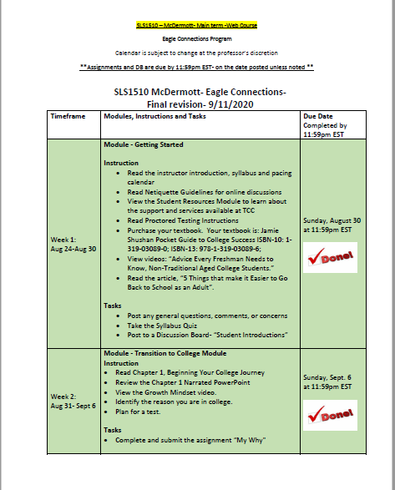
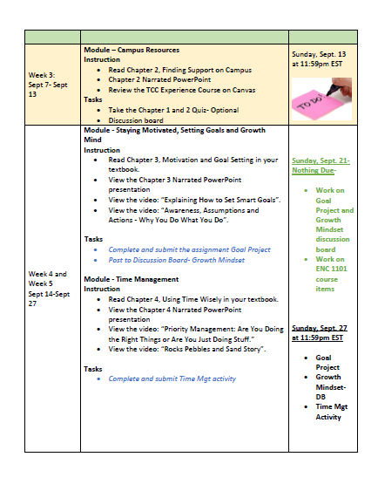

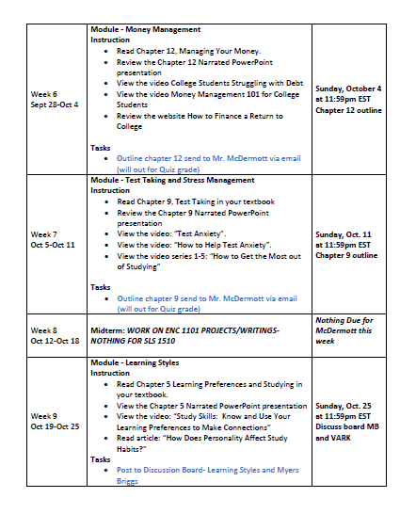

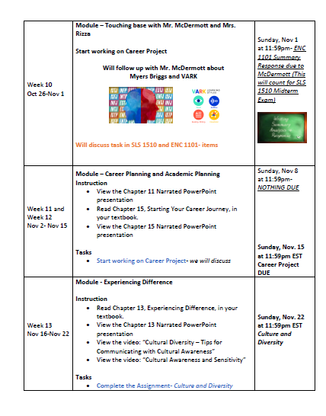

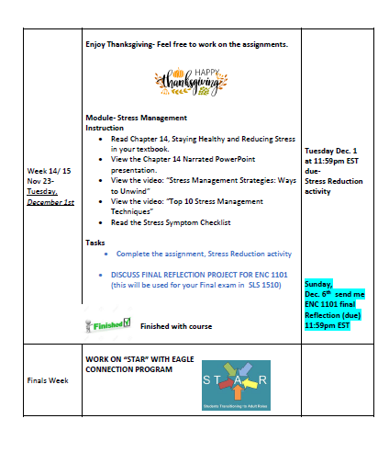

Example Parts of Syllabus- SLS 2261

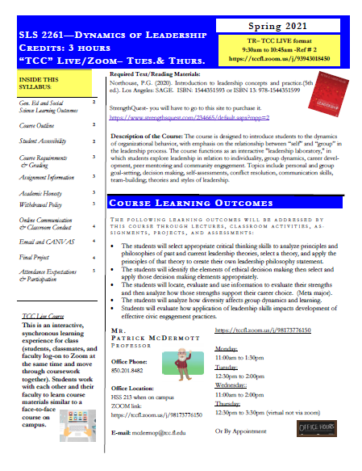
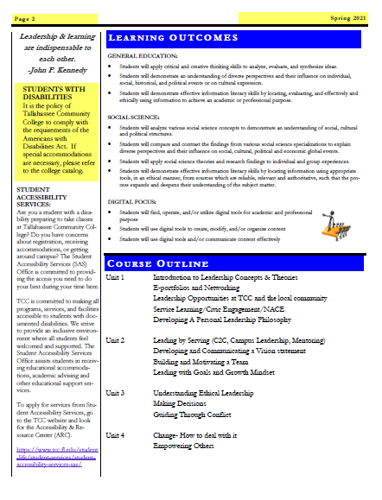

Example of Parts of Typical Calendar provided- SLS 2261

January 18th – 24th  Leading by serving (campus leadership, mentoring)  Leadership opportunities at TCC and in local community  Servant Leadership and Civic Engagement  Go over semester – Chapter/Case study assignment | TCC Resources via Canvas links  Chapter 2: Recognizing your Traits  Chapter 3: Understanding Philosophy and Style  Q/A day  Tuesday, January 19th | Due: Friday, January 22nd at 11:59pm EST - Leadership Theories Activity
January 25th – January 31st  Guest Speaker: Networking and Career Skills-NACE  Professional Networking  Leadership Career Skills  Assign/Start working on Personal Leadership vision/philosophy and E-portfolio | Chapter 3: Understanding Philosophy and Style  Chapter 7: Creating a vision  Chapter 8- Establishing a Constructive Culture  TCC Resources via Canvas links | Start working on Personal Leadership philosophy  Due: Sunday, January 31st at 11:59pm EST Discussion Board- Communities
February 1st – 7th  Online Mini Exam | Chapter 8- Establishing a Constructive Culture  Q/A day  Thursday, February 4th | Follow up to Personal Leadership Philosophy  Due: Sunday, February 7th at 11:59pm EST  “ Mini” Exam 1 (Chapters 1, 2, 4, 7 and notes) due via online  &  NACE Assignment
February 8th- 14th  Art of Connecting with Others  APA and Leadership Research Assignment- assign  Guest Speakers: APA and Leadership Research | Chapter 5- Developing Leadership skills | Due: Friday, February 12th at 11:59pm EST -DRAFT of E-portfolio (LinkedIn)

Example of Modified Calendar- SLS 2261

Leadership opportunities at TCC and in local community  Servant Leadership and Civic Engagement  Go over semester – Chapter/Case study assignment | TCC Resources via Canvas links  Chapter 2: Recognizing your Traits  Chapter 3: Understanding Philosophy and Style  Q/A day  Tuesday, January 19th
January 25th – January 31st  Guest Speaker: Networking and Career Skills-NACE  Professional Networking  Leadership Career Skills  Assign/Start working on E-portfolio (NACE and Resume) | Chapter 3: Understanding Philosophy and Style  Chapter 7: Creating a vision  Chapter 8- Establishing a Constructive Culture  TCC Resources via Canvas links |   Start working on Personal Leadership philosophy  Due: Sunday, January 31st at 11:59pm EST Discussion Board- Communities
February 1st – 7th  Assign/Start working on Personal Leadership vision/philosophy  Chapter Outlines  Email Mr. McDermott- Chapter 1, 2 and 3 outlines to mcdermop@tcc.fl.edu by Sunday, February 7th at 11:59pm EST- Will count as Mini Exam 1. | Chapter 8- Establishing a Constructive Culture  Q/A day  Thursday, February 4th  Feel Free to work on you NACE and Resume | Follow up to Personal Leadership Philosophy  Due: Sunday, February 7th at 11:59pm EST  “ Mini” Exam 1 (Chapters 1, 2, Chapter 3) will be outlines- Send Mr. McDermott via email
February 8th- 14th  Art of Connecting with Others  Guest Speakers: APA and Leadership Research- February 11th you do not need to attend class- Work on Resume and NACE Assessment with Isabella during class and work on Chapter 5 outline | Chapter 5- Developing Leadership skills | Due: Friday, February 12th at 11:59pm EST -DRAFT of E-portfolio- Resume and NACE Self- Assessment (This is your due date)
February 15th- 21st  Art of Connecting with Others  Meet with Mr. McDermott- Feb 18th during Q/A day to discuss Movie Reflection | Chapter 9- Embracing Diversity  Q/A day  Thursday, February 18th
February 22nd – 28th  Guiding through conflict  Chapter Outline:  Email Mr. McDermott- Chapter 11 outline and Conflict assessment and assignment to mcdermop@tcc.fl.edu by Sunday, February 7th at 11:59pm EST- Will count as you Mini Exam 2.  Vote on rest of semester chapters: | Chapter 11- Conflict  Q/A day  Thursday, February 25th | Due: Monday, February 22nd at 11:59pm EST - Chapter 9 - Group assignment  Due: Sunday, February 28th at 11:59pm EST- “ Mini” Exam 2 (Chapter 11 and Complete Conflict Assignment- Send to Mr. McDermott via email )
March 1st- 7th  Self-Assessments Project- TBA  Communication skills | Chapter 11- Conflict  Chapter 6- Engaging your Strengths | Keep working on your Major Assignments  Due: Sunday, March 7th at 11:59pm EST – Global/Cultural diversity- Communication
March 8th – 14th  Understanding yourself and Marketing your self  Positive Leadership | Chapter 6- Engaging your Strengths  SQ Materials  Q/A day  Thursday, March 11th | **FINAL E-portfolio DUE (NACE and Resume)-- Friday, March 12th at 5:00pm EST**
March 15th- 21st | SPRING BREAK – Enjoy | 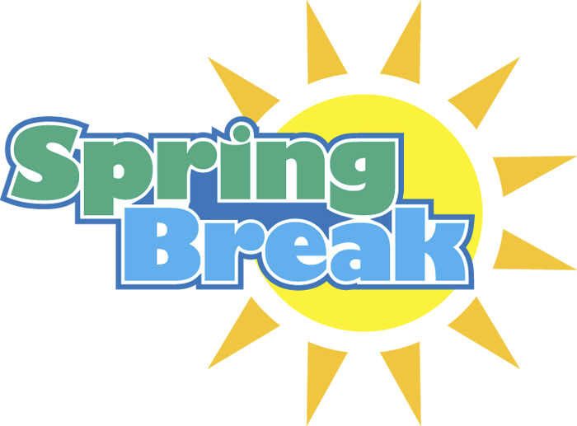
March 22nd – 28th  Growth Mindset and Locus of Control  Building and motivating a team  Goals  Assign Cases | Locus of Control Article  Growth Mindset  Google Articles
March 29th- April 4th  Assignments  Topics based on voting:  - Chapter 10- Out Members  - Chapter 12- Ethics  - Chapter 13- Overcoming Obstacles  - Chapter 14- Destructive Leadership  Art of Changing Culture  Ethics (will discuss on with you on Friday meeting) | Q/A day  Thursday, April 1st  Based on voting:  Chapter 10, Chapter 12, Chapter 13, Chapter 14 | Class-StrengthsQuest Assessment/ Self-Assessment Project Results and Reflection DUE this week- We will discuss at our Friday meeting (TBA)  Myers Briggs/SQ will discuss
April 5th – 11th  Case study | Based on voting:  Chapter 10, Chapter 12, Chapter 13, Chapter 14 | Case study- Done in class this week
April 12th- April 18th  Work Movie Assignment | Q/A day- Last one of Semester  Thursday, April 15th | NO CLASS- Tuesday- April 13th -Work on your Movie Leadership/Reflection Paper  ** Movie Leadership Paper- Post in Chapter Assignment due via the Assignment Link  Friday, April 16th at 11:59pm EST**
April 19th - rest of the semester  Assignments- Rest of semester  If you need help/Advising  Wrap-up and Final SWOT prep discussion  VERY BUSY !! | 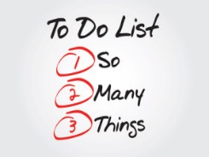 | “Mini” Exam- TBA- Outline based on VOTE and Ethics Assignment  due via email to Mr. McDermott  Sunday, April 25th at 11:59pm EST  FINAL  Vision/Philosophy Statement  DUE  Monday, April 26th 11:59pm EST (also listed below)
Final Meeting- SWOT
9:30am course- Thursday, April 29th - 10am to 12pm

SWOT DISCUSSION
&
FINAL
Vision/Philosophy Statement
DUE online via assignment link
Monday, April 26th at 11:59pm EST

Chapters you are responsible to Read for the semester:
- Chapter 1
- Chapter 2
- Chapter 3
- Chapter 5
- Chapter 7
- Chapter 8
- Chapter 11
- Will vote on 2- Chapter 10, Chapter 12, Chapter 13, Chapter 14
Chapters outlines you will complete this semester:
- Chapters 1, 2, 3
- Chapters 11
- Chapter 10, 12, 13 or 14 ( will decided after spring break after vote you will outline 2 of them)
Assignments you do not need to or will be replace based on Agreement:
- “Mini” Exam 1 ( this exam will be Chapter 1, 2 and 3 outlines)
- “Mini” Exam 2 ( this exam will be Chapter 11 and Conflict assignment)
- “Mini” Exam 3 ( you will not do this exam)
- “Mini” Exam 4 ( this exam will be Chapter outlines voted on after spring break and Ethics assignment)
- Chapter Assignment ( this will be your Movie Reflection paper)
- Leadership Research paper ( this assignment you will not do)
- E-portfolio ( this will be your Resume and NACE Reflection worksheet)
- Philosophy and Vision will be based on “you” and your future childcare work you plan on doing (more details will be discussed when we meet after spring break)

