UNIVERSAL DESIGN RESOURCES

CAST - www.cast.org
Nonprofit education research and development organization that works to expand learning opportunities for all individuals through Universal Design for Learning.
- National Center on Universal Design for Learning – www.udlcenter.org
CAST center with mission to shine spotlight on the stories, people, ideas, and conversations about and around universal design for learning.
- Universal Design on Campus – http://udloncampus.cast.org/
CAST center focused on universal design in post-secondary education.
- National Center on Accessible Educational Materials – https://aem.cast.org
CAST center on accessible materials including resources for distance education -
Center for Excellence in Universal Design – http://universaldesign.ie
Ireland based organization dedicated to enabling the design of environments that can be accessed, understood and used regardless of a person's age, size, ability or disability.
Institute for Human Centered Design – https://humancentereddesign.org
Organization based in Boston, dedicated to enhancing the experiences of people of all ages, abilities, and cultures through excellence in design.
Think College - Universal Design - https://thinkcollege.net/think-college-learn/universal-design
Eight part resource from Think College at the Institute for Community Inclusion, on application of universal design to higher education.

WebAim: Web Accessibility in Mind - https://webaim.org
Comprehensive resource on web accessibility.

W3C Web Accessibility Initiative - www.w3.org/WAI
World Wide Web Consortium website with extensive resources on web accessibility.
- WCAG 2.1 – Web Content Accessibility Guidelines 2.1 - www.w3.org/TR/WCAG21
Accessibility guidelines from the World Wide Web Consortium.

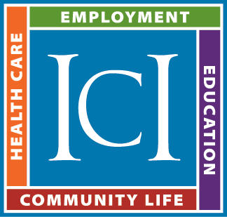
Prepared by David Hoff
Institute for Community Inclusion - University of Massachusetts Boston
Office: 617-287-4308 - Cell: 617-480-9230
Email: david.hoff@umb.edu
www.communityinclusion.org

