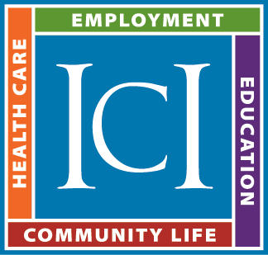
Work-Based Learning Resources

Jobs For the Future (JFF)
JFF has a variety of resources on their website: www.jff.org
These include -
- Report: Not As Hard As You Think: Engaging High School Students in
Work-Based Learning
- Report: Making Work-Based Learning Work
- 7 Principles for Effective Work-Based Learning
- Work-Based Learning Framework
- Work-Based Learning Self-Assessment Tool
- Work-Based Learning System Development Guide

U.S. Department of Education
- Work Based Learning Toolkit - https://cte.ed.gov/toolkit
- Federal Partners in Transition: What to Know About Work-Based Learning for Students and Youth with Disabilities - https://www2.ed.gov/about/offices/list/osers/transition/products/fpt-fact-sheet--work-based-eperiences--11-5-15.pdf

Center on Transition Innovations – Virginia Commonwealth University
Fast Facts: Work Based Learning for Students with Disabilities - http://centerontransition.org/documents/publications/Work_Based_Learning_Fast_Fact.pdf

National Center on Secondary Education and Transition
Quality Work-Based Learning and Postschool Employment Success
Summary brief on work-based learning specific to students with students - http://www.ncset.org/publications/viewdesc.asp?id=1192

Article from Teaching Exceptional Children
Strategies for Creating Work-Based Learning Experiences in Schools for Secondary Students with Disabilities By Jennifer Cease-Cook, Catherine Fowler, and David W. Test
Available at: www.explorevr.org

Association for Career and Technical Education
Section of website dedicated to Work-Based Learning
www.acteonline.org/professional-development/high-quality-cte-tools/work-based-learning

Information from the Strengthening Career and Technical Education for the 21st Century Act
Passed by the U.S. Congress and signed into law in July 2018, this bill reauthorized the Carl D. Perkins Career and Technical Education Act of 2006.

WBL Definition
Definition of Work-Based Learning from the Strengthening Career and Technical Education for the 21st Century Act
WORK-BASED LEARNING.—The term ‘work-based learning’ means sustained interactions with industry or community professionals in real workplace settings, to the extent practicable, or simulated environments at an educational institution that foster in-depth, firsthand engagement with the tasks required in a given career field, that are aligned to curriculum and instruction.

State Plan Requirements
The Strengthening Career and Technical Education for the 21st Century Act includes a requirement that a state’s plan for implementation must contain the following regarding special populations, which includes individuals with disabilities.
A description of the eligible agency’s program strategies for special populations, including a description of how individuals who are members of special populations—
- will be provided with equal access to activities assisted under this Act;
- will not be discriminated against on the basis of status as a member of a special population;
- will be provided with programs designed to enable individuals who are members of special populations to meet or exceed State determined levels of performance described in section 113, and prepare special populations for further learning and for high-skill, high-wage, or in-demand industry sectors or occupations;
- will be provided with appropriate accommodations; and
- will be provided instruction and work-based learning opportunities in integrated settings that support competitive, integrated employment.

