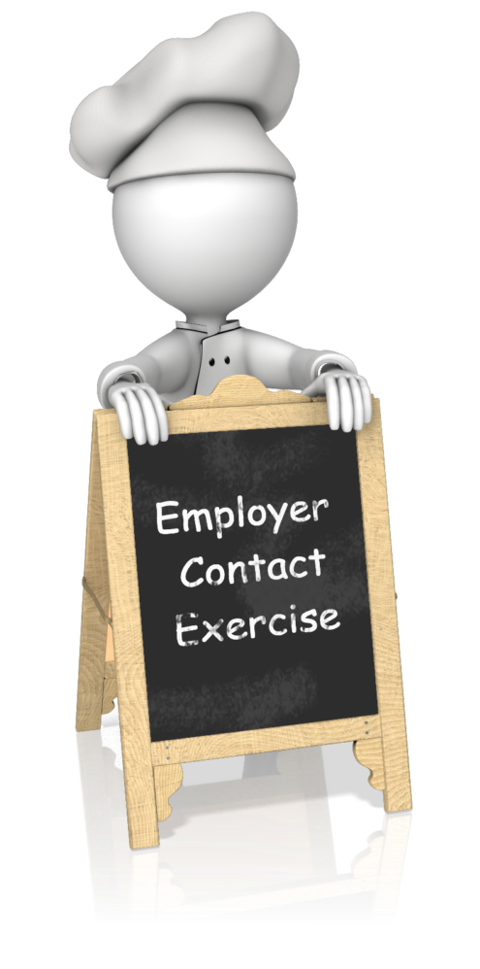

A food service manager needs to hire a food preparation person, to make sandwiches and salads for a cafeteria operation in a 600 person office building. He runs an advertisement which is spotted by the job developer for an agency which provides employment services to people with disabilities. The job developer calls the number in the ad, and talks to the food service manager. The conversation goes as follows:

Job Developer: This is Madeline Jones from XYZ Services. I work with people with developmental disabilities. I saw your ad in the paper for the food preparation person. I have a woman who I am trying to find a job for, and I would like to know if you would consider her for this position.

Manager: You know, I would really love to do something like this, but I don't see how it would work here. I'm very busy and the place is somewhat chaotic. We also work in some pretty tight quarters. I just don't see how it would work.

Job Developer: She really needs a job. Would you please consider hiring her?

Manager: As I said, I would really like to be involved in something like this, but I don't see it working here.

Job Developer: Could I at least send you a brochure on our program?

Manager: Sure, no problem. (He gives the job developer the mailing address, and they exchange good-bye pleasantries.)

The manager receives the brochure in the mail a few days later. He puts the brochure in his desk, where it sits until he moves out of the office 3 years later.

If you were the job developer, is there anything you would have done differently? Specifically outline the steps you would have taken.

