We are gearing up to see you all in person in less than a month. To help you prepare for the 2025 SELN Annual Meeting, we are excited to share some preliminary information with you. The purpose is to help your team reflect on current priorities and prepare for meaningful participation. Please take a few minutes to look through them and come ready for robust discussions and connection opportunities with your peers in other states!
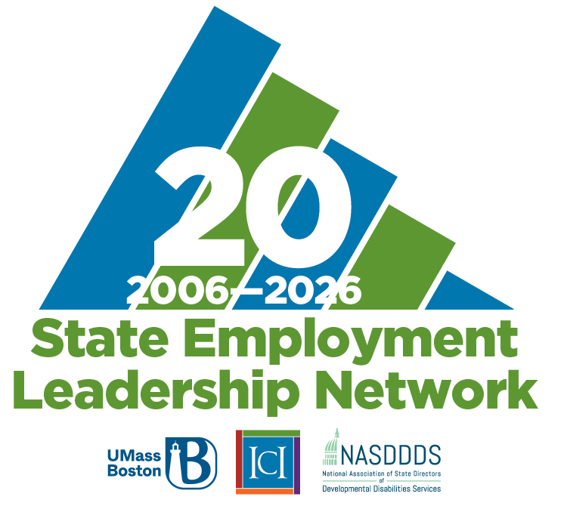
Pre-Meeting Reflection Questions
- What are the top 1–2 employment or community inclusion priorities your team is focused on right now?
- Where do you feel momentum building? What’s getting in the way?
- What questions or challenges do you want to explore with peers?
- Who from your team is attending the meeting, and what roles do they play?
StateDate Dash review items
- Data Note plus #92: National Survey of State Intellectual and Developmental Disabilities Agencies’ Employment and Day Services (1988–2022)​
- Five Questions on StateData | Think Work ​
- Your state’s Blue Book Appendix page​
Roll Call preparation
- Name and title
- State
- An achievement from last year​
- Your intention for your time at the annual meeting
Ally Map Lab internal partners to identify
- Who is in the chain of command for employment decisions? ​
- Who supports employment in your Medicaid waivers? ​
- Who do you go to for employment data? ​
- Who write employment policy for your agency?
- Who supports employment with tribal groups? ​
- Who monitors quality in employment services? ​
- Who supports case managers with employment? ​
- Who supports Employment providers?
Parallel Leadership Track definitions
The categories and descriptions below are designed to help participants identify which of the 2 leadership tracks they should choose, based on which of the roles most closely match your own. There is no wrong answer and if you’re struggling to choose, go with “Launching Leaders”.

Legacy Leaders: Visioning the path
- Visioning
- High-level, state-systems design or redesign
- Cross-agency alignment and relationship building
- Policy setting
- Sustaining
- Succession planning is critical for institutional knowledge

Launching Leaders: Building the path forward
- Convening
- Operationalizing
- Bridging
- Reporting
- Optimizing
- Policy refinement/interpretation
- Systems capacity building (TCM, providers, etc.)
- Building a team and foundation

If you have any questions, please reach out Amy Huppi at Amy.Huppi@umb.edu. See you soon in Alexandria, VA!

