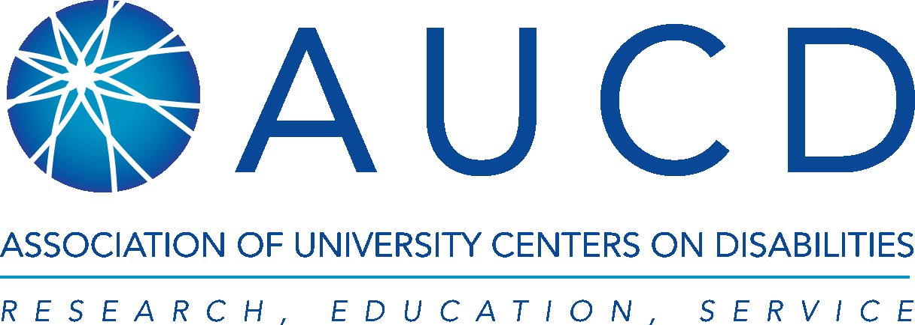

Every Student Achieves Act (S. 1177)
Preliminary Summary of Provisions that Directly Impact on Students with Disabilities

December 10, 2015

The Senate passed the Every Student Succeeds Act (ESSA, S. 1177) on December 9, 2015 by a vote of 85-12. The House of Representatives passed an identical bill on December 2 by a vote of 359-64. The next step is for the President to sign the bill, which is expected as soon as today, December 10.

While AUCD had advocated for a stronger federal role in the accountability system, the association supported the compromise measure and believes the final bill is stronger than the outdated No Child Left Behind Act (NCLB) and the current waivers that are in effect today in most states. Indeed, using data and new knowledge about how to most effectively teach students with disabilities, the new bill goes farther than the original 2002 NCLB to provide assistance to these students with disabilities to successfully graduate and become college and/or career-ready.

NCLB, which reauthorized the Elementary and Secondary Education Act (ESEA) in 2001, was tremendously important for students with disabilities. First, NCLB reinforced that students with disabilities are general education students first and should be held to the same high expectations as all other students. By requiring students with disabilities to participate in state and district-wide assessments and to have their progress measured and reported, the academic progress of students with disabilities now matter to people other than their parents. Since NCLB was signed into law, graduation rates for students with disabilities have increased from 48% in 2001 to 64% in 2013. Their math and reading scores have also increased significantly.

The following is a summary of provisions contained in the Every Student Succeeds Act that most directly impact students with disabilities:

Annual Statewide Testing and Accountability Systems
Annual statewide testing in reading and math is critical to measuring achievement gaps among groups of students, student growth toward state standards, and progress toward state graduation requirements as well as school/district/state effectiveness. ESSA continues to require states to test students in reading and math in grades 3 through 8 and once in high school. The law will not require states to achieve proficiency for all students by a specific date as was required by NCLB. States will set their own goals and their own consequences for meeting or not meeting those goals.

ESSA continues to include students with disabilities in state accountability systems and ensures students with disabilities will continue to have access to the general curriculum and be taught curriculum that is aligned with challenging academic content standards.
ESSA further ensures accommodations for assessments for students with disabilities. Those assessment results must be disaggregated so that we can see how students with disabilities compare to students without disabilities. The new bill goes even farther than current law by requiring states to incorporate concepts of Universal Design for Learning in both assessments and instruction so that all children can benefit from our new understanding of how to provide access to diverse learners.

ESSA requires that state accountability systems report on the proficiency of students with disabilities at the grade, school, LEA, and SEA levels. States must report progress of students in subgroups (including students with disabilities) on academic achievement as measured by the state annual assessments (including alternate assessments) and high school graduation rates.

The ESSA requires accountability systems to measure and report on the following indicators: academic achievement; student growth; graduation rates; and English language proficiency. In addition, included in the accountability system there must be not less than one indicator of school quality that differentiates schools can be used, including, possibly, student engagement, educator engagement, student access to advanced course work, postsecondary readiness, school climate, and other relevant indicators. However, academic factors must count for “much” more as a group than the other indicators. Accountability systems must be able to differentiate school effectiveness at the subgroup level using the indicators chosen by a state.

Local school district report cards must contain information on student achievement by subgroup, including students with disabilities, compared to students state-wide.

Alternate Assessments and 1% Cap

In a significant policy achievement, the new law caps participation of students taking alternate assessments, based on alternative academic achievement standards (AS-AAS) to one percent in the state (for each academic subject). This is important because the research shows that the overwhelming majority of students with disabilities can take the general assessment with accommodations. Less than 10% of students with disabilities (who represent 1% of the total student population) have the most significant cognitive disabilities and, therefore, may require an alternate assessment based on alternate academic achievement standards. The new law is different from the current law and regulation. NCLB and its regulations did not cap the percentage of students who could take the alternate assessment. There was a cap of 1% of alternate assessment scores that could be used in the accountability systems. The cap on the percentage of students taking the alternate assessment will mean that more students with disabilities will remain eligible for high school graduation and thus for participation in postsecondary education programs as well as jobs that require high school diplomas.

The new law also prohibits the development of modified standards, which codifies current regulations. In addition, the alternate academic achievement standards must: be aligned with challenging academic content standards, promote access to the general curriculum, reflect professional judgement to the highest standards possible, be designated in the Individualized Education Plan (IEP), be aligned to ensure students are on track to pursue postsecondary education or employment consistent with the goals of the Workforce Innovation and Opportunity Act (WIOA) of competitive integrated employment.

The new law also provides transparency for parents of students who take alternate assessments by ensuring that parents are informed of their child being assessed with the alternate assessment and told of the implications regarding graduation or eligibility for a regular diploma. The new law further directs that participation in the alternate assessment does not preclude a student from attempting to meet the requirement for regular high school diploma.

Educational Goals

In a big departure from NCLB, states will have wider discretion in setting goals and establishing the accountability system, but with federal guardrails.

The bill requires Local Education Agencies (LEAs) to provide locally-developed, evidence-based interventions for the bottom five percent of schools, schools where less than two-thirds of students graduate, and schools with consistently underperforming subgroups, including students with disabilities. Annual state reports must contain the method by which the state identifies schools with consistently underperforming subgroups and what progress is being made toward goals. Annual state reports also must contain information on the number and percentages of students with the most significant cognitive disabilities taking the alternate assessment by grade and subject

In another positive improvement from waivers and a win for disability and other civil rights groups, the performance of each subgroup of students must be measured separately, meaning states can no longer report student performance on combined groups, so-called super-subgroups, which sometimes masked the performance of some subgroups.

Bullying and Restraints and Seclusion

The ESSA requires states to create and make available an annual report that must contain information on incidents of bullying and harassment and the use of discipline procedures in schools. State plans must include information on how the state will support local educational agencies to reduce the use of aversive behavioral interventions that compromise student health and safety. In the report language accompanying the bill, the committee spells-out that the use of aversive interventions includes restraints and seclusion.

Federal Authority

Due to a back-lash against the perceived intrusion of federal government into state and local education efforts, the ESSA limits some of the authority of the U.S. Secretary of Education, especially with regard to state decision-making about testing, academic standards, and how to intervene in schools that are not closing achievement gaps. The bill specifically prohibits the Department of Education from forcing or even encouraging the use of the Common Core State Standards (note: the original NCLB also does not mention the common core). However, the Department of Education will still have the authority to approve state plans and many of the state plan provisions have been strengthened.

Next Steps

The next step is for the President to sign the bill into law, which could take place as soon as today, December 10. Then, it will be up to state advocates, including the University Centers for Excellence in Developmental Disabilities, to make sure the state and local agencies develop strong accountability plans. AUCD will sponsor a webinar outlining the disability-related provisions and how University Centers and its state partners can become involved in helping to ensure a smooth implementation soon after the New Year. Stay tuned for further details.

This summary will continue to be updated as AUCD continues to review and analyze the changes in the law.

