Methods

*Data Selection*

From VCell, the data was exported by selecting a segment of the ellipsoid spanning the major axis of the ellipsoid as indicated by the black line in the figure below.

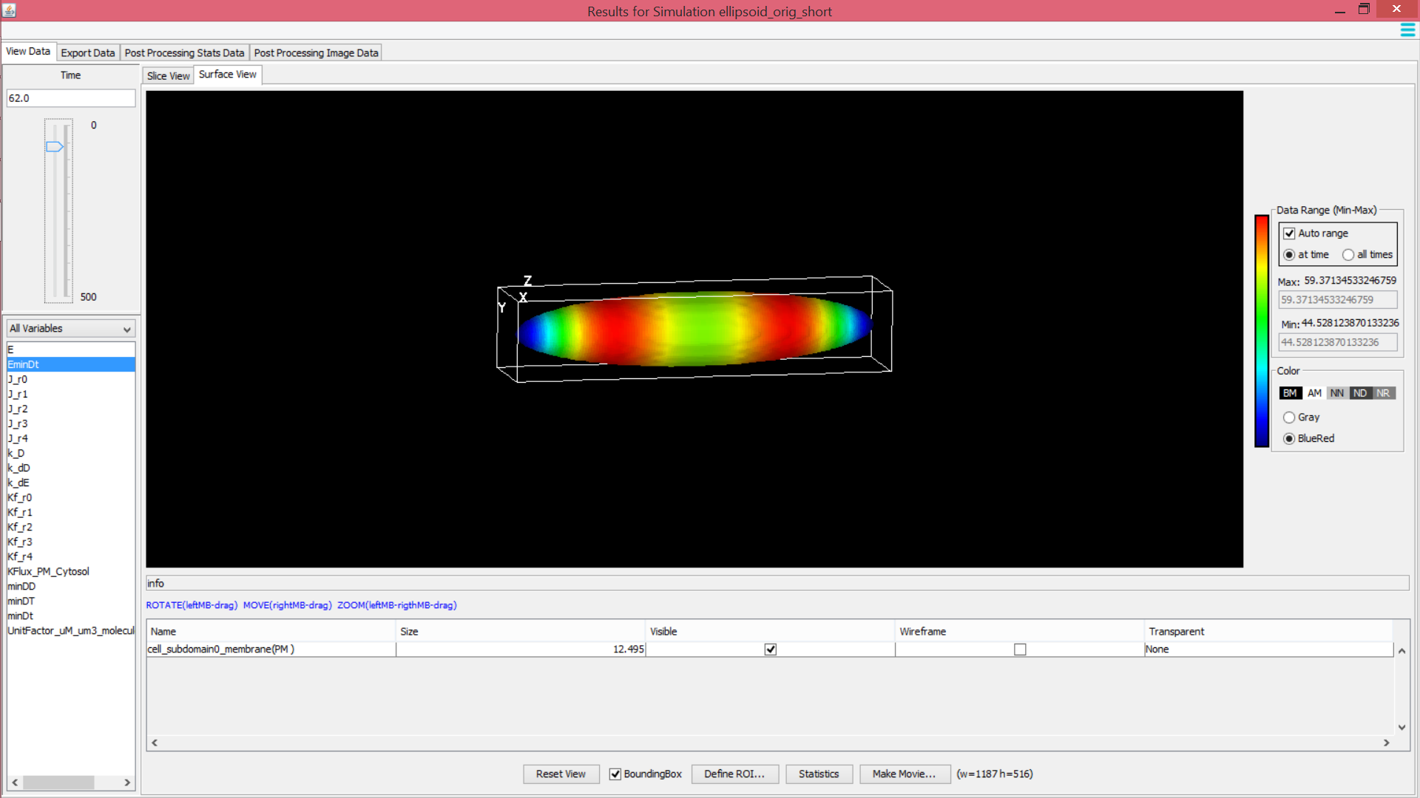

The selection was made by slicing the geometric region along the XZ plane. As the spatial and temporal patterns of the system are symmetric with respect to the long axis of the ellipsoid, the data was chosen by taking cells from one end of the ellipsoid to the other from the slice nearest Y=0 as highlighted below.

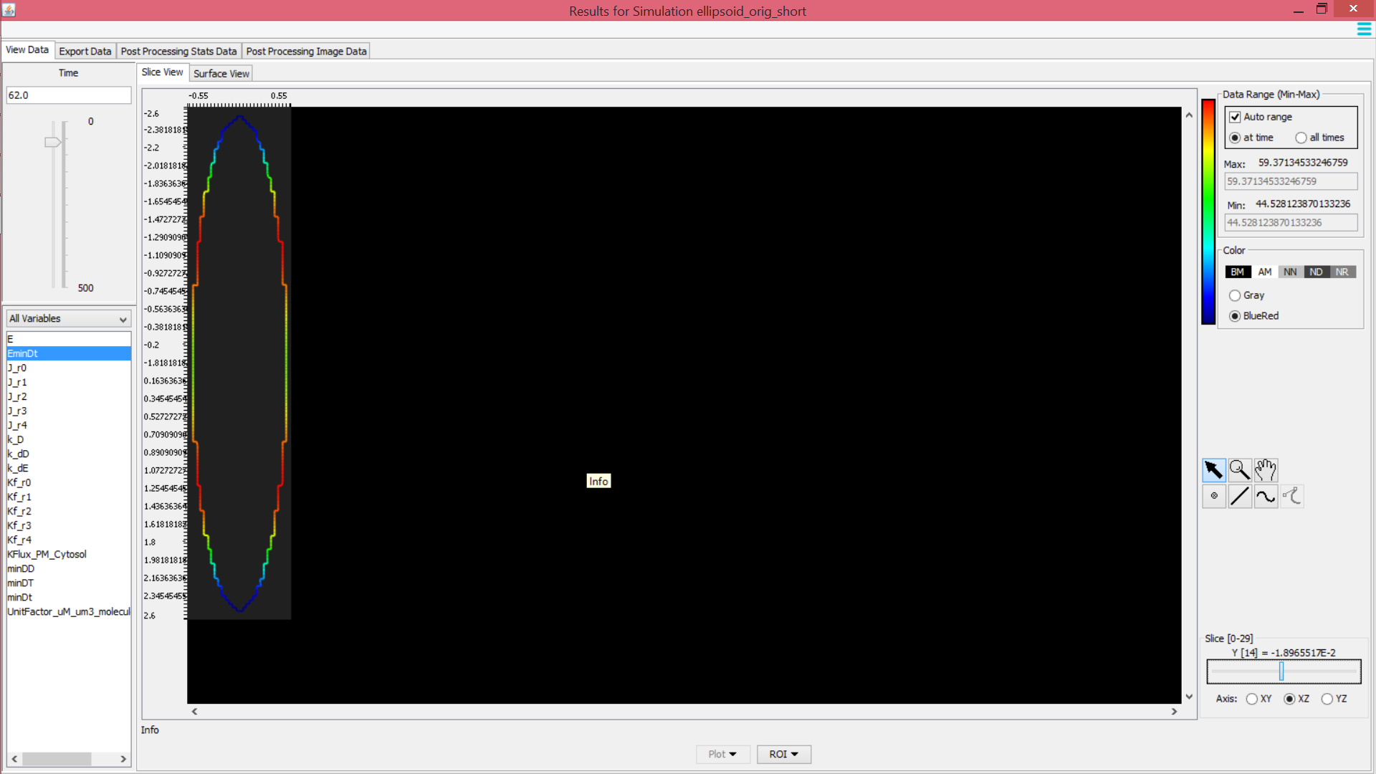

*Analysis*

We were interested in the spatial and temporal changes of the membrane bound complex minE and minDt (denoted as EminDt) and the membrane bound particle minDt. In particular, we analyzed the changes of the average wavelength and average maximum height of the spatial distribution of the particles over time, changes in symmetry of the distribution across the plane Z=0, and changes in total number of particles bound to the membrane over time.

Consider a sample spatial distribution of EminDt and minDt at a particular time shown below. The wavelength is defined as the distance (um) between local maxima. The maximum height is defined as the number of particles at a given time and distance. These two properties are denoted in the figure below.

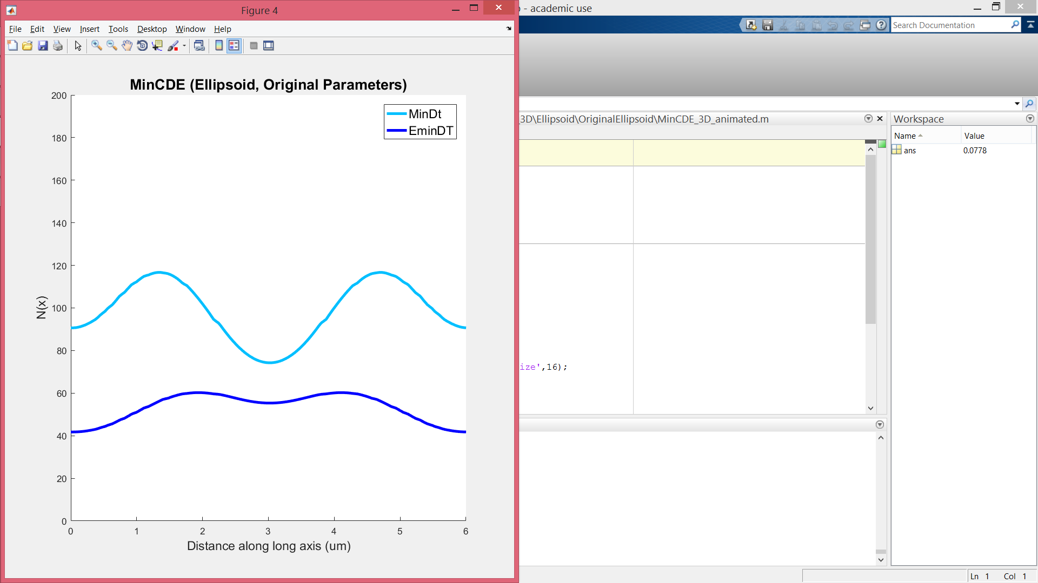

Wavelength (um)

Peak Height (Number of molecules)

To analyze trends in the average wavelength and height, cell symmetry, and total number of bound particles, we developed a simple function to identify local maxima. The function requires a minimum of one and a maximum of two inputs. The first required input is a horizontal vector of the data, and the second optional input is a threshold value that indicates the minimum difference between two data points to indicate a significant difference between the two values. By default, the threshold value is 0.025% of the maximum value.

The data is then simplified to a vector of ±1 as follows: for each point, consider the difference between its value and the value of the previous data point. If the difference is positive and larger than the threshold, the current data value is replaced with +1 to indicate that the data is increasing. Similarly, if the difference is negative and has a larger magnitude than the threshold, the current data value is replaced with -1 to indicate that the data is decreasing. If the current data shows no significant difference from the previous data value, that is the magnitude of the difference between the two points is less than the threshold, the current data is replaced by the trend value (±1) of the previous data point to indicate no change in the previous data trend. The local maximum are thus the data points of value +1 where the next data point has value -1. The function then returns the number of local maxima found as well as their indices in the data vector.

For each of the two species, EminDt and minDt, at each time point, the number of local maxima in the spatial distribution of the molecules as well as their indices were recorded. Using the indices of the local maxima, the heights of the local maxima were extrapolated and averaged for each time point, resulting in an average maxima height of the species at a given time. Similarly, the average wavelength was found by taking the difference between the distances of adjacent local maxima at a time point, identified by the distance of the maxima along the arc length spanning the major axis using the indices of the local maxima.

In addition to the heights and wavelengths of local maxima, the symmetry of the spatial distribution of each species was quantified by a numerical value, called the symmetry value. Along the major axis, the cell is partitioned into two equal halves. The first half consists of data points from 0 to half of the maximum arc length value, and the second half consists of data points from half of the maximum arc length value to the maximum arc length value. For each data point in the first half of the data set, there exists a point in the second half of the data set equidistant from the center. The differences between equidistant data points in the first half the data set and the second half of the data set are averaged to yield a symmetry value. Thus, a large, positive symmetry value indicates that more of the molecules reside in the first half of the cell. Conversely, a large, negative symmetry value indicates that more of the molecules reside in the second half of the cell.

The last property we examined were temporal changes in the number of membrane bound particles over time. The number of bound particles over time was found by summing the number of particles along the arc length at a given time. The four examined properties were plotted as shown below. The first row of graphs are the plots for EminDt while the second row of graphs are the plots for minDt. From left to right, the plots are as follows: (a) The average height of local maxima at each given time point. The points are colored according to the number of local maxima present at the time point. (b) The average wavelength plots the average distance between the local maxima at a given time. If there is only one local maximum present at the time, the average wavelength is 0 um. (c) The plots of the symmetry values as explained above. (d) The plot of the total number of membrane bound molecules over time. This plot shows the temporal oscillations of the system.

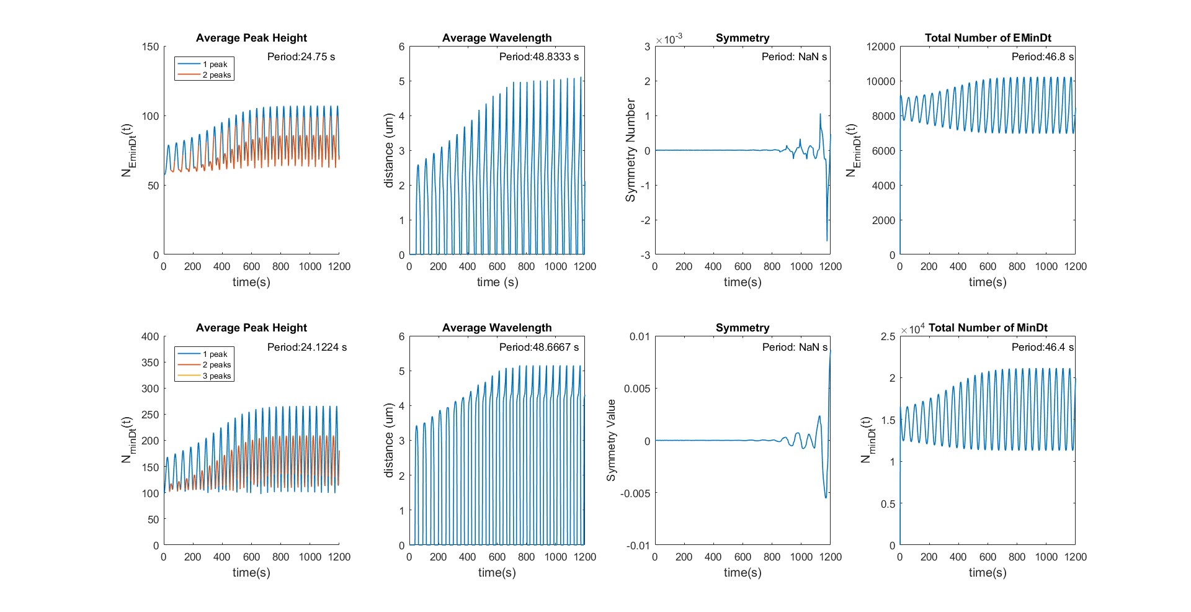

Using the same method of finding local maxima as described above, the period for each of the property was calculated. From the indices of the local maxima, the time differences between adjacent local maxima were averaged to yield the period value as shown in the upper right hand corner of each plot. If the property is aperiodic, the period value yields the first occurrence of a local maxima. The periods of all MinCDE systems are listed below.

MinCDE Ellipsoid System – Steady State Period After 1200s

|  |  |  |  |  |  |  |  |  |
| --- | --- | --- | --- | --- | --- | --- | --- | --- |
| Geometry Changes | Period of MinE Property (s) | | | | Period of MinDt Property (s) | | | |
| Height | Wavelength | Symmetry | Total Number | Height | Wavelength | Symmetry | Total Number |
| Original (1um * 5um) | 21.56±6.60 | 41.33±14.00 | 0.00 | 41.11±14.67 | 21.22±5.79 | 40.89±15.33 | 0.00 | 40.00±15.23 |
| L10 (1um *10 um) | 13.15±4.86 | 13.00±4.33 | 0.00 | 36.22±13.02 | 11.74±1.94 | 12.95±6.00 | 0.00 | 45.09±10.11 |
| Reduced L (1um*2.5 um) | 60.23 | 0.00 | 0.39 | 4.82e3 | 111.21 | 0.00 | 1.03 | 8.15e3 |
| Reduced R (0.5um*5um) | -- | 0.00 | -- | -- | -- | 0.00 | -- | -- |
| Sphere | 0.00 | 0.00 | 0.00 | 4.09e3 | 0.00 | 0.00 | 0.00 | 7.14e3 |
| Concentration Changes | Period of MinE Property (s) | | | | Period of MinDt Property (s) | | | |
| Height | Wavelength | Symmetry | Total Number | Height | Wavelength | Symmetry | Total Number |
| Doubled DT | 64.07 | 0.00 | 0.00 | 8.63e3 | 333.58 | 0.00 | 0.00 | 3.72e4 |
| Doubled E | 7.19±1.15 | 14.37±1.33 | 14.29±1.93 | 7.19±1.17 | 333.58 | 0.00 | 0.00 | 3.72e4 |
| Doubled E, Doubled DT | 12.29±4.75 | 19.53±15.27 | 0.00 | 38.94±5.44 | 9.97±7.25 | 10.00±1.85 | 0.00 | 38.33±8.10 |
| Geometry Changes | Period of MinE Property (s) | | | | Period of MinDt Property (s) | | | |
| Height | Wavelength | Symmetry | Total Number | Height | Wavelength | Symmetry | Total Number |
| Hydrolysis * 10 | 5.71±1.23 | 5.78±0.62 | 5.73±0.84 | 6.41±0.96 | 6.39±1.07 | 9.77±7.35 | 5.75±0.72 | 5.62±1.70 |
| Hydrolysis * 0.1 | 58.00 | 0.00 | 0.00 | 9.20e3 | 124.52 | 0.00 | 0.00 | 1.59e4 |

The notation in the table is as follows:

Average ± Std Dev The measured property in its steady state has oscillations

Value The measured property in its stead state has no oscillations and attains a fixed value

-- No steady state achieved in 1200s

3.0 Red values indicate that the steady state property is NOT significantly different from the average values over the span of 1200s

MinCDE Ellipsoid System – Average Period over 1200s

|  |  |  |  |  |  |  |  |  |
| --- | --- | --- | --- | --- | --- | --- | --- | --- |
| Geometry Changes | Period of MinE Property (s) | | | | Period of MinDt Property (s) | | | |
| Height | Wavelength | Symmetry | Total Number | Height | Wavelength | Symmetry | Total Number |
| Original (1um * 5um) | 24.75 | 48.83 | NaN* | 46.72 | 24.12 | 48.67 | NaN* | 46.40 |
| L10 (1um *10 um) | 13.63 | 13.66 | NaN* | 38.00 | 12.22 | 13.61 | NaN* | 45.85 |
| Reduced L (1um*2.5 um) | 24.00* | NaN* | NaN* | 2.00* | 20.00* | NaN* | NaN* | 22.00* |
| Reduced R (0.5um*5um) | 53.36 | 54.86 | 115.00* | 52.00 | 43.19 | 50.75 | 126.00* | 51.83 |
| Sphere | NaN* | NaN* | NaN* | NaN* | NaN* | NaN* | NaN* | NaN* |
| Concentration Changes | Period of MinE Property (s) | | | | Period of MinDt Property (s) | | | |
| Height | Wavelength | Symmetry | Total Number | Height | Wavelength | Symmetry | Total Number |
| Doubled DT | 88.00* | NaN* | NaN* | 22.00* | 64.00* | NaN* | NaN* | 2* |
| Doubled E | 7.17 | 12.22 | 15.09 | 7.79 | 64.00* | NaN* | NaN* | 2* |
| Doubled E, Doubled DT | 14.49 | 23.76 | NaN* | 43.04 | 12.48 | 12.02 | NaN* | 42.5 |
| Geometry Changes | Period of MinE Property (s) | | | | Period of MinDt Property (s) | | | |
| Height | Wavelength | Symmetry | Total Number | Height | Wavelength | Symmetry | Total Number |
| Hydrolysis * 10 | 6.03 | 6.43 | 7.92 | 8.08 | 6.28 | 9.88 | 7.22 | 7.38 |
| Hydrolysis * 0.1 | NaN* | NaN* | NaN* | NaN* | NaN* | NaN* | NaN* | 2.00* |

* Not periodic.