***Example Reaction for Protein pairs P1:P2 and a Membrane Specie M***

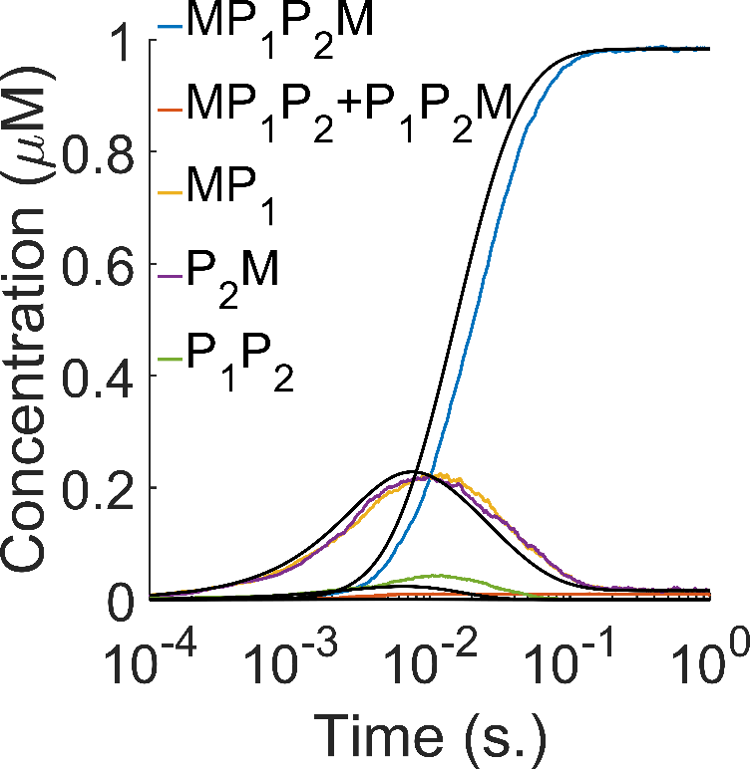

Figure 1 Time-dependence of the simulations comparing ODEs (black lines) with RD simulations (colors). Time-scales from ODEs are similar to RD methods despite lacking explicit diffusion because our definitions of macroscopic rates implicitly account for diffusion. KaPP=107M-1, koff=1s-1,KaPM=2 106M-1. 24 FPR Trajectories. Initial molecule numbers are P1=P2=100 (1μM) and M=3704 (17,000 μm-2) in a 466.8x466.8x761.8 nm3 box (0.1660 μm3 volume, 0.218 μm2 surface area and V/A=0.762). DM=0.5 ${nm}^{2}/μs$ and DP1=DP2=50 ${nm}^{2}/μs$ and $σ^{PP}=σ^{P_{1}M}=σ^{P_{2}M}=1nm$. For ODE set, we used 50 μm3 volume, 65.63 μm2 surface area and V/A=0.762. Δt=0.1μs.

***Individual Reactions for Protein pairs P1:P2***

The system has 9 species, $\left[P_{1}\right], \left[P_{2}\right],\left[M\right],\left[P_{1}P_{2}\right],\left[P_{1}M\right],\left[P_{2}M\right],\left[P_{2}P_{1}M\right],\left[P_{1}P_{2}M\right],\left[MP_{1}P_{2}M\right]$, with the following individual equilibria.

5.1. P1+P2⇋ P1P2 (

5.2. M+P1⇋ MP1 (

5.3. M+P2⇋ P2M (

5.4. M+P1P2⇋ MP1P2 (

5.5. P1P2+M⇋ P1P2M (

5.6. MP1+P2⇋ MP1P2 (

5.7. P1+ P2M ⇋ P1P2M (

5.8. MP1+ P2M ⇋ MP1P2M ()

5.9. M+ P1P2M ⇋ MP1P2M (

5.10. MP1P2+M⇋ MP1P2M (

Table 1: Parameter specs for different simulation techniques. $K_{a}^{P_{1}M}=K_{a}^{P_{2}M}=K_{a}^{PM}$.

|  |  |  |  |  |  |  |  |  |  |  |
| --- | --- | --- | --- | --- | --- | --- | --- | --- | --- | --- |
|  | Volume  (μm3) | Surface Area  (μm2) | (μM) | (μM) | (μm-2) | (M-1) | (M-1) | koff  (s-1) | (M-1 s-1) | (M-1 s-1) |
| FPR | 0.166 | 0.218 | 1 | 1 | 17000 | 107 | 2 106 | 1 | 107 | 2 106 |
| ODE-Mathematica | 50 | 65.63 | 1 | 1 | 17000 | 107 | 2 106 | 1 | 107 | 2 106 |
| ODE-VCell | 50 | 65.63 | 1 | 1 | 17000 | 107 | 2 106 | 1 | 107 | 2 106 |
| SSA-VCell | 50 | 65.63 | 1 | 1 | 17000 | 107 | 2 106 | 1 | 107 | 2 106 |
| PDE-VCell | 50 | 65.63 | 1 | 1 | 17000 | 107 | 2 106 | 1 | 107 | 2 106 |
| Smoldyn-VCell | 0.166 | 0.218 | 1 | 1 | 17000 | 107 | 2 106 | 1 | 107 | 2 106 |

Table 2: Additional parameter specs for different simulation techniques.

|  |  |  |  |  |  |  |  |  |
| --- | --- | --- | --- | --- | --- | --- | --- | --- |
|  | () | (s-1) | () | (s-1) | () | () | (s-1) | (s-1) |
| FPR | 16.828 | 1.0100 | 3.3386 | 1.0053 | - | - | - | - |
| ODE-Mathematica | - | - | - | - | 1.58489 | 1.19502 | 0.19089 | 0.71964 |
| ODE-VCell | - | - | - | - | $$\frac{K_{a}^{PP}}{ (2σ^{PP})}$$ | $$\frac{K_{a}^{PM}}{ (2σ^{PM})}$$ | 1 | 1 |
| SSA-VCell | - | - | - | - | $$\frac{K_{a}^{PP}}{ (2σ^{PP})}$$ | $$\frac{K_{a}^{PM}}{ (2σ^{PM})}$$ | 1 | 1 |
| PDE-VCell | - | - | - | - | $$\frac{K_{a}^{PP}}{ (2σ^{PP})}$$ | $$\frac{K_{a}^{PM}}{ (2σ^{PM})}$$ | 1 | 1 |
| Smoldyn-VCell | - | - | - | - | $$\frac{K_{a}^{PP}}{ (2σ^{PP})}$$ | $$\frac{K_{a}^{PM}}{ (2σ^{PM})}$$ | 1 | 1 |

Table 3 Equilibrium concentrations of species in Figure 1. Mean and standard deviations ($\sqrt{\frac{1}{N-1}}\sum_{i=1}^{N}{{\left|A_{i}-μ\right|}^{2}}$) in parentheses provided for stochastic simulations.10 SSA trajectories taken. For PDE, spherical geometry simulated (Mesh:31x31x31) with maximum timestep 0.001s. Smoldyn (Mesh:27x27x57) has the same reaction geometry as the FPR and timestep is 1μs. 8 Smoldyn trajectories.

|  |  |  |  |  |  |  |  |  |
| --- | --- | --- | --- | --- | --- | --- | --- | --- |
| Equilibrium  Concentrations | $$\left[MP_{1}P_{2}M\right]$$ | $$\left[P_{2}P_{1}M\right]$$ $$+$$ $$\left[P_{1}P_{2}M\right]$$ | $$\left[P_{1}M\right]$$ | $$\left[P_{2}M\right]$$ | $$\left[P_{1}P_{2}\right]$$ | $$\left[P_{1}\right]$$ | $$\left[P_{2}\right]$$ | $$\left[M\right]$$ |
| FPR (24 Traj) | 0.9846  (0.0078) | 0.0062  (0.0049) | 0.0154  (0.0078) | 0.0154  (0.0078) | 0  (0) | 0  (0) | 0.0004 (0.002) | 16082  (0) |
| ODE-Mathematica | 0.9836 | 7.3662 10-5 | 0.0161 | 0.0161 | 5.2529 10-7 | 2.2581 10-4 | 2.2581 10-4 | 16089.15 |
| ODE-VCell | 0.9833 | 7.3636 10-5 | 0.0161 | 0.0161 | 5.2513 10-7 | 2.2916 10-4 | 2.2916 10-4 | 16082.98 |
| SSA-VCell (10) | 0.9835  (0.0004) | 4.6496 10-5  (5.4684 10-5) | 0.0159  (3.429 10-4) | 0.0159  (3.429 10-4) | 3.3223 10-6  (1.0506 10-5) | 2.2924 10-4  (8.0629 10-5) | 1.5282 10-4  (5.980110-5) | 16082.95  (0.0613) |
| PDE-VCell | 0.9889 | 7.4081 10-5 | 0.0161 | 0.0161 | 5.2848 10-7 | 2.2989 10-4 | 2.2989 10-4 | 16077.77 |
| Smoldyn-VCell (8) | 0.9650  (0.0107) | 0  (0) | 0.0350  (0.0107) | 0.0338  (0.0119) | 0  (0) | 0.0014  (0.0035) | 0  (0) | 16081.26  (1.6059) |

***Example Reaction for Protein pairs P1:P1 and a Membrane Specie M***

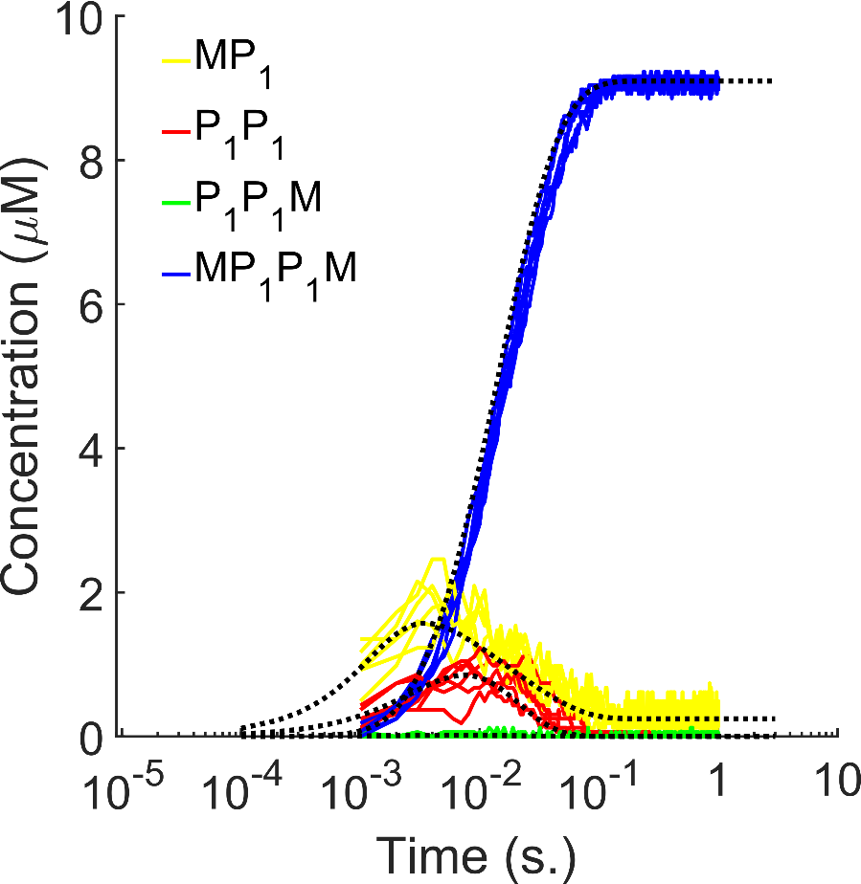

Figure 2 FPR Simulation of {M,P1} reaction networks (red, solid) in comparison with ODE (dashed lines). Number of species plotted as a function of time. 300 P1 particles (18.4504 μM) in a $300$ x $300$ x300nm cuboid box (V=0.027 μm3, A=0.09 μm2) with 1000 M’s ([M]0=11111.1 μm-2). DM=1 and DP1=20 ${nm}^{2}/μs$. 6 FPR trajectories were used. 106M-1s-1 and 1s-1 for the elemental reactions (P1-M and P1-P1). Δt=0.1μs.

***Individual Reactions for Protein pairs with self-binding***

The system has only 6 species, $\left[P_{1}\right], \left[P_{1}P_{1}\right],\left[M\right],\left[P_{1}M\right],\left[P_{1}P_{1}M\right],\left[MP_{1}P_{1}M\right]$, with the following individual equilibria.

S2.1. $P_{1}$ + $P_{1}$ ⇋ $P_{1}P_{1}$ ($K_{a}^{PP})$

S2.2. $P_{1}$ M+ $P_{1}$ ⇋ $P_{1}P_{1}$ M (${2K}_{a}^{PP})$

S2.3. $P_{1}$ + M ⇋ $P_{1}$ M ($K_{a}^{PM})$

S2.4. $P_{1}P_{1}$ + M ⇋ $P_{1}P_{1}$ M ($2K_{a}^{PM})$

S2.5 $P_{1}P_{1}$ M + M ⇋ M $P_{1}P_{1}$ M ($\frac{K_{a}^{PM}}{2}/(2σ^{PM}))$

S2.6. $P_{1}$ M + $P_{1}$ M ⇋ M $P_{1}P_{1}$ M ($K_{a}^{PP}/(2σ^{PP}))$

Reactions 5 and 6 are in 2D. Reactions in 2D list the 2D Ka values and thus require species be in units of A-1.

Table 4: Parameter specs for different simulation techniques for Figure 2.

|  |  |  |  |  |  |  |  |  |  |
| --- | --- | --- | --- | --- | --- | --- | --- | --- | --- |
|  | Volume  (μm3) | Surface Area  (μm2) | (μM) | (μm-2) | (M-1) | (M-1) | koff  (s-1) | (M-1 s-1) | (M-1 s-1) |
| FPR | 0.027 | 0.09 | 18.45 | 11111 | 106 | 106 | 1 | 106 | 106 |
| ODE-Mathematica | 0.027 | 0.09 | 18.45 | 11111 | 106 | 106 | 1 | 106 | 106 |
| ODE-VCell | 0.027 | 0.09 | 18.45 | 11111 | 106 | 106 | 1 | 106 | 106 |
| SSA-VCell | 0.027 | 0.09 | 18.45 | 11111 | 106 | 106 | 1 | 106 | 106 |
| PDE-VCell | 0.027 | 0.09 | 18.45 | 11111 | 106 | 106 | 1 | 106 | 106 |
| Smoldyn-VCell | 0.027 | 0.09 | 18.45 | 11111 | 106 | 106 | 1 | 106 | 106 |

Table 5: Additional parameter specs for different simulation techniques for Figure 2.

|  |  |  |  |  |  |  |  |  |
| --- | --- | --- | --- | --- | --- | --- | --- | --- |
|  | () | (s-1) | () | (s-1) | () | () | (s-1) | (s-1) |
| FPR | 3.3433 | 1.007 | 1.6661 | 1.003 | - | - | - | - |
| ODE-Mathematica | - | - | - | - | 0.81594 | 0.749814 | 0.982722 | 0.903076 |
| ODE-VCell | - | - | - | - | $$\frac{K_{a}^{PP}}{ (2σ^{PP})}$$ | $$\frac{K_{a}^{PM}}{ (2σ^{PM})}$$ | 1 | 1 |
| SSA-VCell | - | - | - | - | $$\frac{K_{a}^{PP}}{ (2σ^{PP})}$$ | $$\frac{K_{a}^{PM}}{ (2σ^{PM})}$$ | 1 | 1 |
| PDE-VCell | - | - | - | - | $$\frac{K_{a}^{PP}}{ (2σ^{PP})}$$ | $$\frac{K_{a}^{PM}}{ (2σ^{PM})}$$ | 1 | 1 |
| Smoldyn-VCell | - | - | - | - | $$\frac{K_{a}^{PP}}{ (2σ^{PP})}$$ | $$\frac{K_{a}^{PM}}{ (2σ^{PM})}$$ | 1 | 1 |

Table 6 Equilibrium concentrations of species in for Figure 2. Mean and standard deviations ($\sqrt{\frac{1}{N-1}}\sum_{i=1}^{N}{{\left|A_{i}-μ\right|}^{2}}$) in parentheses provided for stochastic simulations.6 FPR trajectories taken.

|  |  |  |  |  |  |  |
| --- | --- | --- | --- | --- | --- | --- |
| Equilibrium  Concentrations | $$\left[MP_{1}P_{1}M\right]$$ | $$\left[P_{1}P_{1}M\right]$$ | $$\left[P_{1}M\right]$$ | $$\left[P_{1}P_{1}\right]$$ | $$\left[P_{1}\right]$$ | $$\left[M\right]$$ |
| FPR (6 Traj) | 9.0919  (0.0605) | 0  (0) | 0.2665 (0.1209) | 0  (0) | 0  (0) | 7777.78  (0) |
| ODE-Mathematica | 9.0962 | 0.0028 | 0.2463 | 3.2704 10-5 | 0.0057 | 7779.40 |
| ODE-VCell |  |  |  |  |  |  |
| SSA-VCell |  |  |  |  |  |  |
| PDE-VCell |  |  |  |  |  |  |
| Smoldyn-VCell |  |  |  |  |  |  |