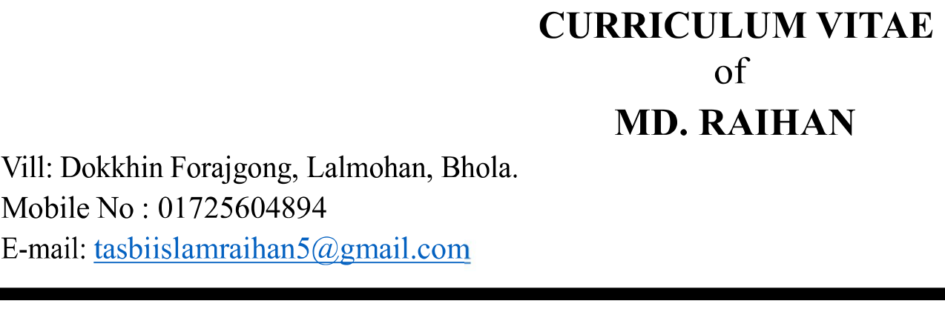

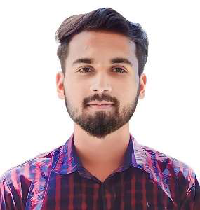

**Career Objective:**

To work with a reputed organization where my skills and abilities can be applied to improve its operation, to contribute to its success, and also to increase my skills.

**Strength:**

●Paint   
●Good looking   
●Easy learner   
●Work professionally limit direc on   
●Discipline   
●Pleasant personality   
●Be able to work in long hour   
●Be able to work with deadline target   
●Be able to work with under pressure

**Education Qualification:**

|  |  |  |  |  |
| --- | --- | --- | --- | --- |
| **Name of Exam** | **Group /**  **Department** | **Board** | **Result** | **Passing Year** |
| SSC | Science | Barishal | 4.61 | 2018 |
| Diploma in Engineering | Civil | BTEB | 3.27 out of 4.00 | 2022 |

**Training Summary:**

|  |  |  |  |  |  |
| --- | --- | --- | --- | --- | --- |
| **Training Title** | **Institute** | **Result** | **Year** | **Board** | **Duration** |
| Fire Science & Occupational Safety | Bangladesh Fire Service & Civil Defence Training complex | B Grade | 2021 | Dhaka | 6 Months  (Batch-11) |
| Firefighting, Fire Prevention, Rescue and First Aid Training | Bangladesh Fire Service & Civil Defence Directorate | Good | 2021 | Dhaka | 02 Days |

**Total 2 Years of Work Experience: -**

1.Work With **Shine Embroidery Ltd.**

Post: Assistant Safety Officer

Joining Date: 1 August 2021.

2.Presently Working With **Fair Electronics (Samsung Company Ltd.)**

Post: Fire Safety Officer

Joining Date: 1 March 2023.

**Skills and Computer Work:**

Technical applications: Photography, efficient in MS Word, MS Excel, E-mail and internet Browsing.

**Language proficiency:**

Good Communication Skill Both in Bengali & English Strong command on business correspondence, report

writing & Public speaking.

**Interests:**

Reading Books, Listening Music, Sports, Traveling, Watching Movie.

**Personal Particulars:**

Fathers Name : Md. Jasim Uddin

Mothers name : Easmin

Date of Birth : 01/01/2003

Gender : Male

Marital Status : Single

Height : 5’5”

Weight : 62 kg

Blood group : B+

Religion : Islam

Nationality : Bangladeshi (by birth)

NID : 9161647756

Post : 8330

Permanent Address : Village- Dokkhin Forajgong, P.S: Lalmohan, District:Bhola.

Present Address : Village- Dokkhin Forajgong, P.S: Lalmohan, District:Bhola.

Declaration:

I, the undersigned, certify that, to the best of my knowledge and belief, this curriculum vitae correctly describe my

qualifications.

Md. Raihan