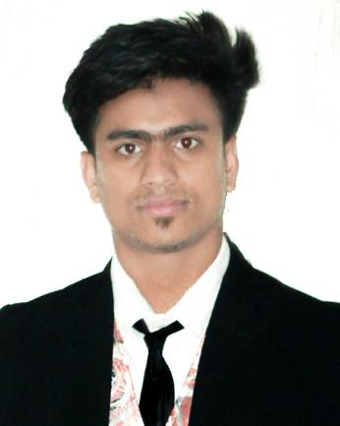

Curriculum vitae Of   
**Amdadul Huq Rifat**

|  |
| --- |
| **MAILINGADDRESS:** |

House# 56, Road# 06, Mohammadia Housing Ltd, Mohammadpur, Dhaka-1207   
Cell: 01735-440223   
E-mail: amdadulhaqrifat20@gmail.com

|  |
| --- |
| **CAREEROBJECTIVES:** |

Build up career with a challenging environment in an organization that is dynamic and where hospitality, sincerity, skill and performance are the criteria for one’s appraisal and recognition. To manage people, interface with customer services.

|  |
| --- |
| **EDUCATIONALQUALIFICATION:** |

**Diploma in Engineering:**

|  |  |  |
| --- | --- | --- |
| Institute | : | : Bhola Polytechnic Institute |
| Department | : | : Refrigeration and Air Condition |
| Result | : | 3.50 |
| Passing Year | : | 2023 |
| Board | : | : BTEB |
| Duration | : | : 4th Year |

**Higher Secondary Certificate: (HSC)**

|  |  |  |
| --- | --- | --- |
| Institute | : | : Dr. Azhar Uddin Degree College |
| Group | : | : Science |
| Result | : | : GPA: 4.17 (out of 5.00) |
| Passing Year | : | 2020 |
| Board | : | : Barisal |

**Secondary School Certificate: (SSC)**

|  |  |  |
| --- | --- | --- |
| Institute | : | : Abdur Ohab Secondary School |

|  |  |  |
| --- | --- | --- |
| Group | : | : Science |
| Result | : | : GPA: 3.78 (out of 5.00) |
| Passing Year | : | 2018 |
| Board | : | : Barisal |

**NTVQF Level-1 Certificate**

|  |  |  |
| --- | --- | --- |
| Institute | : | : Hazi Nurul Islam College |
| Course | : | : Plumbing & Pipefitting |
| Result | : | : Competent |
| Duration | : | : 4 Months |
| Board | : | : BTEB |

**NTVQF Level-1 Certificate**

|  |  |  |  |  |  |  |  |  |  |  |  |  |  |  |  |  |  |  |
| --- | --- | --- | --- | --- | --- | --- | --- | --- | --- | --- | --- | --- | --- | --- | --- | --- | --- | --- |
| |  |  |  | | --- | --- | --- | | Institute | : | : Bhola Technical Training Center | |  | : :  :  : |  | | Course | Welding | | Result | : Competent | | Duration | 4 Months | | Board | BTEB | | **Computer Skills:** | | | | |
| **MS Office Package** | **:** MS Words, MS Excel |
| **Operating System** | **:**  windows 10 |
| **Basic Skill** | **:** Internet Browsing and Others. |

|  |
| --- |
| **STRENGTH:** |

 Communicative, friendly, positive thanking attitude & willing to serve dedicatedly  Readiness to work with a stress worthy environment.   
 Handle high pressure situation and deadlines.   
 Sharp sense of social responsibility.

 Dynamic, extrovert, and resourceful.

|  |
| --- |
| **HOBBY:** |

 Reading of Books, Newspaper, Magazines and Sports.

|  |
| --- |
| **LANGUAGEANDCOMMUNICATIONEFFICIENCY:** |

|  |  |  |  |  |
| --- | --- | --- | --- | --- |
| Language | Reading | Writing | Listening | Speaking |
| Bangla | Excellent | Excellent | Excellent | Excellent |
| English | Excellent | Excellent | Good | Medium |

|  |
| --- |
| **PERSONALDETAILS:** |

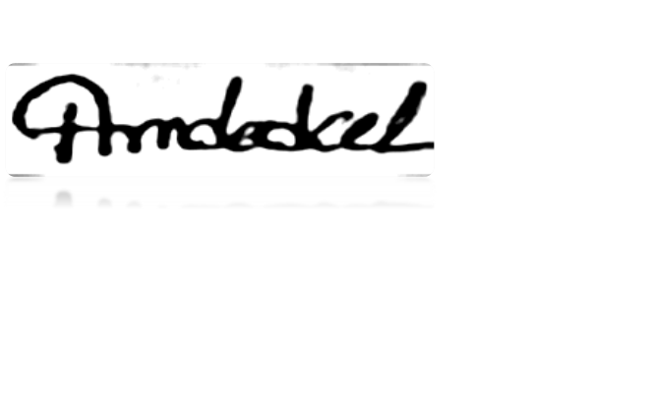

|  |  |  |
| --- | --- | --- |
| Name | : | : Amdadul Huq Rifat |
| Father’s Name | : | : Md. Humayan Kabir |
| Mother’s Name | : | : Moriam Begum |
| Permanent Address | : | : Vill: Kishorgonj, P.O: Kishorgonj P.S: Lalmohon, Dist: Bhola |
| Date of Birth | : | : 01 January 2002 |
| Marital Status | : | : Unmarried |
| Gender | : | Male |
| Height | : | 5’-5” |
| Weight | : | 61KG |
| Blood Group | : | B+ |
| Religion | : | Islam |
| Nationality | : | : Bangladeshi |

|  |
| --- |
| **DECLARATION OF AUTHENTICITY** |

I declare hereby that all information. I have presented so far are true to my knowledge. I hope you will consider my application and kindly give me an opportunity to prove my ability.

Date: …………………….

Amdadul Huq Rifat