«unit_name»

«unit_code»

# Ecosystem classification

## IUCN Global Ecosystem Typology (version 2.0)

Transitional Marine-Freshwater-Terrestrial realm  
 MFT1 Brackish tidal biome  
 MFT1.2 Intertidal forests and shrublands  
 «unit_code» «unit_name»

## Other classifications

### IUCN Habitat Classification Scheme (version 3.1)

1 Forest

1.7 Forest – Subtropical/tropical mangrove vegetation above high tide level

12 Marine Intertidal

12.7 Marine Intertidal - Mangrove Submerged Roots

### Other classifications

Other ecosystem classification names and the classification system used

Classification name of the ecosystem being assessed as listed by the classification system chosen for the assessment (e.g., G, intertidal mud, sand or salt flats under the Ramsar classification).

A PHOTOGRAPH OF THE ECOSYSTEM WITH SOURCE AND TITLE / MAP OF THE ECOSYSTEM WITH SOURCE, AUTHOR(S), TITLE, DESCRIPTION

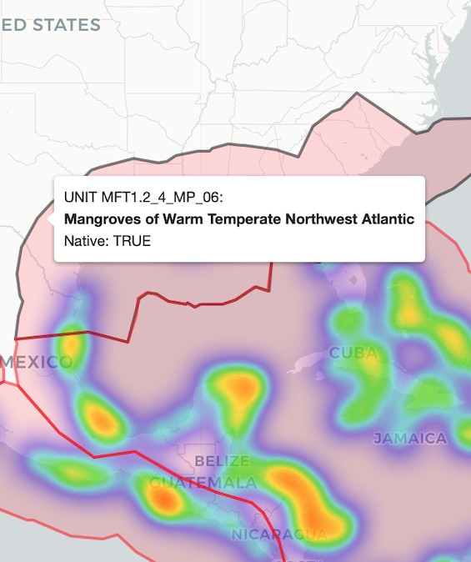

# Description of Ecosystem Components

## Summary

Text that broadly describes the ecosystem assessed.

«summary»

## Characteristic native biota (biotic components of the ecosystem)

Description of characteristic and/or indicative species of the ecosystem: native species, functional/morphological groups. The characteristic native biota should demonstrate the “uniqueness” of the ecosystem assessed and the ecosystem description should reflect the functional role and dominance of these species.

«biota»

## Physical environment (abiotic components of the ecosystem)

Description of characteristic abiotic elements of the ecosystem (climate and bioclimatic parameters, soil parameters, biochemical parameters, etc.). This includes description of the abiotic environment and its fundamental functions, as well as its temporal and spatial limits.

«abiotic»

## Key processes and interactions

Description of key interactions and processes that govern ecosystem functioning within and between biotic and abiotic complexes (migrations, export of larvae, movement of nutrients and sediments, etc.).

«biotic»

The description of the ecosystem should be supplemented with:

A conceptual model (diagram illustrating key processes and interactions) with title, author and description

A photograph of the ecosystem with source and title

# Geographic Distribution of the Ecosystem

## Description of the spatial distribution of the ecosystem

Description that specifies the biogeographic boundary of the assessed ecosystem.

«distribution»

The description of the spatial distribution of the ecosystem will be accompanied by:

A map of the ecosystem with source, author(s), title and description

# Ecosystem Threats and Vulnerabilities:

## Main vulnerabilities and pathways to degradation

Description of the main threats and pathways/processes to degradation that can lead to ecosystem collapse in the near future. The identified threats should cause perceptible symptoms that prove the ecosystem is at risk of collapsing (e.g., changes in ecosystem distribution, changes in the physical environment or disturbances in key interactions or processes within or between biotic or abiotic ecosystem components).

«threats»

## Description of threatening processes

Description of the main threats or degradation process that could lead to ecosystem collapse.

The description of threats to the ecosystem must be accompanied by: One or more photographs illustrating the identified threats with title(s) and sources



## Threat classification

Following the IUCN Threat classification (version 3.2).

1 Residential & commercial development

1.1 Housing & urban areas

1.2 Commercial & industrial areas

1.3 Tourism & recreation areas

2 Agriculture & aquaculture

2.4 Marine & freshwater aquaculture

2.4.1 Subsistence/artisanal aquaculture

2.4.2 Industrial aquaculture

5 Biological resource use

5.1 Hunting & collecting terrestrial animals

5.3 Logging & wood harvesting

5.4 Fishing & harvesting aquatic resources

7 Natural system modifications

7.2 Dams & water management/use

8 Invasive & other problematic species, genes & diseases

8.1 Invasive non-native/alien species/diseases

9 Pollution

9.1 Domestic & urban waste water

9.2 Industrial & military effluents

9.2.1 Oil spills

9.3 Agricultural & forestry effluents

9.3.1 Nutrient loads

9.3.2 Soil erosion, sedimentation

10 Geological events

10.2 Earthquakes/tsunamis

11 Climate change & severe weather

11.1 Habitat shifting & alteration

11.4 Storms & flooding

## Definition of the collapsed state of the ecosystem

Description of what the “collapsed” state of the ecosystem would look like relative to the main threats identified. It should include description of the biotic and abiotic parameters of the “collapsed” state, as well as that of useful proxies for understanding the “collapsed” state.

«collapse_spatial»

«collapse_functional»

The description of threats to the ecosystem must be accompanied by:

One or more photographs illustrating the identified threats with title(s) and sources

# References

|  |
| --- |
| «references» |

# Appendix

## List of Key Mangrove Species

List of plant species considered true mangroves or key plant species in mangrove communities according to Red List of Threatened Species (RLTS) spatial data. We included species whose range maps intersected with the boundary of the marine provinces/ecoregions described in the Distribution section.

|  |  |  |  |  |
| --- | --- | --- | --- | --- |
| Class | Order | Family | Species | RLTS category |
| «key_class» | «key_order» | «key_family» | «key_species» | «key_category» |

## List of associated species

List of taxa that are associated with mangrove habitats in the Red List of Threatened Species database. We included only species with entries for Habitat 1.7: "Forest - Subtropical/Tropical Mangrove Vegetation Above High Tide Level" or Habitat 12.7 for "Marine Intertidal - Mangrove Submerged Roots", and with suitability recorded as "Suitable", with "Major Importance" recorded as "Yes", and any value of seasonality except "Passage". We further filtered species with spatial point records in GBIF (some species are excluded due to mismatch in taxonomic names or lack of georeferenced records).

|  |  |  |  |  |  |  |  |
| --- | --- | --- | --- | --- | --- | --- | --- |
| Class | Order | Family | Species | Authority | RLTS category | Common name | Seasonality |
| «assoc_class» | «assoc_order» | «assoc_family» | «assoc_species» | «assoc_author» | «assoc_category» | «assoc_common» | «assoc_season» |