RStudio Cloud (== Posit Cloud) for uDASH Year 10 Work experience
Prepared by José Ferrer

This document contains instructions for
- registering and signing up
- open a project using a link and copying it to “Your Workspace”

Instructions for signing up to Posit Cloud

To register and sign up you need to follow eight simple steps:

- Go to https://login.rstudio.cloud/register
- Sign up with email, password and their name
- This sets up an account in “Posit”, you need to click on the first option: “Posit Cloud” (previously known as “RStudio Cloud”)
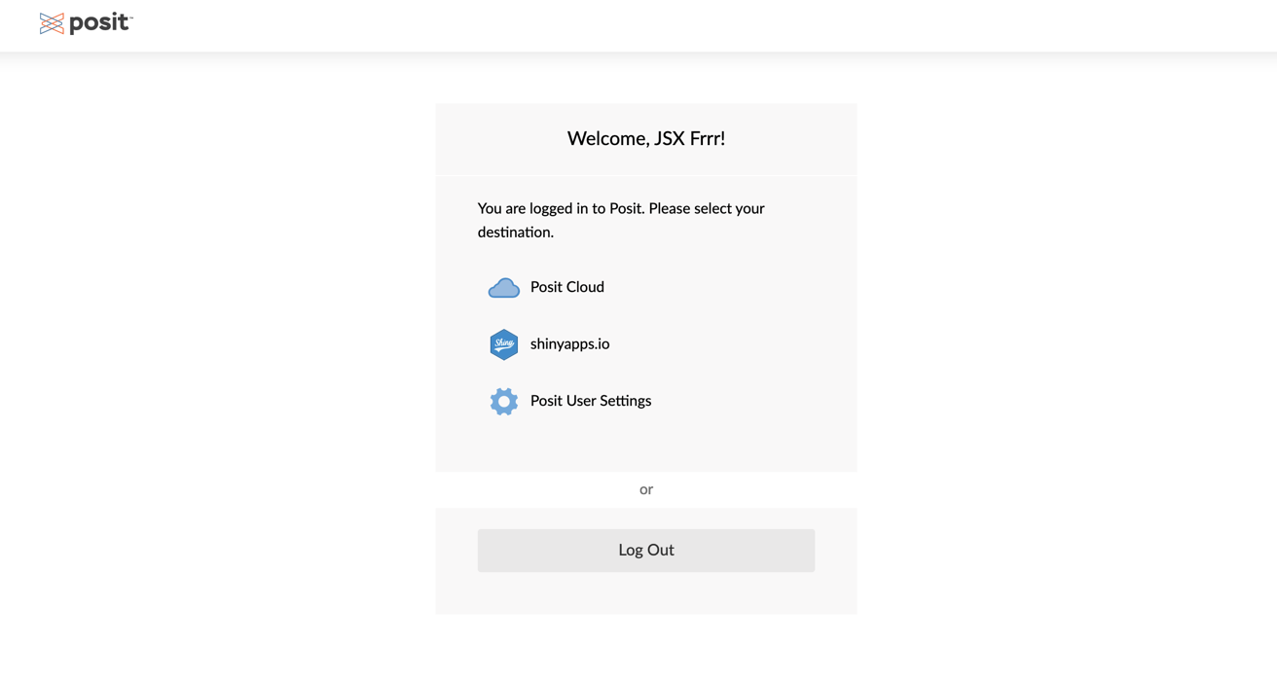

- It will prompt for the email and password again
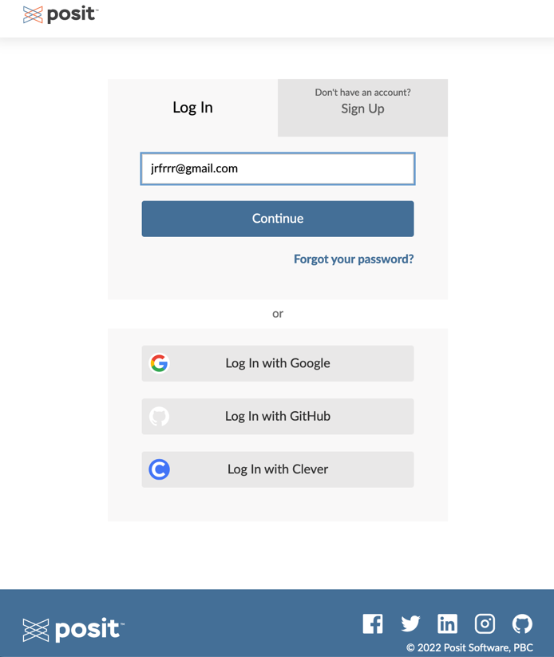
- The first time you login it will ask you to verify your email account,
- Go to your inbox and look for an email from Posit Cloud and click on the “Verify your email” link and you will see a “Email Verified” message

- Once verified, go back to the login page, and click on the “Continue” button.
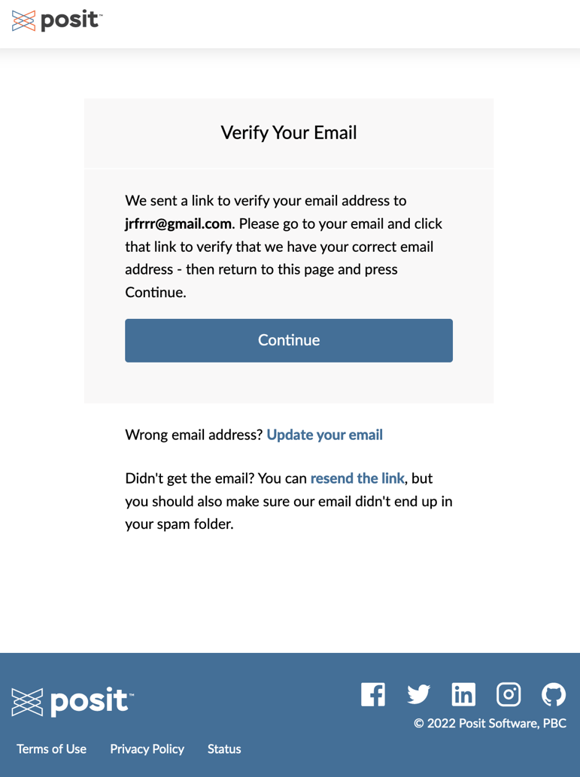
- You should now be logged in posit Cloud and will see a dashboard with Your Workspace and Your Content, it will look like this:
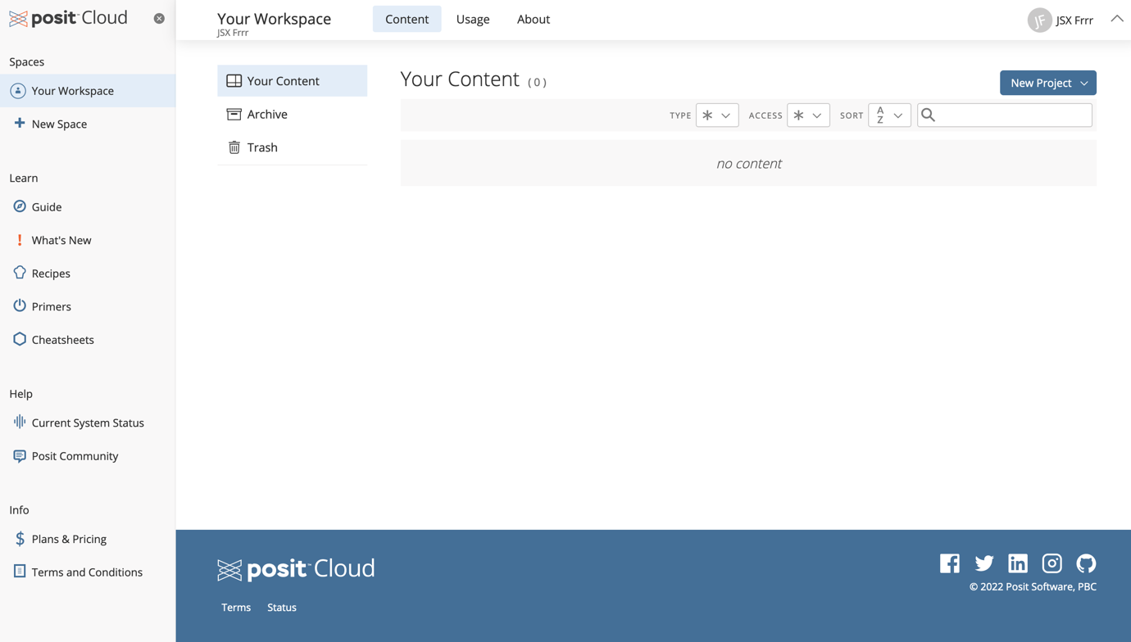

Open a project using a link and copying it to “Your Workspace”

To work on a project in Posit cloud you need to have a copy in your workspace. Follow these nine steps:

- Make sure you are logged in to Posit cloud
- You will receive a link from your instructors via email or in the Slack channel, for example https://posit.cloud/content/5018793
- Copy this link and enter it in your browser’s address bar, it will start deploying a temporary copy of the project, this can take some seconds to complete, in the meantime verify that the name of the project and owner are correct (This link is for the uDASH-Y10WE Day 3 and was shared by José R. Ferrer Paris)
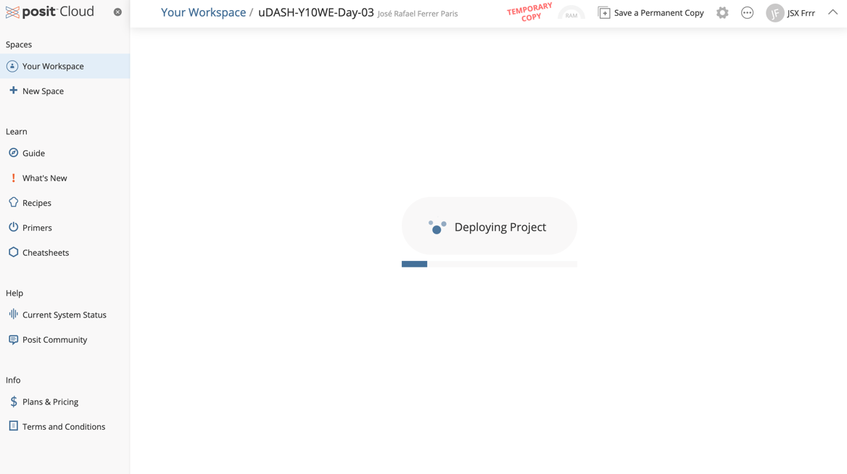

- Once loaded, click on “Save a Permanent Copy” on the top bar, and the window should reload the project as a permanent copy. You can verify that the red the project name is the same, but the “Temporary copy” message and the original owner name should be gone:
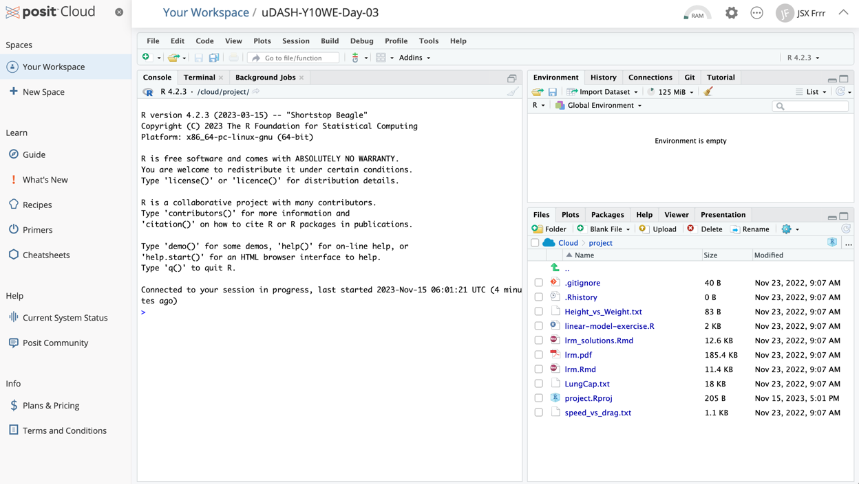
- You can now browse the files in your local copy of the project in the “Files” tab in the lower right panel
- When you open a file, check a yellow ribbon on top prompting you to install certain packages, click on Install and … 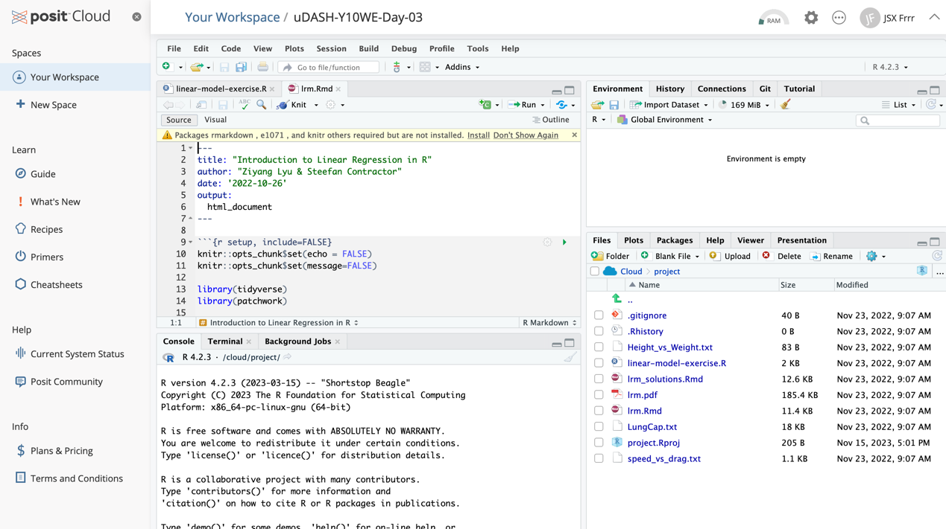
- Package installation will start as a background job in the lower left panel, you will see plenty of red messages, but you just need to wait for this to finish. You only need to install the packages once, if you get the same prompt when you open other files, first verify the installed packages in the tab “Packages” to avoid re-installing packages.
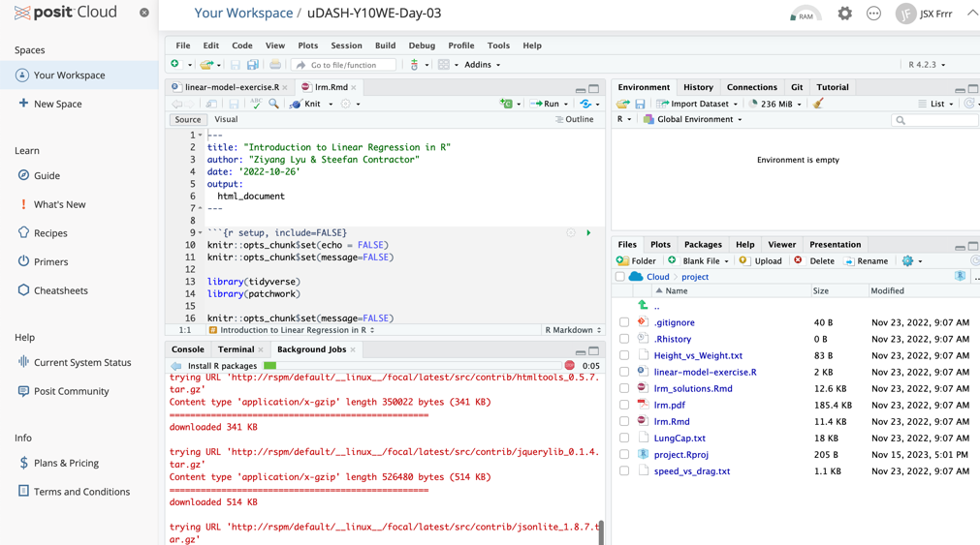
- Now you can start working on this project, running commands from the files in the top left panel or in the Console in the bottom left panel.
- Happy coding!

