
MoBatch Customized Help Sample

Table of Contents
Introduction 2
Instructions for creating customized help 2
Creating customized help document 2
Using customized help document 2

Introduction
This sample document can be modified and used for customized help for customers.
The customized help would typically be used to describe business rules or instructions on using MoBatch at a particular installation.

Instructions for creating customized help

Creating customized help document
- Rename the MoBatch_Sample_Custom.doc file that should always be installed into the same folder as the MoBatch executable.
- Edit the newly renamed document using Microsoft Word (include screenshots or any other requirements). Ensure that you define headings and subheadings as style Heading 1, Heading 2 etc.
- Right-click on the Table of Contents (just below text Table of Contents on the 1st page) and select Update Field / Update Entire table. This uses all of your headers to provide a new table of contents.
- Save the modified document (to have an editable version of the document).
- After saving normally, use save as and select to save as Single File Web Page (*.mht,*mhtml), keeping same document name except for the extension.

Using customized help document
- Ensure that the new document with the .mht extension is always stored in the same folder as MoBatch.exe on every client/server.
- Run MoBatch and under the Configuration menu option, select Application Settings. 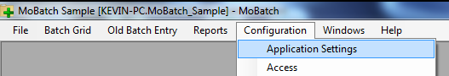
- In the top grid click on the row with ID CustomHelpFile. At the bottom, change the value from MoBatch_Sample_Custom.mht to your new .mht file. Click on Save.
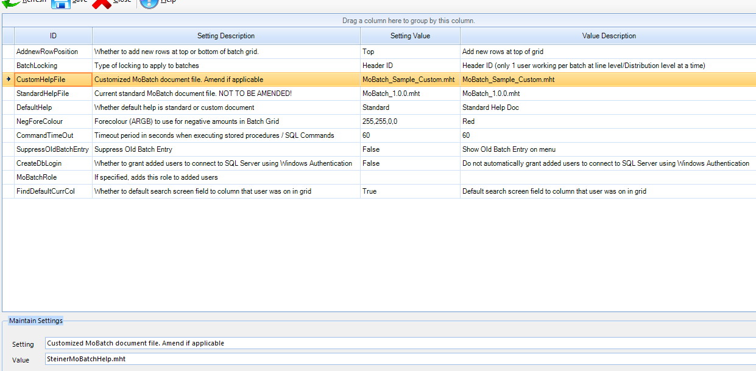
- In the top grid click on the row with ID DefaultHelp. At the bottom select as value either “Standard Help Doc” if you want the user to see the standard MoBatch User Help document when clicking on a help button, or “Custom Help Document” if you want the user to open your new customized help document when clicking on a help button. Click on Save.
Note: The above only determines which help document you want to open when clicking on a help button.
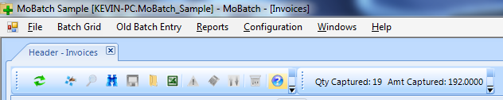
But the user will always access the standard MoBatch User Help if they click on Help > User Help, and will always access the customized help document if they click on Help > Customized Help.
