SmartMed Final Documentation

Team Plants vs Zombies

ISTE 260.03: Designing the User Experience

December 16th, 2014

Team Members:

Julianna Gabler

Chevy Mac

Sarah Pezzullo

Kevin Whetstone

Justine Woodward

Product overview

SmartMed is a product that each individual who take medication will find extremely useful. The product has many different features that allow patients to maintain medical adherence. SmartMed acts like a portable alarm clock that alerts the patient when to take their pills. The alert is in the form of sound, vibrate, or both. There are two different alarms that can be set to notify the patient about their pills since there are two different pill compartments. It is important for patients to take their medication regularly for serious health issues since forgetting to take pills can lead to more serious symptoms and problems. For example: people who are severely diabetic, SmartMed can be used to carry and remind them to take their insulin. SmartMed is designed to encourage freedom and flexibility while still maintaining a better health for patients.

Initial Proposal

**How it works**

SmartMed will have some kind of alarm for each pill box that you set the pillbox to take your pills. In order to set up the alarm for the pill box can be with lights, phone or vibration. Anyone is able to set up the pillbox in any way that they want to set up the pillbox. SmartMed will be good for people who have memory loss, elders, can’t handle the smartMed themselves so this will help them to take their medication on time. Therefore, there are too many elders that have forgotten their medicine so this will help them in the future.

**Problem**

Users are often forgetful of the many pills they have to take, when to refill prescriptions, what to take pills with, and sometimes don’t even hear alarms. Users are not always tech-savvy therefore reminders are difficult to maintain. Often users will write notes that can be easily lost or set alarms that are missed because they cannot hear them. Forgetting to take medication repeatedly can cause many problems and can even be disastrous.

**Solution**

Our solution to fix the problems that rise in the current product that only have the sound on it, however our product will adding more features to open more population of other users, other than population that rely on the sound. The solution also provides a central location for users to access important information regarding their medications, set reminders to take their pills via cell phone, as well as customize the alarms on their pill box. Users can also set alerts on when to refill prescriptions or visit the doctor for a new one.

The use of text messages over an app was chosen because the product is geared towards senior citizens and those who aren’t tech-savvy. With this in mind, research indicates that senior citizens prefer to buy feature phones over smart phones and those who do possess smart phones often do not download applications and use it as if it’s a feature phone. The use of text messages allows the user to set up reminders in simple process online in which messages will be sent to the user’s phone.

**Product UI**

The product consists of two parts essentially. The first part is the physical smart pill box itself. The pill box is equipped with the ability to vibrate, use lights, and to sound an alarm. The box also contains the ability to connect to a usb port to be programmed by the online web portal. Each pill box has an easy setup process for its alarm that requires the user to plug in their pill box to do so. This is accomplished with a usb to micro cable that connects to the computer.

The second part is the online web portal. The online web portal allows users to program their smart pill box by selecting the lights, how strong vibration going to be, and select their preference of the sound. They are also able to select if they would like to receive text reminders to take pills along with the ability to set reminders to pay medical bills and refill prescriptions.

**Purpose**

The purpose of product is to help customers to get reminders to take and refill their medical pills in a way that it is accessible and easy to do so.

**Blueprints**

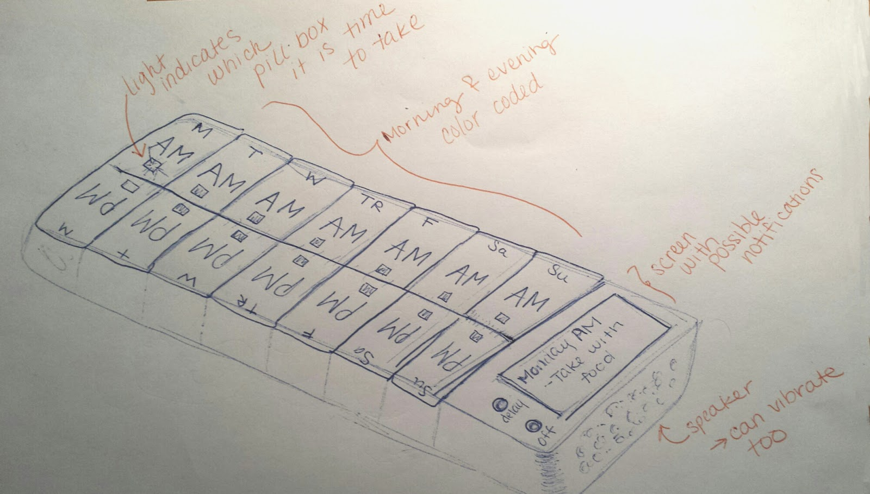

**Affordances and Features**

* Pill Box
  + vibration
  + battery
  + micro port
  + lights
  + small screen
  + 2 basic button controls
    - alarm off
    - delay (snooze)
  + A weeks’ worth of slots that are numbered
    - each day has a morning and night section
* Web portal:
  + mobile friendly
  + alert setup
    - pill box requires simply to plug it in
  + medication information
  + manage medical bills
  + manage when to refill prescriptions
  + simple & easy to navigation

**Components**

* Smart Alarm Pill Box
* Web Portal for set up, management, and reminders (eliminated)

**Prototype Technologies**

We will develop a web portal for the users to access along with a pill box that users can use. The web portal will utilize HTML5, CSS3, PHP, and possibly Javascript. We will also design a smart pill box that vibrates, flashes lights, and sounds an alarm if the medication has not been taken. We will develop the pill box through many prototypes and designs before we decide which one is the best.

Research

**Medfolio Pill Box**

The product can be confusing on how it works due to many lights, audio, boxes, and may not be clear to senior citizen which have problem with accessibly. However they have freedom to modify the product to match their preferences and is simple to use and has good flexibility. However the product did not come with user documentation.

**MedReady**

The product helps user to take medicine by alarm system with sound or flashing light to remind them to take their pill. It is useful so the user doesn't forget to take an medication. It notifies caregiver (if applicable), if the user triggers an non-compliance event. The user can control and set the time on each day for taking medication (reminders), although it was not used to help people with severe health problems. This product is flexible and simple to use, and comes with help document located on its website.

**Liff Smart Pill Box**

This product lets the user to remember and take the pills. The user can bring the pill box on the go or leave it at home. The user can send the notifications to family members and remind them to take pills. The product comes in two different sizes that allow one to hold as much as one wants. It is very flexible and is efficient to use, which allows customization for reminders, schedule, etc. Somehow this product does not come with help documentation.

**uBox**

This product lets the user take pillbox on the go, and helps user to keep track of their medicine. It is very small, which make it easy to travel around with. It has one container that allows one to add a lot of medicine in one pillbox. It will alert the user with light first, then audio, and if not responded, it will then send text message. This product however, may be difficult to understand for using it, however it is very flexible with sizes of pillbox. Sadly this product doesn’t come with tutorial or help documentation for how to use product.

Visual Variables and Summary

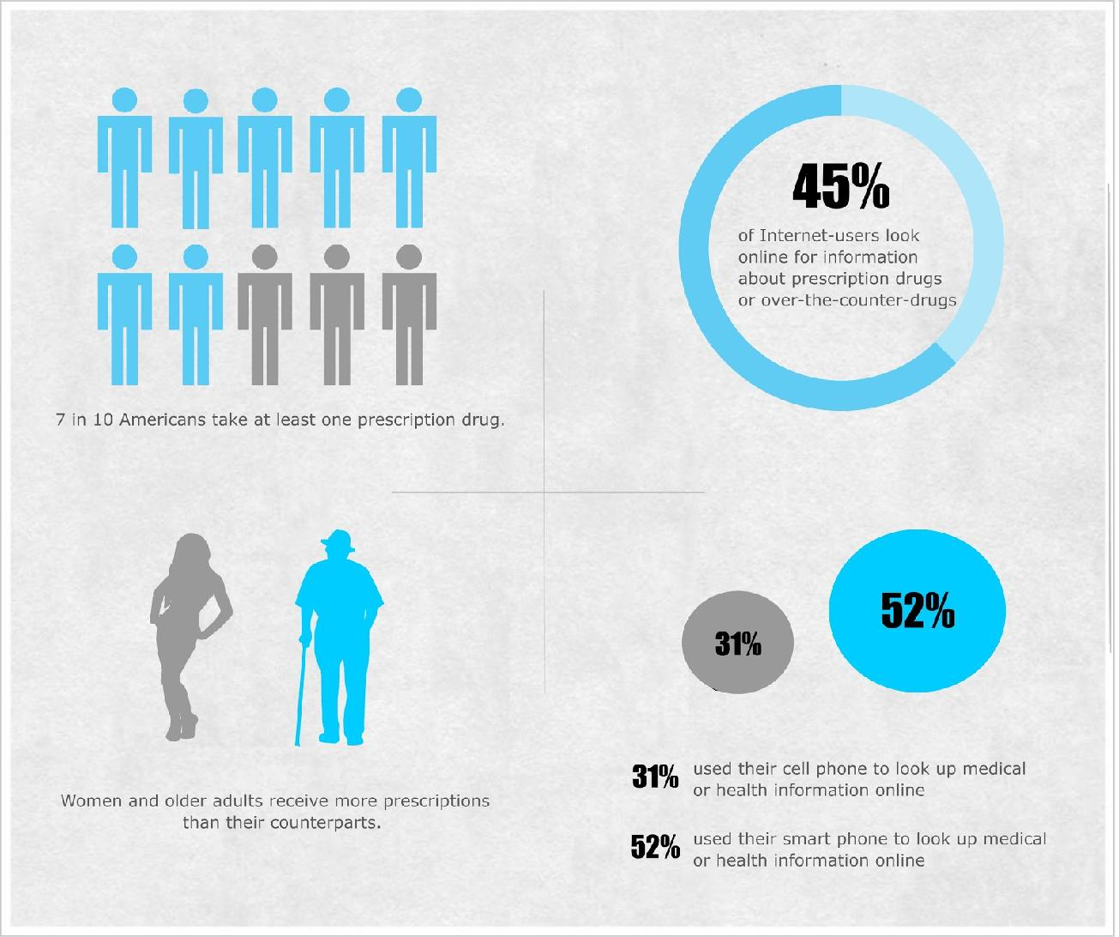

Technologies have improved for the pillbox for the elderly, people who have memory loss (Amnesia), and hearing impaired people. SmartMed will be very helpful for people who can’t depend on other people to help them at all times. Also, Technologies has impacted the pillbox which it will give some kind of alert for people remind them to take their daily pill without missing their pill.  Alarm, lights, and vibrations have impacted the pillbox to remind them to take their pill. These technologies will improve over time.

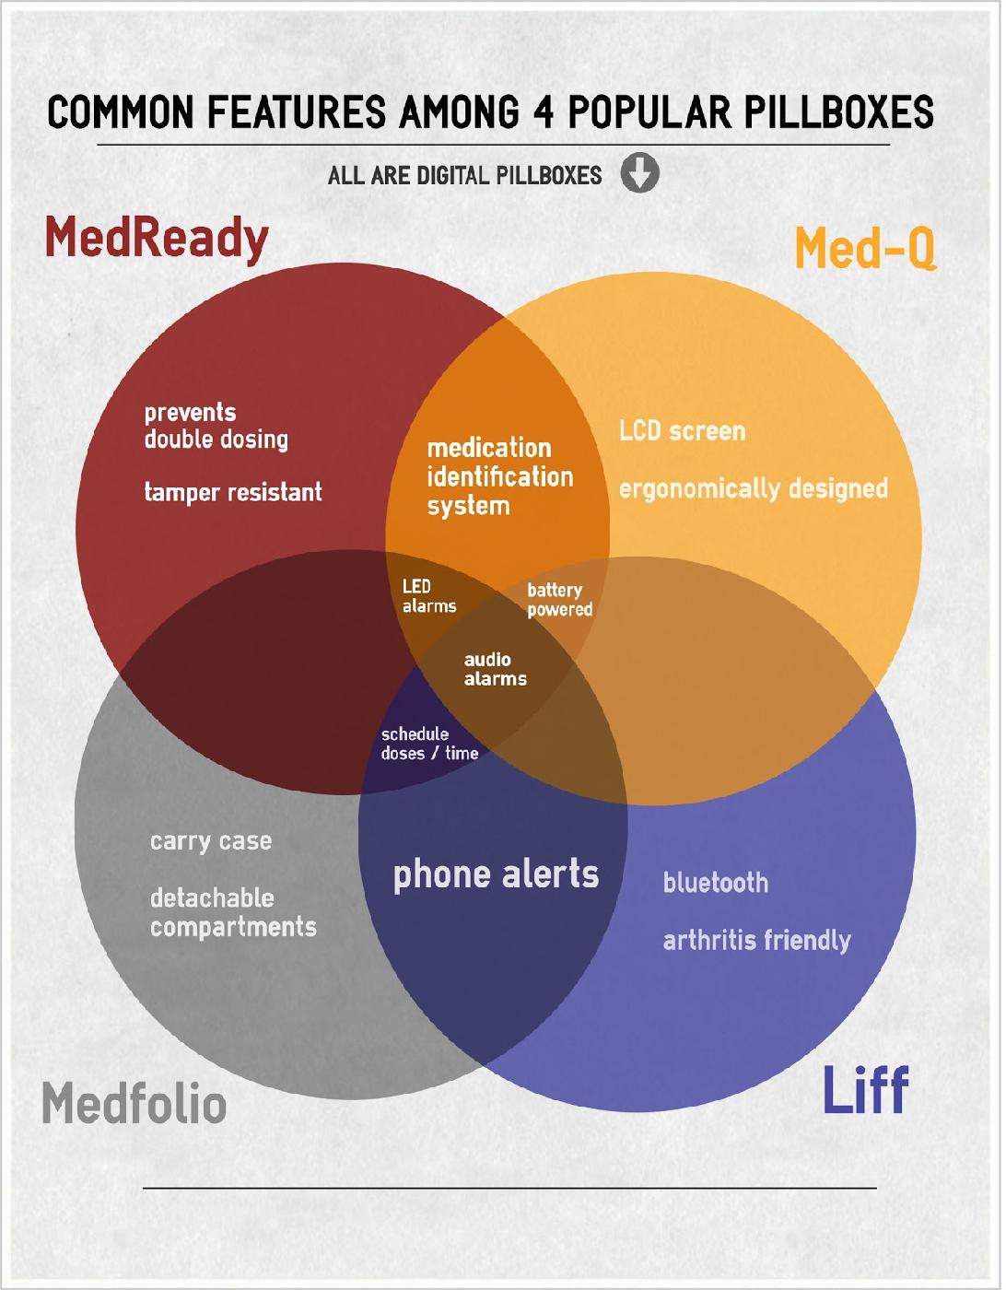

Kickstarter Analysis

**Who do you expect will invest?**

We expect anyone who will to buy these product for serious health reasons, general population, senior citizens, and people (who tend to forget their pills) to invest for our product. They might want to make this happen and to have our product that will help them to remember taking their pills. We also have a website that we build for this product so that we manage the pillbox and set the reminders for every day. The website will run on the nova server, http://nova.it.rit.edu/~jrg4017/260/, we will create reminders that enable users to enter their information and reminders on the website. You can view it on the browser or on the mobile device. Not everyone is going to remember to set the SmartMed everyday so the website will set the reminder for the month at one time.

**Why do you think they’ll invest this much?**

Yes, we believe that they’ll invest this product because it could be helpful for these customers to remind them for their medication. People who have serious health problems need to have their pill taken so this will be worth the money for them to be in a better health. There are several people who need to take their medicine mandatory due to their health reasons. For example, there are several people who have diabetes; they may need to take a pill to reduce their health reason so they don’t end up in the hospital. Hospital bills cost a lot of money so SmartMed is investing a pillbox that will help patients to reduce going to the hospital and taking their medicine on time. SmartMed will be worth the money for people who needs to take their medicine on time and cannot be forgetful. This product will help them to remind them and these people who have health problems may have less health problems if they take their medicine on time when they aren’t home to take the pill.

**What is your product? Write a one paragraph summary of your product which will get people interested in investing in you.**

Our product is SmartMed, a pill box that can be taken “on the go” which fits your schedule, and fits your need. It has a size of “Sticky Notepad” and it is compact which it is easy to fit inside your purse or pocket. SmartMed will be very useful for people who required to their medicine daily which this product will have everything for them on-the-go. It is convenient for people who travels, works a lot of hours. However, a lot of people aren’t going to remember to take their medicine when they are busy to doing several things. They aren’t going to remember their medicine because they may have several things on their mind even though medicine is important to take. Also, it comes with alarm that can do two thing, is either vibrate, sound, or both.

**How will you get people excited? Write one paragraph about your approach to get people interested in your product.**

Our product will get people excited about the cool features that SmartMed have. We have a demo video about the SmartMed product that we invented. The only thing that will get people to be excited for is the alarm because it will remind them to take the pill. Many people will be hoping this product will help them to reduce their health problems and going to the hospital or seeing doctors. These will help people realize they need to take their medicine on time so that their bodies are used it at the same time everyday.  Also, we will make real promises, use the images and videos to advertise, and offer free gifts every time people make a donation.

Usability Test Guidelines

**Introduction**

“Hello, [Person Name]. We need your help for testing our product. It is in prototype stage. Our product is SmartMed, which can help our customers to take their medication through the alert as reminder system and it is made for people who travel very often. Our product benefit best for our users who tend to be away from home a lot or travel a lot, however we wanted to run a usability test for it before we can release our product to public. So, do you have any questions regarding our prototype? Don’t be afraid to ask, we wanted to improve our system’s strength and eliminate any flaws. My name is (person name), I am a developer of SmartMed and we have spent a lot of our time into this in hoping it would make people’s life easier for taking medication without forgetting when traveling far away from home, or very often.The Usability Test for testing our product SmartMed was few reason, in which improving our system’s strength and eliminating any flaws found. It is a test that help us in which we are evaluating a product by testing on our users. It would also give us input on how user use our SmartMed such as putting pill in, setting up an alarm, pressing buttons, so forth. It also helps us to fix the problems found in prototype if the user has identified it while evaluating.”

**Task**

1. **Turn on the device**

The user needs to know how to turn the device on by pressing the on button to turn on the device.

1. **Set one alarm**

The user needs to set the first alarm in order to utilize the pill box. Completion: The task is considered complete when the user holds down the green button to change the alarm to 8:00 PM

1. **Set the second alarm**

This is to set the box’s second alarm. The task is similar to previous task

1. **Load pills**

The task is designed to see if the user understands the concept of two different pill slots

1. **Turn off the alarm**

To indicate whether the user can easily identify how to turn off the alarm when going off

1. **Turn off the device**

To indicate that the user understands how to turn off the alarm successfully. Similar to first task

Usability Test Results

**Data**

* **How difficult was each task?**

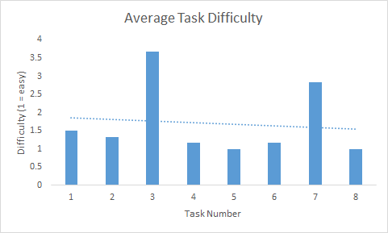

* **How satisfied were people with the product?**

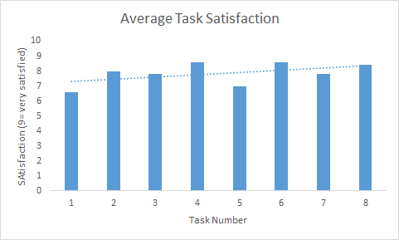

**Key for understanding graphs:**

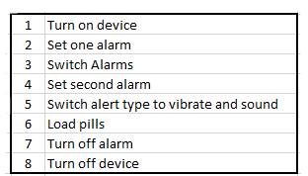

**Feedback from Users**

* Need bigger buttons on the side
* Better labels for buttons
  + Push concepts for each button's’ function across
* Consider a touch screen
* Add a volume control wheel/switch
* The alarm time needs fixing
* Add a minute & hour button for set alarm
* Add a +/- for setting the alarm
* Change the way switch alarm works
* The product is thought to be very easy to teach others
  + Just need to learn themselves first
* The product is overall good, but need to change the icon on one button
* Very useful
* Need to add labels on each button
* Need to change some button colors to make more useful to understand the tasks of each button
* It is nice to have phone app for our product.
* Paternal control to block children to take pills

Final

**Final Feedback**

The product is overall good, but need to change the icon on one button

* Very useful
* Need to add labels on each button
* Need to change some button colors to make more useful to understand the tasks of each button
* It is nice to have phone app for our product.
* Paternal control to block children to take pills

**Changes to this product**

Based on feedback, we improve it even further, and we even add a tour for how to use this product, it can be found at http://nova.it.rit.edu/~jrg4017/260[/](http://people.rit.edu/ktw5685/260/). Below are our final design screenshots. We decided a smaller on-the-go smart box would be beneficial as competition usually designed weekly or bi-weekly products. We wanted to provide something to customers to allow them to be flexible in their needs

