**DuoTrax Documentation**

**Software requirements**

- MATLAB version ≥ 2012a  (7.14.0.739)

- Image processing toolbox

- Statistics toolbox

**Installation**

- Download or clone the code from https://github.com/kristinbranson/cbtrack_GUI.

- Go to the folder ‘GUIs’

>> cd *DuoTrax_location*/GUIs

- Run the GUI

>> DuoTrax

**Introduction**

DuoTrax can be used to track individual or multiple videos. The process is divided in two parts: setup and tracking. When tracking multiple videos, the user will first have to set up the parameters of all the videos, and then all videos will be tracked consecutively. The setup process has four substeps: background setup, regions of interest (ROI) setup, body tracking parameters setup and wing tracking parameters setup. The tracking step is divided in four substeps: input file check (optional), body and wing tracking (detection, head/tail disambiguation and ID assignment), results visualization (optional) and results check (optional). Additionally, the code can compute per-frame features and can create a sample video using the results of the tracker.

The GUI has seven windows: main GUI (Fig. 1), background setup (Fig. 2), ROI setup (Fig. 4), body tracking parameters setup (Fig .5), wing tracking parameters setup (Fig. 7), tracking (Fig 8) and final results visualization (Fig. 9). Once each of the steps has been completed, the user can navigate through the different windows using the buttons on top of the GUI[1]. The name of the current experiment will also be displayed in the GUI. Every time the user goes to the next step (by clicking ‘Accept’) some files will be saved, including a new parameters file (*out_params.xml*) that contains the parameters for the current setup and can be used in future projects.

**Preparing files**

*Single video:* Create a folder containing the movie file (with the name *movie.ext[2]*) and a parameters file (with the name *params.xml*). The name of the folder will be used both as the experiment name and the analysis protocol name.

*Multiple videos in the same folder*: Several videos can be tracked at once if they are in the same folder. Create as many sub-folder as videos you want to track. In each sub-folder put one[3] movie file and one parameters file. The name of the main folder will be used as the analysis protocol name and the name of each subfolder as the experiment name.

*Multiple videos in different locations*: Several videos can also be tracked at once even if they are in different locations. Each folder must contain the movie and parameters files. Create a text file as follows:

*analysis_protocol*

*/path_to_parameters_file/params.xml*

*/path_to_video1*

*/path_to_video2*

.

.

.

The first line (*analysis_protocol*) is the name given to the group of experiments, the second line contains the path to a single parameters file that will be used by all the experiments, and the following lines are the path to each video folder (the name of each folder will be used as the experiment name). To use a different parameters file for each experiment, replace the second line with *multiple*. If using a single parameters file, each experiment folder must contain only the movie file, if using multiple parameters files, each experiment folder must also include its corresponding *params.xml*.

**Main GUI**

* *File selection* (1)*:* Use the radio buttons to load a single video, videos from an experiment directory or from an experiment file. Click ‘Browse’ to select the desired file or directory.
* *Use existing data* (2)*:* If active, DuoTrax will try to load information regarding the background and ROIs. In the same folder as the video file, put the files *bgdata.mat* and *roidata.mat* created during the *Background setup*and *ROI setup*steps.
* *Restart from other file* (3): A video tracking that has been canceled can be restarted by selecting this option. Temporary files are created and saved at each step if ‘Save temporary files’ (7) is selected. Only individual videos can be restarted and no other options from this window can be changed.

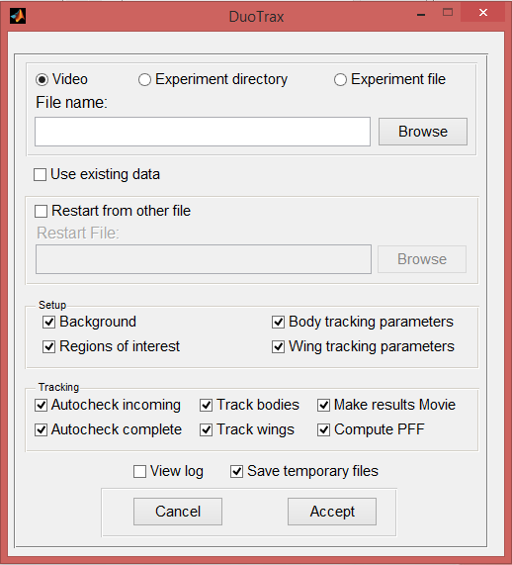

1

2

3

4

5

6

7

Figure : Main GUI

* *Setup steps* (4): Any of the substeps during setup can be skipped. If the user decides to skip any of these steps, DuoTrax will use the information from the parameters file and will perform any required computations automatically.
* *Tracking* (5): If the user decides to skip any of the tracking substeps, those will not be performed at all.
* *View log* (6): It this option is checked, the user will be able to see the log in an additional window. Either way, the log will be automatically saved in a text file (*cblog.txt*)in the experiment folder.
* *Save temporary files* (7): If this option is selected, one file per video will be created in each experiment folder. The files will be named *Temp_yyyymmdd_experimentname.mat*. These temporary files can be used to restart the setup and tracking processes (3).
* *Finishing*: The user cannot go back to this window once ‘Accept’ is clicked. Before the background setup starts, the code checks that the input files and parameters are correct if ‘Autocheck incoming’ is selected and it will create a report with the name *automatic_checks_incoming_results.txt*.

**Background setup**

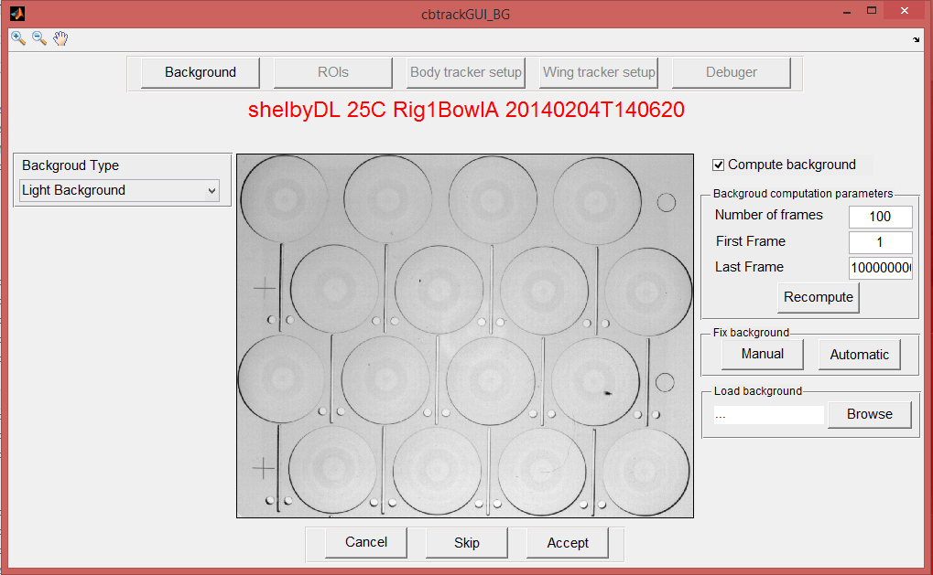

7

8

6

5

4

3

1

2

Figure : Background setup

* *Initial computation*: Before the GUI is displayed, the background will be computed automatically as the mean of a certain number of frames. Instead, if ‘Use existing data’ (2 in Fig. 1) has been selected, the background will be loaded from *bgdata.mat*. The result will be displayed in the axis (1)
* *Background type* (2): Select light or dark background.
* *Compute background* (3): If this option is not selected, the background will not be computed and it will be replaced by a black image.
* *Parameters* (4): The background can be computed again using the new parameters by pressing ‘Recompute’.
* Number of frames: Number of frames used to compute the background.
* Initial and Final: First and last frames that can be used to compute the background.
* *Fix background* (5): Sometimes the background still has some errors (6), but this can be fixed. The user can use a manual or an automatic approach and in both cases it requires to select the region that needs to be fixed.
  + Manual: A new window will open showing the complete video (Fig. 3). The user can scroll through the video using the slider (a), ‘Play’ button (b) or the edit box (c). The user must select a frame interval (d) in which there are no flies in the region. The background will be recomputed using that information.
  + Automatic: This method is recommended when there are no frames in with no flies in the selected region, so the manual method cannot be used. In this case, the selected region will be fixed by filling it through linear interpolation.

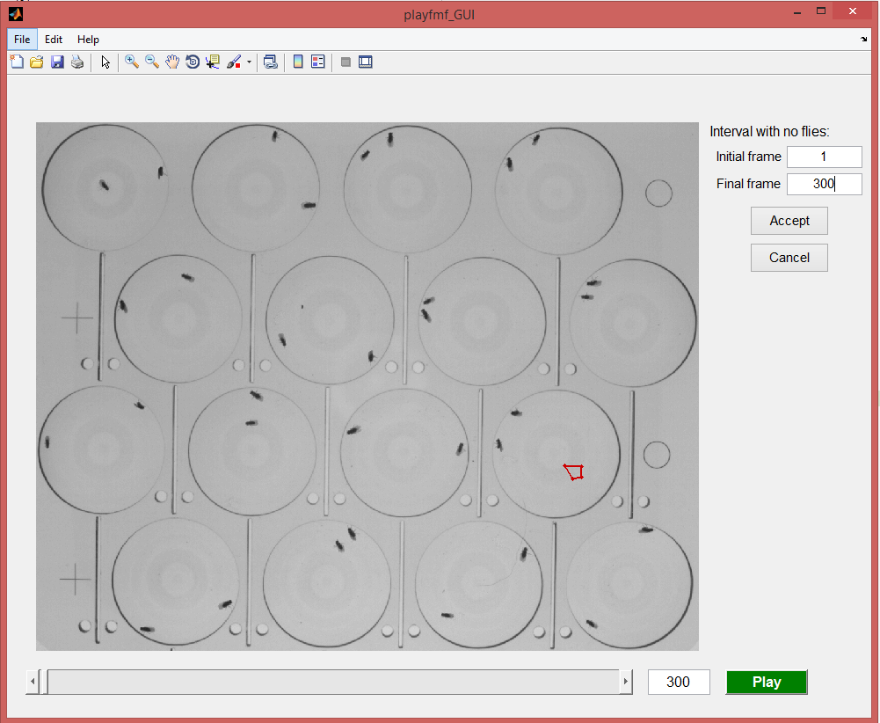

b

c

a

d

Figure : Manually fix background

* *Load background* (7):The user can also ‘Load’ an old background by selecting a file like *bgdata.mat* (see next point).
* *Finishing* (8): Once the background is properly computed, clicking ‘Accept’ takes the user to the next step. It saves an image of the computed background (*bg.png*) and a file containing all background information (*bgdata.mat*), which can be used for future projects. The user can ‘Skip’ the current video and go to the next one or ‘Cancel’ the whole project.

**Regions of interest setup**

* *Initial computation*: Before displaying the GUI, it will try to detect ROIs using the background image and the parameters from *params.xml* (*roimus* and *mean_roi_radius*). If the field *roimus* is left empty, the whole image is treated as a single ROI.

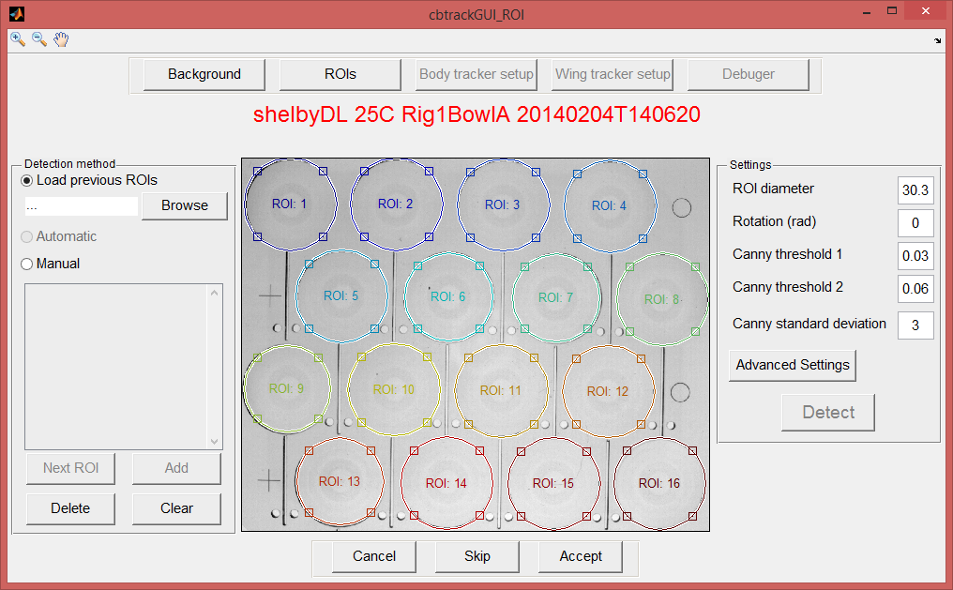

5

4

3

2

1

Figure : Regions of interest setup

* *Load* (1): Previously detected ROIs can be loaded form a file if a file similar to *roidata.mat* (See last point of the section) is loaded.
* *Manual* (2): In order to detect ROIs the code needs some information regarding the approximate location of the center of each ROI and its radius. If this information is not provided in the parameters file, the user can input it manually. To do so, select ‘Manual’ and click points in the edge of each ROI (at least 3 points per ROI). When enough points have been selected, click ‘Next ROI’ to start the next ROI. The user can ‘Add’ points to any ROI even after clicking ‘Next ROI’. Individual points or a whole group of them can be deleted by clicking ‘Delete’ and clicking in the list of points. To delete all the points, click ‘Clear’. Once all the points have been selected, click ‘Detect’ (3).
* *Fixing ROIs* (4): Once ROIs are detected, they will be shown in the figure. The circumferences can be dragged and resized to adjust them to the actual ROIs.
* *Parameters* (5):
  + ROI diameter: ROI diameter in mm, used to convert the units from pixels to mm (if unknown set it to 2).
  + Rotation: Base rotation of the whole video
  + Canny threshold and standard deviation: Parameters for the Canny edge detector.
* *Finishing*: Once the user clicks ‘Accept’ the ROI information will be saved in *roidata.mat*, which can be reused for future projects.

**Body tracking parameters**

There are three main uses for this window. First, it is used to set parameters to track the body of the flies and visualize the preliminary results in some frames. Second, in this step the code will count the number of flies in each ROI by sampling some frames in the video. Finally, the user can also setup additional parameters regarding the results video and the per-frame features.

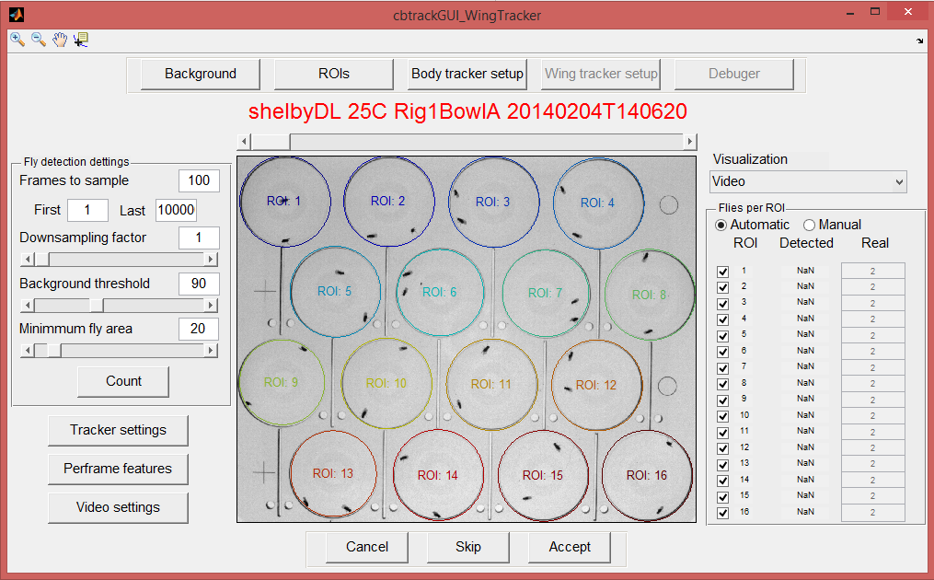

8

7

6

5

4

3

2

1

Figure : body tracking parameters setup

* *Initial computation*: A determined number of frames will be sampled form the video and will be displayed in the main axes.
* *Visualization* (1): The user can scroll through the sampled frames (2) and use different visualizations to test the selected parameters.
  + Video: Original frames.
  + Background subtraction: Difference between the background and the original image.
  + Bodies: Pixels considered bodies according to the background threshold.
  + Connected components: Pixels belonging to the same connected component are displayed using the same color.
  + Detected flies: Small connected components are removed.
  + Ellipse fit: Results from fitting the pixels belonging to the same fly to an ellipse.
* *Parameters* (3): Parameters of the body detection algorithm.
  + Frames to sample: Number of frames sampled to count flies.
  + First and last: First and last frames allowed to be sampled to count flies.
  + Downsampling factor: Videos can be downsampled to reduce noise.
  + Background threshold: Threshold value to identify pixels belonging to the body. For higher values, only the darkest pixels are selected.
  + Minimum fly area: Number of pixels of the smallest connected component that is considered a fly.
* Count (4): Once the parameters are set, the flies are counted by sampling a determined number of frames. The number of flies per ROI will be displayed (5), but it can also be fixed manually[4].
* Tracker settings (6):
  + Debug: If active, the user will be able to visualize the results of the body tracking and the final results.
  + Track wings: Wings will only be tracked if this option is selected.
  + Video duration: First and final frames that will be tracked. Set ‘Inf’ as the final frame to track the whole video.
  + ID flies: Select whether the flies’ identity is assigned based on their body size or wing size (for flies with clipped wings).
  + Advanced settings:

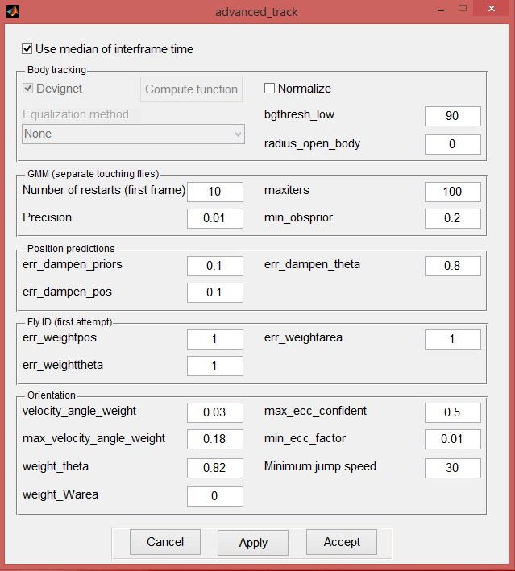

d

e

f

c

b

a

Figure : Advanced body tracking parameters

+ Devignetting (a): The original video can be devignetted if needed. To do so, a devignetting function is required and, to compute it, the user will be asked to select video of a white background. It can only be used if the background is not computed.

+ Equalization (b): If the illumination changes with time, the frames can be equalized. This can be done using a base histogram (computed either form a single or multiple fames) or by expanding it so the intensity values always range from 0 to 255. It can only be used if the background is not computed.

+ Normalization (c): The frames can be normalized dividing by the background. This is useful when the ROIs are not uniform.

+ GMM (d): Advanced parameters for the Gaussian Mixture Model used to separate touching flies.

+ Fly ID (e): Parameters used to assign identities to the flies.

+ Orientation (f): Parameters used during the head/tail disambiguation.

* *Per-frame features* (7): The user will be able to set up some parameters and to select which features should be computed.
* *Video settings* (8): The user can set the results video that will be created at the end of the tracking process.

**Wing tracking parameters**

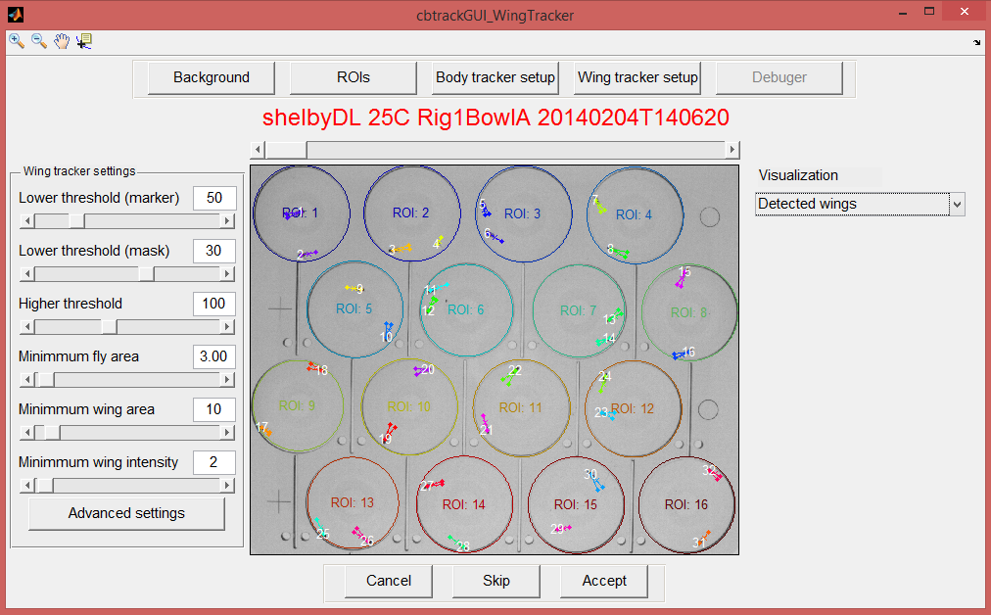

1

2

3

4

Figure : Wing tracking parameters

* *Visualization* (1): The user can scroll through the sampled frames (2) and use different visualizations to test the selected parameters.
  + Video: Original frames.
  + Background subtraction: Difference between the background and the original image.
  + Bodies: Pixels considered bodies according to the higher threshold.
  + Wings: Pixels considered wings according to the higher and lower thresholds.
  + Foreground: Pixels that are considered flies (bodies or wings).
  + Body wing segmentation: Pixels belonging to bodies and wings are represented in different colors.
  + Connected components: Pixels belonging to the same connected component are displayed using the same color.
  + Fly segmentation: Separation of touching flies.
  + Detected wings: Previsualization of the wing detection results.
* *Parameters* (3):
  + Lower threshold (marker and mask): Lower threshold values used to identify and segment wings. For higher mask values, only darker pixels are selected.
  + Higher threshold: For lower values, the darkest pixels are not considered part of the wings.
  + Minimum fly area: Minimum area (in px) to be considered a fly. Smaller connected components will be discarded.
  + Minimum wing area: Minimum area (in px) to be considered a wing. Smaller connected components will be discarded.
  + Minimum wing intensity: Minimum fraction of pixels of the peak of the second wing relative to the first.
* *Finish* (4): When the user clicks ‘Accept’, if the user is tracking several videos, the setup process will start for the next video. When the last video has been set up, or if only tracking a single video, the actual tracking process will start.

**Tracking**

If the debugging option has been selected (in ‘Tracker settings’ during ‘Body tracking setup’), the user will be able to visualize the tracking results as they are being computed. Otherwise, only a progress bar will be shown.

* *Start tracking/Continue* (1): The user can start and pause the tracking process at any moment. While it is paused, the user can scroll through the tracked portion of the video using the slider or ‘Play/Stop’ (2). Both body and wings are tracked, but only the results from the body tracking are displayed, the wings can be visualized in the next window.
* *Clear* (3): The user can choose to clear all the tracked results or clear only those result after the frame that is currently being visualized.
* *Save* (4): The tracking results will be saved automatically every 5000 frames (if ‘Save temporary files’ was selected in the main window), but the user can choose to save then at any given moment.

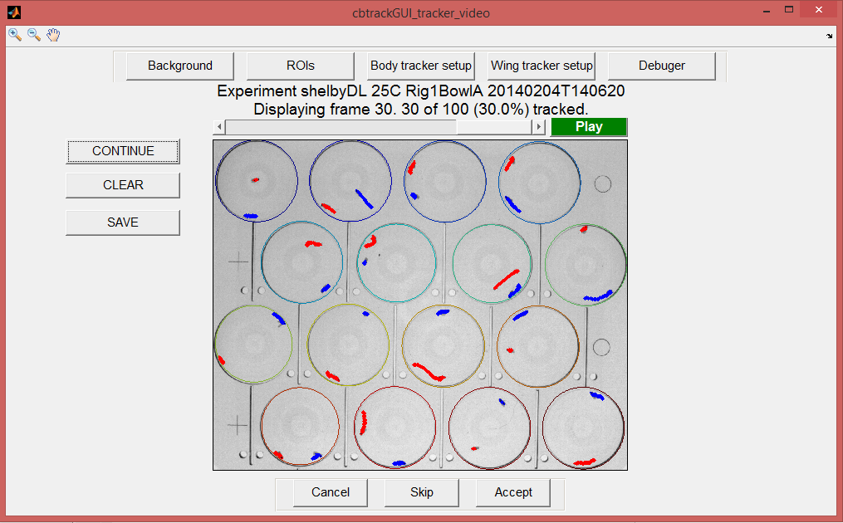

5

4

3

2

1

Figure : Tracking

* *Finishing* (5): If not all frames have been tracked when the user clicks ‘Accept’, the remaining frames are discarded. The head/tail disambiguation and identity assignment are performed before displaying the next window.

**Results visualization**

* *Visualizing results* (1): The user can visualize the final results, including the tracked wings.
* *Clear* (2): The user can clear all or part the results at any moment.
* *Finish* (3): When the user clicks ‘Accept’, if the user is tracking several videos, the tracking process will start for the next video. When the last video has been tracked, or if only tracking a single video, the results videos will be created and the per-frame features will be computed for each video. Finally, DuoTrax will check that the tracking process was correct using the ‘auto_checks_complete’ from the parameters file, and it will create a report with the name *automatic_checks_complete_results.txt*.

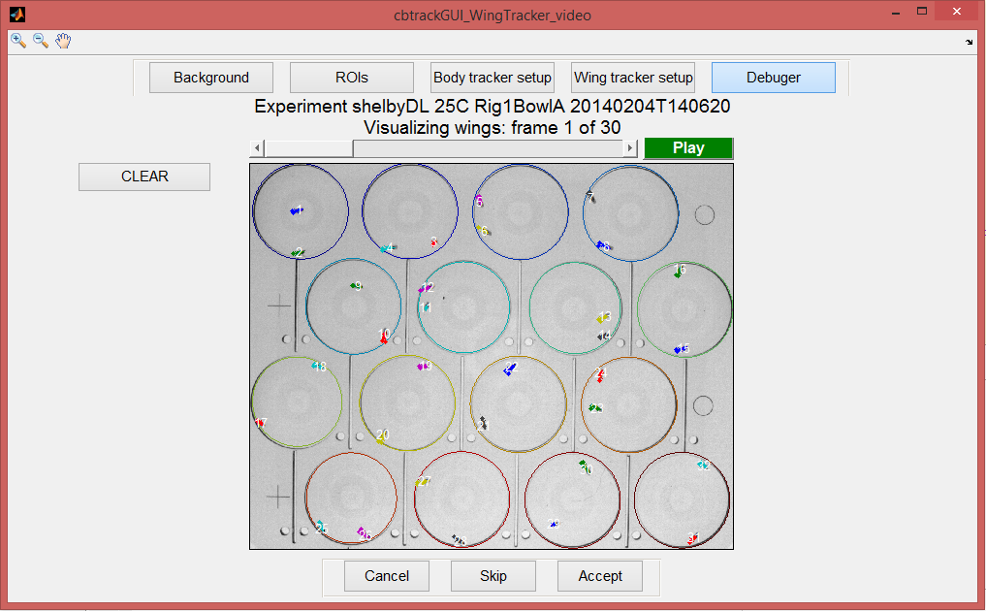

1

2

3

Figure : Results visualization

1. If tracking multiple videos, the user will not be able to go back to the setup process once it is completed.
2. .*ext* can be: *.ufmf*, *.fmf*, *.sbfmf*, *.avi*, *.mp4*, *.mov* or *.mmf*.
3. If there is more than one video file in a folder (e.g. the output results video created by DuoTrax), the folder will be skipped
4. If the computed and the expected number of flies does not match, there parameters might not be properly set up.