# Utilization (x-axis) vs Response time (y-axis) vs (single and multi-server comparison)

## M/M/1

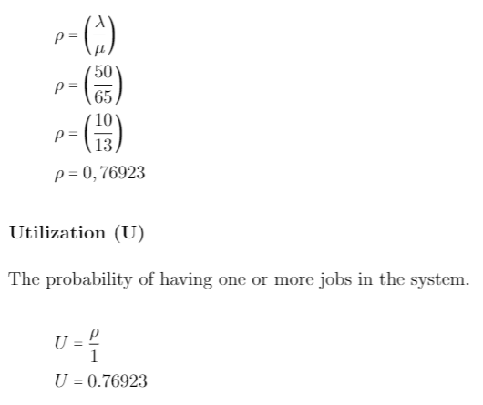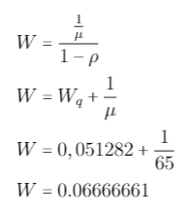

## M/M/s

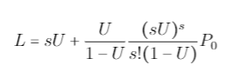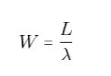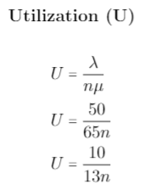

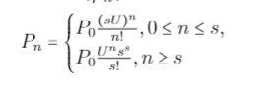

# Number of customers vs Throughput,

# Number of customers vs Response Time, and

# Number of customers vs Utilization.