Data
The main source of data for his paper is from the Saint louis County Assessor’s office and is based on the property tax rolls for the years 2000 through 2025. This data is supplemented with data from the GIS offices within the county and the American Community Survey 5-year datasets. Further verification was carried out using the property lookup feature hosted by the Saint Louis County Assessor’s office website.

Ownership Data
Within the property tax rolls is both location and ownership information for all parcels located within the county. While there is more detailed information for all properties across the several files that make up the property database, we focused on the primary parcel data which denotes the unique parcel identification number, the tenure of the property (owner versus nonowner occupied), the property classification, and the names and addresses of the owners as recorded by the assessor’s office.
On average, there are about 396,000 parcels of land with information in each year of the database and we denoted the tenure of the parcel as owner if the property address matched the owner’s address. After filtering out the non-owner parcels, we use regular expression searches of the property owner’s names to identify the type of owner of each parcel across all property classes. This was carried out as an iterative process starting with the more obvious cases of ownership types. For example, if “LLC” or “Incorporated” was in the owner’s name, the parcel was classified as corporate or if “Bank” was in the owner name, the parcel was classified as REO. Any property that was not classified using these obvious terms, was then visually searched for other terms such as spelling variations or other indicators that would indicate the type of owner for each parcel.
By the end of the process, there were eight categories of ownership types that were identified and into which each parcel was classified. Those categories and the share of the entire sample of parcels across the 2011 to 2023 timeframe are shown in the table below. Any parcel that was already classified as owner occupied based on the address comparison were automatically classified as privately owned. The table also shows how the property ownership categories differ by land use class where multi-use properties are aggregated to the “Multi” land use class.
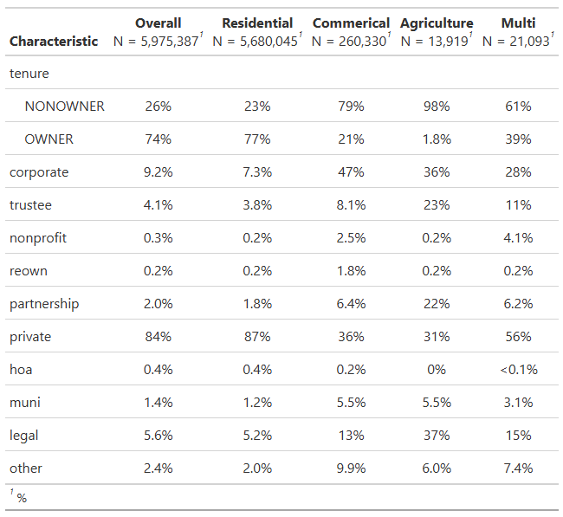
Of the almost 5.7 million residential parcels across the timeframe, seventy-seven (77%) percent are classified as owner occupied contributing to the eighty-seven (87%) percent of parcels that are privately owned. Just over seven percent (7.3%) are owned by a corporate entity with trustees accounting for the next largest share at 3.8%, followed by partnerships at 1.8%. To help simplify the analysis we combine the trustee and partnership categories into a new category called “legal” and combine the nonprofit, reown, hoa, and muni categories into the “other” category.
Figure 1 shows the share of parcels with ownership type equal to the corporate, legal, and other categories (the remaining share is private). Parcels in the other category make up a rather constant share across the years at around 2.5%. Parcels in the “legal” category see a slight increase in share across the years ranging from about 4.8% to a high of 6.3 percent of the total parcels within the county. The image clearly shows the increasing share of corporate own parcels across the years as the share of corporate owned parcels almost doubles from about 6.6% in 2010 to a high of 11.6% by 2024.
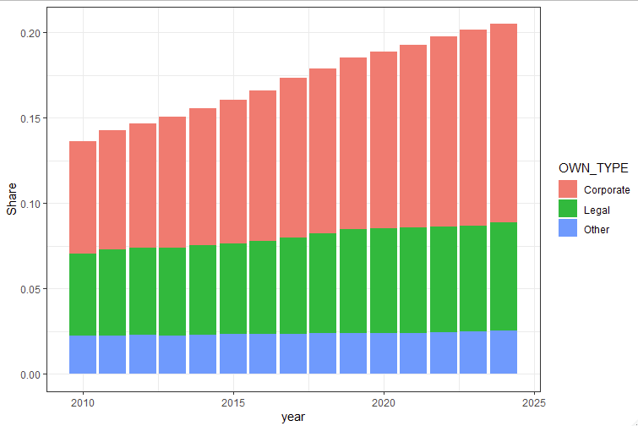

Sales Data
The county assessor’s office also tracks all property transactions within the county and maintains the core database of sales by adding any new data each year. Using the database as of 2024, we start with 930,889 with some observations reaching back as far as the 1950’s. The further back in time one goes, however, the less reliable is the data and so we limit ourselves to the 2011 to 2023 timeframe. We also limit ourselves to only arm’s length valid transactions of single-family homes with a nominal sale price greater than $1,000 which brings our observation count to 273,563 sales records.
We link this data to the ownership data by joining on the parcel identification and the year prior to the sale and the year directly after the sale year reported in the sales database. This allows us to determine the owner type and tenure before and after the sale of the given parcel. By linking this to parts of the accessor’s database that contains more detailed information about the home, we can classify homes that are sold by the builders and identify those units in the data. In cases of missing or conflicting information that we observe, we double check the ownership information using the property lookup feature hosted by the county assessor’s office on their website. We also remove any sale that has a real price above $2.5 million and then add a count for the number of times each parcel sells. These changes and removing properties with missing information results in a total of 143,300 sales remaining to work with.
The figure below shows the average real price of transactions from 2011 through 2024 for each of the four combinations of transaction tenure change. We see the largest growth in home values occur for the owner-to-owner transactions followed by the nonowner to owner type. This is expected as most literature indicates that owners occupied housing sales for a premium. Of note, however, is the strong showing and large gains in the owner to nonowner average real price, especially after 2018 when the more recent surge in corporate home buying started. Finally, transactions between non-owners see some small gains, but nothing significant indicates there are likely contributing factors behind these sales.
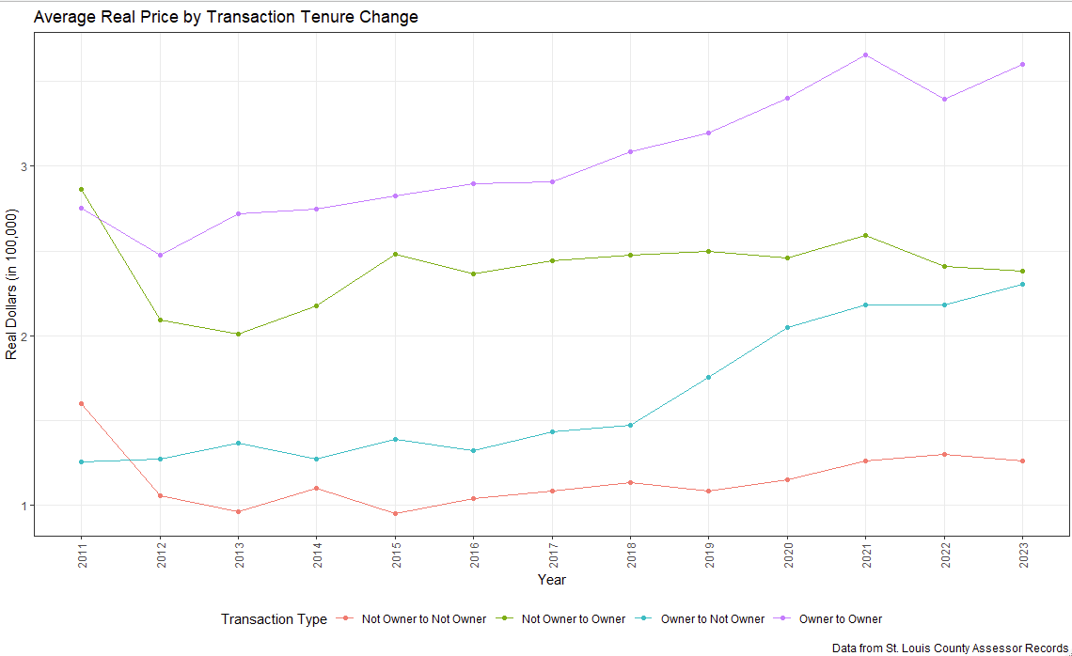
The next figure shows how the average price changes by the buyer type of the year of the sample. What is of most interest in this figure is that the legal buyers seem to be increasing in price to almost that of private buyers while corporate buyers are not seeing prices stay rather constant.

Finally, since we accept there are several unobserved factors that will complicate the analysis, we opt to utilize a repeated sales approach so that unobservable factors that are constant can be differenced out of the data. While this method is not perfect, it does allow us to focus on the key effects we are looking for in our analysis. Therefore, we remove any parcel that is only sold once in the data and limit the sales to those that occur with at least one year between the sales and remove any cases where the sale took place between the builder of the unit and the first owner. This results in a dataset with 34,812 observations across the period from 2012 to 2023.
There are fewer sales during 2012 and 2013 and we see that prices are generally falling for those two years. Part of this is that there is a smaller time between sales since the ownership data only dates back to 2011 meaning that all sales in 2012 take place within one year. We will account for this issue by estimating two samples, one with these observations and one limiting the observations to fewer years to ensure the time to sale is not driving the results. On average, the time between sales is about 3.7 years with prices generally rising across the timeframe.

By linking the ownership data to the sales data, we can determine how changes in price and time to sale change, if at all, based on the type of transaction and we tract the transaction between different types of owners. In the table below we see that 68% of all transaction occurs between two private agents which account for all the owner-to-owner transactions and about a third of the owner to nonowner and nonowner to owner transactions. Among the owners to nonowner sales, 40% are between a private owner to a corporate owner with another 26% being between private owners and legal owners such as trustees or partnerships. Conversely, among the nonowner to owner transactions, corporate to private owners account for 40% of this direction and 23% of the transactions are between legal agents and private owners. Most variation between types of owners occurs in the transactions between nonowner and other nonowners; however, a majority of these are private to private or some variation between corporate and private agents.
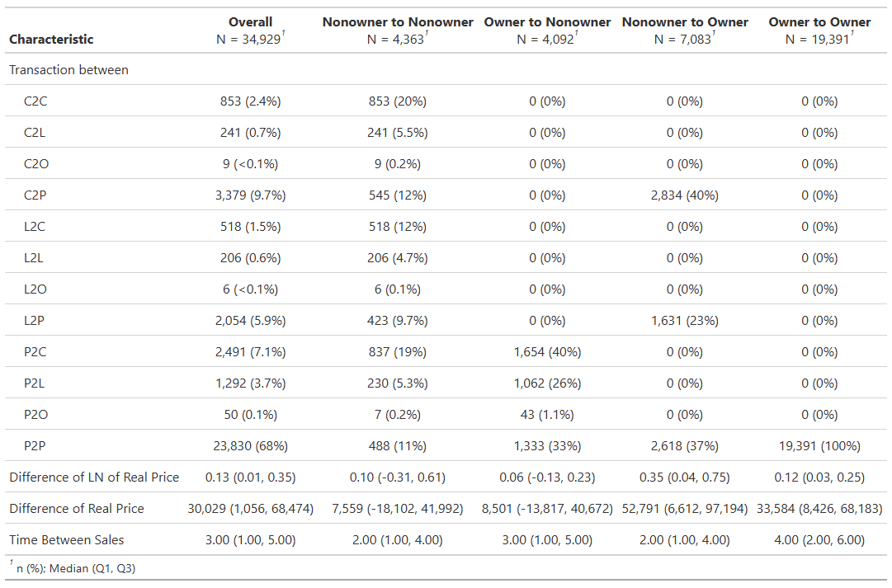
Across the transfers we see that nonowner to nonowner and owner to nonowner see the smallest gains with between 2 and 3 years elapsing between sales. Larger gains are seen in the owner to owner or the nonowner to owner transactions with owner-to-owner transactions seeing the longest time between sales of four years.

