SparkFun’s Guide to Arduino

Project 3

9 LED Grid Planning Template

1. Use the following template to plan out your design. Color or shade in each circle for the LED that you want to be lit.

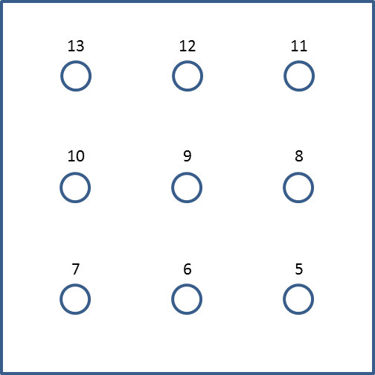

1. Convert these to code for the Arduino, using either HIGH or LOW to designate LEDs that are ON or OFF. Use the starting template below to help. Insert a HIGH or a LOW in the blank space for each LED.

digitalWrite(13, );

digitalWrite(12, );

digitalWrite(11, );

digitalWrite(10, );

digitalWrite(9, );

digitalWrite(8, );

digitalWrite(7, );

digitalWrite(6, );

digitalWrite(5, );

1. Now, generalize this for each pattern you wish to generate on your 9 LED monitor.