

Bug Reporting System
Class : 0908M
- TeamLeader : Nguyen Chi Tam.
- Members : Tu Chi Dung.
Ngo Phuc Nguyen.
Date | Tasks | Members
28-Oct-2010 | Analyse requirement | -Nguyen Chi Tam  -Tu Chi Dung
29-Oct-2010 to 30-Oct-2010 | Use Case | -Nguyen Chi Tam
31-Oct-2010 to 1-Oct-2010 | Specification | -Nguyen Chi Tam  -Tu Chi Dung

Contens
1.Use Case Diagram
2.List of the Actor
3.List of the Use Case
4.Specification Use Case
4.1 Order by email
4.2 Order by phone
4.3 Order directly at the company
4.4 Complaint via mail
4.5Complaint via phone
4.6 Login
4.7 Logout
4.8 View Customers
4.9 Search Customers
4.10 View Orders
4.11 Add Orders
4.12 Update Orders
4.13 Search Orders
4.14 Update Status Dispatches
4.15 Update Customers
4.16 Add Products
4.17 Delete Product
4.18 Update Product
4.19 View products
4.20 Search products
4.21 Add Category
4.22 Update Category
4.23 Delete Category
4.24 View Category
4.25 Search Category
4.26 View Complaint
4.27 Search Complaint
4.28 Update Complaint
4.29 Add Complaint
4.30 View Account Manager
4.31 Search Account Manager
4.32 Create Account Manager
4.33 Update Account Manager
4.34 Delete Account Manager

1/Use-Case
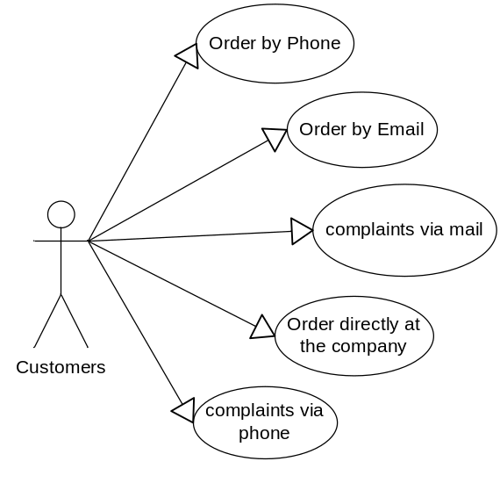
Picture 1 – Actor Customers

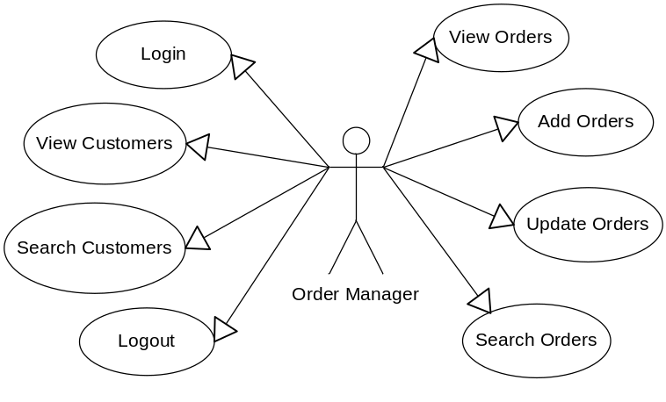
Picture 2 – Actor Order Manager
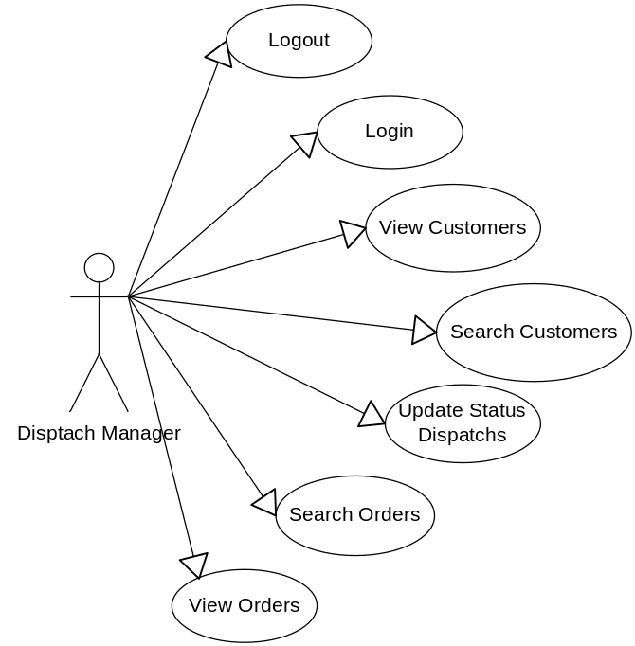
Picture 3 – Actor Dispatch Manager

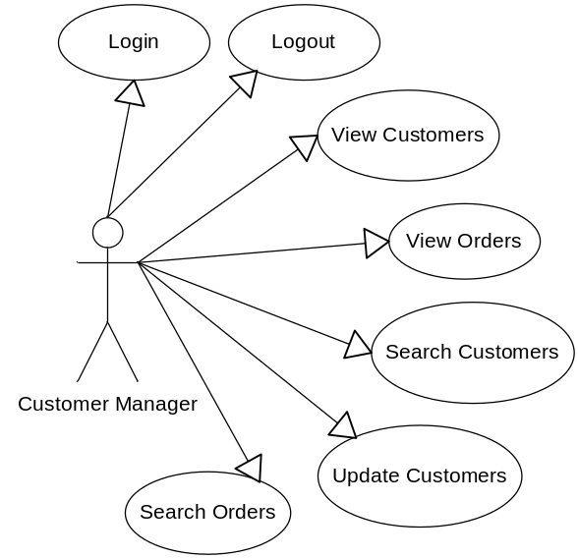
Picture 4 – Actor Customer Manager
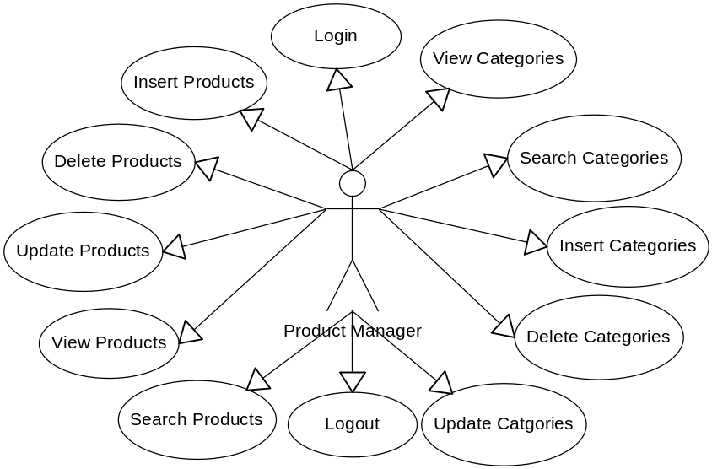
Picture 5 – Actor Product Manager
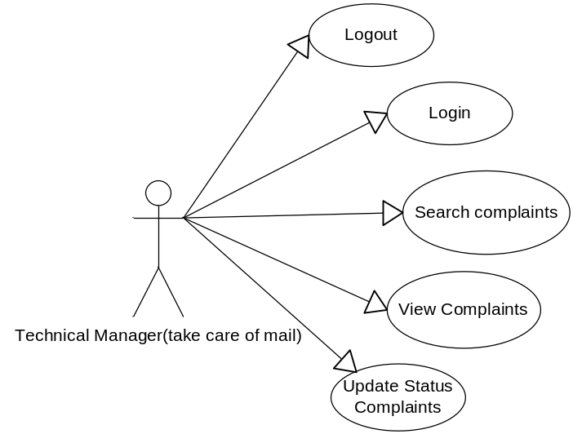
Picture 6 – Actor Technical Manager

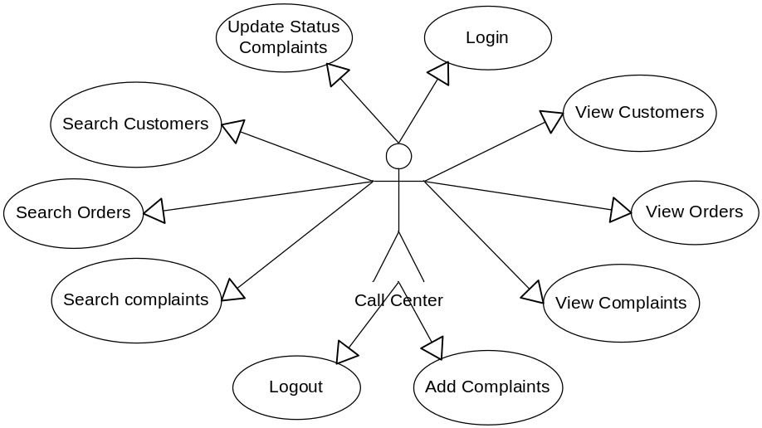
Picture 7 – Actor Call Center
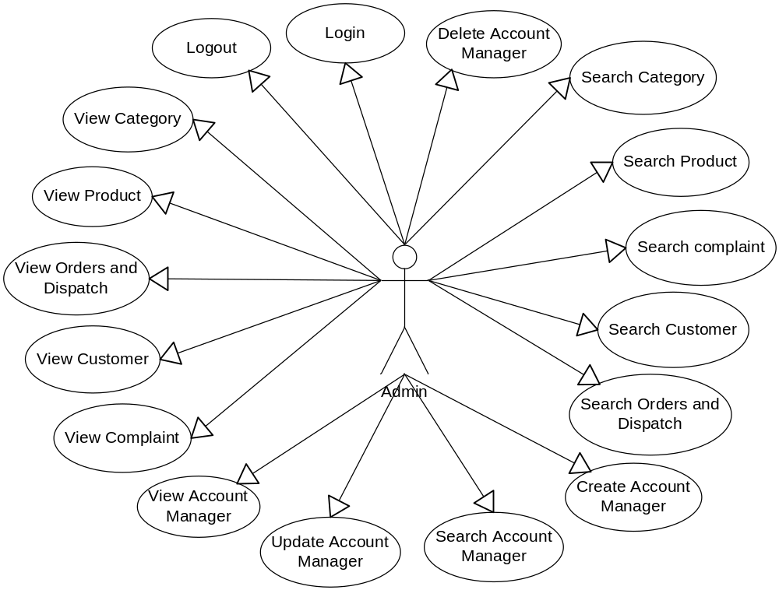
Picture 8 – Actor Admin

2/List of Actors
No. | Actors | Comment
1 | Customers | Customer orders and submit a complaint
2 | Dispatch and Order Manager | Manage Order
3 | Account Manager | Manage Account
4 | Product Manager | Manage Product
5 | Technical Manager | Support Technical
6 | Call Center | Sales and receive complaints
7 | Admin | Manage everything
8 | Disptach Manager | Manage dispatch

3/List of Use-Case
No. | Use-Case | Comment
1 | Order by email
2 | Order by phone
3 | Order directly at the company
4 | Complaint via mail
5 | Complaint via phone
6 | Login | Users logged into the system
7 | Logout | Users exit the system
8 | View Customers | Details of Customer
9 | Search Customers | Users search for customer
10 | View orders | Details of order and dispatch
11 | Add orders
12 | Update orders | Update information and status of orders
13 | Search orders
14 | Update Status Dispatches
15 | Update Customers | Update information of accounts
16 | Add Products
17 | Delete Product
18 | Update Product
19 | View products
20 | Search products
21 | Add Categories
22 | Update Categories
23 | Delete Categories
24 | View Categories
25 | Search Categories
26 | View Complaints
27 | Search Complaints
28 | Update Status complaints
29 | Add Complaints
30 | View Account Manager
31 | Search Account Manager
32 | Create Account Manager
33 | Update Account Manager
34 | Delete Account Manager

4/ Description
4.1 Order by email
Use Case | Order by email
Summary | Customer can order by mail.
Major Events : | Step 1 : Customer sent an Order Email to company  Step 2 : Email center receive order and information of customer  Step 3 : Customer will receive goods in shortest time

4.2 Order by phone
Use Case | Order by phone
Summary : | Customer can order by phone
Major Events : | Step 1 : Customer call to company to order  Step 2 : Phone center receive order and information of customer  Step 3 : Customer will receive goods in shortest time

4.3 Order directly at the company
Use Case | Order directly at the company
Summary : | Customer can order at company
Major Events : | Step 1 : Customer go to company to order  Step 2 : Customer can view product and order at company  Step 3 : Reception receive order and information of customer  Step 4 : Customer will receive goods in shortest time

4.4 Complaint via mail
Use Case | Complaint via mail
Summary : | When using product if something need to reflect and complaints. Customer can sent an Email to complaint to company
Major : | Step 1 : Customer sent an Email to complaint  Step 2 : Email center receive complaint of customer and waiting for the answer of technical

4.5Complaint via phone
Use Case | Complaint via phone
Summary : | When using product if something need to reflect and complaints. Customer can call to company to complaint
Major Events : | Step 1 : Customer call to company to complaint  Step 2 : Call center receive complaint of customer and waiting for the answer of technical
Orther Events :

4.6 Login
Use Case | Login
Summary : | Function “Login” allows user login to system with corresponding powers
Major Events : | Step 1 : When user start application form login will be displayed  Step 2 : User enter their Username and Password  Step 3 : Press button “Login” program will check Username and Password in database.  Step 4 : If exist program will display a confirmation message “Login Successful”  Else program will display a confirmation message “Login Failed”  Step 5 : User press button “Exit” to exit this form
Orther Events :

4.7 Logout
Use Case | Logout
Summary : | Function “Logout” help user logout the program
Major Event : | Step 1 : When user want to signout click "Logout" on the program interface  Step 2 : Program will display a confirmation message “Do you want to sign out ?”  Step 3 : If click “Yes” user will exit program and disconnect with database  If click “No” user will turn back application interface
Orther Events :

4.8 View Customers
Use Case | View Customers
Summary : | View account information of customer
Major Events : | Step 1 : Click on tab “ Customer List”  Step 2 : Select a record of customer and click “Detail”  Step 3 : Window “ Detail of Customer ” will be loaded from database  Step 4 : Press button “Close” to close window “Detail of Customer”
Orther Events :

4.9 Search Customers
Use Case | Search Customers
Summary : | Search Customer
Major Event : | Step 1 : Click on tab “Customer list”  Step 2 : Enter a keyword, select district and city of customer then press button “Search Customer”  Step 3 : Program will check this customer in database  Step 4 : If exist program will display detail of customer  Else program will display a confirmation message “No customer in this customer list”
Orther Events :

4.10 View Orders
Use Case | View Orders
Summary : | View detail of order
Major Events : | Step 1 : Click on tab “Order list”  Step 2 : Select an order want to view detail and then click button “View Detail”  Step 3 : Window “Detail of Order” will be loaded form database  Step 4 : Click “Close” to close this window
Orther Events :

4.11 Add Orders
Use Case | Add Orders
Summary : | Function “Add Order” help user add an order to the list of order
Major Events : | Step 1 : Click on tab “List order”  Step 2 : Press button “Add Order”  Step 3 : “Form Add Order” will be displayed. User enter information of order and press button “Add”  Step 4 :Program will display a confirmation message “Do you want to add order ?”  Step 5 : If click “OK” order will be added into database and display in add order list  If click “No” form Add Order will exit
Orther Events :

4.12 Update Orders
Use Case | Update Orders
Summary : | Function “Update Order” help user update information and status of order
Major Events : | Step 1 : Click on tab “Order list”  Step 2 : Select a record to update then click button “Update Order”  Step 3 : “Form Update Order” will display on screen , user enter detail of order and then press button “Update”  Step 4 : : Program will display a confirmation message “Do you want to update order ?”  If click “OK” order will be update into database and display in order list  If click “No” “Form Update Order” will exit
Orther Events :

4.13 Search Orders
Use Case | Search Orders
Summary : | Search an order in order list
Major Events : | Step 1 : Click on tab “Order List”  Step 2 : Enter Name and phone number of customer  Step 3 : Program will check this information in database  Step 4 : If exist program will display this order  Else Program will display a confirmation message “No order in Order List ?”
Orther Events :

4.14 Update Status Dispatches
Use Case | Update Status Dispatches
Summary : | Function “Update Status Dispatch” help user update the status of dispatch
Major Events : | Step 1 : Click on tab “ Order list”  Step 2 : Select an order need to update status. Press button “Update Dispatch”  Step 3 : “Form Update Dispatch” will be displayed on screen then update status of dispatch  Step 4 : Click “OK”. Status of dispatch will be updated and display in order list
Orther Events :

4.15 Update Customers
Use Case | Update Customers
Summary : | Function “Update Customer” help user update information of customer
Major Events: | Step 1 :Click on tab “ Customer list”  Step 2 : Select a record to update then click button “Update Customer”  Step 3 : “Form Update Customer” will display on screen and then update information of customer  Step 4 :Press button “Update” Program will display a confirmation message “Do you want to update this customer ?”  Step 5 : If click “OK” detail of customer will update in database and display in customer list  If click “No” “Form Update Customer” will exit
Orther Events :

4.16 Add Products
Use Case | Add Products
Summary : | Function “Add Product” help user add a product and detail of this product into product list
Major Events : | Step 1: In tab “Product list” user can view product list  Step 2 :Press button “Add Product” “Form Add Product” will be displayed  Step 3 : User enter information of product into this form and press button “Add”  Step 4 :Program will display a confirmation message “Do you want to add this product ?”  Step 5 : If click “Yes” product will be added into database and display in product list  If click “No” form Add product will exit
Orther Events :

4.17 Delete Product
Use Case | Delete Product
Summary : | Function “ Add product” help user delete a product from product list
Major Events : | Step 1: In tab “Product list” user can view product list  Step 2 :User can delete a product if press button “Delete”  Step 3 :Program will display a confirmation message “Do you want to delete this product ?”  Step 4 : If click “Yes” product will be delete into database and don’t display in product list  If click “ No” Undelete product
Orther Events :

4.18 Update Product
Use Case | Update Product
Summary : | Function “Update Product” help user update information of product
Major Events: | Step 1 :Click on tab “Product list” user can view product list  Step 2 : Select a record to update then click button “Update Product” to update information of product  Step 3 : “Form Update Product” will display on screen and then update information of product  Step 4 :Press button “Update” Program will display a confirmation message “Do you want to update this product ?”  Step 5 : If click “OK” detail of product will update in database and display in product list  If click “No” “Form Update Product” will exit
Orther Events :

4.19 View products
Use Case | View products
Summary : | Function “View Product” help user view information of Product
Major Events : | Step 1: Click on tab “Product list”  Step 2: Select a product and press button “Detail”  Step 3: “Form Product Detail” will be displayed with all information load from database  Step 4:Press button “Close” “Form View Product” will exit
Orther Events :

4.20 Search products
Use Case | Search products
Summary : | Search information of Product
Major Events : | Step 1: Click on tab “Product List”  Step 2 : Enter a keyword and press button “Search Product”  Step 3: Program will check in database  Step 4 : If exist program will display this Product  Else Program will display a confirmation message “No order in product List ?”
Orther Events :

4.21 Add Category
Use Case | Add Category
Summary : | Function “Add Category” help users add product and information of product on the category list
Major Events : | Step 1 : In the tab “ Category list” user can view a list of category  Step 2 : If user want to add a certain category click button “Add Category” then the “ Add Category Form” will appear on the screen  Step 3 : Users enter information into the form “Add Category”  Step 4 : When user entered all information of category users click button “Add”  Step 5 : The program will display a confirmation message “ Do you want to add this category ? ”  Step 6 : Click “Yes” the category will be Added to the database and will be displayed on application  Or click “No” the form will exit
Orther Events :

4.22 Update Category
Use Case | Update Category
Summary : | Function “Update Category” allows users to update the information category
Major Events : | Step 1 : In the tab “ Update Category” user can view a list of category  Step 2 : Users can change information of the category by clicking the button “Update Category” to update information of category  Step 3 : “Form Update Category” will be displayed on the screen  Step 4 : Users enter details which they want to update and then click button “Update”  Step 5 : The program will display a confirmation message “ Do you want to update this category ? ”  Step 6 : Click “Yes” the category will be Updated to the database and will be displayed on application  Or click “No” the form will exit
Orther Events :

4.23 Delete Category
Use Case | Delete Category
Summary : | Function “Delete Category” allows users to delete the information category
Major Events : | Function “Delete Category” allows users to delete the information category  Step 1 : In the tab “ Delete Category” user can view a list of category  Step 2 : Users can delete information of the category by clicking the button “Delete Category” to delete information of category  Step 3 : “Form Delete Category” will be displayed on the screen  Step 4 : The program will display a confirmation message “ Do you want to Delete this category ? ”  Step 5 : Click “Yes” the category will be Delete into the database and will be displayed on application  Or click “No” the form will exit
Orther Events :

4.24 View Category
Use Case | View Category
Summary : | View detail information of category
Major Events : | Step 1 : Click on the tab “ Category List”  Step 2 : Users can see all detail of category
Orther Events :

4.25 Search Category
Use Case | Search Category
Summary : | Search all detail Category
Major Events : | Step 1 : Click on the tab “Search Category”  Step 2 : Enter a keyword and then click on the button “Search Category”  Step 3 : Program will check this keyword in database  Step 4 : If the database have information which users entered, program will display that on the screen  Else program will display a confirmation message “No category in the category list”
Orther Events :

4.26 View Complaint
Use Case | View Complaint
Summary :
Display the customer’s complaint information sent by Email or called to company

Major Events : | Step 1 : Click on the tab “Complaint list”  Step 2 : Users want to see one of complaint : Select a record and click “Detail”  Step 3 : Window “Form Detail of Complaint “ contain information of complaint will be uploaded from database and display  Step 4 : Press button “Close” to close that form
Orther Events :

4.27 Search Complaint
Use Case | Search Complaint
Summary : | Search complaint
Major Events : | Step 1 : Click on tab “ Complaint List”  Step 2 : Enter customer name and status of complaint then press button “Search”  Step 3 : Program will check the customer name and status of complain that users entered in database  Step 4 : If the complaint is exist in database : Program will display information  Else program will display a confirmation message “No Complaint”
Orther Events :

4.28 Update Complaint
Use Case | Update Complaint
Summary : | Function “Update Complaint” help users update status of complaint
Major Events : | Step 1 : Click on tab “ Complaint List”  Step 2 : Choose complaint to update status and then click on the button “Update Status”  Step 3 : From “Update Status Complaint” will be displayed on the screen. Users update status of complaint  Step 4 : Press button “OK”. Status of complaint is updated and display in complaint list
Orther Events :

4.29 Add Complaint
Use Case | Add Complaint
Summary : | Function “ Add Complaint” help users to add a complaint to Complaint List
Major Events : | Step 1 : Click on tab “ Add Complaint”  Step 2 : Press button “Add Complaint”  Step 3 : Form “Add Complaint” will display and users can insert information of complaint  Step 4 : Press button “Add” on the screen display a confirmation message “Do you want to add a complaint ?”  Step 5 : Click “Yes” the complaint will be add into the database and will be displayed on application  Or click “No” the form will exit
Orther Events :

4.30 View Account Manager
Use Case | View Account Manager
Summary : | Users can view all account manager
Major Events : | Click on tab “ Account Manager”. Account’s information will be displayed
Orther Events :

4.31 Search Account Manager
Use Case | Search Account Manager
Summary : | Users can look for an account
Major Events : | Step 1 : Click on tab “Account Manager”  Step 2 : Enter an account name and press button “Search”  Step 3 : Program will fine that name in database  Step 4 : If the database have that name, program will display on the screen  Else program will display a confirmation message “No result in this list”
Orther Events :

4.32 Create Account Manager
Use Case | Create Account Manager
Summary : | Function “Create Account Manager” help users create an account manager
Major Events : | Step1 : Click on tab “Account Manager”  Step 2 : Press button “ Create Account”  Step 3 : Form “ Create Account” will display. User can insert information of account  Step 4 : Press button “Add” program will display a confirmation message “Do you want to create an account ?”  Step 5 : Click “Yes” the account will be update into the database and will be displayed on application  Or click “No” the form will exit and do not add
Orther Events :

4.33 Update Account Manager
Use Case | Update Account Manager
Summary : | Function “Update Account” allows users to update the information account
Major Events : | Step 1 : Click on tab “ Update Account”  Step 2 : Users can change information of the category by clicking the button “Update Account” to update information of Account  Step 3 : “Form Update Account” will be displayed on the screen  Step 4 : Users enter information which they want to update and then click button “Update”  Step 5 : The program will display a confirmation message “ Do you want to update this Account ? ”  Step 6 : Click “Yes” the account will be Updated to the database and will be displayed on application  Or click “No” the form will exit
Orther Events :

4.34 Delete Account Manager
Use Case | Delete Account Manager
Summary : | Function “Delete Account” allows users to delete the information account
Major Events : | Step 1 : In the tab “Account manager” user can view a list of account  Step 2 : Choose an account and press button “Delete”  Step 3 : The program will display a confirmation message “ Do you want to delete this Account ? ”  Step 4 : Click “Yes” the account will be deleted to the database and will be displayed on application  Or click “No” the form will exit
Orther Events :

