

Excell-on Services
Class : 1003M
- TeamLeader : La Quoc Chuong.
- Members : Huynh Trong Gia.
Le Anh Dai.
Nguyen Kim Hoang.
Date | Tasks | Members
03-Apr-2012 | Analyse requirement | -La Quoc Chuong  -Huynh Trong Gia  -Le Anh Dai
8-Apr-2012 to 10-Apr-2012 | Use Case | -La Quoc Chuong  -Le Anh Dai  -Nguyen Kim Hoang
8-Apr-2012 to 10-Apr-2012 | Specification | -La Quoc Chuong  -Huynh Trong Gia  -Le Anh Dai  -Nguyen Kim Hoang

Contents
1.Use Case Diagram
2.List of the Actor
3.List of the Use Case
4.Specification Use Case

4.1 Login
4.2 Logout
4.3 View service type
4.4 Add service type
4.5 Update service type
4.6 Delete service type
4.7 Search service type
4.8 View service order(detail)
4.9 Add service order(detail)
4.10 Update service order(detail)
4.11 Delete service order(detail)
4.12 Search service order(detail)
4.13 View product
4.14 Add product
4.15 Update product
4.16 Delete product
4.17 Search product
4.18 View status payment
4.19 Add status payment
4.20 Update status payment
4.21 Delete status payment
4.22 Search status payment
4.23View customer
4.24 Add customer
4.25 Update customer
4.26 Delete customer
4.27 Search customer
4.28 View employee
4.29 Add employee
4.30 Update employee
4.31 Delete employee
4.32 Search employee
4.33 View department
4.34 Add department
4.35 Update department
4.36 Delete department
4.37 Search department
4.38 View role
4.39 Add role
4.40 Update role
4.41 Delete role
4.42 Search role

1/Use-Case
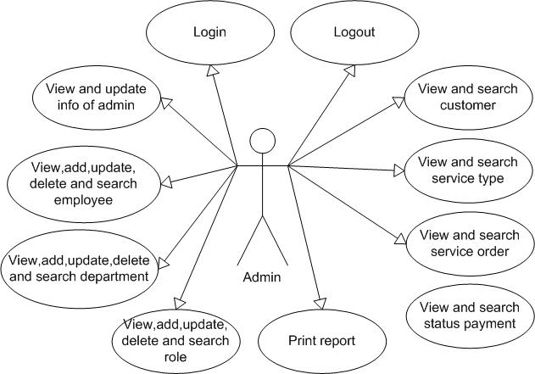
1 – Actor Admin
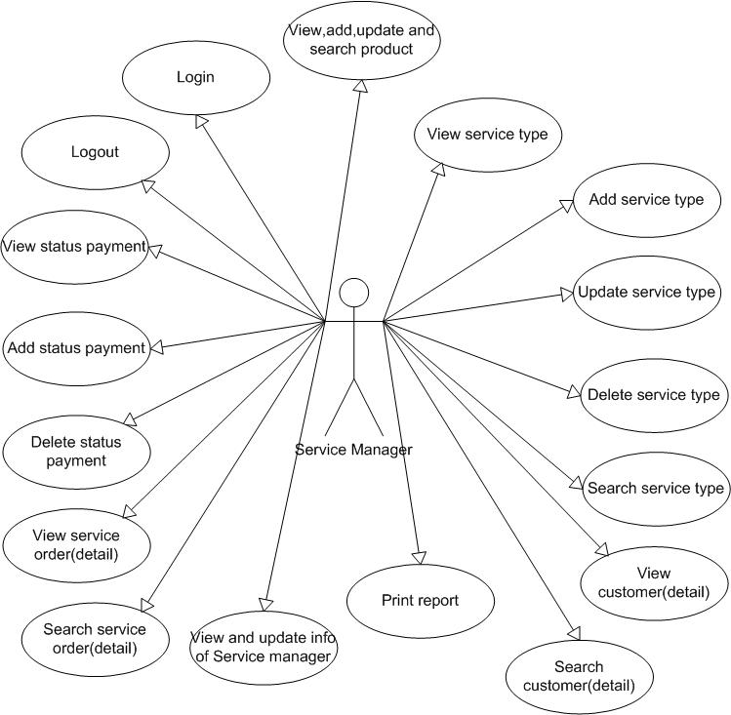
2 – Actor Service Manager
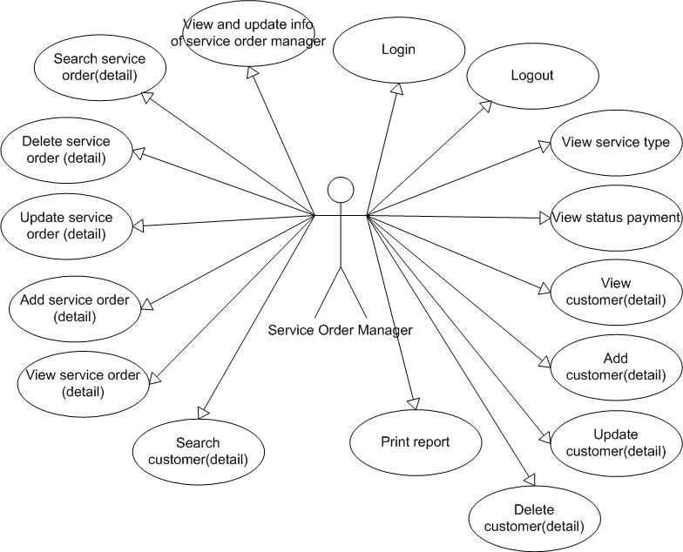
3 – Actor Service Order Manager
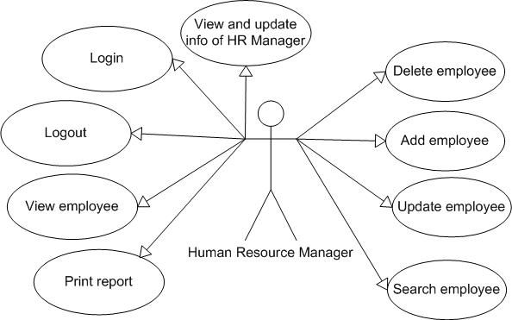
4 – Actor HR Manager
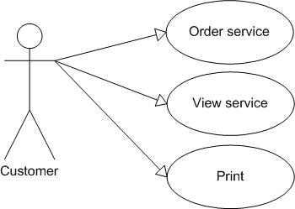
5 – Actor Customer

2/List of Actors
No. | Actors | Comment
01 | Admin | Manage everything
02 | Service manager | Manage service and order service
03 | Manager service order(detail) | Service order manager
04 | HR manager | Manage employee(account)
05 | Customer | Order service and view service

3/List of Use-Case
No. | Use-Case | Comment
01 | Login | Users logged into the system
02 | Logout | Users exit the system
03 | View empployee
04 | Add employee
05 | Add employee
06 | Update employee
07 | Delete employee
08 | Update info of HR Management
09 | View service type
10 | View service order
11 | View service order detail
12 | View product
13 | View employee
14 | View customer
15 | View deparment
16 | Search department
17 | Search customer
18 | Search service type
19 | Search product
20 | Search employee
21 | Search service order
22 | Update info of admin
23 | View service order
24 | Add service order
25 | Update service order
26 | Delete service order
27 | View service order detail
28 | Update service order detail
29 | View service type
30 | Add service type
31 | Update service type
32 | Delete service type
33 | View status payment
34 | Add status payment
35 | Update status payment
36 | Delete status payment
37 | Order service
38 | View service

4/ Description
4.1 Login
Use Case | Login
Summary : | Function “Login” allows user login to system with corresponding powers
Major Events : | Step 1 : When user start application form login will be displayed  Step 2 : User enter their Username and Password  Step 3 : Press button “Login” program will check Username and Password in database.  Step 4 : If exist program will display a confirmation message “Login Successful”  Else program will display a confirmation message “Login Failed”  Step 5 : User press button “Exit” to exit this form
Orther Events :

4.2 Logout
Use Case | Logout
Summary : | Function “Logout” help user logout the program
Major Event : | Step 1 : When user want to signout click "Logout" on the program interface  Step 2 : Program will display a confirmation message “Do you want to sign out ?”  Step 3 : If click “Yes” user will exit program and disconnect with database  If click “No” user will turn back application interface
Orther Events :

4.3 View service type
Use Case | View service type
Summary | View type of service and details of that service.
Major Events : | Step 1 : click on tab service type  Step 2 : a list of service type will be loaded from database and show on website.
Orther Events :

4.4 Add service type
Use Case | Add service type
Summary : | Add a new service type
Major Events : | Step 1 : click on tab service type  Step 2 : a list of service type will be loaded from database and show on website. Click add button and a form to create a new service type will be show on website. User need to fill all fiel require and click create button to create new .

4.5 Update service type
Use Case | Update service type
Summary : | Update service type
Major Events : | Step 1 : click on tab service type  Step 2 : a list of service type will be loaded from database and show on website. User need to select a record in that list and click update button. A form update service type will be show on website. After user changed information, click update button to update.

4.6 Delete service type
Use Case | Delete service type
Summary : | Delete a service type
Major : | Step 1 : click on tab service type  Step 2 : a list of service type will be loaded from database and show on website. User need to select a record in that list and click delete button.

4.7 Search service type
Use Case | Search service type
Summary : | Search service type
Major Events : | Step 1 : click on tab service type  Step 2 : a list of service type will be loaded from database and show on website. User need to fill a keyword in search form and click search button.
Orther Events :

4.8 View service order(detail)
Use Case | View service order(detail)
Summary : | View information of service order
Major Events : | Step 1 : Click on tab service order  Step 2 : a list of service order will be loaded from database and show on website. If user want to see details of service, just select a record.
Orther Events :

4.9 Add service order(detail)
Use Case | Add service order(detail)
Summary : | Add new service order
Major Events : | Step 1 : Click on tab service order  Step 2 : a list of service order will be loaded from database and show on website. If user want to see details of service, just select a record.If user want to add new service order, just click add button . A form to create a new service order will be show on website. User need to fill all information require and click Add button to create new.
Orther Events :

4.10 Update service order(detail)
Use Case | Update service order(detail)
Summary : | Update information of service order
Major Events : | Step 1 : Click on tab service order  Step 2 : a list of service order will be loaded from database and show on website. User need to click update button beside a selected record.
Orther Events :

4.11 Delete service order(detail)
Use Case | Delete service order(detail)
Summary : | Delete service order
Major Events : | Step 1 : Click on tab service order  Step 2 : a list of service order will be loaded from database and show on website. User need to click delete button beside a selected record.
Orther Events :

4.12 Search service order(detail)
Use Case | Search service order(detail)
Summary : | Delete service order
Major Events : | Step 1 : Click on tab service order  Step 2 : a list of service order will be loaded from database and show on website. User need to fill keywords on search form and click search.
Orther Events :

4.13 View product
Use Case | View product
Summary | View product
Major Events : | Step 1 : click on tab product  Step 2 : a list of product will be loaded from database and show on website.
Orther Events :

4.14 Add product
Use Case | Add product
Summary | Add product
Major Events : | Step 1 : click on tab product  Step 2 : a list of product will be loaded from database and show on website.User need to click add button to create a new product. A form will be show on website, user need to fill all information and click create button to create a new one.
Orther Events :

4.15 Update product
Use Case | Update product
Summary | update product
Major Events : | Step 1 : click on tab product  Step 2 : a list of product will be loaded from database and show on website.User need to click update button beside on a selected record.
Orther Events :

4.16 Delete product
Use Case | Delete product
Summary | delete product
Major Events : | Step 1 : click on tab product  Step 2 : a list of product will be loaded from database and show on website.User need to click delete button beside on a selected record.
Orther Events :

4.17 Search product
Use Case | Search product
Summary | search product
Major Events : | Step 1 : click on tab product  Step 2 : a list of product will be loaded from database and show on website. User need to fill keywords on search form and click search.
Orther Events :

4.18 View status payment
Use Case | View status payment
Summary | View status payment
Major Events : | Step 1 : click on tab status payment  Step 2 : a list of status payment will be loaded from database and show on website.
Orther Events :

4.19 Add status payment
Use Case | Add status payment
Summary | add status payment
Major Events : | Step 1 : click on tab status payment  Step 2 : a list of status payment will be loaded from database and show on website. User need to click add button to create a new one. A form will be show on website, user need to fill all information and click create button to create a new one.
Orther Events :

4.20 Update status payment
Use Case | Update status payment
Summary | Update status payment
Major Events : | Step 1 : click on tab status payment  Step 2 : a list of status payment will be loaded from database and show on website. User need to click update button beside on a selected record.
Orther Events :

4.21 Delete status payment
Use Case | Delete status payment
Summary | Delete status payment
Major Events : | Step 1 : click on tab status payment  Step 2 : a list of status payment will be loaded from database and show on website..User need to click delete button beside on a selected record.
Orther Events :

4.22 Search status payment
Use Case | Search status payment
Summary | search status payment
Major Events : | Step 1 : click on tab status payment  Step 2 : a list of status payment will be loaded from database and show on website. User need to fill keywords on search form and click search.
Orther Events :

4.23 View customer
Use Case | View customer
Summary | View customer
Major Events : | Step 1 : click on tab customer  Step 2 : a list of customer will be loaded from database and show on website.
Orther Events :

4.24 Add customer
Use Case | Add customer
Summary | add customer
Major Events : | Step 1 : click on tab customer  Step 2 : a list of customer will be loaded from database and show on website. User need to click add button to create a new one. A form will be show on website, user need to fill all information and click create button to create a new one.
Orther Events :

4.25 Update customer
Use Case | Update customer
Summary | update customer
Major Events : | Step 1 : click on tab customer  Step 2 : a list of customer will be loaded from database and show on website. User need to click update button beside on a selected record.
Orther Events :

4.26 Delete customer
Use Case | Delete customer
Summary | delete customer
Major Events : | Step 1 : click on tab customer  Step 2 : a list of customer will be loaded from database and show on website. User need to click delete button beside on a selected record.
Orther Events :

4.27 Search customer
Use Case | Search customer
Summary | search customer
Major Events : | Step 1 : click on tab customer  Step 2 : a list of customer will be loaded from database and show on website. User need to click delete button beside on a selected record. . User need to fill keywords on search form and click search.
Orther Events :

4.28 View employee
Use Case | View employee
Summary | View employee
Major Events : | Step 1 : click on tab employee  Step 2 : a list of employee will be loaded from database and show on website.
Orther Events :

4.29 Add employee
Use Case | Add employee
Summary | add employee
Major Events : | Step 1 : click on tab employee  Step 2 : a list of employee will be loaded from database and show on website. User need to click add button to create a new one. A form will be show on website, user need to fill all information and click create button to create a new one.
Orther Events :

4.30 Update employee
Use Case | Update employee
Summary | update employee
Major Events : | Step 1 : click on tab employee  Step 2 : a list of employee will be loaded from database and show on website. User need to click update button beside on a selected record.
Orther Events :

4.31 Delete employee
Use Case | Delete employee
Summary | delete employee
Major Events : | Step 1 : click on tab employee  Step 2 : a list of employee will be loaded from database and show on website. User need to click delete button beside on a selected record.
Orther Events :

4.32 Search employee
Use Case | Search employee
Summary | search employee
Major Events : | Step 1 : click on tab employee  Step 2 : a list of employee will be loaded from database and show on website. User need to click delete button beside on a selected record. . User need to fill keywords on search form and click search.
Orther Events :

4.33 View department
Use Case | View department
Summary | View department
Major Events : | Step 1 : click on tab department  Step 2 : a list of department will be loaded from database and show on website.
Orther Events :

4.34 Add department
Use Case | Add department
Summary | add department
Major Events : | Step 1 : click on tab department  Step 2 : a list of department will be loaded from database and show on website. User need to click add button to create a new one. A form will be show on website, user need to fill all information and click create button to create a new one.
Orther Events :

4.35 Update department
Use Case | Update department
Summary | update department
Major Events : | Step 1 : click on tab department  Step 2 : a list of department will be loaded from database and show on website. User need to click update button beside on a selected record.
Orther Events :

4.36 Delete department
Use Case | Delete department
Summary | delete department
Major Events : | Step 1 : click on tab department  Step 2 : a list of department will be loaded from database and show on website. User need to click delete button beside on a selected record.
Orther Events :

4.37 Search department
Use Case | Search department
Summary | search department
Major Events : | Step 1 : click on tab department  Step 2 : a list of department will be loaded from database and show on website. User need to click delete button beside on a selected record. . User need to fill keywords on search form and click search.
Orther Events :

4.38 View role
Use Case | View role
Summary | View role
Major Events : | Step 1 : click on tab department  Step 2 : a list of department will be loaded from database and show on website.
Orther Events :

4.39 Add role
Use Case | Add role
Summary | add role
Major Events : | Step 1 : click on tab role  Step 2 : a list of role will be loaded from database and show on website. User need to click add button to create a new one. A form will be show on website, user need to fill all information and click create button to create a new one.
Orther Events :

4.40 Update role
Use Case | Update role
Summary | update role
Major Events : | Step 1 : click on tab role  Step 2 : a list of role will be loaded from database and show on website. User need to click update button beside on a selected record.
Orther Events :

4.41 Delete role
Use Case | Delete role
Summary | delete role
Major Events : | Step 1 : click on tab role  Step 2 : a list of role will be loaded from database and show on website. User need to click delete button beside on a selected record.
Orther Events :

4.42 Search role
Use Case | Search role
Summary | search role
Major Events : | Step 1 : click on tab role  Step 2 : a list of role will be loaded from database and show on website. User need to click delete button beside on a selected record. . User need to fill keywords on search form and click search.
Orther Events :

