

**D3.1 – Music, Society, and Citizenship:   
Methods and Indicators**

***OpenMusE***

***An open, scalable data to-policy pipeline for European music ecosystems***





Funded by the European Union. Views and opinions expressed are however those of the author(s) only and do not necessarily reflect those of the European Union or the European Research Executive Agency. Neither the European Union nor the granting authority can be held responsible for them.



**Project Factsheet**

Acronym: **OpenMusE**

Title: **An open, scalable data to-policy pipeline for European music ecosystems**

Coordinator: SINUS Markt- und Sozialforschung GmbH

Reference: 101095295

Type: Research and Innovation Action

Program: Horizon Europe

Start: 1st January 2023

Duration: 36 months

Website: <https://www.openmuse.eu/>

Consortium: **SINUS Markt- und Sozialforschung GmbH**, Germany (SINUS), Coordinator

**TURUN YLIOPISTO,** Finland (UTU)

**UNIVERSITEIT VAN AMSTERDAM,** Netherlands (UVA)

**Scuola Superiore di Studi Universitari e di Perfezionament,** Italy (SSSA)

**EKONOMICKA UNIVERZITA V BRATISLAVE,** Slovakia (EUBA)

**Reprex B.V.,** Netherlands (REPREX)

**SYNYO GmbH,** Austria (SYNYO)

**MUSIC INNOVATION HUB SPA IMPRESA SOCIALE,** Italy (MIH)

**Slovenský ochranný zväz autorský pre práva k hudobným,** Slovakia (SOZA)

**Aloaded AB,** Sweden (ALOADED)

**Music Export Ukraine,** Ukraine (MEU)

**Muzikos Eksporto Fondas,** Lithuania (MXF)

**ARTISJUS MAGYAR SZERZOI JOGVEDO IRODA EGYESULET,** Hungary (ARTISJUS)

**MUSICAUTOR SDRUZHENIE,** Bulgaria (MUSICAUTOR)

**HEARDIS! GMBH,** Germany (HEARDIS)

**Deliverable Factsheet**

Number: **D3.1**

Title:  **Music, Society, and Citizenship: Methods and Indicators**

Lead beneficiary: UTU

Work package: WP3

Task: T3.1

Dissemination level: Public

Submission date: 31.11.2023

Main author(s): James Edwards, SINUS

Contributor(s): XX, UTU

XX, SINUS

XX, REPREX

XX, MIH

Quality check: XX, UVA

XX, SSSA

Document history:

|  |  |  |  |
| --- | --- | --- | --- |
| **Revision** | **Date** | **Main modification** | **Author** |
| 0.1 | 13/09/2023 | Structural draft | James Edwards |

**Disclaimer of Warranties**

*This project has received funding from the European Union’s Horizon Europe, research and innovation programme, under Grant Agreement No.* 101095295*.*

This document has been prepared by OpenMusE project partners as an account of work carried out within the framework of the EC-GA contract no 101095295.

Any dissemination of results must indicate that it reflects only the author’s view and that the Commission Agency is not responsible for any use that may be made of the information it contains.

Neither Project Coordinator, nor any signatory party of OpenMusE Project Consortium Agreement, nor any person acting on behalf of any of them:

1. makes any warranty or representation whatsoever, express, or implied,
2. with respect to the use of any information, apparatus, method, process, or similar item disclosed in this document, including merchantability and fitness for a particular purpose, or
3. that such use does not infringe on or interfere with privately owned rights, including any party's intellectual property, or
4. that this document is suitable to any particular user's circumstance; or
5. assumes responsibility for any damages or other liability whatsoever (including any consequential damages, even if Project Coordinator or any representative of a signatory party of the OpenMusE Project Consortium Agreement, has been advised of the possibility of such damages) resulting from your selection or use of this document or any information, apparatus, method, process, or similar item disclosed in this document.

Working material

Task and deliverable descriptions

T3.1. Methods and indicators (lead: UTU; contributors: SINUS, REPREX, MIH). [Start: M5, End: M11]

This task will focus on the development of indicators following the indicator development cycle of Eurostat, starting with understanding user needs.

* It will focus on aspects of musical value that do not immediately translate into economic value, as well as on sustainability dimensions of music culture and industry, within an SDG framework
* Regarding means of measurement, it will update the cultural access and participation (CAP) survey methodology recommended in 2012 by ESSnet Culture (as adapted by ARTISJUS, SOZA, and REPREX) in light of new methods developed by the Eurobarometer and European Social Survey core teams in 2020-2022.
* It will close with a user workshop where we will demonstrate to (sub-)national policy users, EU-level policy users, and music education and business users a general indicator development framework, as well as many indicator candidates to facilitate a dialogue of needs.

The methods and indicators will be presented in D3.1.

T3.2. Data collection, synthesis, and reporting (lead: SINUS; contributors: UTU, REPREX). [Start: M11, End: M22]

Collection and reporting of the data points identified in T3.1.

* First, the task will collect open-source data on cultural access and participation utilising the software package developed in WP4. Relevant data on environmental impacts will also be collected from the European Environmental Agency and Eurostat using the software package developed in WP4.
* Second, the task will conduct new cultural access and participation (CAP) surveys in Bulgaria, Germany, Hungary, and Italy. The survey strategy will update the 2012 culture statistics recommendation of ESSnet-Culture in light of 2020-2022 methods and use the ICET model framework to enable comparability with business transaction data. To maximise the accuracy of recall and enable synthesis with financial year business data, the CAP surveys will be carried out in Jan/Feb 2024. The survey results will be retrospectively harmonised with earlier CAP surveys conducted by ARTISJUS, SOZA, the Commissions Eurobarometer survey, and EU-SILC for stability and larger international and historical comparison dating back to 2007; the piracy surveys of the EUIPO in years 2013; and the piracy research of UVA and SSSA.
* Harmonisation with prior surveys will allow the construction of synthetic longitudinal datasets – one of the outputs will be the comparison of cultural access and participation live and online before, during, and after the COVID-19 pandemic, including differences between social segments and impact on well-being.

The open collaboration method will be used: all methods and instruments will be fully open, and all data will be harmonised, enabling any representative organisation to localise them and join the action with few time or cost barriers. Localisation assistance may be provided in partner countries.

**T3.3. Policy context, pilot study, and impact pathways (lead: MIH; contributors: SINUS, REPREX, SSSA, MUSICAUTOR). [Start: M22, End: M34]**

This task will comprise three phases:

* Open policy analysis of music, society, and citizenship in Europe. The policy analysis will focus on sustainability and corporate social responsibility in the music industry, within an SDG framework, as well as the state of the art on research on the non-economic contributions of music to society, e.g. via the impact of cultural participation on social cohesion and well-being.
* Implementation of a pilot study in Italy. The pilot study will focus on sustainability and corporate social responsibility in the music industry, within an SDG framework. It will demonstrate the ability of reproducible research and innovation tools to help MSMEs comply with emerging social and environmental sustainability regulations, at a viable cost.
* Co-creation of policy guidelines and recommendations for scaling and transferring the pilot on an EU27+ level. Using the Open Policy Analysis guidelines, we will demonstrate how to fill partially or fully the data gaps on music, society, and citizenship identified in the Feasibility Study of the European Music Industry. The policy analysis, pilot study design and results, and transfer potential will be presented in D3.2.

We will furthermore explore synergies with the ongoing MusicAIRE project Eviota Music to avoid risks of duplication of work.

Deliverables

**Deliverable D3.1 – Music, Society, and Citizenship: Novel data collection methods and indicators**

Following the Open Policy Analysis Guidelines, this deliverable identifies critical research questions, data sources and gaps, and data collection methods regarding music society, and citizenship in Europe. It also presents composite indicators developed to measure the social value and contributions of music. The second iteration will be reviewed by selected stakeholders. The indicators will furthermore be added to the Open Music Observatory (D5.1).

**PM distribution**

|  |  |
| --- | --- |
|  | WP3 |
| P01 SINUS | 23 |
| P02 UTU | 12 |
| P03 UVA | 2 |
| P04 SSSA | 13 |
| P05 EUBA |  |
| P06 REPREX | 2 |
| P07 SYNYO |  |
| P08 MIH | 13 |
| P09 SOZA |  |
| P10 ALOADED |  |
| P11 MEU |  |
| P12 MXF | 2 |
| P13 ARTISJUS | 1 |
| P14 MUSICAUTOR | 2 |
| P15 HEARDIS |  |
| Total PMs per WP | 70 |

Working links

GitHub repository: <https://github.com/dataobservatory-eu/music_society_citizenship>

Zenodo community: <https://zenodo.org/communities/music_observatory/>

Zotero group: <https://www.zotero.org/groups/4559070/digital_music_observatory>

Glossary

XX

**Executive Summary**

Following the Open Policy Analysis Guidelines, Deliverable D3.1 – *Music, Society, and Citizenship: Methods and Indicators* identifies critical research questions, data sources and gaps, and data collection methods regarding music society, and citizenship in Europe. It also presents composite indicators developed to measure the social value and contributions of music. The second iteration will be reviewed by selected stakeholders. The indicators will furthermore be added to the Open Music Observatory (D5.1). The deliverable begins by … XX

**Table of Contents**

Working material 5

Task and deliverable descriptions 5

Working links 5

Glossary 5

Introduction 8

1 Literature Review 9

2 Data Gaps 10

2.1 Data Gaps Immediately Relevant to National Policy in Slovakia 10

2.2 Data Gaps Relevant to EU-Level Policy 10

2.3 Data Gaps Relevant to Civil Society Actors and the General Population 10

3 Data Sources 11

3.1 Survey Data 11

3.1.1 Labour force surveys: e.g., EU Labour Force Survey (EU-LFS) 12

3.1.2 Cultural access and participation (CAP) surveys 12

3.1.3 Enterprise surveys 12

3.2 Administrative Data 12

3.3 Secondary Data Sources 12

4 Data Collection Methodology 12

4.1 Data-to-Policy Pipeline 12

4.2 Music Industry Registers 13

4.3 Indicator Candidates 13

5 Toward Evidence-Based Policies on Music, Society, and Citizenship 14

5.1 Key Policy Concepts 14

5.2 Data Collection Targets 14

6 Conclusion and Outlook 15

References 16

Annex: Stakeholder Workshop Draft Agenda 17

Introduction

The Open Music Europe work plan is grounded on a series of policy dialogues and documents produced by the European Commission during the 2010s and early 2020s, which culminated in the establishment of the Music Moves Europe framework. A key output of the 2018 Preparatory Action “Music Moves Europe: Boosting European music diversity and talent” was the *Feasibility study for the establishment of a European Music Observatory* (Commission et al. 2020) (in short: EMO Feasibility Study). The Open Music Europe work plan is structured in accordance with the four pillars identified in the EMO Feasibility Study: WP1 focuses on the economy of music in Europe; WP2 on music diversity and circulation; WP3 on music, society, and citizenship; and WP4 on innovation and future trends.

In specific, WP3 focuses on three significant music policy problems: how can the total social value of music, including non-market value, be conceptualised, assessed, and represented; and how can the environmental, social, and governance sustainability of the sector and a wide range of actors within it be more accurately and efficiently evaluated? Our research intends to help design and monitor policies that advance these goals, while supporting the “triple transition” of the music industry:

“To set a course for the New Era scenario, Europe must simultaneously begin to overhaul the way it approaches climate issues, technology and the underlying shape of its society. This triple transition of green, digital and social factors will need to anchor policymaking at almost every level. Finance, education and institution building will all need to be mobilised, with a constant eye toward improving and sustaining trust in the European project” (European Commission et al. 2022, 24)

All four research work packages in Open Music Europe can furthermore be viewed through a sustainability lens: WP1 deals with sustainable economic practices capable of ensuring ongoing competitive viability; WP2 and WP3 deal with social and environmental sustainability; and WP4 addresses the digital transition.

XX

In accordance with the needs of cultural policymakers, various music sector and industry actors, and the general population, WP3 of Open Music aims to address the following **key research questions**:

1. XX
2. XX
3. XX
4. Literature Review

XX

1. Data Gaps

Music is very much a data-driven industry, particularly insofar as it was one of the first global industries that moved much of its sales to a few global digital platforms that record incredibly detailed information on uses and users alike. Some data gaps in the music industry are illusory from the point of view that the data are recorded somewhere; said data are “only” not processed and aggregated into formats that would be required for public policy analysis. Other data gaps are real, insofar as data on both informal economic activity and non-economic (or marginally economic) activity are collected in a non-systematic manner. In most EU member states, data on access to and participation in music sectors, industries, and cultures among the general population also collected rarely, if at all.

The *Feasibility study for the establishment of a European Music Observatory* enumerates a number of data sources and gaps in its pillar on music, society, and citizenship (Commission et al. 2020; see Section 2.3, Figure 6). The main data collection areas specified in the EMO Feasibility Study and their relevance to Open Music Europe follow:

* Education, training, and personal development: music schools and conservatories; training schemes; other formal education practices. Informal education and training practices are also relevant here, though not mentioned in the Feasibility Study. XX
* Audiences: music consumption, including consumer patterns related to piracy; social networks and music. XX
* Music and society: scope of the not-for-profit sector; social impact of music in communities. XX

WP3 is guided by exploitation aims that are relevant to our music industry stakeholders, as well as to the majority of actors in the European music industry as a whole: XX.

* 1. Data Gaps Immediately Relevant to National Policy in XX

In accordance with out pilot-project-driven research agenda, we will start our analysis of data gaps on the national level. Cultural policies are mainly formed on a national level, or even the sub-national level in some European Union member states. Moreover, with few exceptions, European-level data gaps cannot be filled if there are no (interoperable) statistical processes in place in the individual member states that collect the data.

XX

* 1. Data Gaps Relevant to EU-Level Policy

XX

* 1. Data Gaps Relevant to Civil Society Actors and the General Population

XX

1. Data Sources

Open Music Europe intends to build an open statistical infrastructure that is compatible with the national statistical infrastructures of the EU/EEA/candidate member states, but which is based on voluntary industry cooperation. We will build a similar framework that national statistical offices have in Europe, but at a smaller, cheaper, and more flexible scale, and on a different legal basis. We will harvest secondary microdata and process statistical data sources based on the Open Data Directive, in closer attention to the purposes that such data can serve.

As *Open Music Europe D6.3 – Data management plan* indicates, the Open Music Europe consortium will manage data similarly to official statistical processes. The statistical infrastructure of indicators (see Figure 7 below; DOI: <https://doi.org/10.6084/m9.figshare.23600571>) serves as a guideline for our pursuit of mixed data sources:

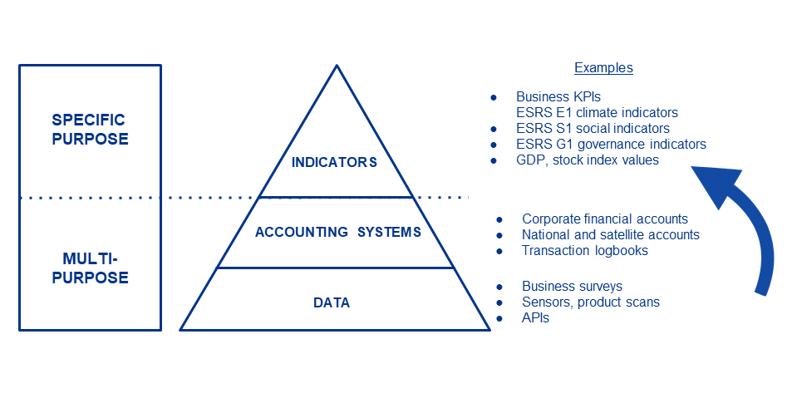

Figure 7: Statistical infrastructure for indicator development

Specifically:

* We will utilise enterprise, mixed, and personal **survey data**. Secondary data from existing survey programmes (e.g., EU-SILC, Eurobarometer, ESS, national-level cultural access and participation surveys, etc.) will be analysed as appropriate. Primary survey data will then be collected using questionnaires and procedures that are ex-ante harmonised with selected existing survey programmes.
* We will tap into **administrative records** (i.e., consistent data sources originally not intended for statistical purposes). Administrative data will be used primarily in WPs 1 and 2 rather than WP3, but overlaps in usage are conceivable.
* We will experiment with similar data sources, such as data harvested regularly from APIs, that Eurostat also considers **“experimental”** in their definitions of statistical processes. The degree to which such data is relevant in WP3 is yet to be determined.

These data sources are all considered in the following sections.

* 1. Secondary Survey Data

XX

* + 1. Labour force surveys: e.g., EU Labour Force Survey (EU-LFS)

XX

* + 1. Cultural access and participation (CAP) surveys

XX

* + 1. Enterprise surveys

XX

* 1. Primary Survey Data

XX

* 1. Administrative records

Administrative data collection refers to the activities involved in collecting, processing, storing, and disseminating statistical data from one or more administrative sources. In the context of national statistical productions, this usually means re-processing tax administration data. The main administrative data sources for Open Music Europe are royalty accounts of individual and collective rights management organisations. These data sources will primarily contribute to the activities of WP1, however, intersections with the work done in WP3 are possible and will be explored.

* 1. Other Secondary Data Sources

In the last two decades, the range and amount of data available by API has increased to the extent that non-professional users often do not find the information they need. The first step in making such data more accessible is to build a means of accessing curated – and, if needed, re-processed – statistical data sources. The rOpenGov collaboration maintained by the University of Turku provides reproducible tools to access such sources. These tools will be further developed into a statistical ecosystem with a more friendly user interface in Open Music Europe WP4. The following data available by API may be utilised in WP3.

* + 1. Input-output data

A good example of these tools will be used in WP3. The iotables R package on rOpenGov, developed under the leadership of REPREX, provides access to the Eurostat data warehouse’s symmetric input-output data. Symmetric input-output and auxiliary tables connect thousands of statistical indicators (which are otherwise difficult to use) into analytical tables, which can be used for economic analyses and social or environmental impact assessments. The iotables package helps the user to bring together the necessary data from Eurostat’s data warehouse and process it into readily-usable indicators and multipliers. This service can be seen as a middleware between data processing and data analysis.

In WP3, input-output data will be used to … XX

* + 1. Reusable microdata and public sector information

The public sector already holds an extraordinary amount of data that can contribute to improving the internal market and to the development of new applications. The 2003/98/EC Directive and Directive (EU) 2019/1024 establish rules and guidelines for the reuse of existing documents held by public sector bodies and data collected within the exercise of public tasks or services of general interest, respectively (for details, please see D1.1 Section 3.3.2).

1. Data Collection Methodology

We want to create a data production method that makes already-available public data more usable for the purposes of music businesses, researchers, and policymakers, and links such public data with further data to fill gaps. The first leg of this “data-to-policy pipeline” requires the creation of a statistical infrastructure, a data observatory, that can receive processed and unprocessed public and private data, link them, and offer a data pipeline for newly collected data as well. The actual statistical collection documentation of the data belongs to T1.2, T2.2, and T3.2; however, the first task in each WP deals with novel methods to consistently collect data.

* 1. Data-to-Policy Pipeline

Open Music Europe offers a “data-to-policy pipeline”, which offers data in processed form that is ready to use in evidence-based business and policy administration. A data pipeline is a method in which raw data is ingested from various data sources and then ported to a data store for further analysis: in this case, to an open, shared, collaborative music observatory (see Figure XX below).

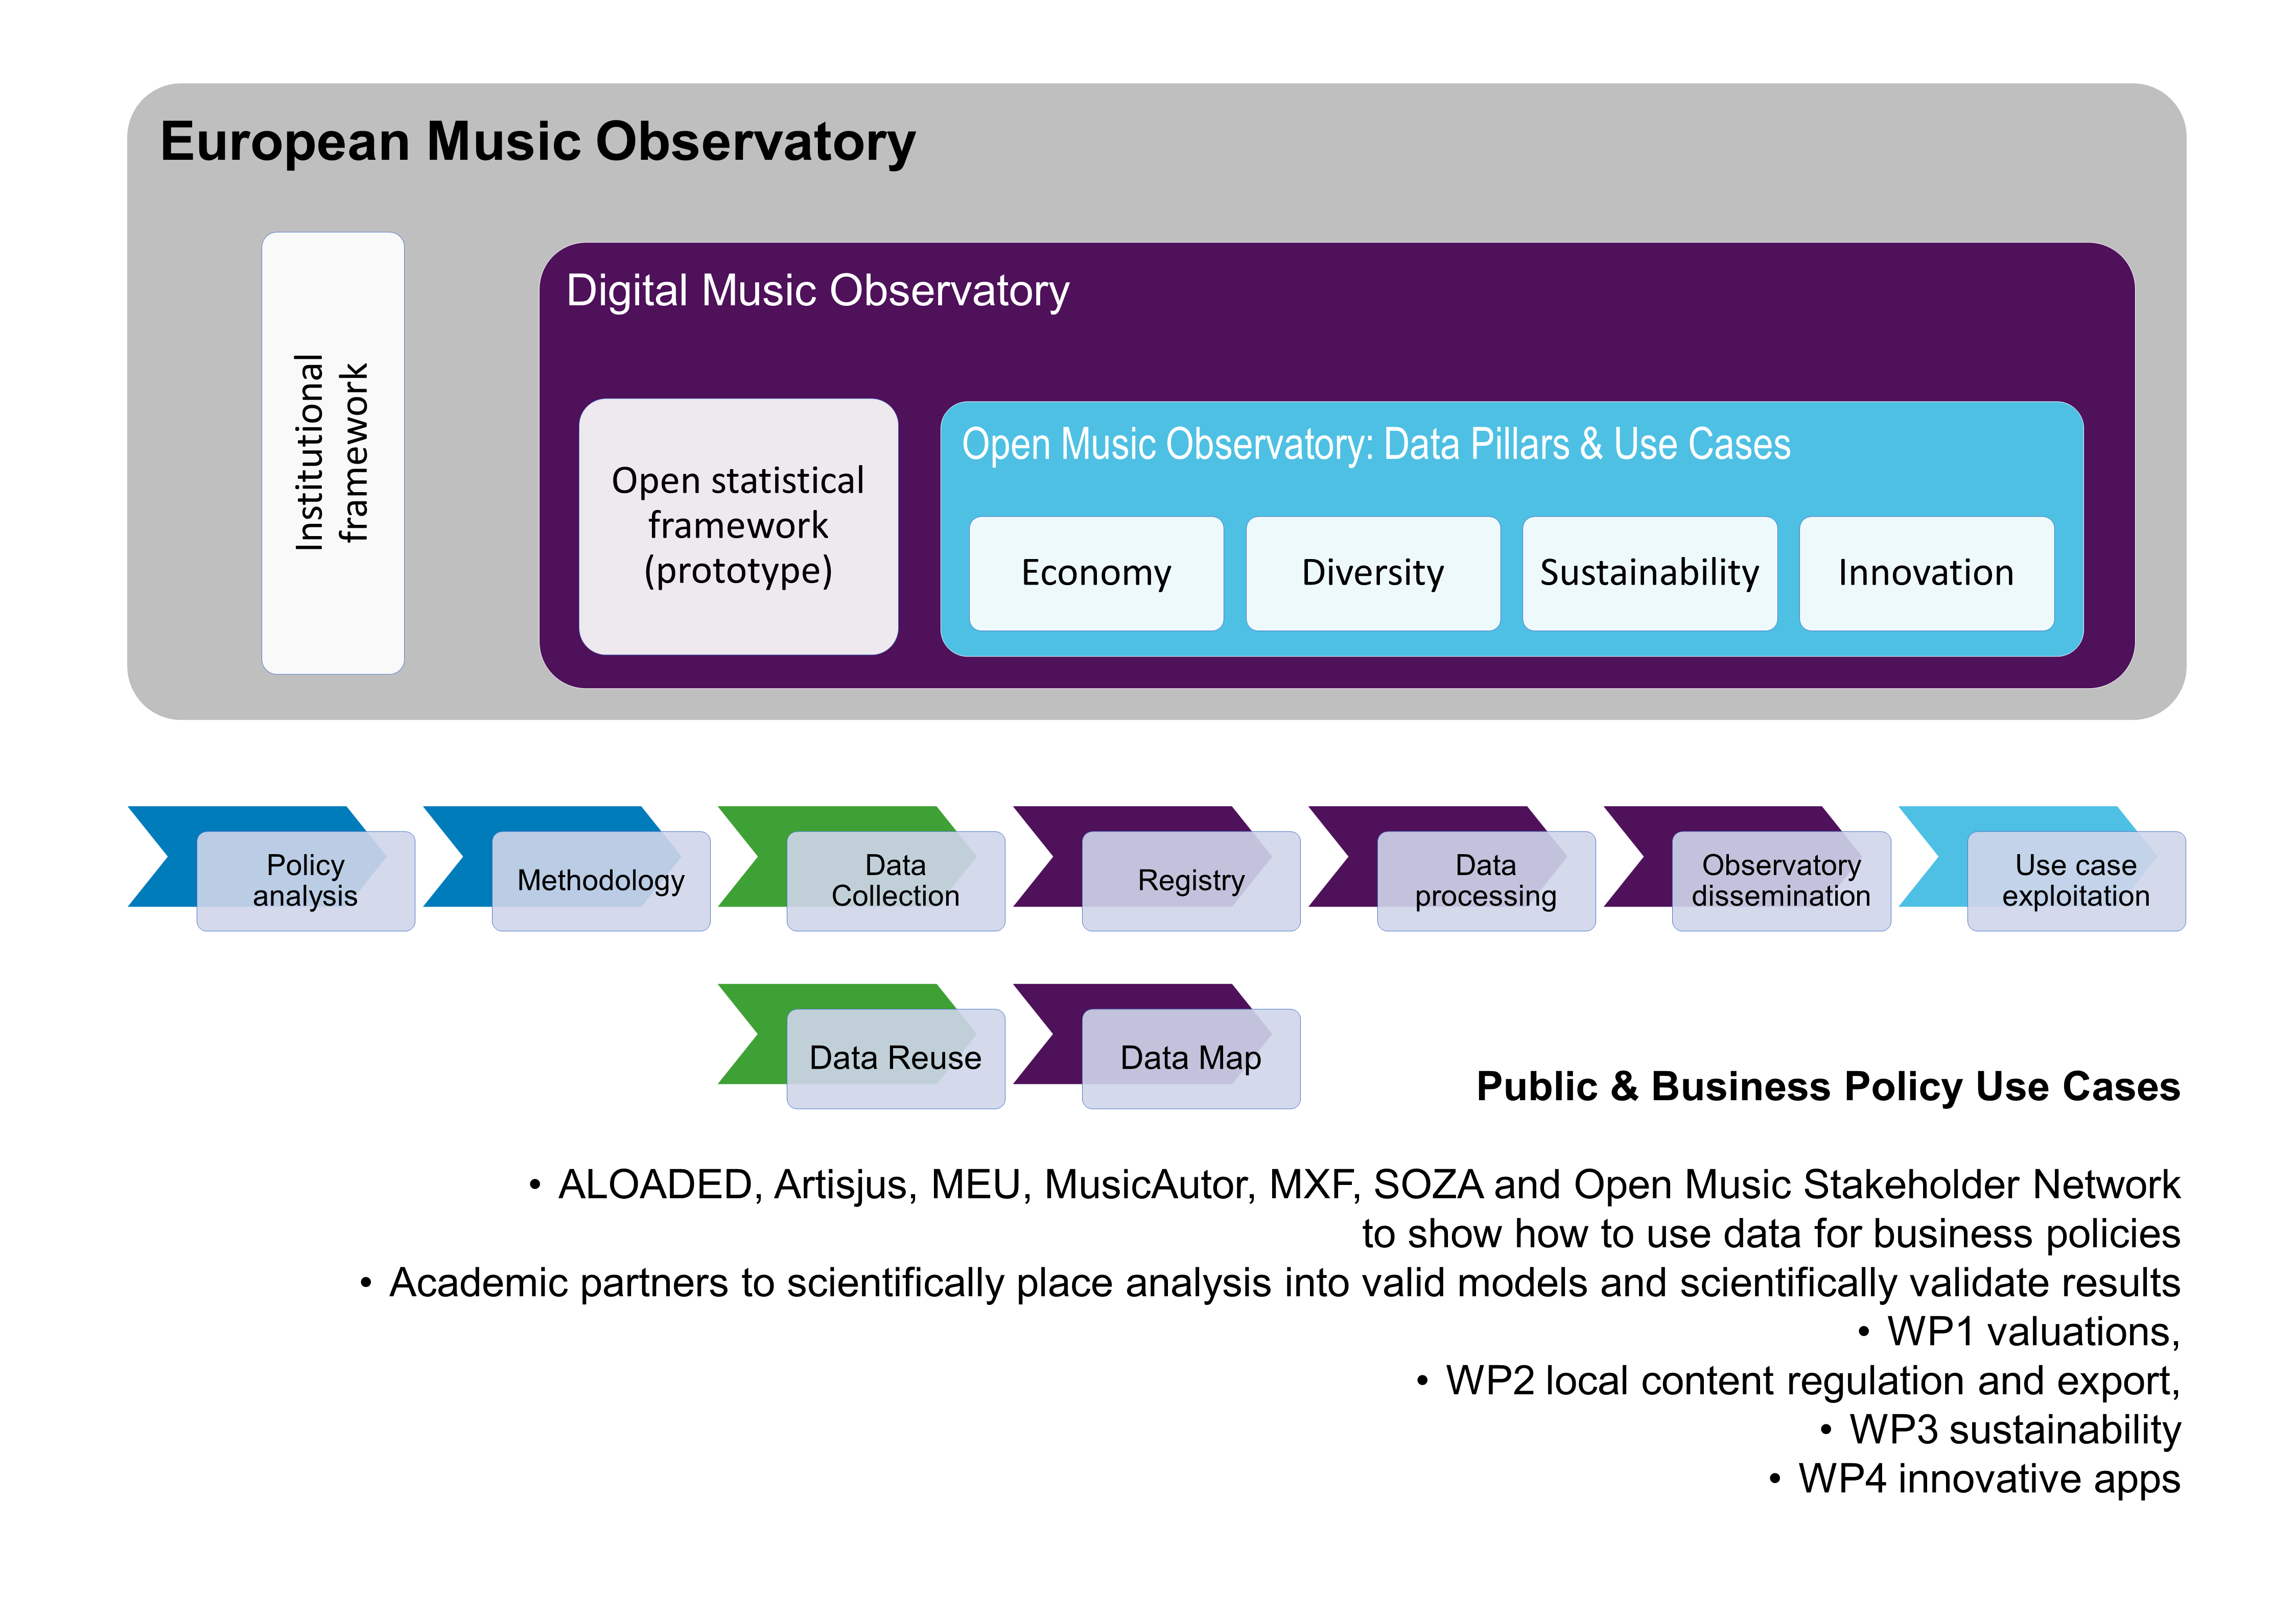

Figure XX: Envisioning a European Music Observatory as a “data-to-policy pipeline”

We extend this pipeline using reproducible research techniques, good statistical practices, and a novel application of the *Open Policy Analysis Guidelines* in order to support evidence-based policy analysis, scientific music research, and sound business strategy-building (for further details, see Antal 2023a).

XX

* 1. Music Industry Registers

XX

* 1. Indicator Candidates

As of October 2023, the following indicator candidates have been proposed, as discussed in a stakeholder workshop planned for September 2023:

|  |  |
| --- | --- |
| **Indicator description and value (XX)** | **Data source** |
| XX | XX |

1. Toward Evidence-Based Policies on Music, Society, and Citizenship

XX

* 1. Key Policy Concepts

XX

* 1. Data Collection Targets

XX

1. Conclusion and Outlook

XX

References

European Commission, Directorate General for Economic and Financial Affairs, Carlo Carraro, Melinda Mills, Benoît Cœuré, Hélène Rey, Ottila Dhand, André Sapir, and Daniela Eichengreen Barry AND Schwarzer. 2022. A New Era for Europe: How the European Union Can Make the Most of Its Pandemic Recovery, Pursue Sustainable Growth, and Promote Global Stability. Luxembourg: Publications Office. <https://data.europa.eu/doi/10.2765/584797>.

Annex: Stakeholder Workshop Draft Agenda

## Music industry specific topics

On the *level of data availability*, we plan to discuss the statistical registers and statistical processes behind the Kult 5-01, 16-01 and 19-01 surveys. These surveys collect data that overlap with the databases of SOZA, SLOVGRAM, and the Slovak music centre (Hudobné Centrum), and they also aim at data points that we envision to be part of a Comprehensive Slovak Music Database (in WP2).

It should be discussed whether the required information can be collected with greater precision and less processing burden with the help of the statistical infrastructure that Open Music Europe is piloting. Specifically, the following points should be on the agenda:

* The idea of a data-to-policy pipeline, as well as the data observatory concept.
* The idea of the Comprehensive Slovak Music Industry Database and the Slovak Music Industry Register.
* A revision of the data collection covered by the three music-related KULT surveys.
* Novel distribution concepts (e.g., the Unlabel concept promoted by Open Music Europe partner REPREX).

On the level of policy, an alignment of the cultural and creative industry topics and the Music Moves Europe agenda should be discussed. We could use music exports as a case study, and also discuss the taxation of music, which is important in the European policy agenda. Specifically, the following points should be discussed:

* The perceived over-taxation of music, and potentially some other creative industries.
* Measurement and policymaking challenges pursuant to the aim of making Slovak music visible both within the Slovak Republic and abroad, and also earning more export revenues.
* The importance of cultural tourism and festivals.

## Cultural and creative industry topics

On the level of data availability, we plan to discuss the further development of the Slovak satellite accounts, which currently do not cover the music industry or some other creative and cultural industries. This discussion should cover statistical registers, data collection processes, and other topics relevant to the production of satellite accounts.

We believe that following IMF, OECD, and ILO best practices may provide a better mapping of music (and some other creative and cultural industries, particularly copyright-based ones), and accordingly, better satellite accounts. This would contribute to the goal of the music industry having similar key indicators as sectors and industries such as fisheries, car manufacturing, banking, etc. (i.e., share in GDP, employment, gross value added and various profitability measures).

On the *level of policy*, we plan to discuss the digital transition agenda of the European Union (e.g., digitisation, as well as environmental, social, and governance sustainability), wherein important legal changes are happening right now. Without fully grasping these changes, the Slovak CCIs/CCSIs may not benefit from the European Green Deal’s new financial tools (this is partly related to Open Music Europe WP3, and partly to WP1).