<http://localhost:8080/SpringRestExample/rest/emp/dummy>

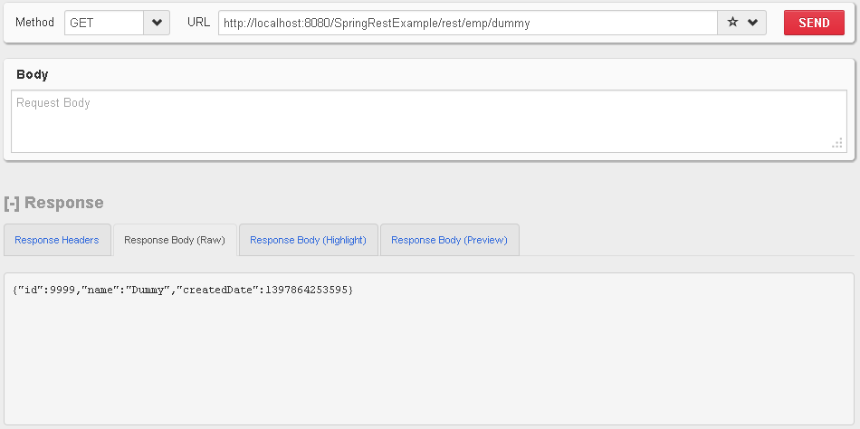

@RequestMapping(value = EmpRestURIConstants.*DUMMY_EMP*, method = RequestMethod.*GET*)

**public** @ResponseBody Employee getDummyEmployee() {

*logger*.info("Start getDummyEmployee");

Employee emp = **new** Employee();

emp.setId(9999);

emp.setName("Dummy");

emp.setCreatedDate(**new** Date());

empData.put(9999, emp);

**return** emp;

}

<http://localhost:8080/SpringRestExample/rest/emp/create>

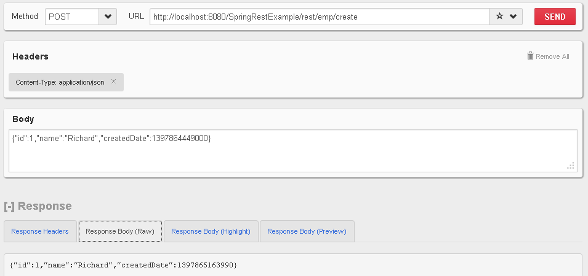

@RequestMapping(value = EmpRestURIConstants.*CREATE_EMP*, method = RequestMethod.*POST*)

**public** @ResponseBody Employee createEmployee(@RequestBody Employee emp) {

*logger*.info("Start createEmployee.");

emp.setCreatedDate(**new** Date());

empData.put(emp.getId(), emp);

**return** emp;

}

[**http://localhost:8080/SpringRestExample/rest/emp/1**](http://localhost:8080/SpringRestExample/rest/emp/1)

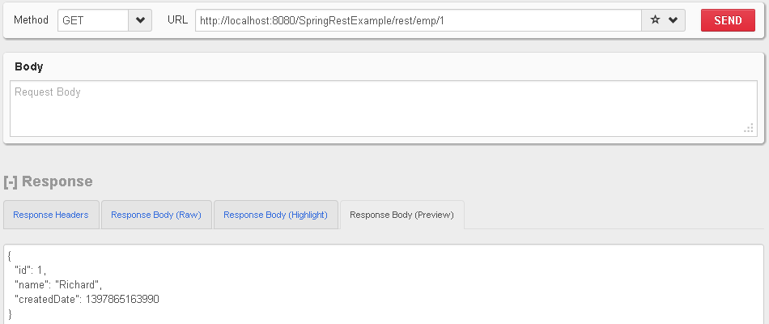

@RequestMapping(value = EmpRestURIConstants.*GET_EMP*, method = RequestMethod.*GET*)

**public** @ResponseBody Employee getEmployee(@PathVariable("id") **int** empId) {

*logger*.info("Start getEmployee. ID="+empId);

**return** empData.get(empId);

}

[**http://localhost:8080/SpringRestExample/rest/emps**](http://localhost:8080/SpringRestExample/rest/emps)

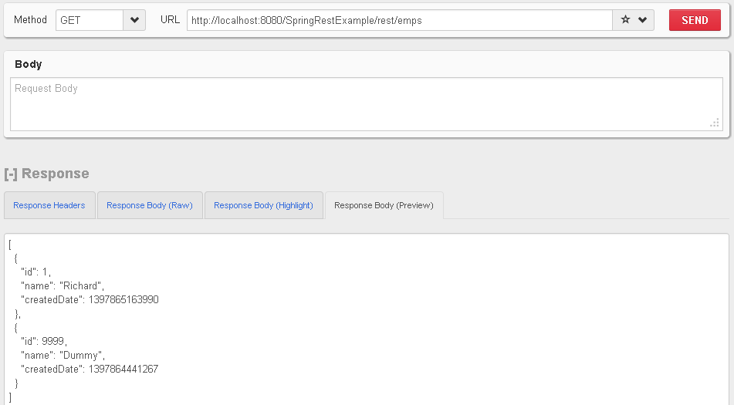

@RequestMapping(value = EmpRestURIConstants.*GET_ALL_EMP*, method = RequestMethod.*GET*)

**public** @ResponseBody List<Employee> getAllEmployees() {

*logger*.info("Start getAllEmployees.");

List<Employee> emps = **new** ArrayList<Employee>();

Set<Integer> empIdKeys = empData.keySet();

**for**(Integer i : empIdKeys){

emps.add(empData.get(i));

}

**return** emps;

}

[**http://localhost:8080/SpringRestExample/rest/emp/delete/1**](http://localhost:8080/SpringRestExample/rest/emp/delete/1)

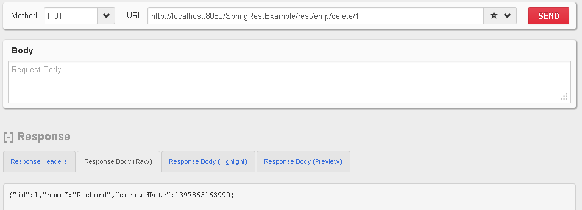

@RequestMapping(value = EmpRestURIConstants.*DELETE_EMP*, method = RequestMethod.*PUT*)

**public** @ResponseBody Employee deleteEmployee(@PathVariable("id") **int** empId) {

*logger*.info("Start deleteEmployee.");

Employee emp = empData.get(empId);

empData.remove(empId);

**return** emp;

}