[**http://localhost:8080/jersey-medium/rest/corporationService/getDefault**](http://localhost:8080/jersey-medium/rest/corporationService/getDefault)

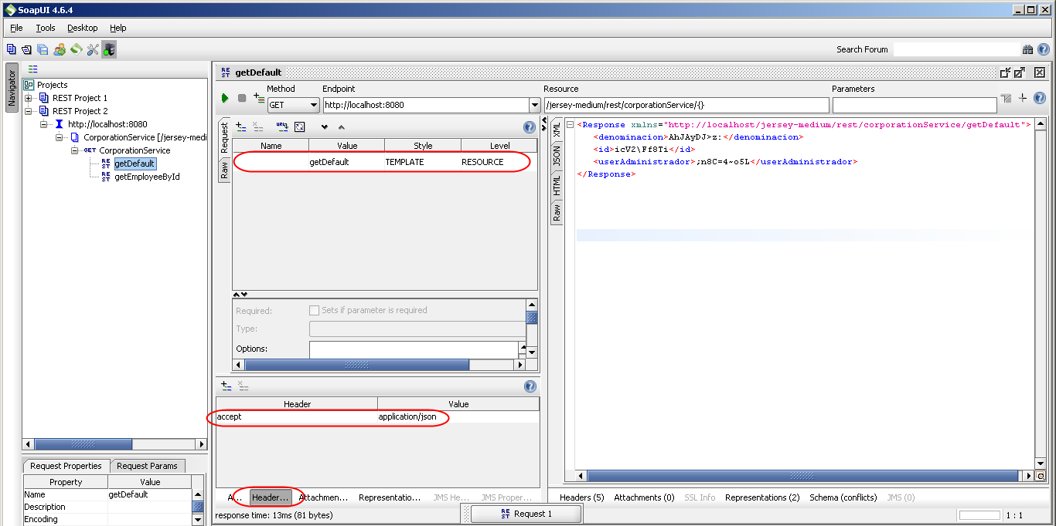

[http://localhost:8080/jersey-medium/rest/corporationService/getEmployeeByUri/{uri}](http://localhost:8080/jersey-medium/rest/corporationService/getEmployeeByUri/%7buri%7d)

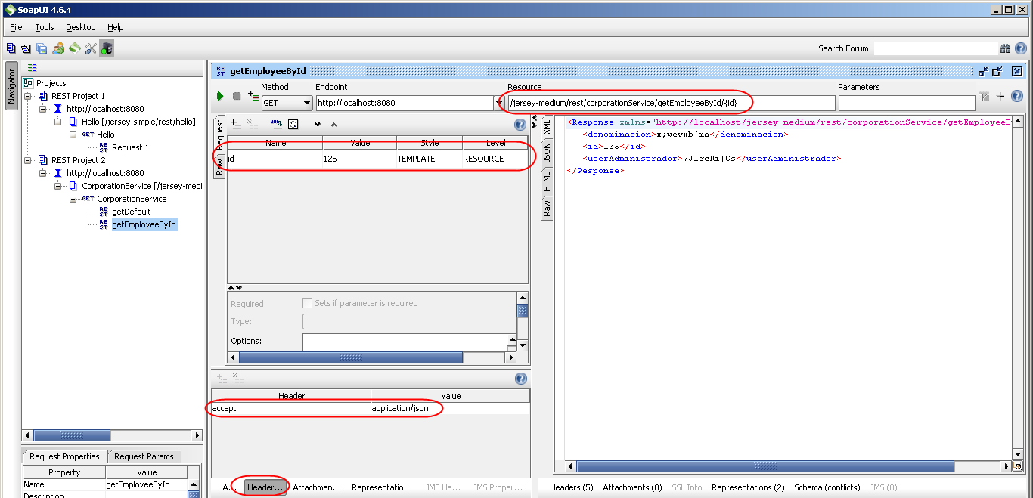

[http://localhost:8080/jersey-medium/rest//corporationService/getEmployeeByUri/{uri}](http://localhost:8080/jersey-medium/rest//corporationService/getEmployeeByUri/%7buri%7d)

