VEEAM KASTEN
The Kasten Resilience Playbook
A Maturity Model, Day-2 Operating Guide & Reference Architecture
A reference framework for measuring, operating, and advancing the maturity of Kubernetes data protection with Veeam Kasten.

Covers:
- A 5-level, 7-dimension maturity model for Kasten deployments
- The day-2 operating model — cadences, roles, and governance
- A reference architecture for policy, storage, and disaster recovery
- A roadmap connecting the first 100 days to long-term maturity
Prepared for internal use — Kasten deployment planning and operations.
July 24, 2026

Contents
1. Introduction 3
1.1 Who this is for 3
1.2 How this guide is organized 3
2. The Kasten Maturity Model 4
2.1 The seven dimensions 4
2.2 Quick-reference summary 5
Maturity model — quick reference (landscape) 6
2.3 Level detail 7
3. The Day-2 Operating Model 10
3.1 Operating cadence 10
3.2 Roles and responsibilities 10
3.3 Core operating practices 11
4. Reference Architecture 12
4.1 Architecture principles 12
4.2 Core components 13
4.3 Disaster recovery topology 13
4.4 Edge and air-gapped patterns 13
4.5 Non-functional considerations 14
4.6 Data Protection Architecture Principles 14
4.7 Disaster Recovery Patterns 15
5. Roadmap: From Day 1 to Level 5 17
6. Using the Companion Self-Assessment 18
7. Run the K10 Production Checklist 19
7.1 What it is 19
7.2 Pull the latest release and deploy it 19
7.3 Attaching a cluster architecture diagram (optional) 19
Appendix — Glossary 21

1. Introduction
This guide gives platform, infrastructure, and application teams a shared way to understand, measure, and improve how Veeam Kasten is deployed and operated over time.
Deploying Kasten is a starting point, not an end state. The difference between an organization that survives a cluster loss or a ransomware event and one that doesn't is rarely the backup tool itself — it is whether backup policy, application awareness, immutability, disaster recovery, and recovery testing have matured into a dependable, repeatable operating model.

1.1 Who this is for
Platform engineers and infrastructure architects responsible for Kubernetes data protection and business continuity; application teams whose stateful workloads depend on Kasten; and security, compliance, and leadership stakeholders who need a common language to describe how protected the organization is.

1.2 How this guide is organized
- Section 2 — The Kasten Maturity Model: five levels across seven dimensions, from ad hoc protection to a continuously adaptive program.
- Section 3 — The Day-2 Operating Model: the recurring cadence, roles, and practices that sustain and advance maturity.
- Section 4 — Reference Architecture: how policy, storage, immutability, and disaster recovery fit together.
- Section 5 — Roadmap: how Veeam's first 100-day rollout maps onto the maturity levels, and what comes after.
- Section 6 — Using the companion self-assessment scorecard.
- Section 7 — Running the k10-checklist production readiness tool from GitHub.
- Appendix — Glossary.

2. The Kasten Maturity Model
Maturity is assessed across seven dimensions that together determine whether an organization can recover — not just whether backups are running. A workload, a cluster, or an entire fleet can sit at different levels simultaneously; the model is meant to be applied per workload tier (production, non-production, edge) rather than as a single fleet-wide score.
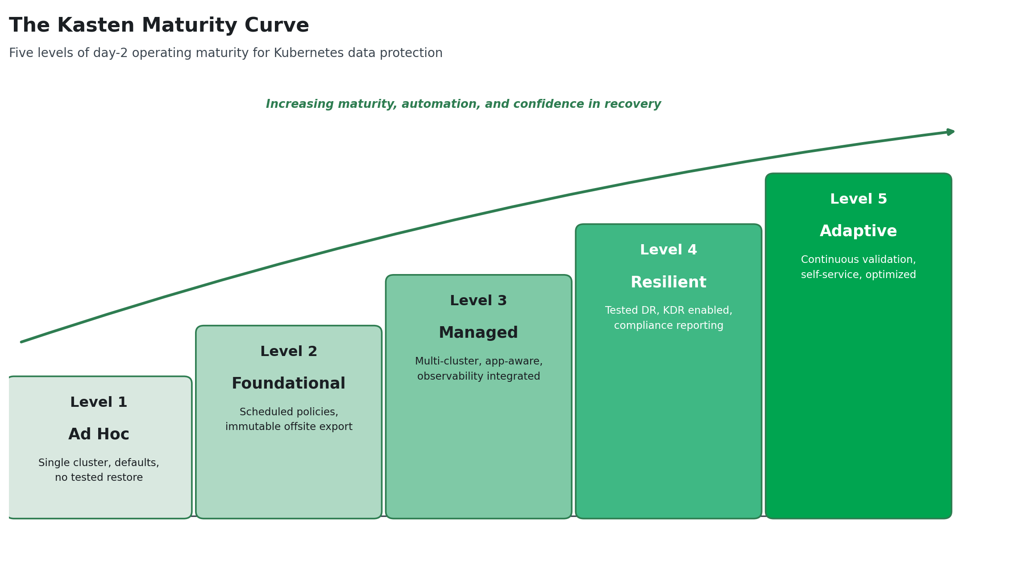

2.1 The seven dimensions
Dimension | What it measures
Coverage & Policy Automation | Whether protection is manual and workload-by-workload or automatically applied to anything matching a policy.
Application Consistency | Whether backups merely capture a crash-consistent volume state or use Kanister Blueprints to quiesce databases and applications correctly.
Storage, Immutability & Security | Where backup data lives, whether it is offsite, and whether it is protected against tampering or deletion — including by a compromised administrator account.
Centralized Management & Multi-Cluster | Whether each cluster is configured independently or governed centrally through Kasten's Multi-Cluster Manager.
Disaster Recovery | Whether a documented, tiered DR plan exists and is tested, from export-only rebuild to warm-standby with continuous import.
Observability, Compliance & Reporting | Whether job health, RPO compliance, and coverage are actively monitored and reportable to auditors and leadership.
People, Process & Continuous Validation | Whether restore procedures are documented, tested on a schedule, and whose results feed back into ongoing improvement.

2.2 Quick-reference summary
A condensed view of all five levels across all seven dimensions follows on the next page in landscape orientation. Detailed narratives for each level begin in section 2.3.

Maturity Model — Quick Reference
Dimension | L1 — Ad Hoc | L2 — Foundational | L3 — Managed | L4 — Resilient | L5 — Adaptive
Coverage & Policy Automation | Manual, single cluster, no policy | Scheduled policies, manual selection | Label/namespace-driven automatic coverage | Fleet-wide, tier-based standardization | Zero-touch onboarding, continuously tuned
Application Consistency | Crash-consistent only | Awareness, not yet applied | Kanister Blueprints on key databases | App-consistent is the default, tested end-to-end | In-house Blueprint library, custom apps onboarded
Storage, Immutability & Security | Local only, no offsite copy | One offsite, immutable target | Multiple profiles, fleet-wide immutability | BYOK/CMEK, lifecycle cost management | SIEM anomaly detection, FinOps-optimized
Centralized Management & Multi-Cluster | Single K10 instance | Single-cluster, independently operated | MCM deployed, global policies/profiles | Full fleet incl. edge/air-gapped, centrally governed | Self-service, namespace-scoped restore
Disaster Recovery | No DR plan | Export-only rebuild-and-restore | DR environment with Import Policy | KDR enabled, tiered cold/warm standby, drills scheduled | Automated game-days, continuous RTO/RPO benchmarking
Observability, Compliance & Reporting | No monitoring | Manual dashboard review | Metrics + alerting integrated, coverage audits | Compliance reporting, coverage as governance metric | Real-time compliance dashboards, proactive licensing
People, Process & Continuous Validation | No runbook, never restored | Owner identified, first restore proven | Documented, emerging review cadence | Scheduled, documented recovery testing | Continuous improvement loop, annual reassessment

2.3 Level detail
Level 1 — Ad Hoc
A Kasten instance exists, but protection is manual, inconsistent, and unproven. This is expected on day one — it becomes a risk if it persists.

Dimension | What it looks like at this level
Coverage & Policy Automation | Manual, one-off backups on a single cluster. No policy exists; workloads can be unprotected without anyone noticing.
Application Consistency | Crash-consistent snapshots only. No Kanister Blueprints in use; databases are not quiesced before capture.
Storage, Immutability & Security | Snapshots remain loyal to the storage device. No offsite export, no immutability, no encryption strategy.
Centralized Management & Multi-Cluster | A single K10 instance on a single cluster. No Multi-Cluster Manager, no global policy concept.
Disaster Recovery | No disaster recovery plan. Recovery, if attempted, is improvised.
Observability, Compliance & Reporting | No monitoring of job success or failure. No compliance evidence exists.
People, Process & Continuous Validation | No documented runbook. No restore has ever been tested.

Level 2 — Foundational
Backups run on a schedule with sensible retention, and at least one export target is offsite and immutable. A first restore has been proven to work.

Dimension | What it looks like at this level
Coverage & Policy Automation | Scheduled backup policies with defined retention (e.g., 1 daily / 4 weekly / 3 monthly). Workload selection still largely manual.
Application Consistency | Awareness of which workloads need application-aware handling, but Blueprints not yet broadly applied.
Storage, Immutability & Security | Exports flow to at least one offsite Location Profile (object storage, Veeam Vault, or VBR repository). Data is encrypted, compressed, and deduplicated in transit.
Centralized Management & Multi-Cluster | Still single-cluster; each K10 instance is configured and operated independently.
Disaster Recovery | Export-only DR: in a disaster, the plan is to rebuild the cluster, reinstall Kasten, and restore from exports.
Observability, Compliance & Reporting | Dashboard reviewed periodically. No external alerting integration yet.
People, Process & Continuous Validation | A backup owner is identified. The first restore test has been performed and passed on a non-critical workload.

Level 3 — Managed
Protection is policy-driven and automatically extends to new workloads. Multiple clusters are centrally visible, application-consistent backup is standard for databases, and failures are alerted, not discovered.

Dimension | What it looks like at this level
Coverage & Policy Automation | Policies driven by namespace or label selectors; new stateful workloads matching a policy are automatically protected — no manual per-workload configuration. Backup windows and job staggering are configured to avoid contention.
Application Consistency | Kanister Blueprints applied to key data services (PostgreSQL, MongoDB, MySQL, and similar) via Blueprint Bindings, with quiescing verified through test restores.
Storage, Immutability & Security | Multiple Location Profiles in use; immutability enforced fleet-wide; backup storage credentials are separated from cluster credentials and access is scoped to least privilege.
Centralized Management & Multi-Cluster | Multi-Cluster Manager (MCM) deployed; Global Policies and Global Profiles distribute consistent configuration across the fleet; licensing is centralized.
Disaster Recovery | DR environment with an Import Policy: restore points are regularly imported into a standby catalog and are visible, but applications are not yet running.
Observability, Compliance & Reporting | Metrics exported to Grafana/Datadog/Thanos-class tooling; alerts fire on failed jobs or RPO breaches; periodic coverage audits close protection gaps.
People, Process & Continuous Validation | Policies and architecture are documented. A recurring review cadence is emerging, and more than one person can operate the environment.

Level 4 — Resilient
Recoverability is proven, not assumed. DR is tested against defined RTO/RPO targets by workload tier, compliance evidence is produced routinely, and immutability is universal.

Dimension | What it looks like at this level
Coverage & Policy Automation | Full fleet coverage validated against inventory; policy presets and global resources standardize configuration by workload tier (production / non-production / edge).
Application Consistency | Application-consistent backup is the default for all stateful workloads. Blueprints are validated through end-to-end backup-and-restore testing, not just backup success.
Storage, Immutability & Security | Immutability (Object Lock / Azure Blob immutability) enforced everywhere; customer-managed encryption keys (BYOK/CMEK) used where supported; storage lifecycle policies manage cost.
Centralized Management & Multi-Cluster | The full multi-cluster fleet, including edge and air-gapped sites, is centrally governed, with local caching (e.g., MinIO) for disconnected clusters synchronized on a schedule.
Disaster Recovery | Kasten DR (KDR) is enabled so the backup catalog itself survives loss of the source K10 instance. DR topology (cold or warm standby) is matched to each workload tier's RTO/RPO, and drills are scheduled.
Observability, Compliance & Reporting | Compliance reporting operational for frameworks such as SOC 2, PCI-DSS, and HIPAA. Backup coverage is tracked as a fleet governance metric, not just a per-cluster status.
People, Process & Continuous Validation | Recovery testing is scheduled (quarterly or better), documented with actual recovery times against RTO targets, and runbooks are kept current. Results are archived for audit.

Level 5 — Adaptive
Data protection is a continuously improving program. Teams self-serve safely, anomalies are caught automatically, and the architecture is re-validated as the business changes.

Dimension | What it looks like at this level
Coverage & Policy Automation | New applications and business units are onboarded with zero manual backup configuration; policy automation is continuously tuned as the estate evolves.
Application Consistency | The Blueprint library is actively maintained and extended in-house; new application types are onboarded with custom Blueprints as they are adopted.
Storage, Immutability & Security | Backup patterns are monitored for anomalies (unexpected size or deletion patterns) via SIEM integration as an early ransomware indicator; storage cost is continuously optimized through FinOps practices.
Centralized Management & Multi-Cluster | Namespace-scoped self-service restore lets application teams recover their own workloads within RBAC boundaries, without platform team involvement.
Disaster Recovery | DR is validated through regular, automated game-day exercises; RTO/RPO performance is measured continuously and re-benchmarked against evolving business requirements.
Observability, Compliance & Reporting | Real-time compliance dashboards; licensing and entitlement usage tracked proactively ahead of renewal; annual architecture review against current business requirements.
People, Process & Continuous Validation | A continuous improvement loop: findings from every drill or incident feed back into policy, architecture, and training. Overall maturity is reassessed at least annually.

3. The Day-2 Operating Model
Reaching a maturity level is not a one-time project — it is sustained by a recurring operating cadence. The practices below are what keep an environment at Level 3 or above from silently drifting back toward Level 1 as clusters, applications, and teams change.

3.1 Operating cadence
Cadence | Activities
Daily / Continuous | • Automated policy execution — CSI snapshots and exports run to schedule.  • Alerting pipeline watches for job failures, missed RPO windows, and storage anomalies.
Weekly | • Review the Kasten dashboard; investigate any failed or warned jobs before they accumulate.  • Confirm all jobs complete within their defined backup window without contention.
Monthly | • Review recent Kasten releases and apply updates on a tested cadence (new versions ship roughly every two weeks).  • Audit backup coverage against the current workload inventory; close any gaps.
Quarterly | • Perform a documented, full recovery test — rotate through different workload types each quarter.  • Review RPO/RTO compliance per workload tier against actual measured recovery times.
Annually | • Review the backup architecture and DR topology against current business requirements.  • Reassess overall maturity level using the companion self-assessment scorecard.
Before renewal | • Review licensing usage across the fleet (via MCM or per-cluster) to confirm entitlement alignment.

3.2 Roles and responsibilities
Data protection maturity requires more than the platform team. A minimal responsibility model:
Role | Responsibility
Platform / Infrastructure team | Owns Kasten deployment, Multi-Cluster Manager, global policies, storage integration, and the DR topology. Accountable for fleet-wide coverage and compliance reporting.
Application teams | Define RPO/RTO needs for their workloads, provide input on database quiescing requirements, and — at higher maturity — perform self-service restores within their namespace.
Security / Compliance | Defines retention and immutability requirements, reviews SIEM alerting on backup anomalies, and consumes compliance reporting for audits (SOC 2, PCI-DSS, HIPAA).
Business / workload owners | Set the tolerance for data loss and downtime that ultimately determines RPO/RTO tiers and DR investment.

3.3 Core operating practices

RPO/RTO tiering
Define recovery point and recovery time objectives per workload tier before selecting tooling or DR topology — the requirements should drive the architecture, not the other way around. Production workloads typically require an RPO in minutes to low hours; non-production workloads can usually tolerate a multi-hour RPO; edge or disconnected sites often carry stricter RTO expectations but weaker connectivity to central backup targets.

Policy governance
Prefer multiple labeled policies over a single wildcard policy protecting everything — this keeps backup windows, retention, and application-aware handling scoped appropriately per workload class. Use namespace- or label-based selectors so new workloads are automatically covered without manual configuration and periodically audit coverage against the actual workload inventory rather than assuming policy scope matches reality.

Credential and secrets hygiene
Backup storage credentials must be distinct from cluster credentials, scoped to least privilege, and rotated independently. A compromised cluster credential should never be sufficient to reach, alter, or delete the backup archive.

Capacity and storage cost management
Monitor backup storage growth and alert on unexpected spikes, which can indicate data corruption or accidental inclusion of high-volume ephemeral data. Use object storage lifecycle policies to move older backups to cheaper storage tiers once the operational retention window closes, while keeping the backup tool's retention settings and the storage lifecycle rules in agreement.

Upgrade management
New Kasten releases ship roughly every two weeks. Test upgrades in a non-production environment on a regular cadence rather than deferring indefinitely and verify Kubernetes version compatibility before upgrading either the cluster or Kasten.

Incident response integration
Route backup job failures and RPO breaches into the same alerting and incident management pipeline used for the rest of the platform. Where available, integrate with SIEM tooling to catch anomalies in backup size or deletion patterns — an early indicator of ransomware or insider threat activity targeting the backups themselves.

Governance reporting
Track backup coverage as a fleet governance metric — which environments have active, tested policies — not merely which environments have Kasten installed. This distinction is what compliance frameworks and leadership need visibility into.

4. Reference Architecture
The architecture below reflects Kasten's centralized-policy, distributed-enforcement model: a Multi-Cluster Manager defines protection policy once, K10 instances on each cluster enforce it locally, and all backup data lands off-cluster in immutable storage.
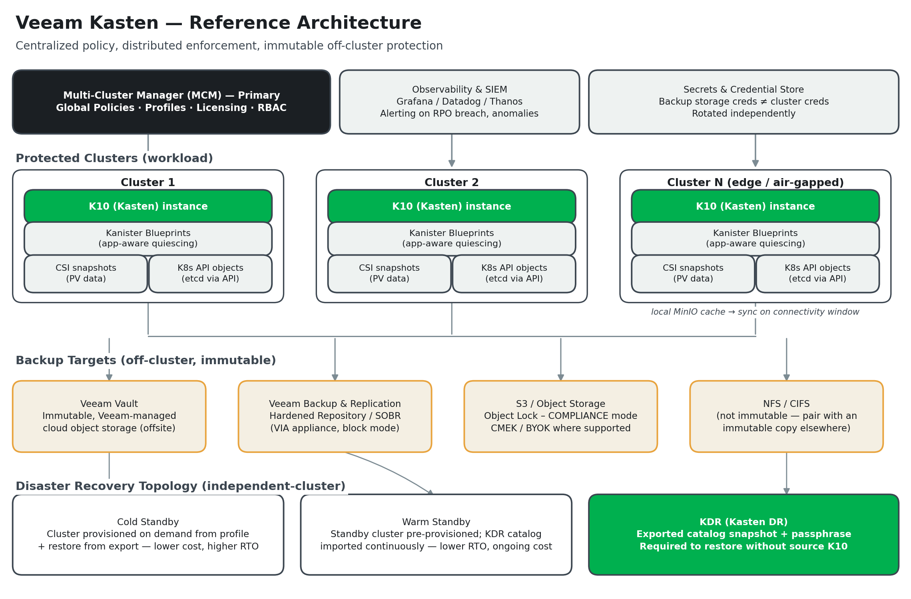

4.1 Architecture principles
- Protect both layers independently. Kubernetes resource state (namespaces, Deployments, StatefulSets, ConfigMaps, Secrets, RBAC, CRDs) and persistent volume data must both be captured — restoring one without the other leaves an application in an inconsistent state.
- Follow the 3-2-1 rule. Maintain at least three copies of data: the live copy on cluster storage, a backup in local/regional object storage, and a cross-region or off-site replicated copy. All backup copies must live off-cluster.
- Use CSI snapshot integration. Storage-native snapshots minimize backup window duration and impact on running workloads, and are Kasten's standard restore path.
- Quiesce databases before capture. Crash-consistent snapshots are not reliable for transactional databases; application-consistent backup via Kanister Blueprints is required for stateful data services.
- Support heterogeneous restore. Backup tooling must be able to restore to the original cluster, a different cluster, a different namespace, or a different cloud provider — this is the primary DR mechanism when the original cluster is unavailable.
- Treat backup data as a ransomware target. Apply write-once (immutable) semantics to all production backup targets, not only regulated workloads, and keep backup storage credentials independent of cluster credentials.
- Test restores, not just backups. A backup that has never been restored against a documented procedure is not operationally valid. Scheduled restore drills to isolated environments are as important as the backup schedule itself.

4.2 Core components
Component | Role
K10 (Kasten) | The per-cluster engine that discovers workloads, enforces backup policy, triggers CSI snapshots, and performs restores.
Kanister & Blueprints | Open-source framework and per-application definitions that quiesce databases and other stateful services for application-consistent backup.
Multi-Cluster Manager (MCM) | Centralized console joining multiple K10 instances; distributes Global Policies and Global Profiles and centralizes licensing and RBAC.
Location Profiles | Definitions of where exported backup data lands — Veeam Vault, Veeam Backup & Replication repositories, S3-compatible object storage, or NFS/CIFS.
Veeam Vault | Veeam-managed, immutable, offsite object storage requiring no separate cloud account or advanced configuration.
Veeam Backup & Replication + VIA | Enables export to Hardened Repositories and Scale-Out Backup Repositories (SOBR) for organizations consolidating container and VM backup.
KDR (Kasten DR) | Exported snapshot of the Kasten catalog itself (including the encryption passphrase and cluster ID) — required to restore if the source K10 instance is lost.

4.3 Disaster recovery topology
This reference architecture uses an independent-cluster DR topology: each cluster is self-contained, and DR is achieved by restoring workloads from backup onto a separately provisioned cluster in a different zone or region — not by stretching a cluster across sites.
Topology | Characteristics
Cold standby | Recovery cluster provisioned on demand from its profile when a failure occurs. No ongoing infrastructure cost. RTO is higher — typically 30 minutes to several hours depending on workload size. Appropriate for non-production tiers and production workloads where the SLA permits.
Warm standby | Recovery cluster pre-provisioned and kept idle or lightly loaded, with backup data continuously imported. RTO is lower — minutes to tens of minutes — at the cost of ongoing infrastructure. Appropriate for production workloads with tight RTO requirements.
Export only | No standby infrastructure. In a disaster, a Kubernetes environment and Kasten are rebuilt from scratch and workloads restored from exported restore points. Acceptable when a multi-hour to multi-day RTO is tolerable.

4.4 Edge and air-gapped patterns
Air-gapped or intermittently connected clusters cannot ship backup data to a cloud object store in real time. Deploy a local S3-compatible target (such as MinIO) on the management cluster or dedicated local infrastructure, accumulate backups locally during disconnected periods, and synchronize to the central store during scheduled connectivity windows. Size local storage for at least two full backups plus all incremental backups expected during the maximum disconnection period, and alert when local utilization approaches capacity. Kasten's centralized policy management and low per-cluster footprint make it well suited to this pattern — policies defined once on the management cluster propagate to every edge cluster without per-site intervention.

4.5 Non-functional considerations
- Encryption in transit and at rest for all backup data; prefer customer-managed keys (BYOK/CMEK) for regulated workloads where supported.
- Compliance retention: PCI-DSS requires alignment with a defined retention schedule; HIPAA requires 6-year retention; SOC 2 auditors expect documented evidence that backup procedures operate as designed. Keep the backup tool's retention settings and object storage lifecycle rules in agreement.
- Backup solution independence: the backup control plane and its credentials should not depend on any service hosted on the clusters it protects, including identity providers — if a protected cluster fails, the backup solution must remain reachable.

4.6 Data Protection Architecture Principles
Data Protection Architecture Principles set out a vendor-neutral set of principles for Kubernetes data protection. Kasten's architecture, described above, is one implementation of these principles; they are repeated here as an independent checklist against which any Kasten deployment can be validated.
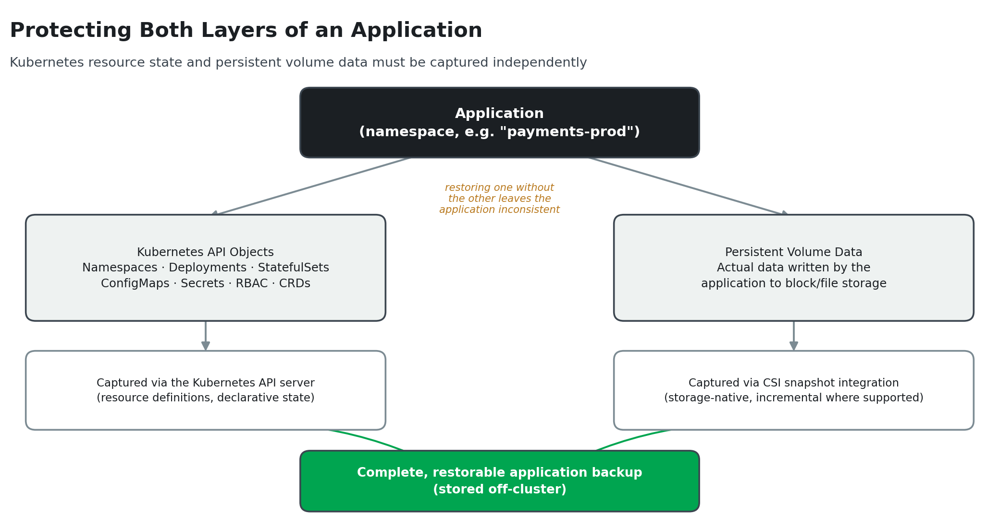
- Protect both layers independently. Kubernetes resource state — namespaces, Deployments, StatefulSets, ConfigMaps, Secrets, RBAC bindings, CRDs — and persistent volume data must both be captured; restoring one without the other leaves an application in an inconsistent state.
- Define RPO/RTO per workload tier before selecting tooling. Production workloads need an RPO in minutes to low hours; non-production can typically tolerate a multi-hour RPO; edge clusters often need a strict RTO but have limited connectivity to central backup targets. The requirements should drive the architecture, not the other way around.
- Require granular, application-level, Kubernetes-native backup. Solutions must capture both the Kubernetes API objects and the persistent volume data they reference and must be able to quiesce databases before creating a backup.
- Follow the 3-2-1 backup rule. Maintain at least three copies of data — the live copy on cluster storage, a backup in a local or regional object store, and a cross-region or off-site replicated copy — with all backup copies stored off-cluster.
- Prefer incremental, storage-integrated backup. Back up persistent storage through CSI snapshot integration to minimize backup window duration and reduce load on running workloads, with incremental backups as the default schedule.
- Require restore flexibility. Backup tooling must support restoring to the original cluster, a different cluster, a different namespace, or a different cloud provider — heterogeneous restore is the primary DR mechanism when the original cluster is unavailable.
- Test restoring, not just backing up. A backup's value is determined entirely by whether it can be restored. Every production workload needs at least one documented, tested restore procedure before its backup can be considered operationally valid.
- Protect against ransomware and data integrity threats. Apply write-once semantics to all production backup targets, consider air-gapping backup data from normal cluster credentials, and integrate with SIEM platforms to detect anomalous backup size or deletion patterns.
- Design for backup multitenancy. Policies should be definable at the namespace level, restore access scoped by Kubernetes RBAC, and self-service recovery available so application teams can manage their own restores without platform engineering involvement.

4.7 Disaster Recovery Patterns
Disaster Recovery Patterns frame recovery requirements by failure type and formalizes the independent-cluster DR topology used throughout this guide. A single namespace loss requires namespace-level restore from the most recent backup. A full cluster loss requires rebuilding the cluster from its profile and restoring all workloads from backup — the standard DR scenario. A regional loss requires replicated backup data in a different region and, for near-zero-RPO requirements, synchronous replication at the storage or database layer, which backup tools alone do not provide.
This reference architecture explicitly uses only the independent-cluster DR topology and rejects stretched-cluster configurations: each cluster is self-contained, and DR is achieved by restoring workloads from backup onto a separately provisioned cluster in a different zone or region.
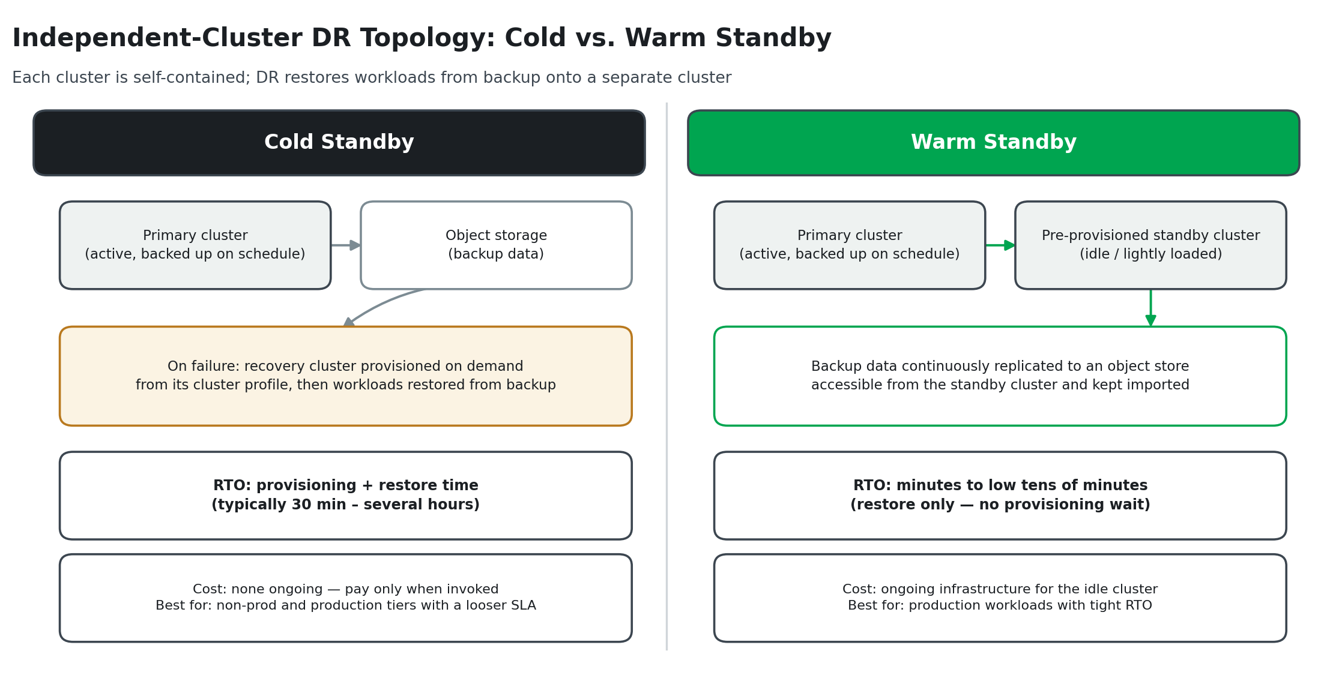
- Cold standby. A recovery cluster is provisioned from the cluster profile on demand when a failure occurs — no ongoing infrastructure cost, no replication to maintain. RTO is higher (typically 30 minutes to several hours). Appropriate for non-production tiers and production workloads where the SLA permits.
- Warm standby. A recovery cluster is pre-provisioned and kept idle or lightly loaded, with backup data continuously replicated to an accessible object store. RTO is lower (minutes to low tens of minutes) at the cost of ongoing infrastructure for the idle cluster. Appropriate for production workloads with tight RTO requirements.
- DR drills are mandatory, not optional. A disaster recovery procedure that has never been executed is an assumption, not a capability. Scheduled DR drills — full restore to an isolated cluster, validated against documented RTO and RPO targets — are required for all production workloads covered by a recovery SLA, with outcomes reviewed and runbooks updated when procedures change.

5. Roadmap: From Day 1 to Level 5
Veeam's 100-day operational roadmap for Kasten is a practical on-ramp to the maturity model above. The table below maps each phase to the maturity level it typically establishes; actual timing varies with environment size and complexity — small environments may compress Phase 1 to a week, and complex ones may extend Phase 3.
Phase | Timeline | Milestones | Maturity
Phase 1 — Foundation | Days 1–14 | M1 Size & plan · M2 Deploy Veeam Kasten · M3 First backup jobs | Level 1 → Level 2
Phase 2 — Harden the Basics | Days 15–45 | M4 Centralized management (MCM) · M5 Application-aware processing · M6 Policy best practices | Level 2 → Level 3
Phase 3 — Optimize & Harden | Days 46–75 | M7 Observability integration · M8 Enhanced resilience & DR · M9 Close coverage gaps | Level 3 → Level 4
Phase 4 — Prove Value | Days 76–100 | M10 Recovery testing · M11 Documentation & reporting · M12 Ongoing hygiene cadence | Level 4 (approaching Level 5)

Level 5 is not a milestone on the 100-day plan — it is what happens after, as game-day drills, self-service restore, SIEM-integrated anomaly detection, and annual architecture reviews become routine. Organizations should expect to operate at Level 4 for some time, under real production load and change, before Level 5 practices take hold.
Do not skip the first restore test.
Whether at Day 10 or Day 100, no backup should be considered valid until it has been restored — even once, to a non-production target. This single step, more than any tool feature, is what separates Level 1 from Level 2.

6. Using the Companion Self-Assessment
This guide is accompanied by a self-assessment workbook (Kasten Maturity Self-Assessment.xlsx) that operationalizes the model in Section 2.
- For each of the seven dimensions, record your Current Level (1–5) and a Target Level for the next planning cycle.
- Use the level descriptors on the Self-Assessment sheet — drawn directly from Section 2.3 — as the reference for scoring.
- Add notes and action items for how you intend to close the gap between current and target state.
- The Summary sheet calculates an overall maturity score and highlights the dimensions furthest from target, so effort can be prioritized.
Reassess at least annually, or after any significant change to the environment (new regulatory requirement, cluster fleet growth, incident, or DR drill).

7. Run the K10 Production Checklist
Alongside the maturity model in this guide, use the k10-checklist tool to work through and document Kasten's production readiness checklist directly against a real environment. It is a small, self-hosted web app — deploy it into any cluster (or run it locally), step through the checklist interactively, optionally attach a cluster architecture diagram, and export the completed result as a PDF for change records and audits.

7.1 What it is
- Repository: github.com/jricho/k10-checklist — an open-source, self-hosted checklist application (Next.js) for Veeam Kasten production readiness.
- Runs anywhere: as a container locally via Docker or deployed into a Kubernetes or OpenShift cluster from a single, version-pinned release manifest.
- Export to PDF: once the checklist is complete, export it as a PDF — the natural artifact to attach to a change record, go-live sign-off, or audit evidence pack.
- Optional architecture diagram: attach a cluster architecture diagram (PNG/JPEG) that is embedded on its own page in the exported PDF alongside the checklist.

7.2 Pull the latest release and deploy it
Every tagged release publishes a single install. yaml (Namespace, Deployment, and ClusterIP Service, with the image tag pre-pinned) as a GitHub Release asset — no need to clone the repository:
- Check the Releases page for the latest tag: github.com/jricho/k10-checklist/releases
- Apply it directly: kubectl apply -f https://github.com/jricho/k10-checklist/releases/download/<tag>/install.yaml (replace <tag> with the release you want, e.g. v0.1.0).
- Confirm the rollout: kubectl -n k10-checklist rollout status deploy/k10-checklist
- Access it: the Service is ClusterIP-only by design (no Ingress/Route is provisioned) — reach it with kubectl -n k10-checklist port-forward svc/k10-checklist 8080:80, then open http://localhost:8080.
- The same install.yaml applies unchanged on OpenShift (substitute oc for kubectl); the image runs under the restricted-v2 SCC without needing a pinned UID.
- Prefer a quick local check instead? docker run --rm -p 8080:8080 docker.io/jricho/k10-checklist:latest and open http://localhost:8080 — no cluster required.
- Need to customize replicas, resources, or the image tag first? Clone the repo and apply the Kustomize bundle under deploy/ instead of the published manifest.

7.3 Attaching a cluster architecture diagram (optional)
The checklist's Cluster Architecture Diagram card accepts an uploaded PNG or JPEG and embeds it on its own page in the exported PDF. Generate one directly from a live cluster or a set of manifests with KubeDiagrams (github.com/philippemerle/KubeDiagrams), an open-source tool that renders Kubernetes objects as an architecture diagram:
- Install the CLI in an isolated environment: pipx install KubeDiagrams (requires Python 3.9+ and Graphviz on PATH).
- Render from a live cluster: kubectl get all --all-namespaces -o yaml | kube-diagrams -o k10-arch.png -
- Or render from manifest files directly: kube-diagrams -o k10-arch.png ./manifests.yaml
- In the checklist app, scroll to Cluster Architecture Diagram, choose the generated PNG, and it is included automatically the next time the checklist is exported. Nothing is uploaded to a backend — the image stays in browser state until the PDF is exported.
Two checklists, one goal.
The k10-checklist tool answers “have we worked through, and can we prove, Kasten's production readiness for this environment?” The maturity model in this guide answers the broader question: “is our organization operationally ready to depend on it, day after day?” Run both before go-live, and again at every major upgrade.

Appendix

Glossary
Term | Definition
RPO (Recovery Point Objective) | The maximum acceptable amount of data loss, measured in time. Drives backup schedule frequency.
RTO (Recovery Time Objective) | The maximum acceptable downtime before a workload must be recovered.
Immutability | Backup data that cannot be modified or deleted for a defined retention period — the core defence against ransomware encrypting or deleting backups.
Kanister | An open-source data management framework used by Kasten to apply application-specific logic (such as database quiescing) during backup and restore.
Blueprint | A Kanister definition of custom, application-specific backup/restore steps. Blueprints are what make a backup "application-consistent" rather than merely crash-consistent.
Multi-Cluster Manager (MCM) | Kasten's centralized management layer, providing global policies, global profiles, unified licensing, and fleet-wide visibility across joined clusters.
KDR (Kasten DR) | Backup of the Kasten catalog itself (encryption passphrase, cluster ID, policy state) so that restores remain possible even if the source K10 installation is lost.
CSI (Container Storage Interface) | The standardized Kubernetes API for interacting with storage systems, enabling snapshot-based backup without application downtime.
Object Lock / WORM | Write-once-read-many storage semantics (e.g., S3 Object Lock in COMPLIANCE mode, Azure Blob immutability with policy lock) that prevent backup data from being altered or deleted before its retention period expires.
Hardened Repository | A backup repository (physical or appliance-based) hardened at the OS level to provide local immutability without requiring in-house Linux security expertise.
SOBR (Scale-Out Backup Repository) | A Veeam construct combining a local performance tier and a capacity tier (such as object storage) into a single logical backup target.
Cold vs. Warm Standby | Cold standby provisions a recovery cluster on demand at failure time (lower cost, higher RTO). Warm standby keeps a recovery cluster pre-provisioned with continuously imported backup data (lower RTO, ongoing cost).
3-2-1 Rule | Maintain at least three copies of data, on two different media, with one copy off-site — the baseline principle behind all resilient backup architectures.

