Joshua Ridel

Professor Cemal Tepe

CS-210-Programming Languages

04/15/2023

Documentation

Firstly, all required variables for the code are set. This includes two separate user-input variables, one for selecting menu options and the other for inputting the Item Name for Menu Option 1. This is followed by a separate frequency variable for every kind of grocery item that can be found in the list. These are needed to save and calculate the frequency of the item counted while reading through the list.

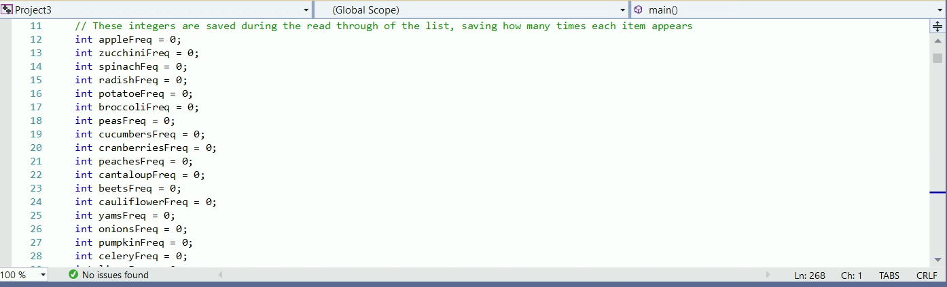

Next, the functions are defined. The first function of note is the “ItemCheckList”. This function reads through the .txt document, increasing the integer variable for the appropriate item every time it appears in the .txt document.

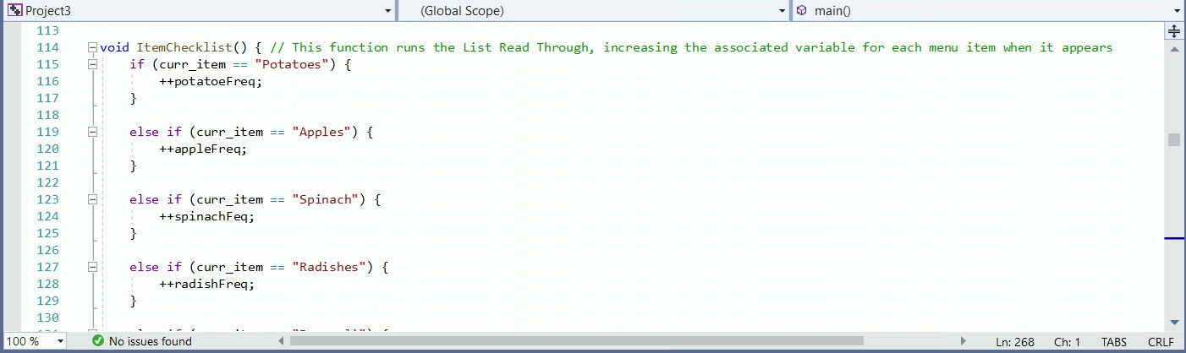

This function also uses the “ListReadThrough” function. This function is called for every instance of ItemCheckList. It’s a line of if statements checking for which of the items is currently being highlighted in the list during the read through, upon which that item’s associated variable is increased by 1. This function was written separately from ItemCheckList to be more optimal.

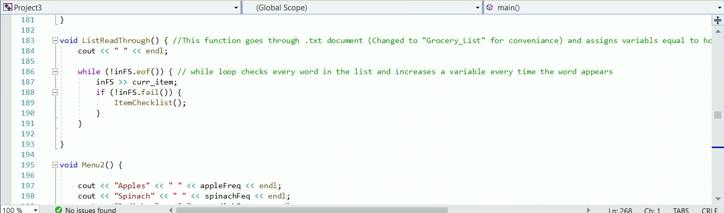

These functions are both called at the start of Main without user-input, for it's required to read through .txt once, and only once, for the other functions to run correctly. These are the functions “Main1”, “Main2”, and “Main3”. These functions are called by user-input from the main menu loop to perform the actions required and listed.

Main1 asks for user-input and will display the number of times that user-input appears in the list. This is done by simply showing the associated item variable for whatever item the user input (If the user didn’t input anything that matches with an item, the user-input will be redisplayed with a frequency of 0).

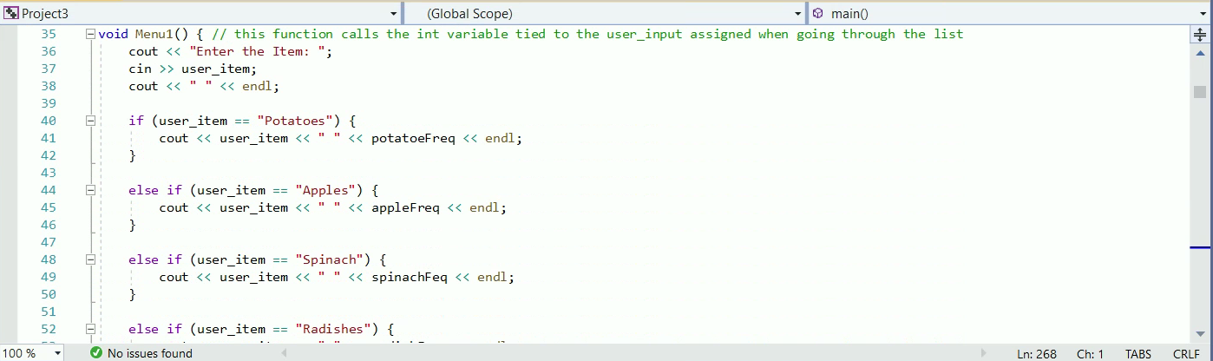

Main2 merely displays every item in the .txt file with its associated frequency variable next to it.

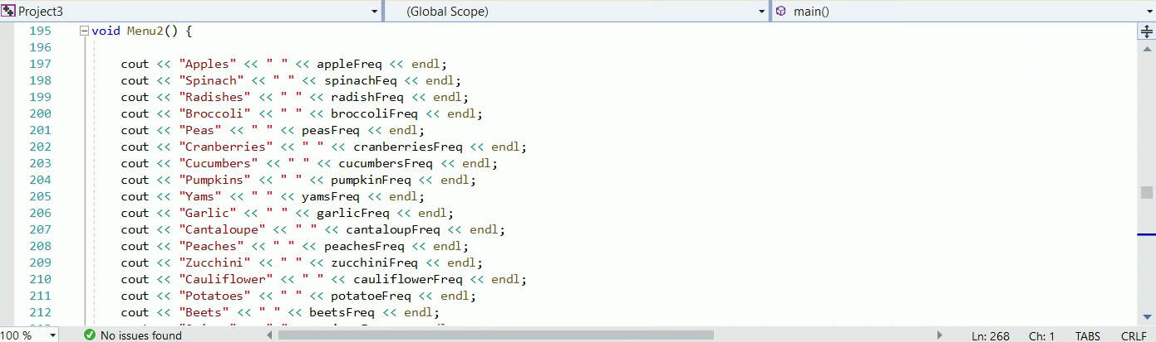

Main3 runs a For Loop, using a particular item frequency variable as a value. It uses this value to determine how many asterisks to display for that particular item.

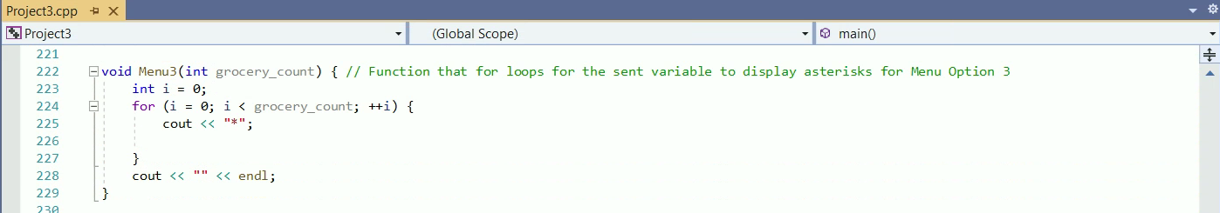

The last function is “DataFile”. This function opens the frequency.dat file and writes in it every item found in the original .txt file with its associated frequency variable. This is primarily just a repeat of “Main2” only with the additions of opening, writing in, and closing a new file.

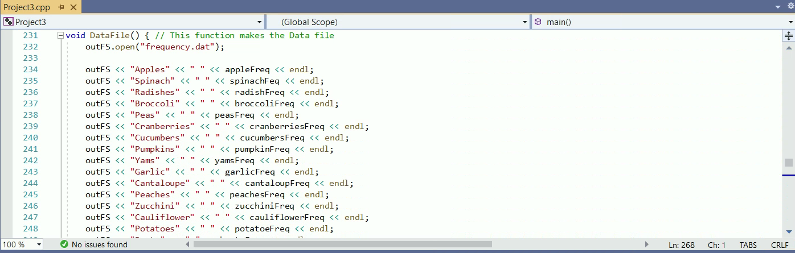

Finally, Main is called. First, the “Grocery_List.txt” file is opened for editing.

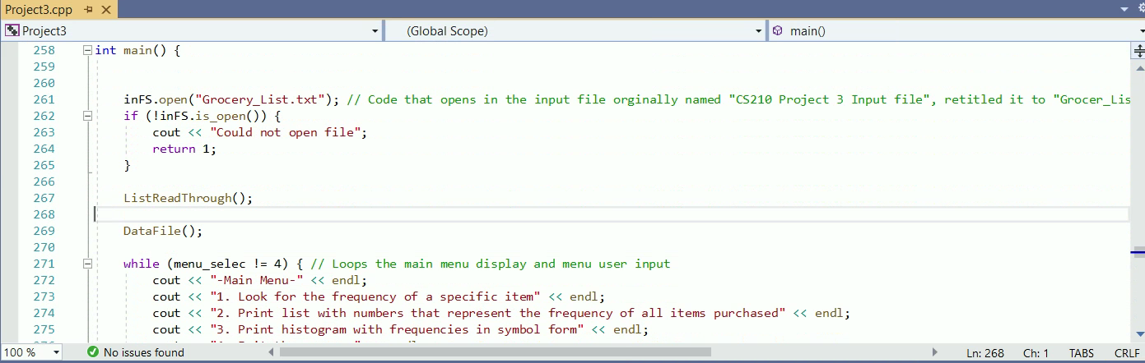

Next, ItemCheckList is called, getting the frequencies for all items from the list. Right after, DataFile is called to input this information into a backup data file. After that, a while loop is used to display the Main Menu options.

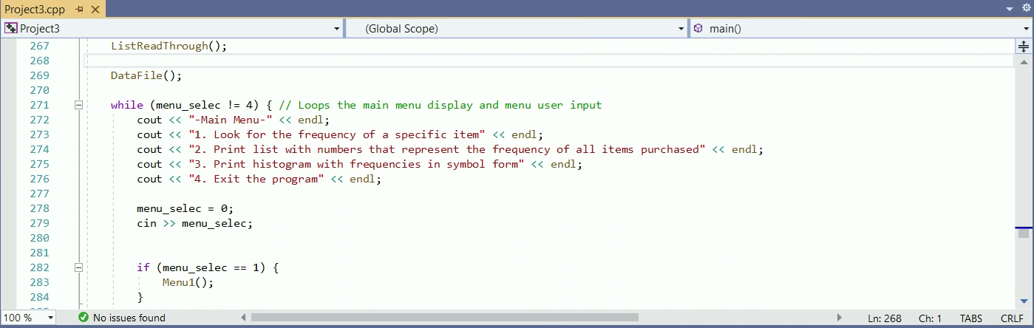

This loop asks for user-input to run one of the displayed options, all marked with an integer. Based-off what the user-inputs, If/Else statements are run to call the appropriate function.

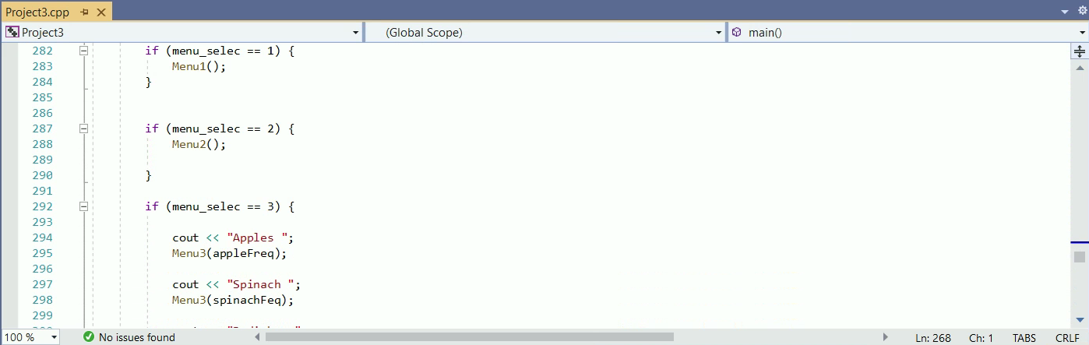

When a 4 is input by the user to quit the program, the original “Grocery_List.txt” is closed and the program exits.

